# The AI Success Trinity

# Mastering DataOps, MLOps, and FinOps for Transformative AI Implementation

### **WARNING: This content was generated using Generative AI. While efforts have been made to ensure accuracy and coherence, readers should approach the material with critical thinking and verify important information from authoritative sources.**

# Table of Contents

Introduction: The Critical Pillars of AI Success 5

The AI Revolution and Its Challenges 5

The promise and potential of AI 5

Common pitfalls in AI implementation 7

The need for robust operational frameworks 10

Introducing DataOps, MLOps, and FinOps 12

Defining the three Ops 12

Their interconnected roles in AI success 15

The synergy of the AI Success Trinity 17

DataOps: Fueling AI with Quality Data 20

The Foundations of DataOps 20

Defining DataOps and its objectives 20

The data lifecycle in AI projects 23

Key principles of effective DataOps 26

Implementing DataOps for AI Success 29

Data quality and governance 29

Automated data pipelines and integration 31

Real-time data processing and analytics 35

Data security and compliance in AI contexts 38

DataOps Best Practices and Tools 40

Collaborative data management 40

Continuous data testing and monitoring 43

DataOps tools and platforms for AI projects 46

MLOps: Streamlining AI Model Development and Deployment 50

Understanding MLOps 50

The evolution from DevOps to MLOps 50

Core components of MLOps 53

The MLOps lifecycle 55

Key MLOps Practices for AI Success 58

Version control for data and models 58

Automated model training and evaluation 61

Continuous integration and deployment (CI/CD) for AI 64

Model monitoring and maintenance 64

MLOps Tools and Frameworks 67

Popular MLOps platforms 67

Open-source vs. proprietary MLOps solutions 70

Integrating MLOps into existing AI workflows 73

FinOps: Optimising AI Costs and ROI 77

The Importance of FinOps in AI 77

Understanding AI-related costs 77

The role of FinOps in AI project success 80

Balancing innovation and cost-effectiveness 82

Implementing FinOps for AI Projects 84

Cost visibility and allocation 84

Optimising cloud resources for AI workloads 87

Budgeting and forecasting for AI initiatives 89

Measuring and maximizing AI ROI 93

FinOps Strategies and Tools 95

Cost optimization techniques for AI infrastructure 95

FinOps platforms and their integration with AI workflows 98

Collaborative cost management across teams 101

Integrating DataOps, MLOps, and FinOps for AI Excellence 105

The Synergistic Approach 105

Aligning DataOps, MLOps, and FinOps objectives 105

Creating a unified AI operations framework 107

Cross-functional collaboration and communication 110

Overcoming Integration Challenges 113

Common obstacles in unifying the three Ops 113

Strategies for seamless integration 116

Change management and cultural shifts 118

Case Studies: AI Success Through Integrated Ops 122

Real-world examples of successful integration 122

Lessons learned and best practices 125

Measuring the impact of integrated Ops on AI outcomes 128

Conclusion: Paving the Way for AI-Driven Transformation 132

Recap: The Critical Role of DataOps, MLOps, and FinOps 132

Key takeaways from each Ops discipline 132

The compounded benefits of integration 134

Future Trends and Considerations 137

Emerging technologies impacting the three Ops 137

Preparing for the evolving AI landscape 140

Call to Action: Implementing the AI Success Trinity 142

Steps to get started with integrated Ops 142

Resources for continued learning and implementation 145

Appendix: Book Generation Details 149

Appendix: Further Reading on Wardley Mapping 150

Core Wardley Mapping Series 150

Practical Resources 153

Specialized Applications 154

# Introduction: The Critical Pillars of AI Success

## The AI Revolution and Its Challenges

### The promise and potential of AI

Artificial Intelligence (AI) stands at the forefront of technological innovation, promising to revolutionise industries, transform societies, and redefine the very nature of human-machine interaction. As we embark on this journey of exploration into the critical pillars of AI success, it is imperative to first grasp the immense promise and potential that AI holds, particularly within the context of government and public sector applications.

AI’s potential extends far beyond mere automation of routine tasks. It offers the capability to analyse vast amounts of data, uncover hidden patterns, and generate insights that can drive evidence-based decision-making at unprecedented scales. In the realm of public service delivery, AI has the power to enhance efficiency, personalise citizen experiences, and optimise resource allocation in ways that were previously unimaginable.

AI is not just another technological advancement; it’s a fundamental shift in how we approach problem-solving and decision-making across all sectors of society.

The promise of AI in government and public sector contexts is multifaceted and far-reaching. Let us explore some of the key areas where AI holds transformative potential:

* Enhanced Public Services: AI can enable more responsive and personalised public services, from healthcare and education to transportation and social welfare.
* Improved Policy Making: By analysing complex datasets and simulating policy outcomes, AI can support more informed and effective policy decisions.
* Efficient Resource Management: AI-driven predictive analytics can optimise the allocation of public resources, reducing waste and improving outcomes.
* Fraud Detection and Prevention: Advanced AI algorithms can identify patterns indicative of fraud in public systems, enhancing integrity and saving taxpayer money.
* Crisis Response and Management: AI can assist in predicting, preparing for, and responding to crises, from natural disasters to public health emergencies.
* Citizen Engagement: AI-powered chatbots and virtual assistants can provide 24/7 access to government services and information, improving citizen satisfaction and engagement.

However, the realisation of AI’s potential in the public sector is not without its challenges. The complexity of AI systems, coupled with the sensitive nature of government data and operations, necessitates a robust and thoughtful approach to implementation. This is where the critical pillars of DataOps, MLOps, and FinOps come into play, forming the foundation for successful AI adoption and deployment.

DataOps ensures the availability of high-quality, relevant data – the lifeblood of AI systems. MLOps provides the framework for developing, deploying, and maintaining AI models at scale, ensuring their reliability and effectiveness. FinOps, in turn, ensures that AI initiatives deliver value for money, optimising costs and maximising return on investment in a sector where fiscal responsibility is paramount.

The true potential of AI in government lies not just in the technology itself, but in our ability to implement it responsibly, effectively, and at scale. This requires a holistic approach that encompasses data, models, and financial considerations.

As we delve deeper into the promise and potential of AI, it becomes clear that its transformative power is intrinsically linked to the operational frameworks that support it. The synergy between DataOps, MLOps, and FinOps creates a robust ecosystem that can harness AI’s potential while mitigating risks and ensuring sustainable, responsible implementation.

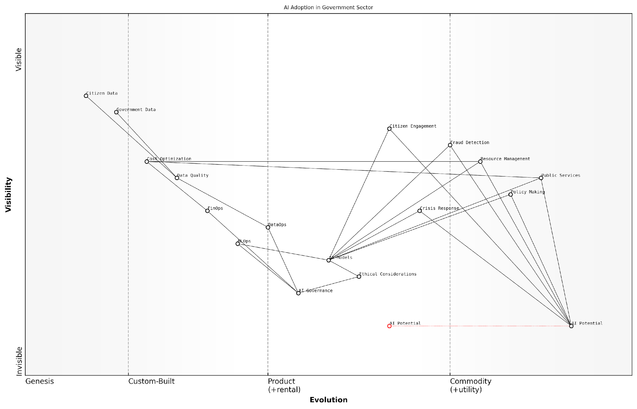

*Draft Wardley Map: [Insert Wardley Map: The promise and potential of AI]*

[Edit this draft Wardley Map](https://create.wardleymaps.ai/#clone:dbb7f4b3e8c0fe6142)

Wardley Map Assessment

The government sector shows significant potential for AI adoption, with opportunities to transform public services and operations. However, success hinges on rapidly developing AI governance, improving data quality, and fostering a culture of innovation while maintaining ethical standards. Strategic focus should be on building a strong AI foundation through governance and data operations, followed by gradual expansion of AI applications across various services. The sector is well-positioned to become a leader in responsible and impactful AI deployment, but must navigate challenges in talent acquisition, data management, and balancing innovation with public trust.

[View full Wardley Map report](http://markdown/wardley_map_reports/wardley_map_report_01_The_promise_and_potential_of_AI.md)

In the subsequent sections, we will explore how these critical pillars work together to unlock the full promise of AI, enabling governments and public sector organisations to leverage this powerful technology for the benefit of citizens and society at large. By understanding and implementing these operational frameworks, we can move beyond the hype of AI and into a realm of practical, impactful, and responsible AI-driven transformation in the public sector.

### Common pitfalls in AI implementation

As organisations embark on their AI journey, they often encounter a myriad of challenges that can derail even the most promising initiatives. Drawing from years of experience in guiding government and public sector entities through AI transformations, I’ve observed several recurring pitfalls that demand our attention. These challenges, if not addressed proactively, can significantly impede the realisation of AI’s transformative potential.

* Lack of clear strategic alignment
* Insufficient data quality and governance
* Inadequate infrastructure and scalability
* Skill gaps and talent shortages
* Overlooking ethical considerations and bias
* Poor model interpretability and explainability
* Inadequate change management and cultural adaptation
* Underestimating the complexity of AI operations
* Neglecting regulatory compliance and data privacy
* Failure to establish robust monitoring and maintenance processes

One of the most pervasive issues I’ve encountered is the lack of clear strategic alignment. Many organisations, particularly in the public sector, rush to implement AI without a well-defined strategy that aligns with their broader organisational goals. This often results in isolated AI projects that fail to deliver meaningful value or scale across the organisation. As a senior government official once remarked to me:

We were so caught up in the excitement of AI that we forgot to ask ourselves why we were implementing it in the first place. It wasn’t until we took a step back and aligned our AI initiatives with our core mission that we started seeing real impact.

Another critical pitfall is insufficient data quality and governance. AI models are only as good as the data they’re trained on, and I’ve seen numerous projects falter due to poor data management practices. This issue is particularly acute in government organisations, where data often resides in siloed legacy systems and lacks standardisation. Implementing robust DataOps practices is crucial to overcoming this challenge.

Inadequate infrastructure and scalability issues also frequently hamper AI success. Many organisations underestimate the computational resources required for AI workloads, leading to performance bottlenecks and inability to scale beyond pilot projects. This is where FinOps practices become essential, ensuring that organisations can optimise their AI infrastructure costs while maintaining the necessary performance and scalability.

Skill gaps and talent shortages present another significant hurdle. The rapidly evolving nature of AI technologies means that many organisations struggle to find and retain the necessary expertise. This challenge is particularly acute in the public sector, where competition with private industry for top AI talent can be fierce. Developing comprehensive training programmes and fostering partnerships with academic institutions can help address this issue.

Overlooking ethical considerations and bias in AI systems is a pitfall with far-reaching consequences, especially for government entities. I’ve witnessed cases where AI systems inadvertently perpetuated societal biases, leading to public backlash and erosion of trust. Implementing robust governance frameworks and ethical guidelines is crucial to mitigate these risks.

Poor model interpretability and explainability can severely limit the adoption and trust in AI systems, particularly in high-stakes decision-making contexts common in government applications. Ensuring that AI models are transparent and their decisions can be explained is crucial for building public trust and meeting regulatory requirements.

Inadequate change management and cultural adaptation often undermine AI initiatives. The introduction of AI can be disruptive to existing workflows and organisational structures. Without proper change management strategies, resistance to adoption can significantly hinder AI success.

Many organisations also underestimate the complexity of AI operations. The ongoing management, monitoring, and maintenance of AI systems require sophisticated MLOps practices. Neglecting these operational aspects can lead to model drift, degraded performance, and ultimately, project failure.

Regulatory compliance and data privacy concerns are particularly critical in the public sector. Failing to address these issues can result in legal challenges and loss of public trust. Implementing robust data governance frameworks and staying abreast of evolving regulations is essential.

Lastly, the failure to establish robust monitoring and maintenance processes can lead to the gradual degradation of AI system performance over time. Continuous monitoring, retraining, and updating of models are crucial for long-term AI success.

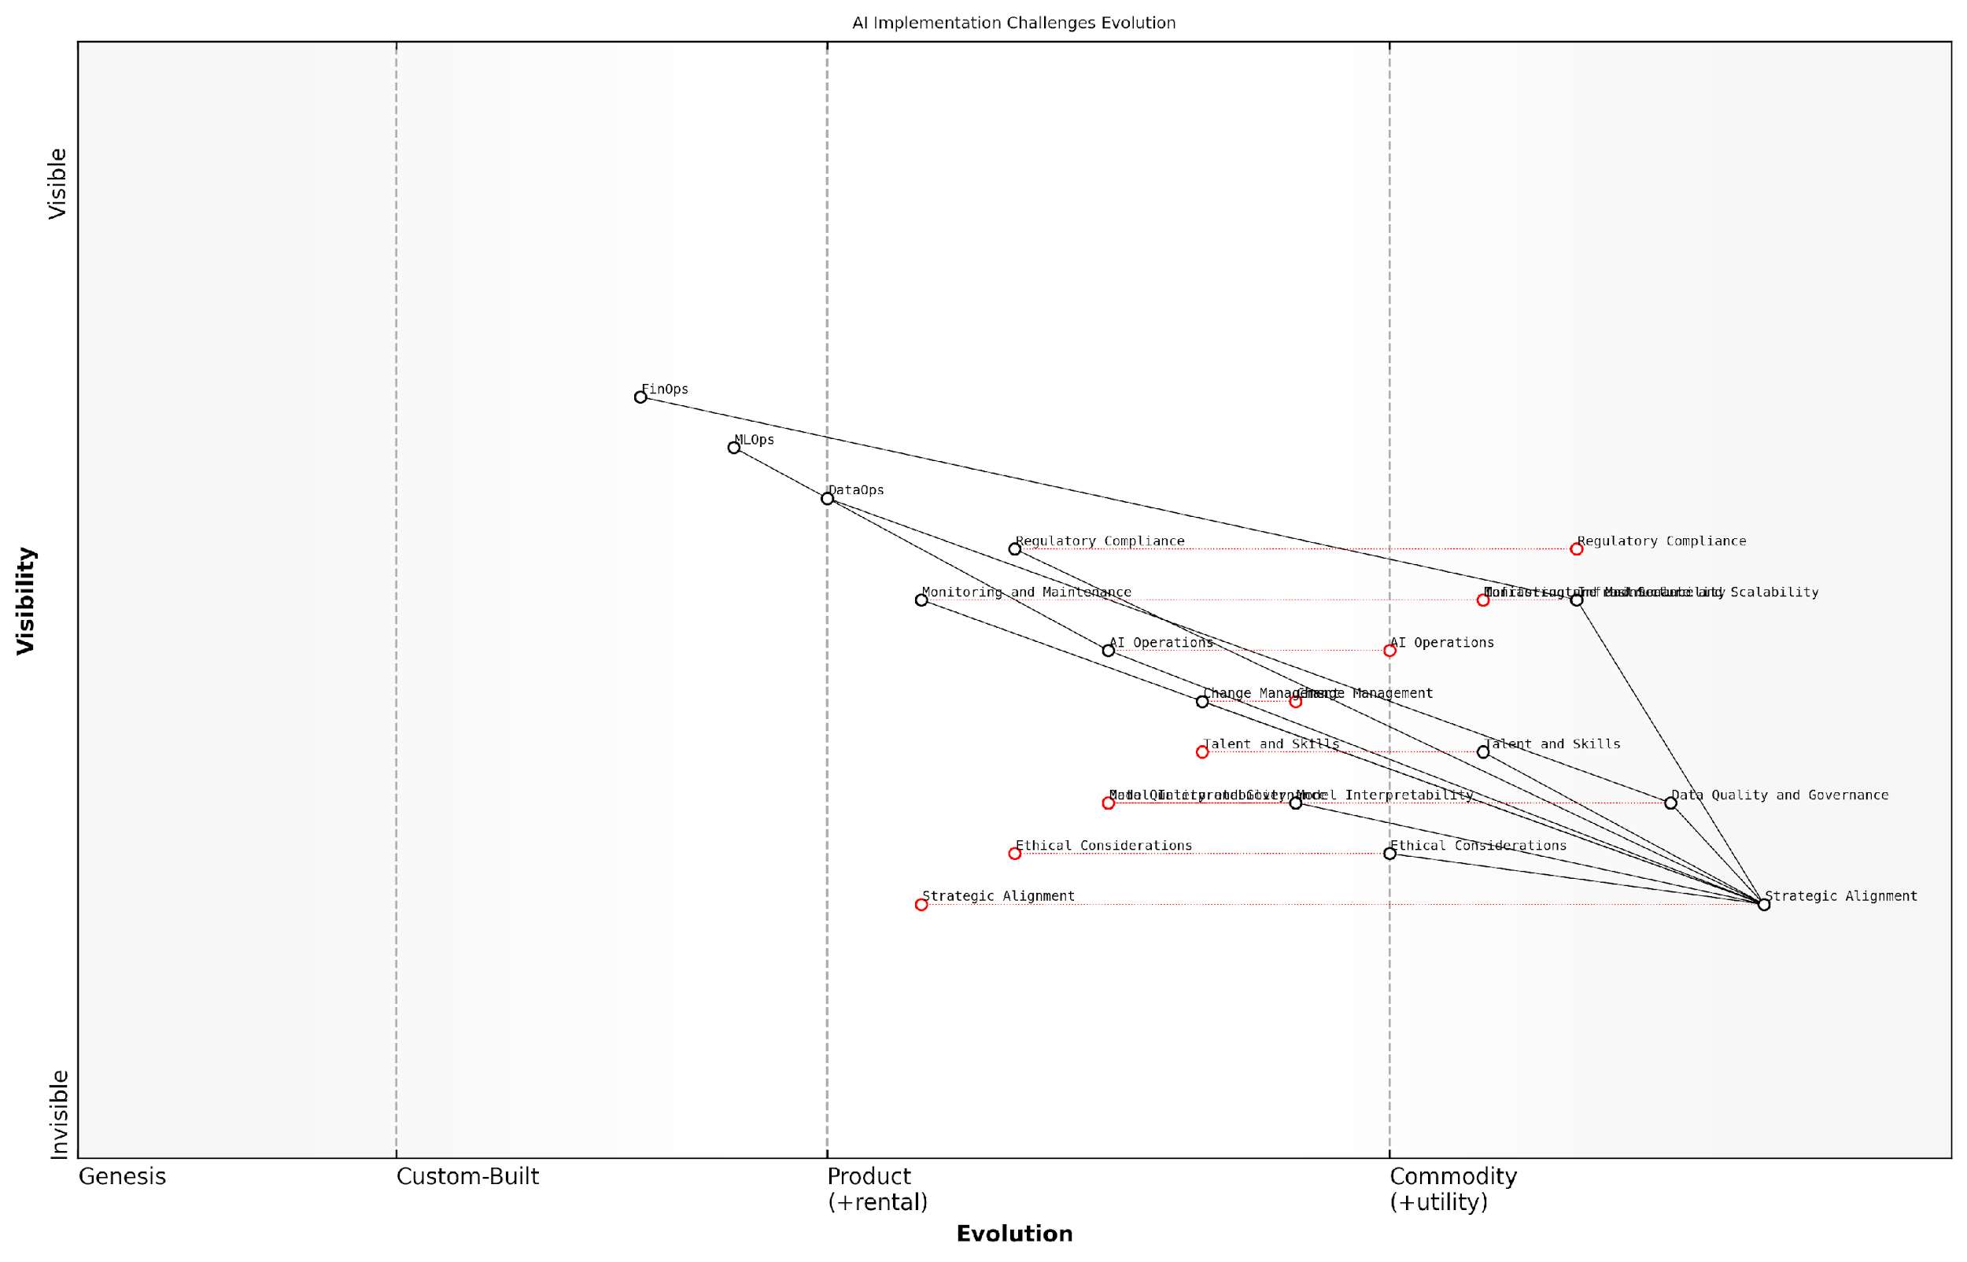

*Draft Wardley Map: [Insert Wardley Map: Common pitfalls in AI implementation]*

[Edit this draft Wardley Map](https://create.wardleymaps.ai/#clone:a13e1e66b94292ddfe)

Wardley Map Assessment

The Wardley Map reveals a public sector AI landscape that is technically capable but needs significant development in strategic alignment, ethical considerations, and public engagement. The key to success lies in bridging the gap between operational efficiency and public-centric, ethical AI implementation. Prioritising trust, transparency, and alignment with public sector values will be crucial for overcoming common pitfalls and achieving transformative AI implementation in government services.

[View full Wardley Map report](http://markdown/wardley_map_reports/wardley_map_report_02_Common_pitfalls_in_AI_implementation.md)

By understanding and proactively addressing these common pitfalls, organisations can significantly increase their chances of successful AI implementation. The integrated approach of DataOps, MLOps, and FinOps provides a comprehensive framework for navigating these challenges and realising the transformative potential of AI in the public sector.

### The need for robust operational frameworks

As the AI revolution continues to reshape industries and governments worldwide, the need for robust operational frameworks has become increasingly apparent. The transformative potential of AI is undeniable, yet its successful implementation remains a significant challenge for many organisations, particularly in the public sector. This subsection explores why robust operational frameworks are critical for AI success and how they address the complexities inherent in AI projects.

The complexity of AI systems, coupled with the rapid pace of technological advancement, demands a structured approach to development, deployment, and maintenance. Robust operational frameworks provide the necessary structure to manage these complexities effectively. They offer a systematic way to address the multifaceted challenges of AI implementation, from data management and model development to cost optimisation and ethical considerations.

* Ensuring data quality and accessibility
* Streamlining model development and deployment processes
* Optimising resource allocation and cost management
* Maintaining regulatory compliance and ethical standards
* Facilitating cross-functional collaboration and communication

One of the primary reasons robust operational frameworks are essential is the need for scalability. Many AI projects begin as small-scale proofs of concept but struggle to transition to enterprise-wide deployment. Operational frameworks provide the scaffolding necessary to scale AI initiatives effectively, ensuring that the same rigour and best practices applied in pilot projects can be maintained as the scope expands.

Without a robust operational framework, organisations risk creating AI silos that fail to deliver value at scale. It’s not just about developing models; it’s about creating a sustainable ecosystem for AI innovation and deployment.

Furthermore, robust operational frameworks are crucial for addressing the unique challenges posed by AI in terms of transparency, explainability, and accountability. As AI systems become more prevalent in decision-making processes, particularly within government and public sector contexts, there is an increasing demand for these systems to be transparent and accountable. Operational frameworks provide the mechanisms to ensure that AI models are developed, deployed, and monitored in a way that aligns with these requirements.

The need for robust operational frameworks is also driven by the imperative to manage the risks associated with AI implementation. These risks range from technical issues such as model drift and data quality degradation to broader concerns around bias, privacy, and security. By providing a structured approach to risk management, operational frameworks help organisations identify, assess, and mitigate these risks throughout the AI lifecycle.

* Continuous monitoring of model performance and data quality
* Regular audits for bias and fairness
* Robust security measures to protect sensitive data and models
* Clear governance structures for AI decision-making processes
* Mechanisms for ongoing stakeholder engagement and feedback

In the context of government and public sector organisations, the need for robust operational frameworks is particularly acute. These entities often deal with sensitive data, complex regulatory environments, and high public scrutiny. Operational frameworks provide the necessary guardrails to navigate these challenges while harnessing the potential of AI to improve public services and decision-making.

For government agencies, implementing AI is not just about technological innovation; it’s about building public trust. Robust operational frameworks are essential for demonstrating that AI systems are being developed and deployed responsibly and in the public interest.

Moreover, robust operational frameworks play a crucial role in fostering a culture of continuous improvement and innovation. By providing clear processes and best practices, these frameworks enable organisations to learn from their experiences, iterate on their approaches, and adapt to the rapidly evolving AI landscape. This is particularly important given the pace of technological change in the field of AI.

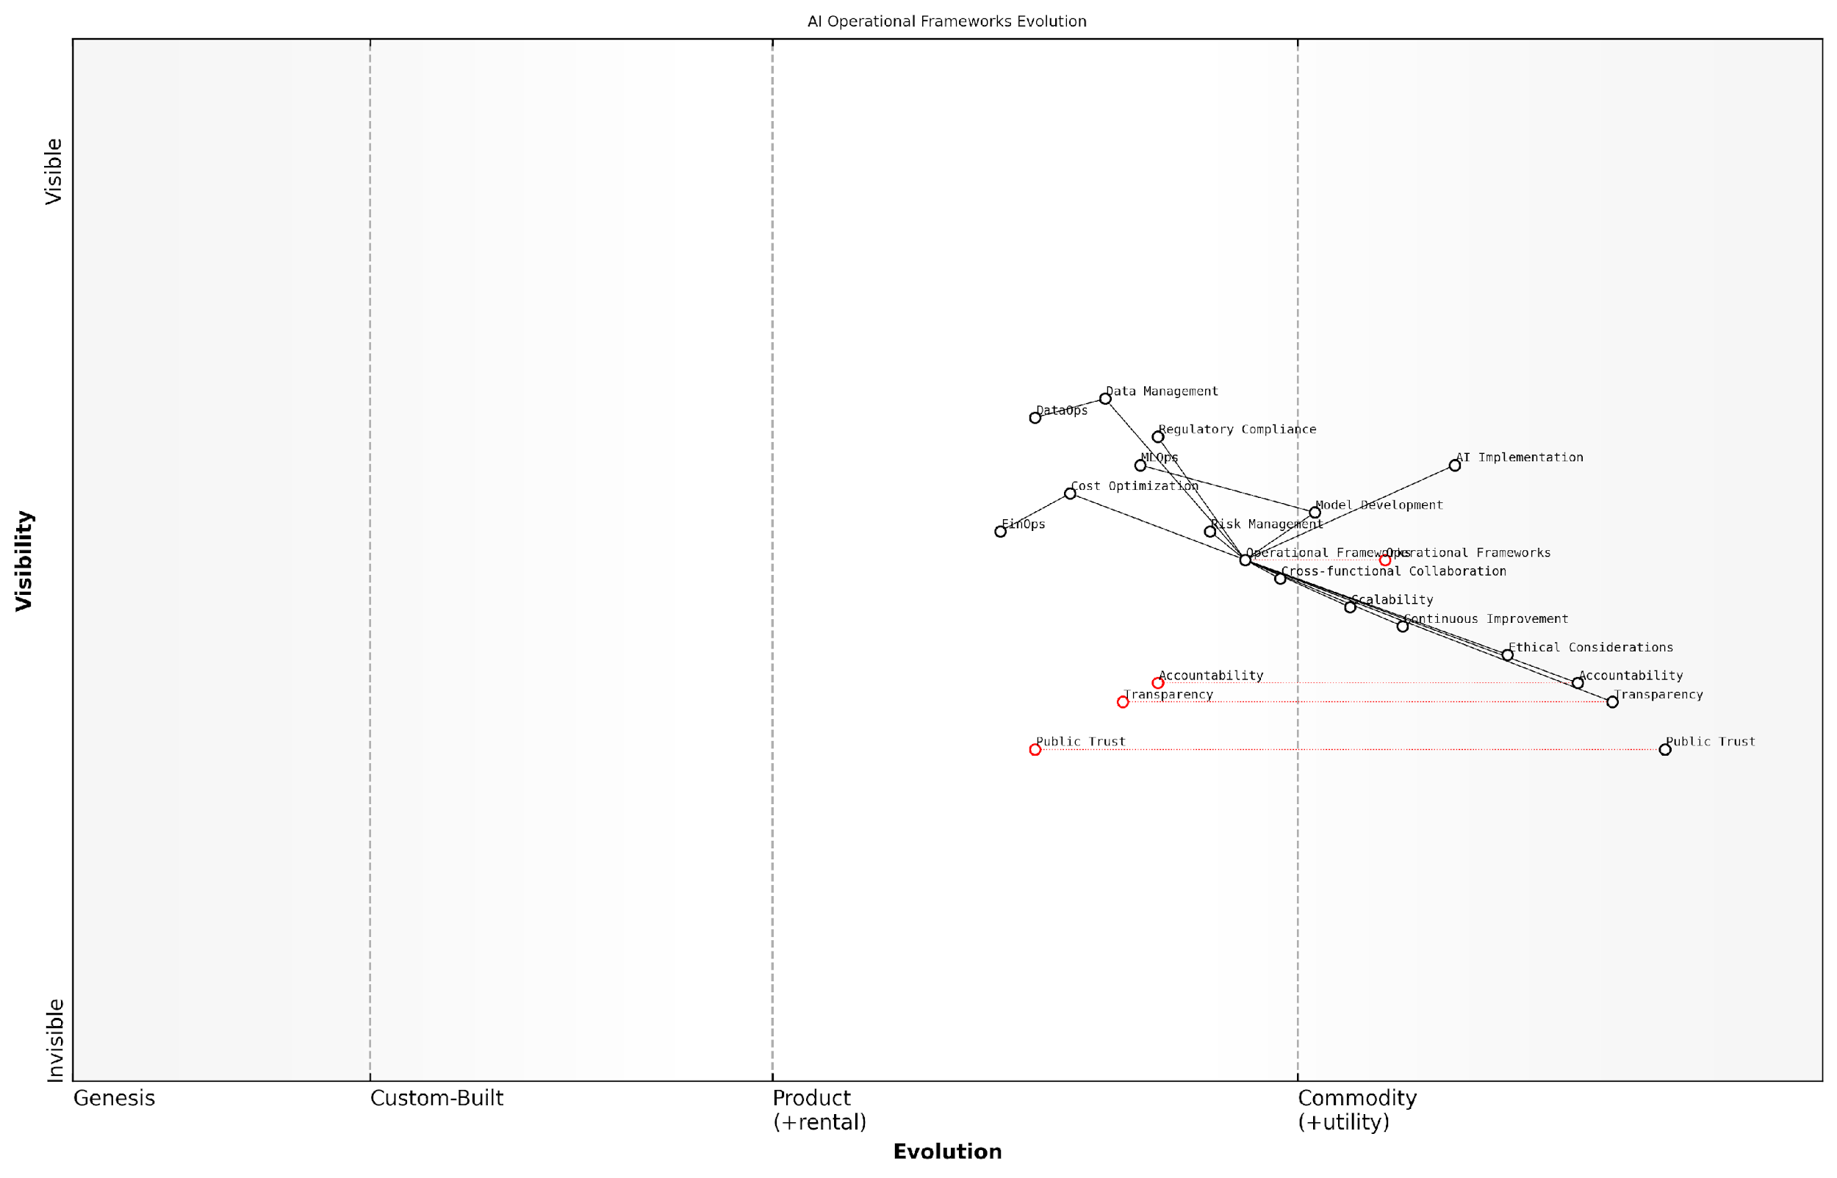

*Draft Wardley Map: [Insert Wardley Map: The need for robust operational frameworks]*

[Edit this draft Wardley Map](https://create.wardleymaps.ai/#clone:ea92fc37577c5b668e)

Wardley Map Assessment

This Wardley Map reveals a strategic landscape where technical AI implementation capabilities are relatively mature, but ethical considerations and public trust are critical evolving factors. The key to success lies in developing robust operational frameworks that seamlessly integrate advanced technical practices with strong ethical guidelines and transparency measures. Organisations that can effectively balance these elements while maintaining adaptability to rapid evolution will likely emerge as leaders in responsible and effective AI implementation.

[View full Wardley Map report](http://markdown/wardley_map_reports/wardley_map_report_03_The_need_for_robust_operational_frameworks.md)

In conclusion, the need for robust operational frameworks in AI implementation cannot be overstated. These frameworks are not merely administrative overhead; they are the foundation upon which successful, scalable, and responsible AI initiatives are built. As we delve deeper into the specific operational disciplines of DataOps, MLOps, and FinOps in the subsequent chapters, we will explore how these frameworks address the multifaceted challenges of AI implementation and pave the way for transformative AI success.

## Introducing DataOps, MLOps, and FinOps

### Defining the three Ops

In the rapidly evolving landscape of artificial intelligence, three operational frameworks have emerged as critical pillars for success: DataOps, MLOps, and FinOps. These ‘Ops’ disciplines represent a paradigm shift in how organisations approach the development, deployment, and management of AI systems. By understanding and implementing these frameworks, organisations can significantly enhance their AI initiatives, ensuring they are not only technologically advanced but also operationally efficient and financially viable.

DataOps, the first of our trinity, is a collaborative data management practice that focuses on improving the quality, speed, and reliability of data analytics. It brings together data engineers, data scientists, and data analysts to create a seamless, automated, and continuously improving data pipeline. In the context of AI, DataOps ensures that high-quality, relevant data is readily available for model training and inference, addressing one of the most fundamental challenges in AI development.

DataOps is to data analytics what DevOps is to software development. It’s about breaking down silos, automating processes, and fostering a culture of continuous improvement in data management.

MLOps, or Machine Learning Operations, extends the principles of DevOps to machine learning systems. It encompasses the entire lifecycle of ML models, from development and training to deployment and monitoring. MLOps aims to streamline the process of getting machine learning models into production and maintaining them over time. This discipline is crucial for scaling AI initiatives, ensuring reproducibility, and maintaining model performance in real-world scenarios.

* Automated model training and retraining
* Version control for data, code, and models
* Continuous integration and deployment for ML models
* Model performance monitoring and alerting
* Governance and compliance management

FinOps, the third pillar of our AI success trinity, focuses on the financial aspects of cloud and AI operations. It’s a cultural practice that brings financial accountability to the variable spend model of cloud, which is often the backbone of AI infrastructure. FinOps enables organisations to make trade-offs between speed, cost, and quality in their AI initiatives. By implementing FinOps practices, organisations can optimise their AI-related expenditures, ensure cost transparency, and maximise the return on investment from their AI projects.

FinOps is not just about cutting costs; it’s about making informed decisions that balance the need for innovation with financial responsibility. In the realm of AI, where computational resources can be a significant expense, this balance is crucial.

The integration of these three Ops disciplines creates a powerful framework for AI success. DataOps ensures a steady supply of high-quality data, MLOps streamlines the development and deployment of AI models, and FinOps optimises the financial aspects of AI operations. Together, they address the key challenges that organisations face in scaling their AI initiatives: data quality and availability, operational efficiency, and cost management.

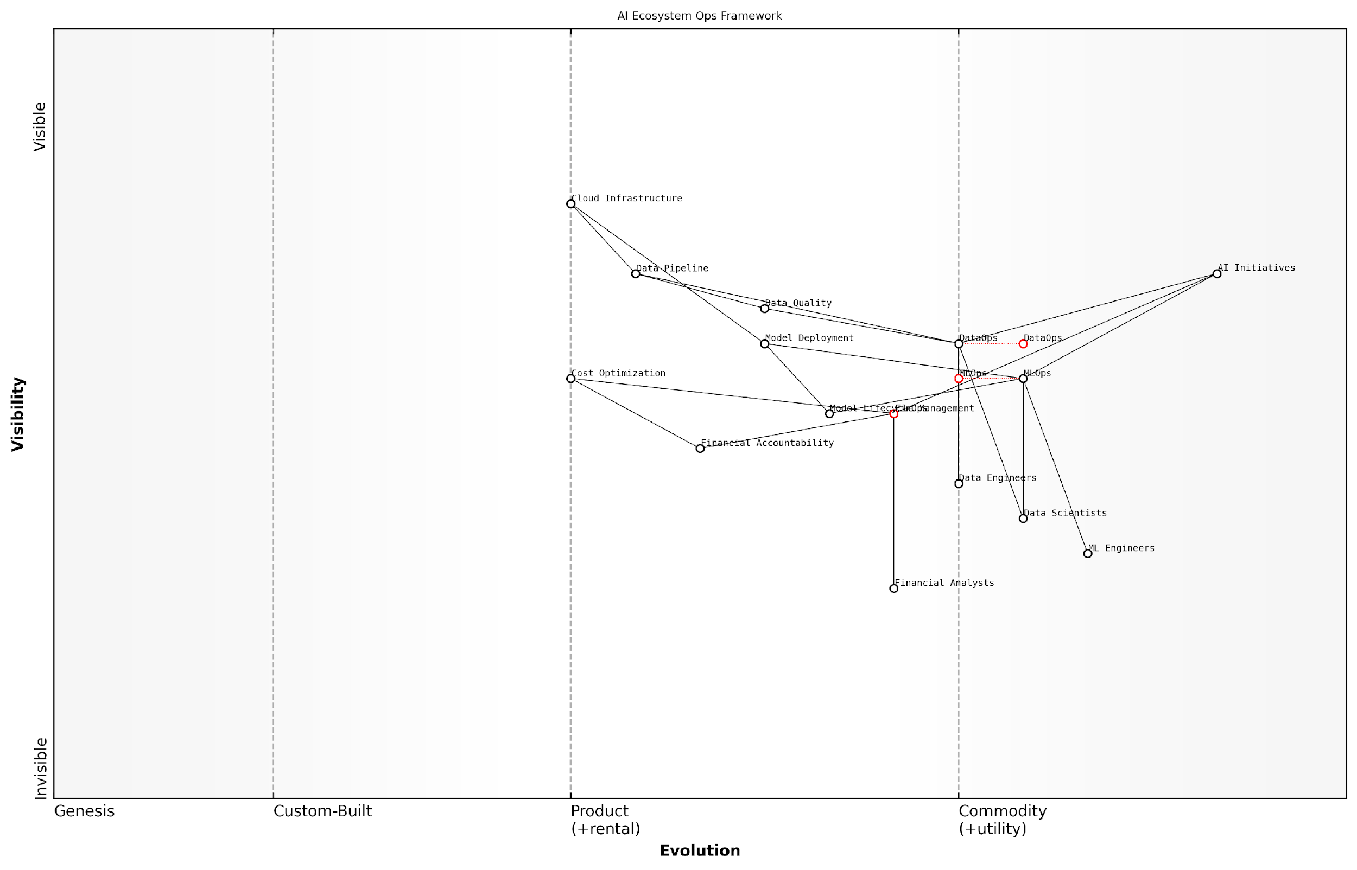

*Draft Wardley Map: [Insert Wardley Map: Defining the three Ops]*

[Edit this draft Wardley Map](https://create.wardleymaps.ai/#clone:3783a63f04ac07bc2f)

Wardley Map Assessment

The AI Ecosystem Ops Framework presents a forward-thinking approach to managing AI initiatives, recognizing the critical interplay between data, model, and financial operations. The strategic positioning of DataOps, MLOps, and FinOps as core components reflects a mature understanding of AI project requirements. However, to maintain competitive advantage, the organisation should focus on deeper integration of these Ops functions, invest in AI-driven automation, and develop robust financial accountability measures. The framework provides a strong foundation for sustainable AI adoption, but continuous evolution and innovation will be crucial in a rapidly advancing AI landscape.

[View full Wardley Map report](http://markdown/wardley_map_reports/wardley_map_report_04_Defining_the_three_Ops.md)

As we delve deeper into each of these Ops disciplines in the subsequent chapters, we will explore their specific methodologies, tools, and best practices. We will also examine how they interact and complement each other, creating a synergistic effect that is greater than the sum of its parts. By mastering these three Ops, organisations can create a robust operational framework that not only supports their current AI initiatives but also provides the flexibility and scalability needed to adapt to future advancements in AI technology.

### Their interconnected roles in AI success

The success of AI initiatives hinges on the seamless integration and orchestration of DataOps, MLOps, and FinOps. These three operational frameworks form a symbiotic relationship, each playing a crucial role in addressing the complex challenges of AI implementation and ensuring sustainable, scalable, and cost-effective AI solutions. As an expert who has advised numerous government agencies and private sector organisations on AI strategy, I can attest to the transformative power of this interconnected approach.

DataOps serves as the foundation, ensuring that high-quality, relevant data is available and accessible for AI models. It addresses the critical challenge of data management, which is often underestimated in AI projects. A senior data scientist at a leading government research institution once remarked, ‘Without robust DataOps, our AI models would be built on shaky ground, leading to unreliable outputs and diminished trust in the technology.’

MLOps builds upon this foundation, streamlining the development, deployment, and maintenance of AI models. It brings software engineering best practices to machine learning, ensuring that models are reproducible, scalable, and maintainable. This is particularly crucial in government contexts, where transparency and accountability are paramount. As a chief technology officer in a major public sector organisation observed, ‘MLOps has revolutionised our ability to deliver AI solutions that meet stringent regulatory requirements while remaining agile and responsive to changing needs.’

FinOps completes the trinity by optimising the financial aspects of AI initiatives. It provides visibility into costs, enables efficient resource allocation, and ensures that AI projects deliver tangible value. In the public sector, where budgets are often constrained and scrutinised, FinOps plays a critical role in justifying AI investments and maximising their return on investment.

* DataOps ensures data quality, accessibility, and governance
* MLOps facilitates efficient model development, deployment, and maintenance
* FinOps optimises costs and ensures value realisation from AI investments

The interconnected nature of these frameworks becomes evident when we consider their collective impact on AI success. For instance, DataOps practices inform MLOps processes by providing insights into data quality and lineage, which are crucial for model performance and explainability. Similarly, MLOps feeds back into DataOps by identifying data gaps or quality issues that emerge during model training and deployment.

FinOps, in turn, influences both DataOps and MLOps by providing cost constraints and efficiency targets. This ensures that data management and model development practices are not only effective but also economically viable. As a FinOps specialist who has worked on large-scale government AI projects noted, ‘By integrating FinOps principles into our DataOps and MLOps workflows, we’ve been able to achieve a 30% reduction in overall AI project costs while improving model performance.’

The true power of AI is unleashed when DataOps, MLOps, and FinOps work in concert, creating a virtuous cycle of continuous improvement and value creation.

This interconnected approach is particularly crucial in government and public sector contexts, where AI initiatives often have far-reaching societal impacts. By ensuring data integrity, model reliability, and cost-effectiveness, the integration of DataOps, MLOps, and FinOps helps build public trust in AI systems and supports responsible innovation in the public interest.

Moreover, the synergy between these frameworks addresses the unique challenges faced by government organisations, such as legacy systems, complex regulatory environments, and the need for cross-agency collaboration. By providing a holistic operational framework, the integration of DataOps, MLOps, and FinOps enables public sector entities to overcome these hurdles and realise the transformative potential of AI.

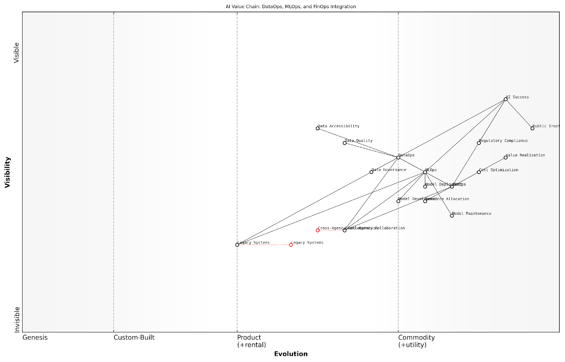

*Draft Wardley Map: [Insert Wardley Map: Their interconnected roles in AI success]*

[Edit this draft Wardley Map](https://create.wardleymaps.ai/#clone:bb35c385f6296e3e98)

Wardley Map Assessment

This Wardley Map reveals a sophisticated understanding of the AI value chain, emphasising the critical integration of DataOps, MLOps, and FinOps for AI success. The strategic position shows a clear path from data management to model operations and financial optimization, culminating in AI success and public trust. Key opportunities lie in evolving legacy systems, enhancing cross-agency collaboration, and further developing model maintenance capabilities. The focus on public trust and regulatory compliance positions this approach well for sustainable AI implementation in sensitive sectors. To maintain a competitive edge, organisations should prioritise data governance, automate MLOps processes, and develop robust cross-agency collaboration frameworks while continuously building public trust through transparent and ethical AI practices.

[View full Wardley Map report](http://markdown/wardley_map_reports/wardley_map_report_05_Their_interconnected_roles_in_AI_success.md)

As we delve deeper into each of these operational frameworks in the subsequent chapters, it is essential to keep in mind their interconnected nature and the compounding benefits they offer when implemented cohesively. The success of AI initiatives in the public sector and beyond increasingly depends on mastering this triad of operational excellence.

### The synergy of the AI Success Trinity

The AI Success Trinity, comprising DataOps, MLOps, and FinOps, represents a powerful synergy that is critical for achieving transformative AI implementation. This triad of operational frameworks forms the backbone of successful AI initiatives, particularly within government and public sector contexts where efficiency, accountability, and scalability are paramount.

At its core, the synergy of the AI Success Trinity lies in its ability to address the multifaceted challenges of AI implementation holistically. Each component of the trinity plays a crucial role in enhancing the overall effectiveness of AI projects:

* DataOps ensures the availability of high-quality, reliable data that forms the foundation of AI models.
* MLOps streamlines the development, deployment, and maintenance of AI models, ensuring they remain accurate and relevant.
* FinOps optimises the financial aspects of AI initiatives, ensuring cost-effectiveness and maximising return on investment.

The synergistic effect of these three disciplines is greater than the sum of their individual contributions. When implemented cohesively, they create a robust ecosystem that supports the entire lifecycle of AI projects, from inception to deployment and ongoing maintenance.

The integration of DataOps, MLOps, and FinOps is not just a best practice; it’s a necessity for organisations seeking to harness the full potential of AI while maintaining operational excellence and fiscal responsibility.

In the context of government and public sector AI initiatives, this synergy is particularly crucial. These sectors often deal with vast amounts of sensitive data, complex regulatory environments, and the need for transparent, cost-effective solutions. The AI Success Trinity addresses these unique challenges by:

* Ensuring data integrity and compliance through robust DataOps practices
* Facilitating rapid, secure deployment of AI models with MLOps, crucial for time-sensitive public services
* Optimising resource allocation and demonstrating fiscal responsibility through FinOps, essential for publicly funded projects

The synergy also fosters a culture of continuous improvement and innovation. By integrating these three operational frameworks, organisations create feedback loops that constantly inform and enhance each aspect of their AI initiatives. For instance, insights gained from FinOps can guide DataOps strategies to focus on the most valuable data sources, while MLOps practices can inform FinOps decisions on resource allocation for model training and deployment.

Moreover, this synergistic approach helps in breaking down silos within organisations. It encourages collaboration between data scientists, IT operations, financial analysts, and domain experts, leading to more holistic and effective AI solutions. This cross-functional collaboration is especially valuable in government settings, where different departments often need to work together to address complex societal challenges.

The true power of the AI Success Trinity lies not just in the individual strengths of DataOps, MLOps, and FinOps, but in their ability to create a unified, agile, and responsive AI ecosystem that can adapt to changing needs and challenges.

As AI continues to evolve and become more integral to public sector operations, the synergy of the AI Success Trinity will become increasingly critical. It provides a framework for scaling AI initiatives responsibly, ensuring that as projects grow in scope and complexity, they remain manageable, cost-effective, and aligned with organisational goals.

In conclusion, the synergy of the AI Success Trinity - DataOps, MLOps, and FinOps - is not just a theoretical concept, but a practical necessity for organisations, especially in the public sector, looking to leverage AI for transformative outcomes. By embracing this integrated approach, government bodies and public sector organisations can ensure that their AI initiatives are not only technologically advanced and fiscally sound but also aligned with their mission to serve the public interest effectively and efficiently.

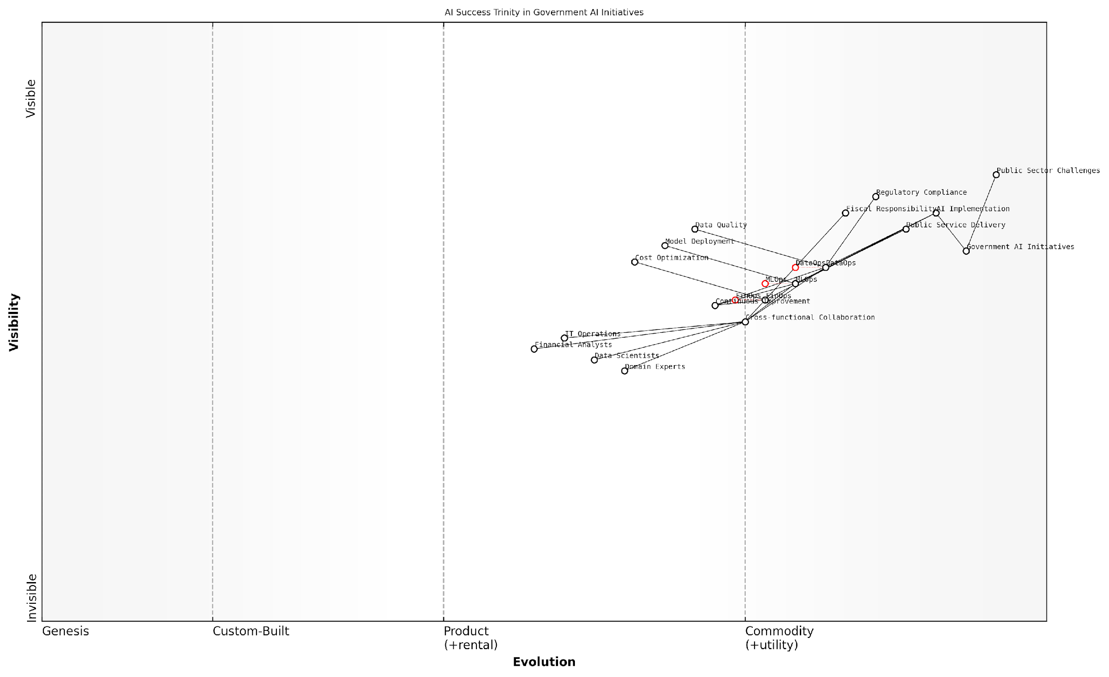

*Draft Wardley Map: [Insert Wardley Map: The synergy of the AI Success Trinity]*

[Edit this draft Wardley Map](https://create.wardleymaps.ai/#clone:c35c5676db0a4ca8f7)

Wardley Map Assessment

The Wardley Map demonstrates a well-structured approach to implementing AI in government initiatives, with a strong focus on the AI Success Trinity of DataOps, MLOps, and FinOps. The strategic positioning of these components, along with the emphasis on regulatory compliance and fiscal responsibility, provides a solid foundation for addressing public sector challenges through AI. However, there are opportunities to enhance cross-functional collaboration, standardise processes, and foster innovation through ecosystem partnerships. By addressing these areas and continuing to evolve the core components, government agencies can maximise the impact of their AI initiatives while maintaining the necessary controls and efficiencies.

[View full Wardley Map report](http://markdown/wardley_map_reports/wardley_map_report_06_The_synergy_of_the_AI_Success_Trinity.md)

# DataOps: Fueling AI with Quality Data

## The Foundations of DataOps

### Defining DataOps and its objectives

DataOps, a portmanteau of ‘Data’ and ‘Operations’, represents a transformative approach to data management that is critical for successful AI implementation. As an expert in the field, I can attest that DataOps is not merely a set of tools or technologies, but a holistic methodology that combines cultural philosophies, practices, and tools to improve an organisation’s ability to accelerate the delivery of high-quality, reliable data to data consumers and AI systems.

At its core, DataOps aims to break down silos between data producers, data engineers, data scientists, and other stakeholders involved in the data lifecycle. This collaborative approach is particularly crucial in the context of AI, where the quality and timeliness of data directly impact the effectiveness and reliability of AI models and applications.

DataOps is to data what DevOps is to software development. It’s about creating a culture of collaboration, automation, and continuous improvement in data management to support the ever-increasing demands of AI-driven organisations.

The primary objectives of DataOps in the context of AI success can be summarised as follows:

* Improve data quality and reliability: By implementing automated testing, monitoring, and validation processes, DataOps ensures that AI systems are fed with high-quality, trustworthy data.
* Accelerate data delivery: Through automation and streamlined processes, DataOps reduces the time it takes to make data available for AI model training and inference.
* Enhance data governance and security: DataOps incorporates robust governance frameworks and security measures to ensure compliance with regulations and protect sensitive information.
* Foster collaboration: By breaking down organisational silos, DataOps promotes better communication and collaboration between data teams, AI developers, and business stakeholders.
* Enable agility and adaptability: DataOps practices allow organisations to quickly respond to changing data requirements and evolving AI needs.
* Optimise resource utilisation: Through efficient data management practices, DataOps helps organisations make the most of their data infrastructure and reduce unnecessary costs.
* Improve data observability: DataOps implements comprehensive monitoring and logging systems to provide visibility into data pipelines and AI model performance.

In the government and public sector context, where AI initiatives often involve sensitive data and have far-reaching implications, the importance of DataOps cannot be overstated. It provides the foundation for responsible AI development by ensuring data integrity, transparency, and compliance with stringent regulatory requirements.

One of the key aspects of DataOps is its emphasis on automation. By automating data pipelines, quality checks, and deployment processes, organisations can significantly reduce human error, increase efficiency, and ensure consistency in data handling. This is particularly crucial for AI projects, where even small data inconsistencies can lead to significant model inaccuracies or biases.

In my experience advising government bodies, I’ve seen firsthand how implementing DataOps practices can transform an organisation’s ability to leverage AI effectively. It’s not just about having good data; it’s about having the right data, at the right time, in the right format, and with the right level of quality assurance.

Another critical objective of DataOps is to enable data democratisation while maintaining proper controls. This means making data accessible to a wider range of users within an organisation, including data scientists, analysts, and decision-makers, while ensuring appropriate access controls and data lineage tracking. In the context of AI, this democratisation allows for more innovative use cases and faster model development, as teams can more easily access and experiment with relevant datasets.

DataOps also plays a crucial role in ensuring the ethical use of data in AI applications. By implementing robust data governance practices, organisations can maintain transparency in how data is collected, processed, and used in AI models. This is particularly important in the public sector, where AI decisions can have significant impacts on citizens’ lives and where public trust is paramount.

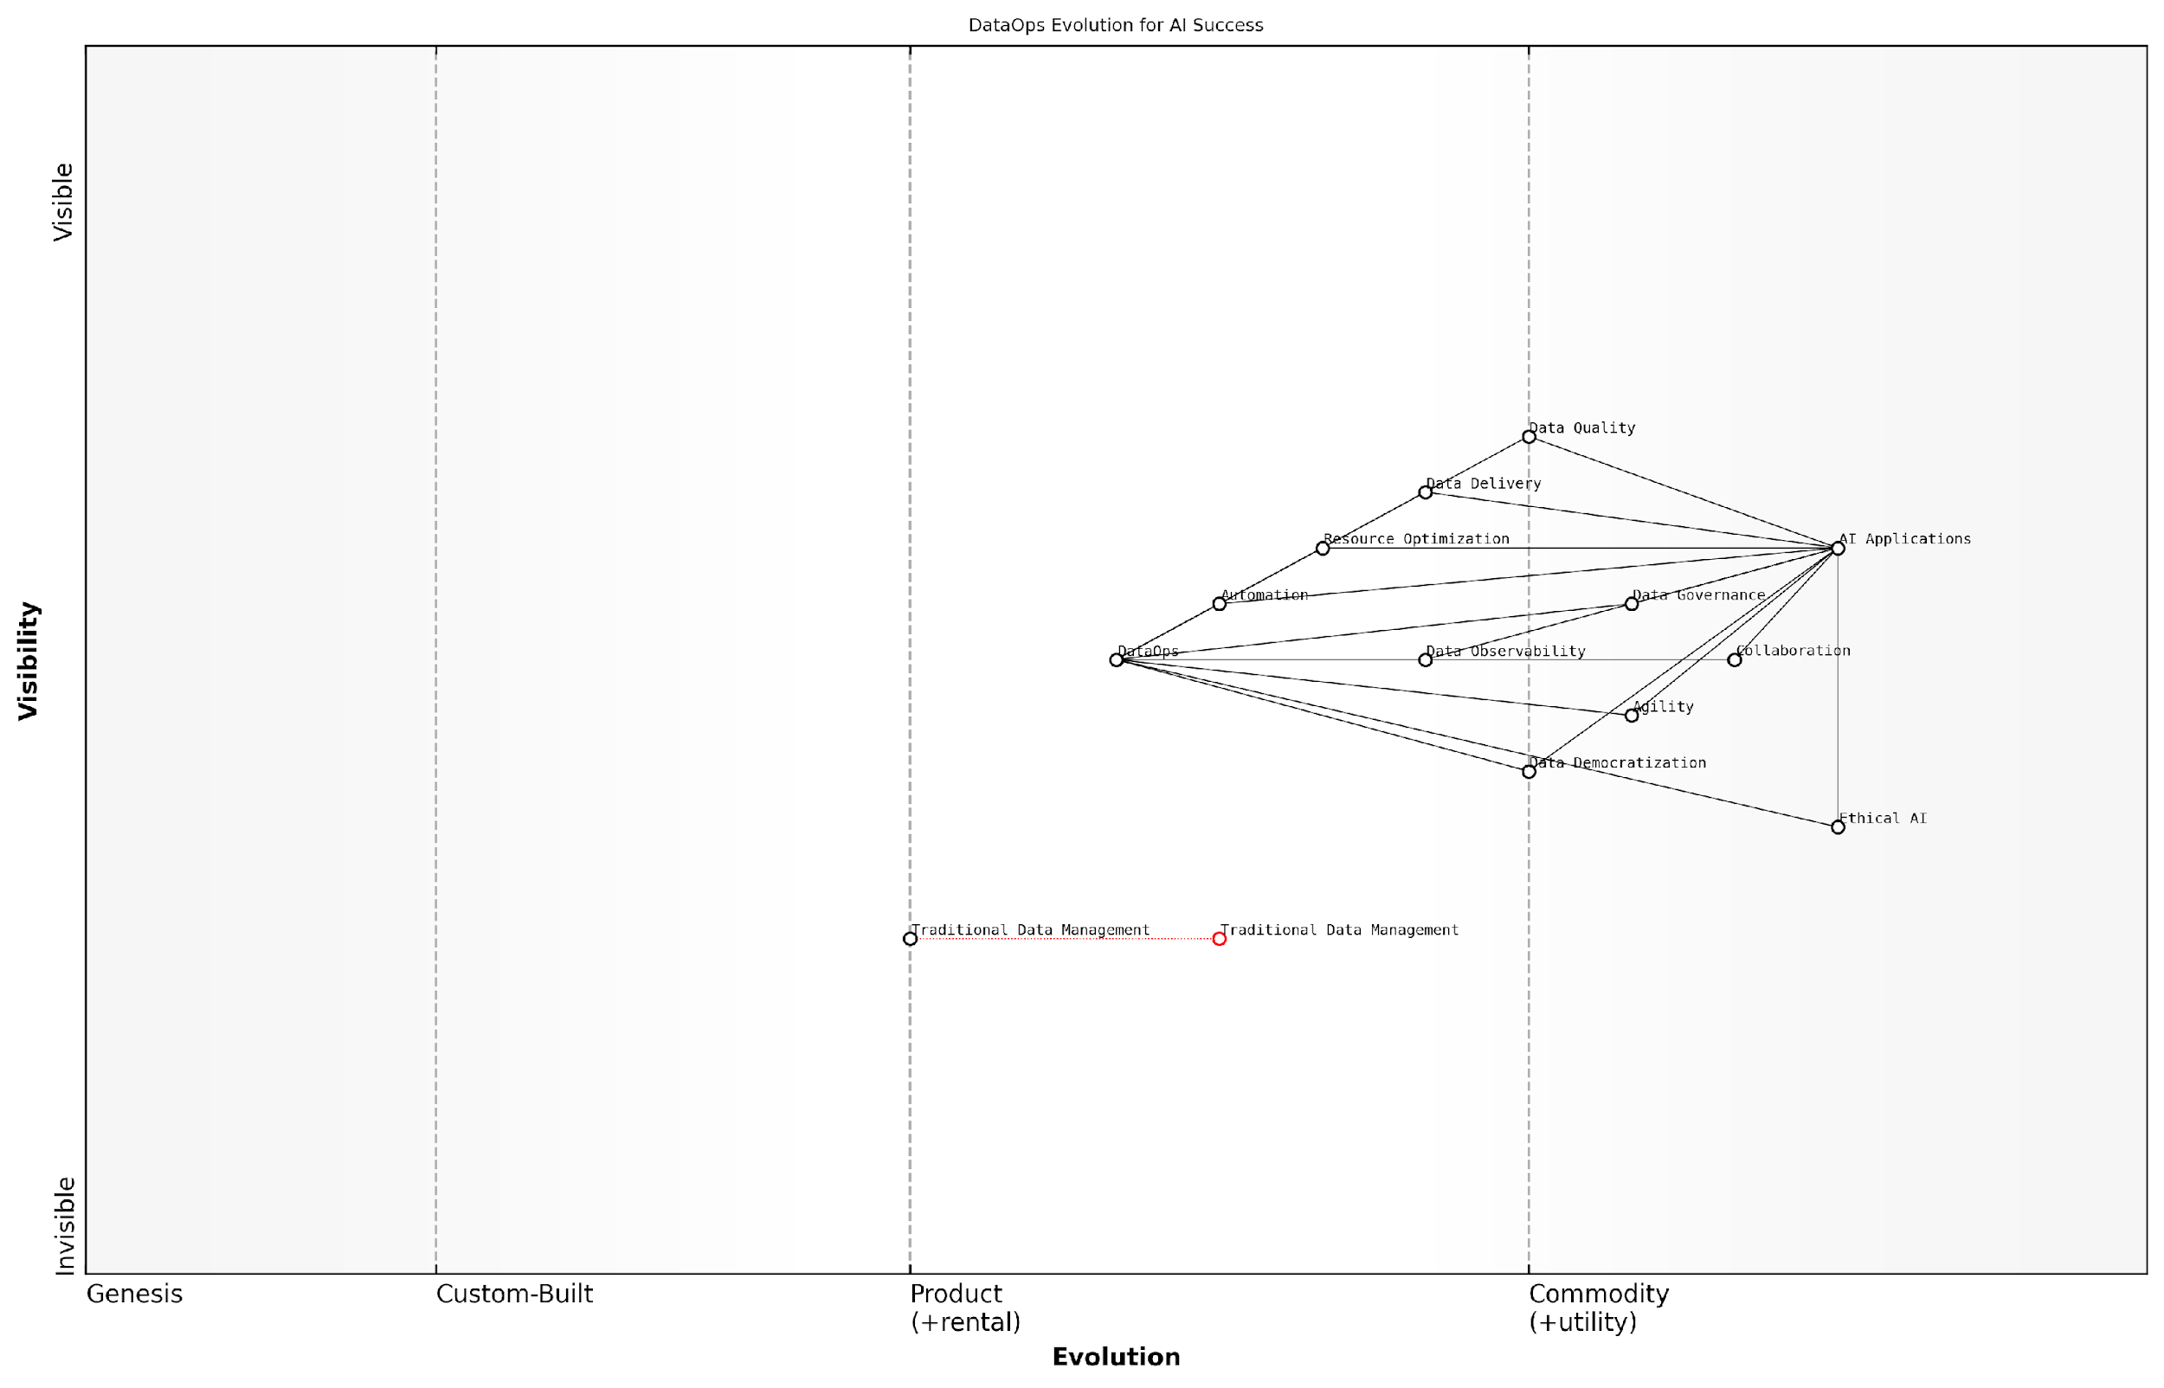

*Draft Wardley Map: [Insert Wardley Map: Defining DataOps and its objectives]*

[Edit this draft Wardley Map](https://create.wardleymaps.ai/#clone:471c58f4028de7fd80)

Wardley Map Assessment

This Wardley Map reveals a strategic focus on evolving data management practices to support AI success in the public sector. The central role of DataOps as an enabler for various data-related components is clear. To maintain a competitive edge, organisations should prioritise the implementation of advanced DataOps practices, invest in data quality and observability, and proactively address ethical AI considerations. The evolution from traditional data management to a more agile, democratised approach is crucial for long-term success in AI applications. Continuous adaptation and innovation in data strategies will be key to meeting the evolving needs of the public sector and staying ahead in the rapidly advancing field of AI.

[View full Wardley Map report](http://markdown/wardley_map_reports/wardley_map_report_07_Defining_DataOps_and_its_objectives.md)

In conclusion, defining DataOps and understanding its objectives is fundamental to achieving AI success. It provides the operational framework necessary to ensure that AI initiatives are built on a solid foundation of high-quality, well-managed data. As organisations in the public sector continue to explore and implement AI solutions, adopting DataOps practices will be crucial in navigating the complexities of data management and ensuring the responsible and effective use of AI technologies.

### The data lifecycle in AI projects

The data lifecycle in AI projects is a critical component of DataOps that underpins the success of artificial intelligence initiatives. As a seasoned expert in this field, I can attest that understanding and optimising this lifecycle is paramount for organisations seeking to harness the full potential of AI. The data lifecycle encompasses the entire journey of data from its creation or acquisition through to its eventual archival or deletion, with several crucial stages in between that directly impact the efficacy of AI models and applications.

To fully appreciate the importance of the data lifecycle in AI projects, we must first break it down into its constituent phases and examine how each contributes to the overall success of AI implementations. The typical data lifecycle in AI projects consists of the following stages:

* Data Collection and Ingestion
* Data Storage and Management
* Data Preparation and Preprocessing
* Data Analysis and Model Training
* Data Validation and Quality Assurance
* Data Deployment and Serving
* Data Monitoring and Maintenance
* Data Archival or Deletion

Let’s delve deeper into each of these stages to understand their significance in the context of AI projects:

1. Data Collection and Ingestion: This initial phase involves gathering data from various sources, which may include internal databases, external APIs, IoT devices, or web scraping. The key challenge here is ensuring that the data collected is relevant, comprehensive, and of sufficient quality to support the AI project’s objectives. In my experience advising government bodies, I’ve observed that establishing robust data collection protocols and leveraging advanced ingestion tools can significantly enhance the quality and reliability of input data.
2. Data Storage and Management: Once collected, data must be stored securely and managed effectively. This stage involves selecting appropriate storage solutions (e.g., data lakes, data warehouses) and implementing data governance policies. For AI projects in the public sector, considerations around data privacy, security, and compliance are paramount. Implementing proper access controls and encryption measures is crucial to maintain public trust and adhere to regulatory requirements.
3. Data Preparation and Preprocessing: Raw data is rarely suitable for immediate use in AI models. This stage involves cleaning, transforming, and structuring the data to make it amenable to analysis and model training. Tasks may include handling missing values, normalising data, encoding categorical variables, and feature engineering. The quality of preprocessing directly impacts the performance of AI models, making this a critical phase in the lifecycle.
4. Data Analysis and Model Training: At this stage, the prepared data is used to train AI models. This involves selecting appropriate algorithms, tuning hyperparameters, and evaluating model performance. The iterative nature of this phase often requires close collaboration between data scientists and domain experts to ensure that the models align with business objectives and ethical considerations.
5. Data Validation and Quality Assurance: Before deploying AI models, it’s crucial to validate the results and ensure the quality of the output. This involves rigorous testing, cross-validation, and often human expert review, particularly in high-stakes applications common in government contexts. Establishing clear quality metrics and validation processes is essential for maintaining the integrity and reliability of AI systems.
6. Data Deployment and Serving: Once validated, the AI models and their associated data pipelines need to be deployed into production environments. This stage involves considerations around scalability, performance optimisation, and integration with existing systems. In my consultancy work, I’ve found that adopting containerisation technologies and microservices architectures can greatly enhance the flexibility and robustness of AI deployments.
7. Data Monitoring and Maintenance: After deployment, continuous monitoring of both the data and the AI models is essential. This involves tracking data drift, model performance, and system health. Regular maintenance, including model retraining and data pipeline updates, ensures that the AI system remains accurate and relevant over time. Implementing automated monitoring tools and establishing clear maintenance protocols are best practices I often recommend to public sector clients.
8. Data Archival or Deletion: The final stage of the lifecycle involves managing data that is no longer actively used. This may involve archiving data for future reference or compliance purposes, or securely deleting data that is no longer needed. Proper data lifecycle management not only ensures regulatory compliance but also optimises storage costs and reduces potential security risks.

The data lifecycle in AI projects is not just a technical consideration, but a strategic imperative. Organisations that master this lifecycle gain a significant competitive advantage in their AI initiatives.

Understanding and optimising the data lifecycle is fundamental to the success of AI projects, particularly in the public sector where data quality, security, and ethical use are of utmost importance. By implementing robust DataOps practices that address each stage of the lifecycle, organisations can ensure a steady supply of high-quality, relevant data to fuel their AI initiatives. This, in turn, leads to more accurate models, more reliable AI systems, and ultimately, better outcomes for citizens and stakeholders.

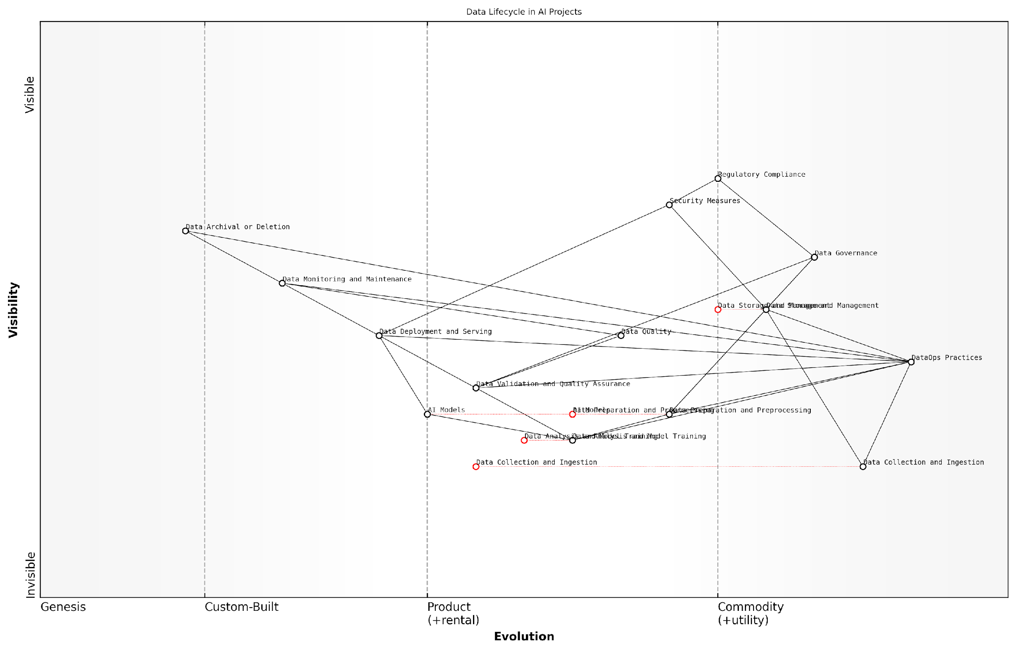

*Draft Wardley Map: [Insert Wardley Map: The data lifecycle in AI projects]*

[Edit this draft Wardley Map](https://create.wardleymaps.ai/#clone:d151e47340385242e1)

Wardley Map Assessment

This Wardley Map represents a well-structured approach to data lifecycle management in public sector AI projects. It demonstrates a strong foundation in DataOps practices, with appropriate emphasis on governance, quality, and compliance. To maintain competitive edge, focus should be on advancing AI model development capabilities and automating data quality processes. The integration of emerging technologies like federated learning and blockchain could further enhance data security and privacy. As the field evolves, maintaining flexibility in infrastructure and continual upskilling of the workforce will be crucial for long-term success.

[View full Wardley Map report](http://markdown/wardley_map_reports/wardley_map_report_08_The_data_lifecycle_in_AI_projects.md)

As we move forward in our discussion of DataOps, it’s crucial to remember that the data lifecycle is not a linear process but a cyclical one. Each stage informs and influences the others, creating a continuous feedback loop that drives ongoing improvement and innovation in AI projects. By mastering this lifecycle, organisations can unlock the full potential of their data assets and pave the way for transformative AI implementations that deliver real value to the public sector and beyond.

### Key principles of effective DataOps

As we delve deeper into the foundations of DataOps, it’s crucial to understand the key principles that underpin effective DataOps practices. These principles form the bedrock of successful AI implementations, ensuring that data pipelines are robust, efficient, and capable of delivering high-quality data to fuel AI models. Drawing from years of experience in advising government bodies and public sector organisations on AI initiatives, I can attest that adherence to these principles is often the differentiator between AI projects that flourish and those that falter.

* Automation and Orchestration
* Continuous Integration and Delivery
* Collaboration and Communication
* Monitoring and Observability
* Governance and Compliance
* Scalability and Flexibility
* Data Quality and Validation

Let’s explore each of these principles in detail, understanding their significance in the context of AI success and how they contribute to the overall effectiveness of DataOps.

1. Automation and Orchestration: At the heart of effective DataOps lies the principle of automation. By automating data pipelines, ETL processes, and data quality checks, organisations can significantly reduce manual errors, increase efficiency, and ensure consistency in data processing. Orchestration tools play a crucial role in managing these automated workflows, ensuring that different components of the data pipeline work in harmony. In the context of AI, automation becomes even more critical as it allows for rapid iteration and experimentation with different datasets and model configurations.

Automation is not just about efficiency; it’s about creating a repeatable, reliable process that can scale with your AI ambitions.

1. Continuous Integration and Delivery (CI/CD): Borrowing from DevOps practices, DataOps emphasises the importance of CI/CD in data management. This principle ensures that changes to data pipelines, schemas, or processing logic are tested and deployed in a controlled, iterative manner. For AI projects, this means that data scientists and ML engineers can work with the most up-to-date and reliable data, accelerating the model development and refinement process.
2. Collaboration and Communication: Effective DataOps breaks down silos between data engineers, data scientists, and business stakeholders. By fostering a culture of collaboration, organisations can ensure that data pipelines are aligned with business objectives and AI model requirements. This principle is particularly crucial in government and public sector contexts, where cross-departmental collaboration can lead to more comprehensive and impactful AI solutions.
3. Monitoring and Observability: Continuous monitoring of data pipelines and processes is essential for maintaining data quality and system performance. Observability goes a step further, providing insights into the internal state of complex data systems. For AI projects, this principle ensures that any anomalies or issues in the data pipeline are quickly identified and addressed, preventing the propagation of errors into AI models.
4. Governance and Compliance: In the era of stringent data protection regulations like GDPR, effective DataOps must incorporate robust governance and compliance measures. This principle ensures that data handling practices adhere to legal and ethical standards, a critical consideration for AI projects in the public sector where trust and transparency are paramount.

In the public sector, governance isn’t just about compliance; it’s about maintaining public trust in our AI initiatives.

1. Scalability and Flexibility: As AI projects grow in scope and complexity, DataOps practices must be able to scale accordingly. This principle emphasises the need for flexible architectures that can handle increasing data volumes and evolving requirements. Cloud-native solutions often play a key role in achieving this scalability, allowing organisations to adapt their data infrastructure as their AI capabilities mature.
2. Data Quality and Validation: Perhaps the most critical principle for AI success, ensuring data quality through rigorous validation processes is fundamental to effective DataOps. This involves implementing data quality checks at various stages of the pipeline, from ingestion to processing and storage. For AI models, the adage ‘garbage in, garbage out’ holds particularly true, making this principle essential for producing reliable and trustworthy AI outcomes.

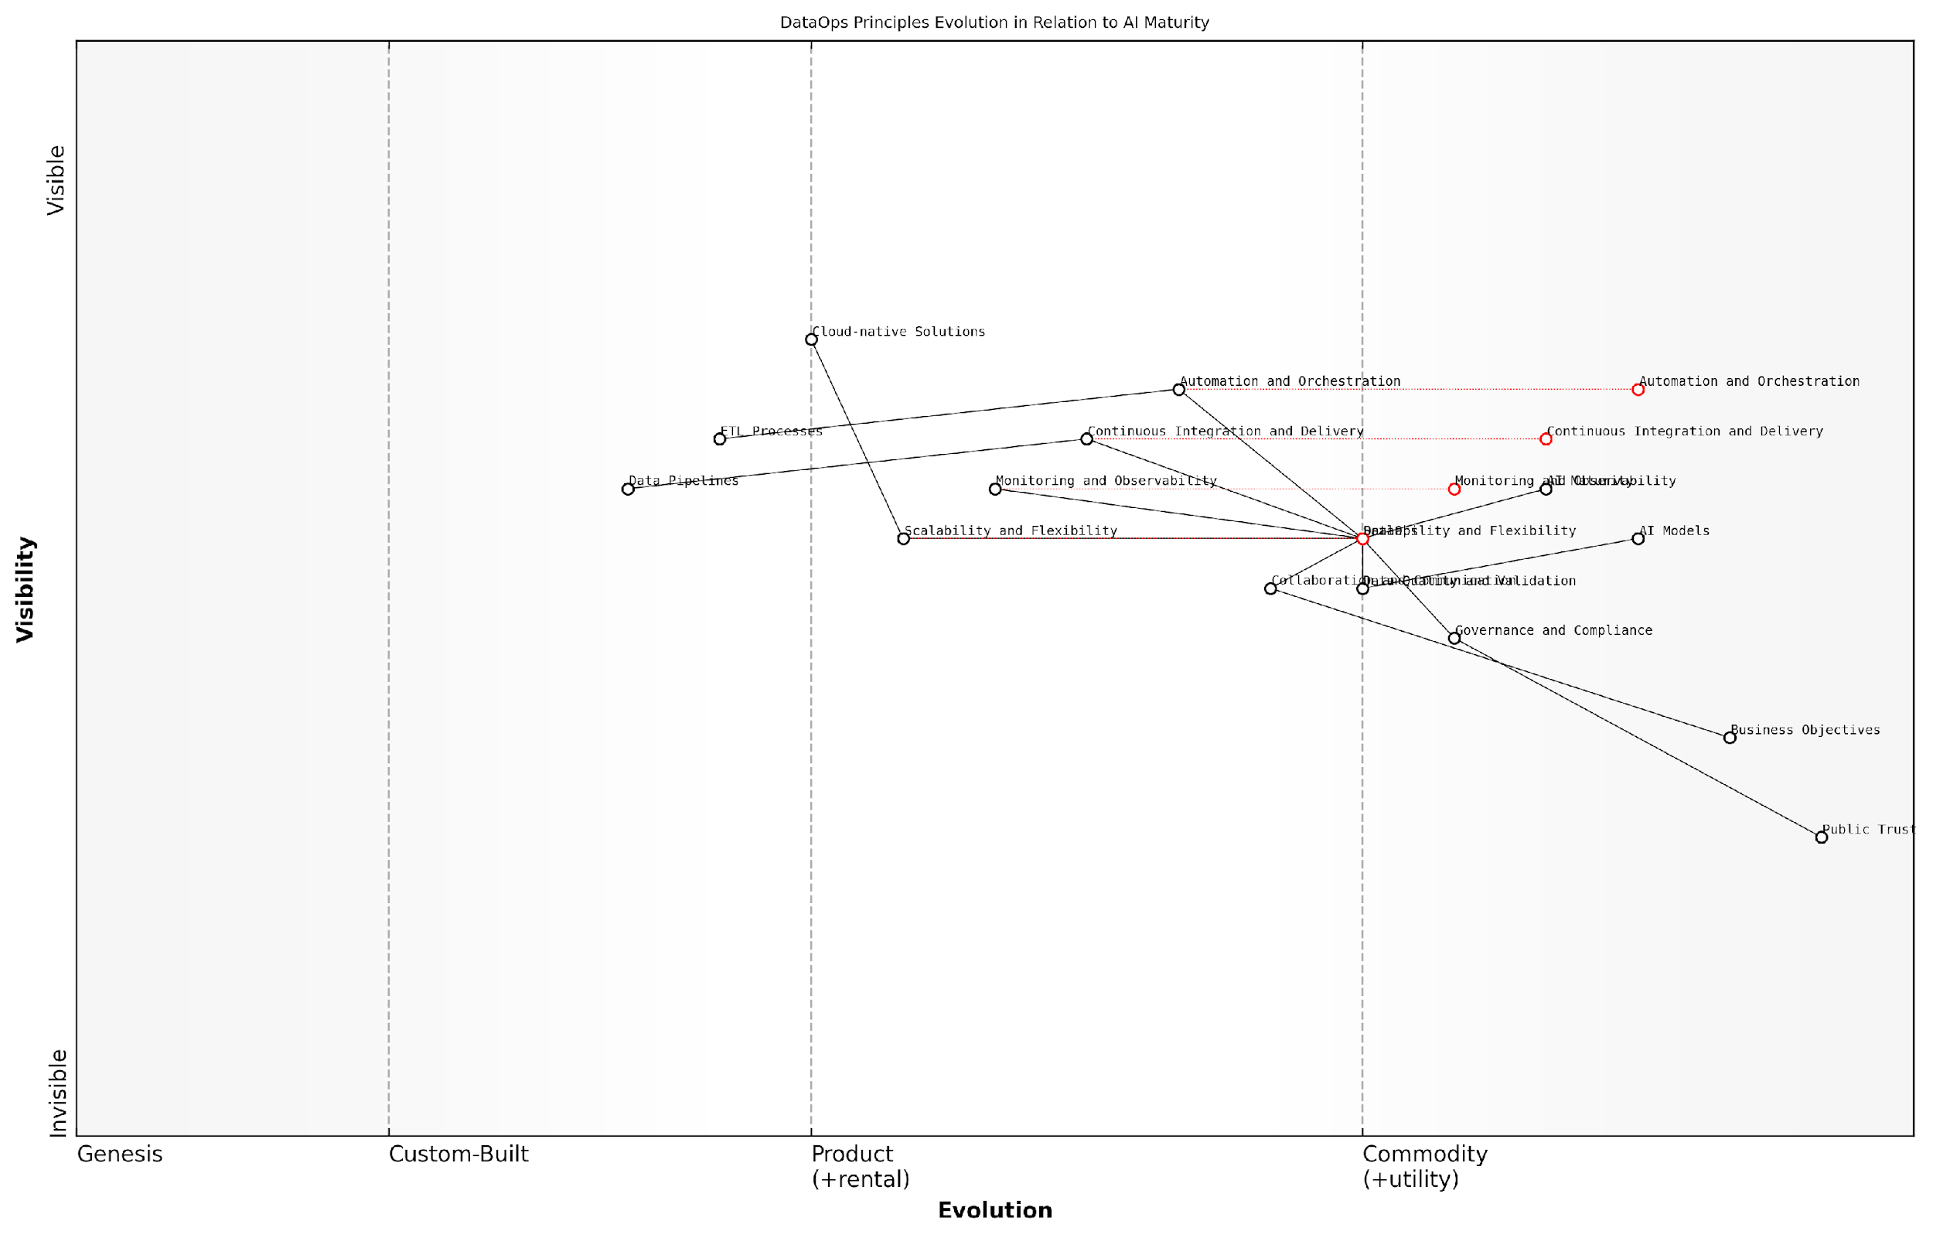

*Draft Wardley Map: [Insert Wardley Map: Key principles of effective DataOps]*

[Edit this draft Wardley Map](https://create.wardleymaps.ai/#clone:76965f38b48d8ce602)

Wardley Map Assessment

This Wardley Map reveals a strong technical foundation for DataOps in the context of AI maturity, with clear evolution paths for key components. However, there’s a need to balance rapid technical advancement with robust governance and better alignment with business objectives. The strategic focus should be on leveraging evolving DataOps principles to accelerate AI maturity while simultaneously developing adaptive governance frameworks and fostering a culture of innovation and continuous learning. This approach will position the organisation to capitalise on emerging AI opportunities while managing associated risks and maintaining public trust.

[View full Wardley Map report](http://markdown/wardley_map_reports/wardley_map_report_09_Key_principles_of_effective_DataOps.md)

By adhering to these key principles, organisations can establish a robust DataOps foundation that not only supports current AI initiatives but also paves the way for future advancements. As we progress through this chapter, we’ll explore how these principles translate into practical implementations and best practices, providing a roadmap for organisations looking to leverage DataOps for AI success.

## Implementing DataOps for AI Success

### Data quality and governance

In the realm of AI implementation, data quality and governance form the bedrock of successful DataOps practices. As a seasoned expert in this field, I cannot overstate the critical importance of these elements in ensuring that AI systems are built on a foundation of reliable, accurate, and compliant data. The adage ‘garbage in, garbage out’ is particularly pertinent in AI contexts, where the quality of input data directly influences the efficacy and trustworthiness of AI-driven insights and decisions.

Data quality in AI projects encompasses several key dimensions that must be rigorously managed and monitored throughout the data lifecycle. These dimensions include accuracy, completeness, consistency, timeliness, validity, and uniqueness. Each of these aspects plays a crucial role in determining the overall quality of data that feeds into AI models and, consequently, the reliability of the AI system’s outputs.

* Accuracy: Ensuring data correctly represents the real-world entity or event it describes
* Completeness: Verifying that all required data is present and accounted for
* Consistency: Maintaining uniform data representation across different systems and datasets
* Timeliness: Guaranteeing data is up-to-date and relevant for the AI application
* Validity: Confirming data adheres to defined formats, ranges, and business rules
* Uniqueness: Eliminating duplicate records to prevent skewed analysis and results

To effectively manage these dimensions of data quality, organisations must implement robust data governance frameworks. Data governance in the context of AI operations involves establishing policies, procedures, and standards that govern how data is collected, stored, processed, and used throughout the AI development lifecycle. This governance structure ensures that data is not only of high quality but also compliant with relevant regulations and ethical standards.

Effective data governance is the linchpin of successful AI implementation. It provides the guardrails necessary to ensure that AI systems are built on a foundation of trust, compliance, and ethical considerations.

A comprehensive data governance framework for AI projects should encompass several key components:

* Data Cataloguing and Metadata Management: Maintaining a centralised inventory of data assets, their sources, and their relationships
* Data Lineage Tracking: Documenting the journey of data from its origin through various transformations and uses in AI models
* Access Control and Security Measures: Implementing robust authentication and authorisation mechanisms to protect sensitive data
* Data Quality Rules and Monitoring: Establishing automated checks and balances to ensure ongoing data quality
* Compliance Management: Ensuring adherence to relevant data protection regulations (e.g., GDPR, CCPA) and industry-specific standards
* Ethical Use Guidelines: Developing and enforcing principles for the responsible and unbiased use of data in AI applications
* Data Stewardship: Assigning roles and responsibilities for data management across the organisation

Implementing these components requires a holistic approach that combines technological solutions with organisational processes and cultural change. Advanced data quality tools, such as data profiling software, data cleansing utilities, and automated data validation systems, play a crucial role in maintaining high data quality standards. These tools should be integrated into the DataOps pipeline to enable continuous monitoring and improvement of data quality.

Moreover, fostering a data-centric culture within the organisation is paramount. This involves educating stakeholders at all levels about the importance of data quality and governance, and empowering them to take ownership of data assets within their domains. Regular training sessions, clear communication of data policies, and incentivising good data management practices can help embed this culture throughout the organisation.

In my experience advising government bodies on AI implementation, I’ve observed that organisations that prioritise data quality and governance from the outset are far more likely to achieve sustainable success in their AI initiatives.

It’s also crucial to recognise that data quality and governance are not one-time efforts but ongoing processes that require continuous attention and refinement. As AI systems evolve and new data sources emerge, the governance framework must adapt to accommodate these changes while maintaining rigorous quality standards.

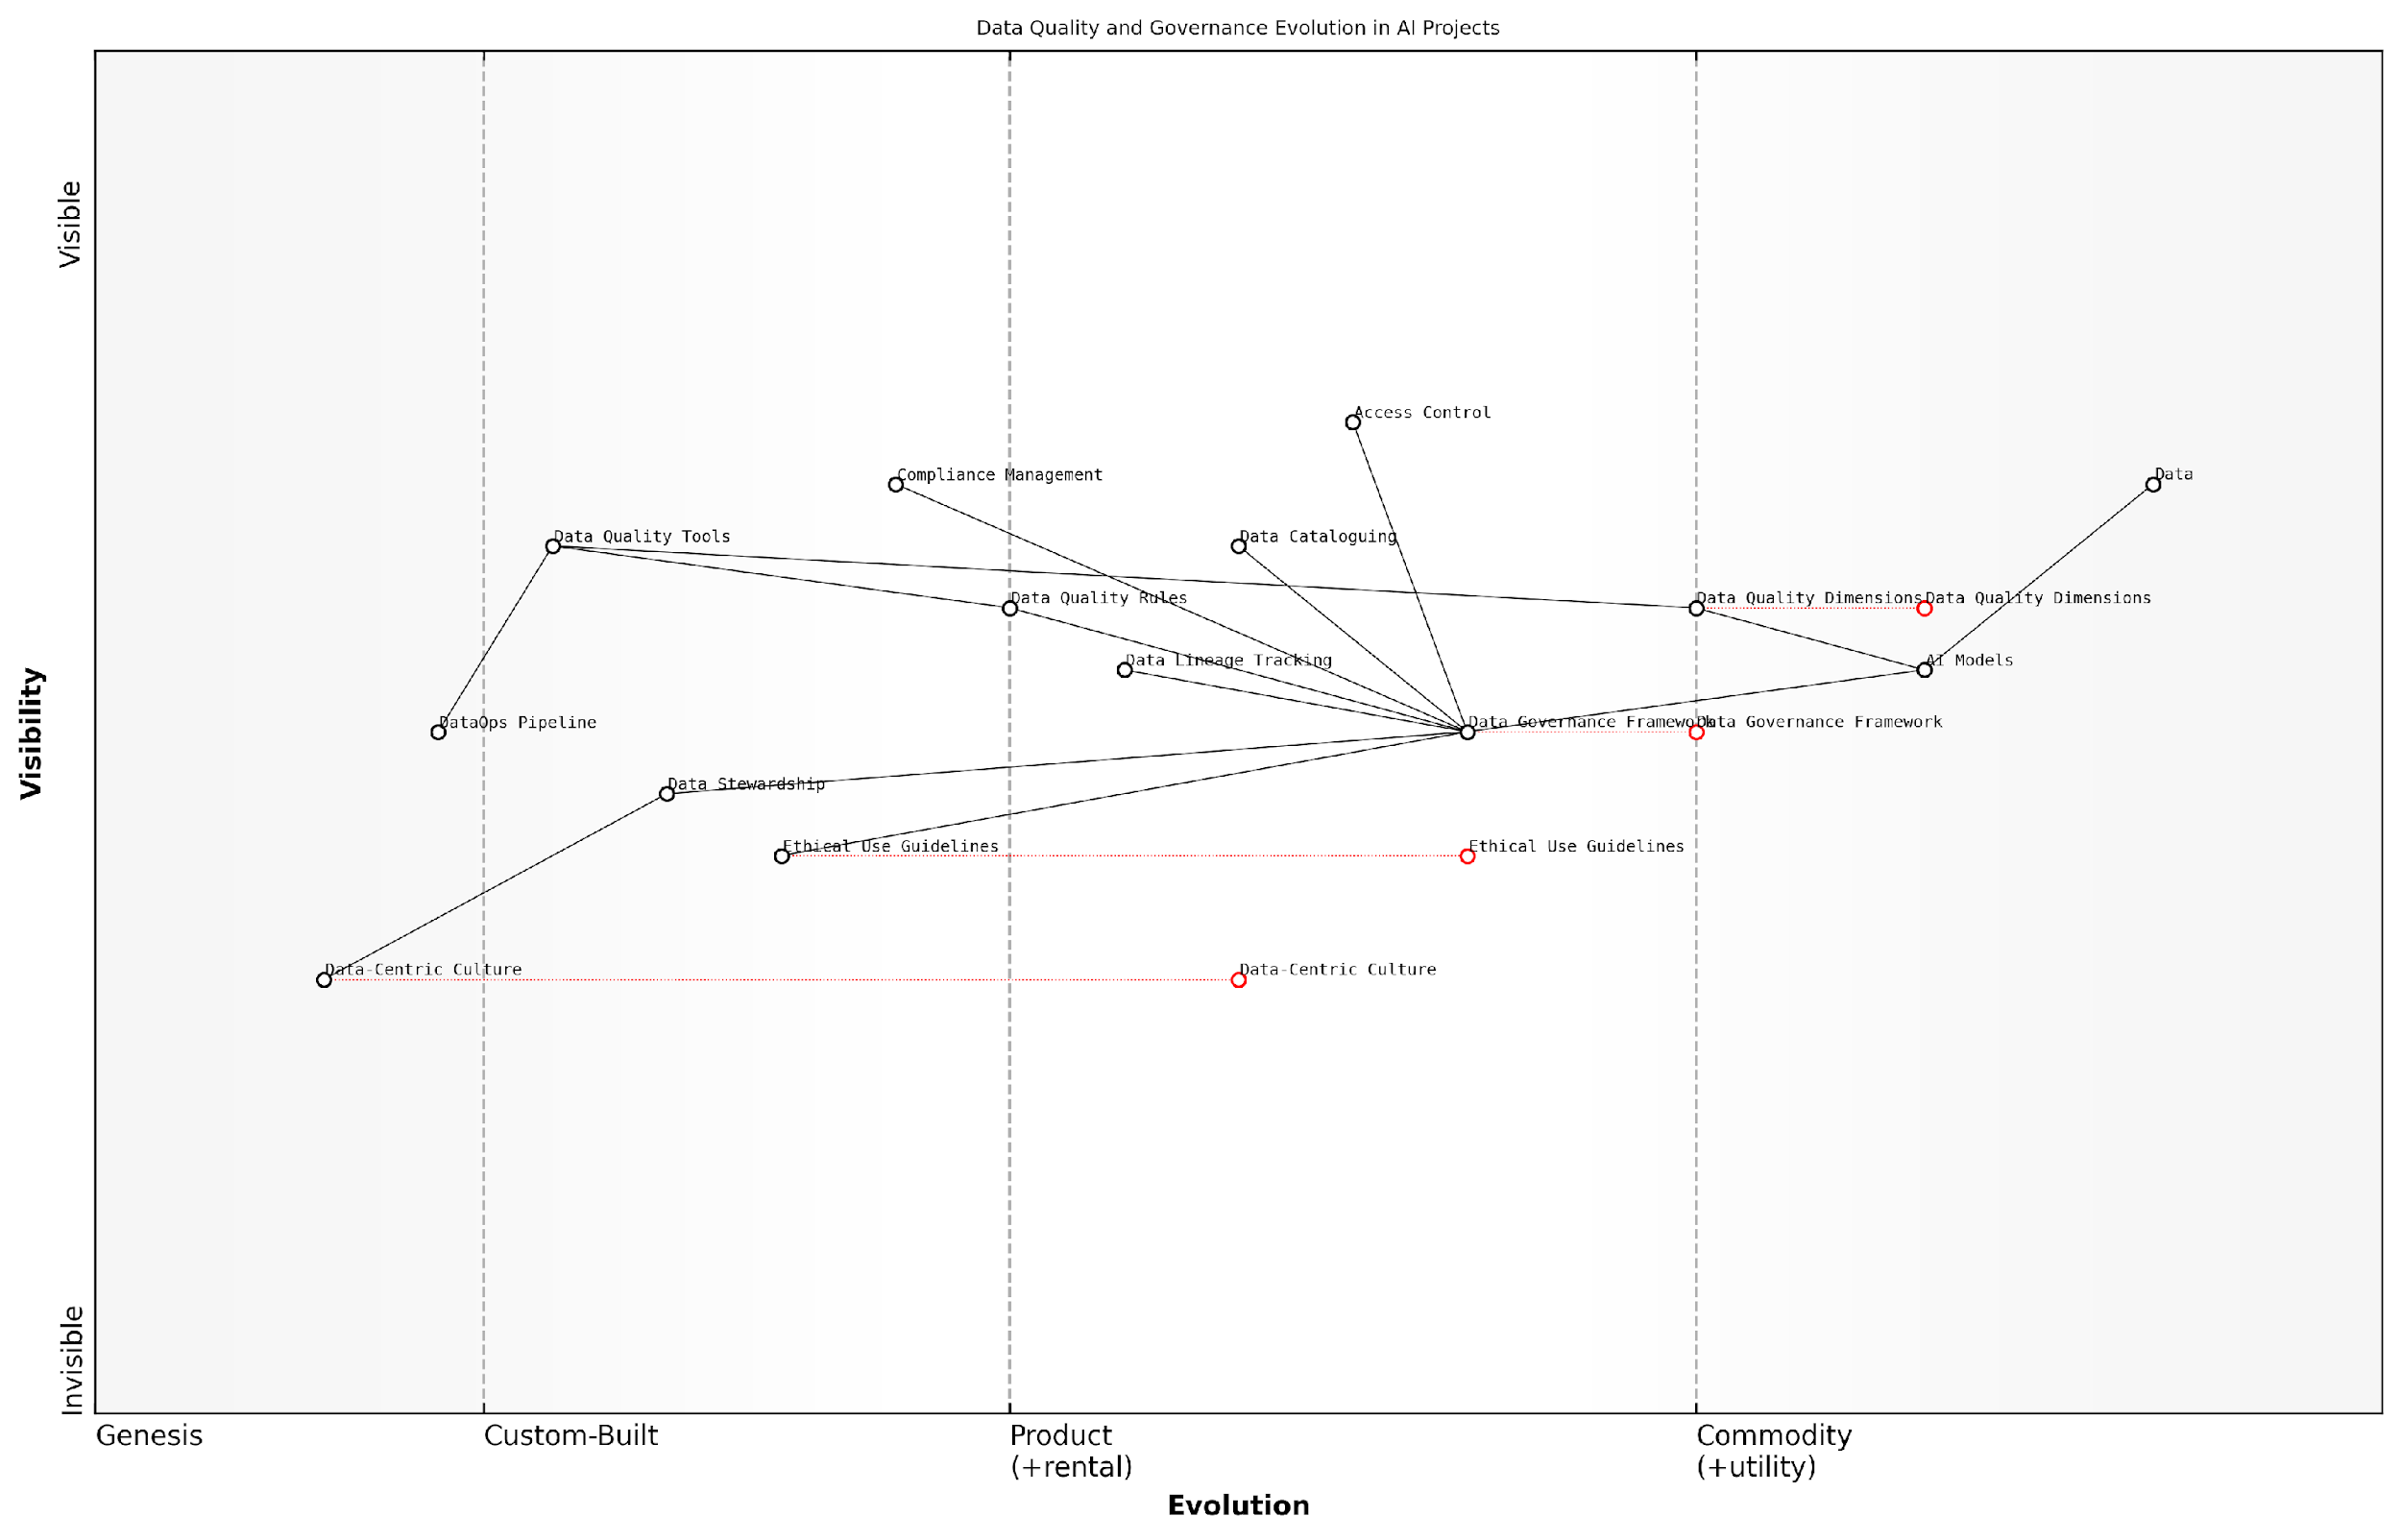

*Draft Wardley Map: [Insert Wardley Map: Data quality and governance]*

[Edit this draft Wardley Map](https://create.wardleymaps.ai/#clone:c12988dc78392de5a5)

Wardley Map Assessment

This map indicates an organisation in transition, moving from a focus on basic data and AI capabilities to a more mature, governance-focused approach. The key strategic imperative is to accelerate the development of a data-centric culture and ethical framework while maintaining technical excellence. Success will depend on effectively balancing and integrating all elements of the data quality and governance ecosystem.

[View full Wardley Map report](http://markdown/wardley_map_reports/wardley_map_report_10_Data_quality_and_governance.md)

In conclusion, data quality and governance are foundational elements of successful DataOps for AI. By implementing robust frameworks and fostering a data-centric culture, organisations can ensure that their AI initiatives are built on a solid foundation of high-quality, well-governed data. This not only enhances the performance and reliability of AI systems but also builds trust among stakeholders and end-users, paving the way for widespread adoption and transformative impact of AI technologies.

### Automated data pipelines and integration

In the realm of DataOps for AI success, automated data pipelines and integration stand as critical components, serving as the arteries through which data flows seamlessly from source to consumption. As an expert who has advised numerous government agencies and public sector organisations on AI implementation, I can attest to the transformative power of well-designed, automated data pipelines in driving AI initiatives forward.

Automated data pipelines are the backbone of efficient DataOps, enabling the continuous, reliable, and scalable flow of data across an organisation’s AI ecosystem. These pipelines automate the process of extracting data from various sources, transforming it into a usable format, and loading it into the appropriate systems for analysis and model training. The integration aspect ensures that these pipelines work harmoniously with existing systems and processes, creating a cohesive data environment that supports AI development and deployment.

Automated data pipelines are not just a convenience; they are a necessity for any organisation serious about leveraging AI at scale. They eliminate manual bottlenecks, reduce errors, and ensure that AI models are always working with the most up-to-date and relevant data.

The implementation of automated data pipelines and integration for AI success encompasses several key elements:

* Data Extraction and Ingestion: Automating the process of pulling data from diverse sources, including databases, APIs, file systems, and streaming platforms.
* Data Transformation and Cleansing: Implementing automated processes to clean, standardise, and transform raw data into formats suitable for AI model consumption.
* Data Validation and Quality Checks: Incorporating automated quality assurance measures to ensure data integrity and consistency throughout the pipeline.
* Metadata Management: Automatically capturing and managing metadata to provide context and lineage for the data flowing through the pipeline.
* Orchestration and Scheduling: Implementing tools to coordinate and schedule pipeline tasks, ensuring timely and efficient data processing.
* Error Handling and Monitoring: Developing robust error handling mechanisms and monitoring systems to maintain pipeline reliability and performance.
* Scalability and Elasticity: Designing pipelines that can automatically scale to handle varying data volumes and processing requirements.
* Security and Compliance: Integrating security measures and compliance checks throughout the pipeline to protect sensitive data and meet regulatory requirements.

In my experience working with government agencies, the implementation of automated data pipelines has been particularly transformative in areas such as fraud detection, citizen service optimisation, and policy impact analysis. For instance, a large public sector organisation I advised was able to reduce their data preparation time for AI models by 70% after implementing automated pipelines, significantly accelerating their AI development cycle.

However, it’s crucial to note that the journey to fully automated and integrated data pipelines is not without challenges. Organisations often grapple with legacy systems, data silos, and cultural resistance to change. Overcoming these hurdles requires a strategic approach that combines technical expertise with change management principles.

The true power of automated data pipelines lies not just in their technical capabilities, but in their ability to foster a data-driven culture within an organisation. When implemented correctly, they become the catalyst for a broader transformation in how data is valued, managed, and utilised across the enterprise.

To successfully implement automated data pipelines and integration for AI success, organisations should consider the following best practices:

* Start with a clear data strategy aligned with AI objectives
* Invest in robust data governance frameworks
* Choose scalable and interoperable tools and platforms
* Prioritise data quality and consistency throughout the pipeline
* Implement comprehensive monitoring and alerting systems
* Foster collaboration between data engineers, data scientists, and domain experts
* Continuously iterate and optimise pipeline performance
* Provide training and support to build internal capabilities

As we look to the future, the role of automated data pipelines in AI success will only grow in importance. Emerging technologies such as edge computing, 5G networks, and IoT devices are set to exponentially increase the volume and velocity of data available for AI applications. Organisations that have mastered the art and science of automated data pipelines will be well-positioned to harness these developments and drive innovation in their AI initiatives.

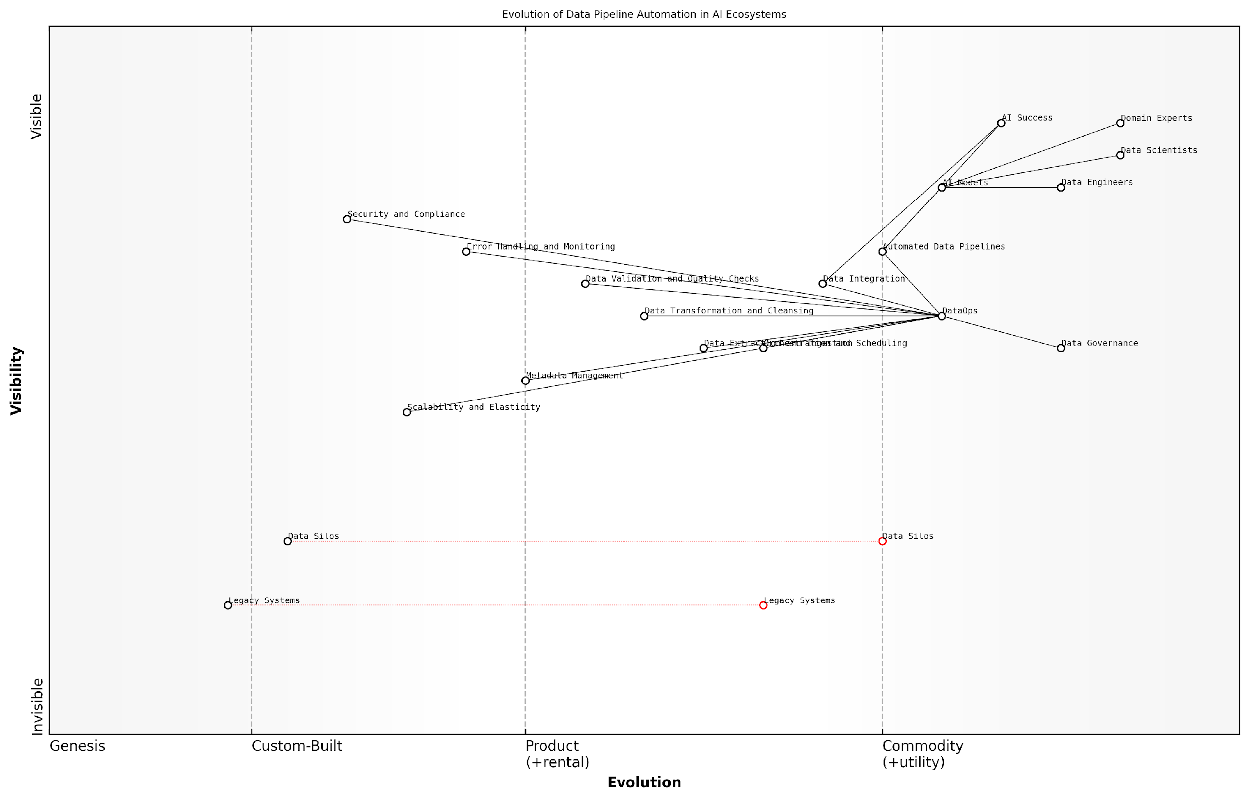

*Draft Wardley Map: [Insert Wardley Map: Automated data pipelines and integration]*

[Edit this draft Wardley Map](https://create.wardleymaps.ai/#clone:c7e97e09db8ad97794)

Wardley Map Assessment

The map reveals a strategic focus on evolving from traditional data management to AI-centric, automated data pipelines. The key to success lies in effectively implementing DataOps, accelerating the evolution of legacy systems, and maintaining a strong emphasis on data governance and quality. Organisations should prioritise the development of automated, scalable data pipelines while fostering collaboration between data scientists, engineers, and domain experts. The future competitive advantage will likely come from the ability to seamlessly integrate advanced AI capabilities with robust, efficient data operations.

[View full Wardley Map report](http://markdown/wardley_map_reports/wardley_map_report_11_Automated_data_pipelines_and_integration.md)

In conclusion, automated data pipelines and integration are not merely technical implementations; they are strategic assets that can significantly enhance an organisation’s ability to leverage AI for transformative outcomes. By embracing these practices within a comprehensive DataOps framework, organisations can create a solid foundation for AI success, ensuring that their data is always ready to fuel the next breakthrough in artificial intelligence.

### Real-time data processing and analytics

In the realm of AI-driven decision-making, the ability to process and analyse data in real-time has become a critical component of successful DataOps implementation. As an expert who has advised numerous government agencies and private sector organisations on AI initiatives, I can attest to the transformative power of real-time data processing and analytics in enhancing AI outcomes and operational efficiency.

Real-time data processing and analytics refer to the ability to ingest, process, and analyse data as it is generated or received, allowing for immediate insights and actions. This capability is particularly crucial in AI contexts, where models often require up-to-date information to make accurate predictions or decisions. The implementation of real-time processing within a DataOps framework ensures that AI systems are continuously fed with the most current and relevant data, thereby improving their performance and reliability.

* Reduced latency in decision-making processes
* Improved accuracy of AI model predictions
* Enhanced ability to detect and respond to anomalies or critical events
* Increased operational efficiency through automated data workflows
* Better alignment between data processing and business needs

To effectively implement real-time data processing and analytics within a DataOps framework, organisations must consider several key aspects:

* Data Ingestion: Implementing robust systems for continuous data capture from various sources
* Stream Processing: Utilising technologies capable of processing high-velocity data streams
* In-Memory Computing: Leveraging in-memory databases for rapid data access and processing
* Event-Driven Architecture: Designing systems that can react to data events in real-time
* Scalable Infrastructure: Ensuring the underlying infrastructure can handle varying data volumes and velocities

One of the most significant challenges in implementing real-time data processing for AI is managing the balance between speed and accuracy. While real-time insights are valuable, they must not come at the cost of data quality or analytical rigour. This is where the principles of DataOps become particularly relevant, emphasising the need for automated quality checks, continuous monitoring, and rapid feedback loops.

Real-time data processing is not just about speed; it’s about delivering timely, accurate insights that drive immediate value. In the context of AI, this means creating a data ecosystem that can keep pace with the rapid decision-making capabilities of machine learning models.

In my experience working with government agencies, the implementation of real-time data processing has been particularly impactful in areas such as public safety, traffic management, and emergency response. For instance, a large metropolitan police force I advised was able to significantly improve its predictive policing capabilities by implementing a real-time data processing system that integrated data from various sources, including social media, emergency calls, and IoT sensors.

To successfully implement real-time data processing and analytics within a DataOps framework, organisations should consider the following best practices:

* Start with a clear understanding of the business use cases that require real-time insights
* Invest in robust data integration and ETL (Extract, Transform, Load) processes
* Implement data quality checks at the point of ingestion to ensure the integrity of real-time data
* Utilise stream processing technologies such as Apache Kafka or Apache Flink for handling high-velocity data
* Develop a comprehensive monitoring strategy to track the performance and reliability of real-time systems
* Ensure that data governance policies are adapted to accommodate the unique challenges of real-time data
* Foster collaboration between data engineers, data scientists, and business stakeholders to align real-time capabilities with AI objectives

It’s also crucial to consider the ethical implications of real-time data processing, particularly in government contexts. The ability to process and analyse data in real-time can raise concerns about privacy and surveillance. Therefore, it’s essential to implement robust data protection measures and ensure transparency in how real-time data is used within AI systems.

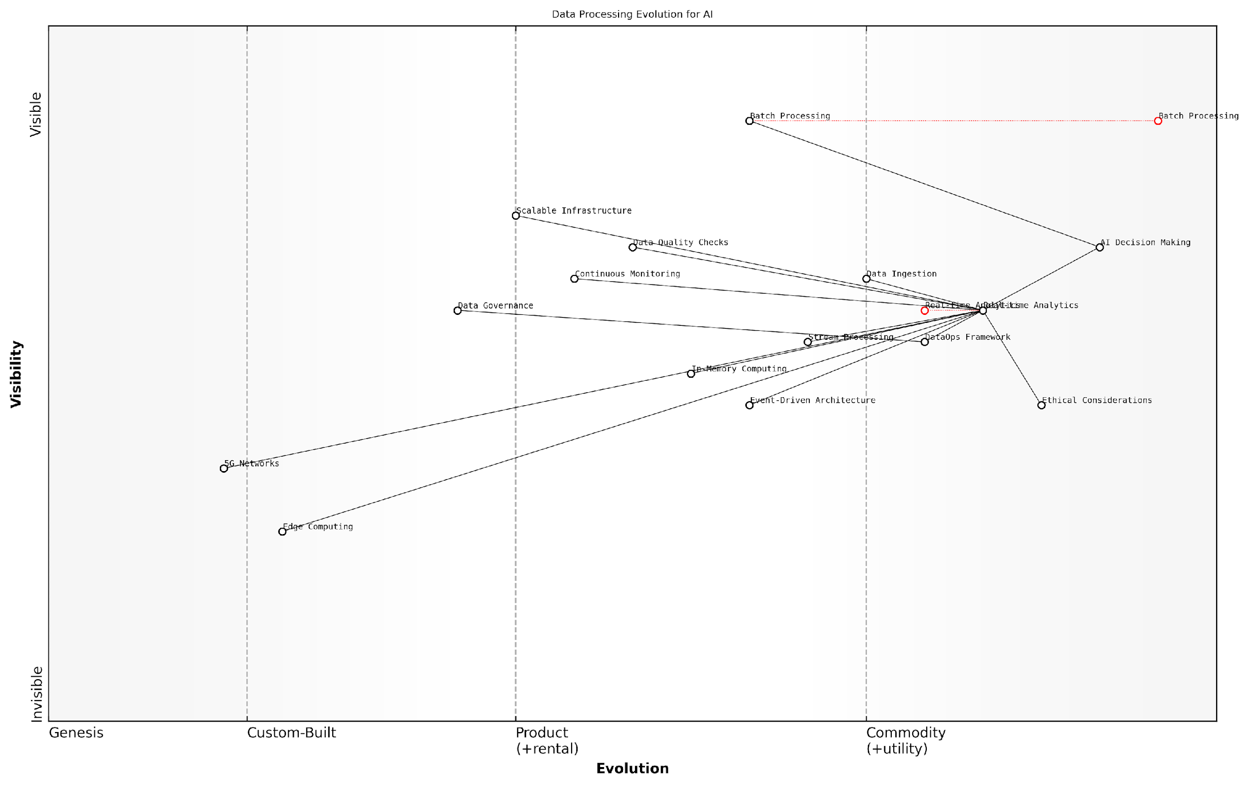

*Draft Wardley Map: [Insert Wardley Map: Real-time data processing and analytics]*

[Edit this draft Wardley Map](https://create.wardleymaps.ai/#clone:366876735ade4aced0)

Wardley Map Assessment

This map represents a data processing ecosystem in transition, moving from traditional batch processing to real-time, AI-driven decision making. The strategic focus should be on accelerating the development of real-time and edge capabilities while ensuring robust data governance and ethical considerations. The integration of emerging technologies like Edge Computing and 5G networks will be crucial for future competitiveness. Organisations must balance the push for real-time processing with the need for data quality, scalability, and ethical AI practices.

[View full Wardley Map report](http://markdown/wardley_map_reports/wardley_map_report_12_Real-time_data_processing_and_analytics.md)

As we look to the future, the importance of real-time data processing and analytics in AI success will only grow. Emerging technologies such as edge computing and 5G networks are set to further enhance our capabilities in this area, enabling even faster and more distributed real-time processing. Organisations that successfully integrate these capabilities into their DataOps practices will be well-positioned to leverage AI for transformative outcomes across a wide range of applications.

The future of AI lies in its ability to make decisions at the speed of thought. Real-time data processing is the key that unlocks this potential, turning the vast sea of data into a powerful current that drives intelligent, timely actions.

In conclusion, real-time data processing and analytics represent a critical component of successful DataOps implementation for AI. By enabling organisations to harness the power of immediate insights, these capabilities pave the way for more responsive, accurate, and impactful AI systems. As we continue to push the boundaries of what’s possible with AI, the ability to effectively manage and leverage real-time data will increasingly become a key differentiator between organisations that merely adopt AI and those that truly thrive in the AI-driven future.

### Data security and compliance in AI contexts

In the realm of AI implementation, data security and compliance are paramount concerns that cannot be overlooked. As AI systems process vast amounts of sensitive information, the need for robust security measures and strict adherence to regulatory requirements becomes increasingly critical. This subsection delves into the intricate landscape of data protection within AI contexts, exploring the unique challenges and essential strategies for maintaining security and compliance throughout the AI lifecycle.

The integration of AI technologies introduces new dimensions to data security. Traditional security measures, while still relevant, must be augmented to address the specific vulnerabilities associated with AI systems. These include potential exploits in machine learning models, data poisoning attacks, and the inadvertent exposure of sensitive information through model outputs. Moreover, the dynamic nature of AI systems, which often require continuous learning and adaptation, presents ongoing security challenges that demand vigilant monitoring and proactive risk management.

AI systems are not just consumers of data; they are also generators of insights that may inadvertently reveal protected information. This dual role necessitates a paradigm shift in how we approach data security and privacy in the age of artificial intelligence.

Compliance in AI contexts extends beyond traditional data protection regulations. While frameworks such as GDPR, CCPA, and industry-specific standards like HIPAA remain crucial, AI-specific guidelines are emerging. These new regulations often focus on the ethical use of AI, algorithmic transparency, and fairness in automated decision-making processes. Organisations must navigate this complex regulatory landscape to ensure their AI initiatives remain compliant and ethically sound.

* Implement robust encryption for data at rest and in transit
* Establish granular access controls and authentication mechanisms
* Conduct regular security audits and vulnerability assessments
* Develop and enforce data governance policies specific to AI workflows
* Implement privacy-preserving techniques such as differential privacy and federated learning
* Establish processes for continuous compliance monitoring and reporting

One of the key challenges in securing AI systems is the need to balance data accessibility for model training and iteration with stringent protection measures. This balance is crucial for maintaining the agility required in AI development while ensuring that sensitive information remains safeguarded. Techniques such as data anonymisation, pseudonymisation, and synthetic data generation can play a vital role in this balancing act, allowing for meaningful model development without compromising individual privacy or organisational confidentiality.

Compliance in AI contexts also necessitates a focus on explainability and transparency. As AI systems become more complex, the ability to interpret their decision-making processes becomes increasingly important, particularly in regulated industries. Techniques such as SHAP (SHapley Additive exPlanations) values and LIME (Local Interpretable Model-agnostic Explanations) can provide insights into model behaviour, aiding in compliance with regulations that require explainable AI.

In the era of AI, compliance is not just about ticking boxes. It’s about building trust through transparency and demonstrating a commitment to ethical AI practices that respect individual rights and societal values.

The implementation of secure and compliant AI systems requires a holistic approach that encompasses people, processes, and technology. This includes fostering a culture of security awareness among AI developers and data scientists, establishing clear protocols for data handling and model deployment, and leveraging advanced technologies such as homomorphic encryption and secure multi-party computation to enable privacy-preserving AI computations.

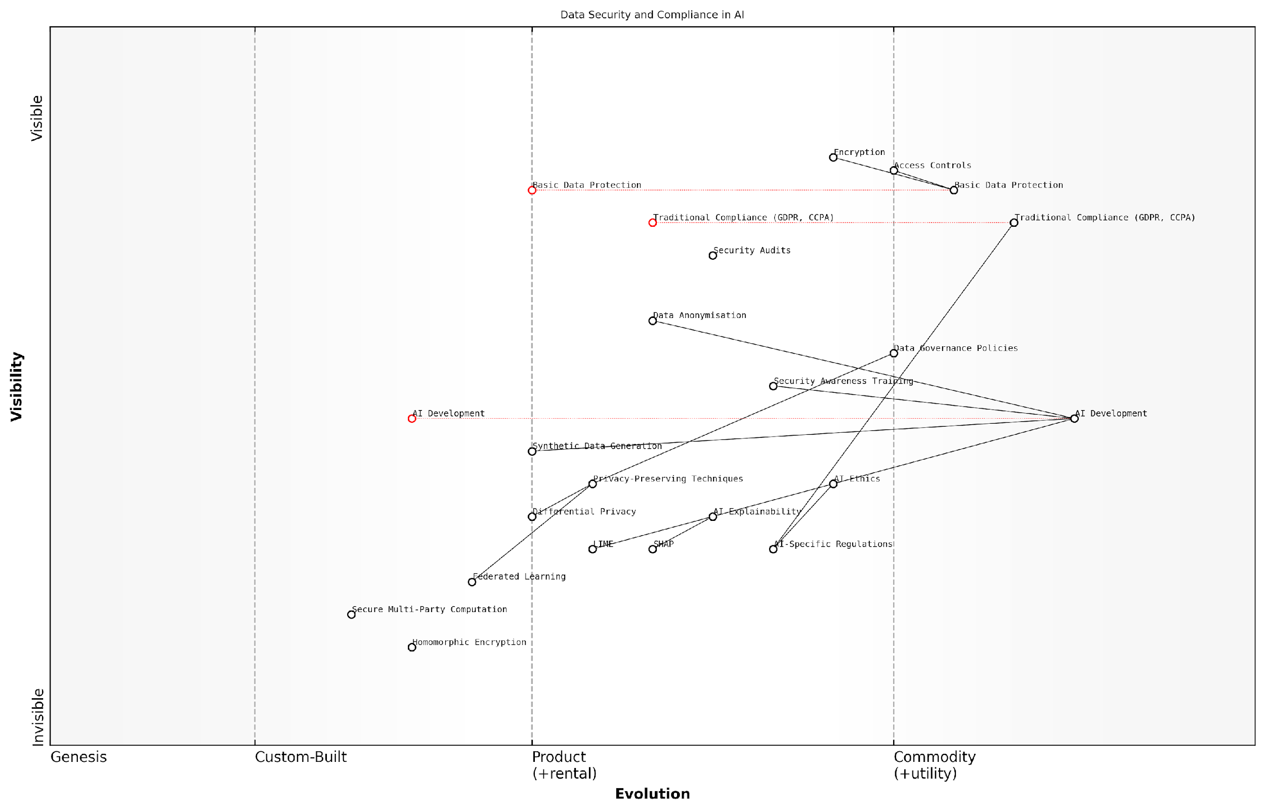

*Draft Wardley Map: [Insert Wardley Map: Data security and compliance in AI contexts]*

[Edit this draft Wardley Map](https://create.wardleymaps.ai/#clone:93586366a561e037ca)

Wardley Map Assessment

The map reveals a strategic landscape poised at the intersection of AI innovation and evolving security and compliance requirements. The organisation is well-positioned in traditional areas but must accelerate development in AI-specific security, privacy-preserving techniques, and ethical AI to maintain competitive advantage and regulatory compliance. Key focus areas should include bridging the gap between traditional and AI-specific compliance, investing in advanced privacy-preserving technologies, and positioning as a leader in ethical and explainable AI. The rapidly evolving nature of this space necessitates a proactive and adaptive strategy, with continuous monitoring of regulatory developments and emerging technologies.

[View full Wardley Map report](http://markdown/wardley_map_reports/wardley_map_report_13_Data_security_and_compliance_in_AI_contexts.md)

As AI systems become more prevalent and influential in decision-making processes, the stakes for security and compliance continue to rise. Organisations must remain vigilant, adapting their strategies to address emerging threats and evolving regulatory landscapes. By integrating robust security measures and compliance frameworks into their DataOps practices, organisations can build trust in their AI initiatives, mitigate risks, and unlock the full potential of AI while safeguarding sensitive information and adhering to ethical standards.

## DataOps Best Practices and Tools

### Collaborative data management

In the realm of DataOps, collaborative data management stands as a cornerstone for successful AI implementations. As an expert who has advised numerous government agencies and public sector organisations on AI initiatives, I can attest that effective collaboration in data management is not merely a best practice—it’s a necessity for achieving transformative AI outcomes.

Collaborative data management in DataOps refers to the orchestrated effort of multiple stakeholders—data scientists, engineers, domain experts, and business analysts—working in concert to ensure data quality, accessibility, and relevance throughout the AI lifecycle. This approach breaks down silos, fosters cross-functional understanding, and ultimately leads to more robust and reliable AI systems.

* Shared responsibility for data quality
* Cross-functional data literacy
* Unified data governance frameworks
* Collaborative data cataloguing and metadata management
* Joint development of data pipelines
* Collective data issue resolution

One of the primary benefits of collaborative data management is the establishment of a shared understanding of data assets across the organisation. This shared knowledge base is crucial for AI projects, as it ensures that all team members are working with consistent, high-quality data. In my experience advising government bodies, I’ve observed that projects leveraging collaborative data management are significantly more likely to produce accurate, unbiased AI models that can withstand scrutiny and deliver tangible value to citizens.

Collaborative data management is the bedrock upon which successful AI initiatives are built. It transforms data from a mere resource into a strategic asset that drives innovation and public service excellence.

To implement collaborative data management effectively, organisations must foster a culture of data stewardship. This involves empowering team members at all levels to take ownership of data quality and to actively participate in data-related decision-making processes. In the public sector, where data often spans multiple departments and agencies, this collaborative approach is particularly crucial for breaking down institutional barriers and ensuring a holistic view of citizen data.

One of the key enablers of collaborative data management is the implementation of centralised data platforms and tools that facilitate seamless collaboration. These platforms serve as a single source of truth, providing a unified interface for data discovery, access, and manipulation. They also enable real-time collaboration, version control, and audit trails, which are essential for maintaining data integrity and compliance in AI projects.

* Data catalogues with social features
* Collaborative ETL and data preparation tools
* Version-controlled data repositories
* Shared data quality dashboards
* Collaborative data modelling environments
* Integrated data lineage and impact analysis tools

In my consultancy work, I’ve seen firsthand how the adoption of these collaborative tools can dramatically improve the efficiency and effectiveness of AI initiatives. For instance, a large government agency I advised was able to reduce its AI model development time by 40% after implementing a collaborative data management platform that enabled real-time cooperation between data scientists and domain experts.

However, it’s important to note that collaborative data management is not without its challenges. Organisations must navigate issues such as data access controls, privacy concerns, and the potential for conflicting priorities among different stakeholders. To address these challenges, it’s crucial to establish clear governance frameworks and decision-making processes that balance collaboration with necessary controls.

The true power of collaborative data management lies in its ability to harness collective intelligence. When diverse perspectives converge around data, we unlock insights that drive transformative AI solutions for the public good.

As AI systems become increasingly complex and data-intensive, the importance of collaborative data management will only grow. Organisations that excel in this area will be better positioned to leverage AI for public service innovation, policy-making, and operational efficiency. They will be able to respond more quickly to changing citizen needs and emerging challenges, using data as a strategic asset to drive evidence-based decision-making.

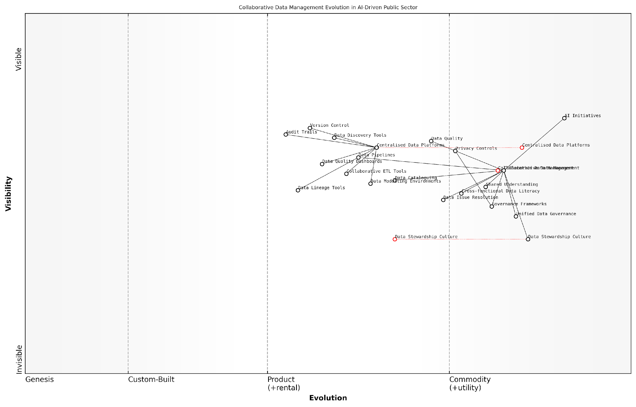

*Draft Wardley Map: [Insert Wardley Map: Collaborative data management]*

[Edit this draft Wardley Map](https://create.wardleymaps.ai/#clone:bf45e7914a6deffdb0)

Wardley Map Assessment

This Wardley Map reveals a public sector actively evolving its collaborative data management capabilities to support AI initiatives. While foundational elements and tools are in place, there’s significant opportunity for advancement in data culture, literacy, and AI-driven practices. The strategic focus should be on accelerating the evolution of key components while ensuring robust governance and privacy protection. Success will require a balanced approach to technology adoption, cultural change, and ecosystem collaboration, positioning the public sector to leverage data effectively for AI-driven innovation and service delivery.

[View full Wardley Map report](http://markdown/wardley_map_reports/wardley_map_report_14_Collaborative_data_management.md)

In conclusion, collaborative data management is not just a best practice—it’s a critical success factor for AI initiatives, particularly in the public sector. By fostering a culture of shared data stewardship, leveraging collaborative tools, and addressing governance challenges head-on, organisations can create a solid foundation for AI success. As we move forward in the age of AI-driven transformation, those who master collaborative data management will be best equipped to deliver innovative, efficient, and trustworthy AI solutions that serve the public interest.

### Continuous data testing and monitoring

In the realm of DataOps for AI success, continuous data testing and monitoring stand as critical pillars, ensuring the ongoing quality, reliability, and relevance of data fuelling AI systems. As an expert who has advised numerous government agencies and public sector organisations on AI implementation, I can attest to the transformative power of robust data testing and monitoring practices in achieving sustainable AI outcomes.

Continuous data testing involves the systematic and automated verification of data quality, integrity, and consistency throughout the data lifecycle. This process is not a one-off activity but an ongoing endeavour that aligns with the agile and iterative nature of AI development. By implementing continuous data testing, organisations can swiftly identify and rectify data issues before they propagate through AI models, ensuring the accuracy and reliability of AI-driven insights and decisions.

* Data profiling: Automatically analysing data characteristics, distributions, and patterns
* Data validation: Verifying data against predefined rules and constraints
* Data consistency checks: Ensuring data coherence across different systems and datasets
* Data completeness tests: Identifying missing or incomplete data points
* Data format and type checks: Confirming adherence to expected data structures

Complementing continuous testing, data monitoring involves the real-time observation and analysis of data flows, quality metrics, and system performance. This vigilant oversight enables organisations to maintain a pulse on their data ecosystem, promptly detecting anomalies, drift, or degradation that could impact AI model performance. In my experience advising on large-scale AI projects, effective data monitoring has often been the differentiator between AI systems that maintain their efficacy over time and those that rapidly become obsolete or unreliable.

* Real-time data quality dashboards: Visualising key data quality metrics
* Automated alerting systems: Notifying relevant stakeholders of data issues
* Performance tracking: Monitoring data processing times and resource utilisation
* Data drift detection: Identifying shifts in data distributions or characteristics
* Usage analytics: Tracking data consumption patterns across AI applications

Continuous data testing and monitoring are not luxuries in AI development; they are necessities. Without them, we’re essentially flying blind, hoping our AI models will perform as expected without any assurance of the quality of their fuel – the data.

The implementation of continuous data testing and monitoring requires a cultural shift within organisations, emphasising the importance of data quality at every stage of the AI lifecycle. This shift aligns closely with the principles of DataOps, fostering collaboration between data engineers, data scientists, and operational teams. In my consultancy work, I’ve observed that organisations that successfully embed these practices often develop a ‘data quality mindset’ that permeates all aspects of their AI initiatives.

To effectively implement continuous data testing and monitoring, organisations should consider adopting specialised tools and platforms designed for these purposes. These tools can automate many aspects of data quality management, freeing up valuable time for data professionals to focus on more strategic tasks. Some popular tools in this space include:

* Great Expectations: An open-source library for data validation and documentation
* Apache NiFi: A platform for automating data flows and implementing quality checks
* Datadog: A monitoring and analytics platform that can be adapted for data quality tracking
* Talend Data Fabric: An integrated suite of apps for data integration and quality management
* Informatica Data Quality: An enterprise-grade solution for comprehensive data quality management

When advising government agencies on AI implementation, I often emphasise the importance of selecting tools that not only meet their technical requirements but also align with their governance structures and compliance needs. The public sector, in particular, must consider factors such as data sovereignty, security clearances, and transparency in automated decision-making processes.

It’s crucial to note that while tools are important, they are not a panacea. The effectiveness of continuous data testing and monitoring ultimately depends on the processes and people behind them. Organisations must invest in training their teams, establishing clear data quality standards, and fostering a culture of data stewardship. This holistic approach ensures that data quality is not just a technical concern but a fundamental aspect of the organisation’s AI strategy.

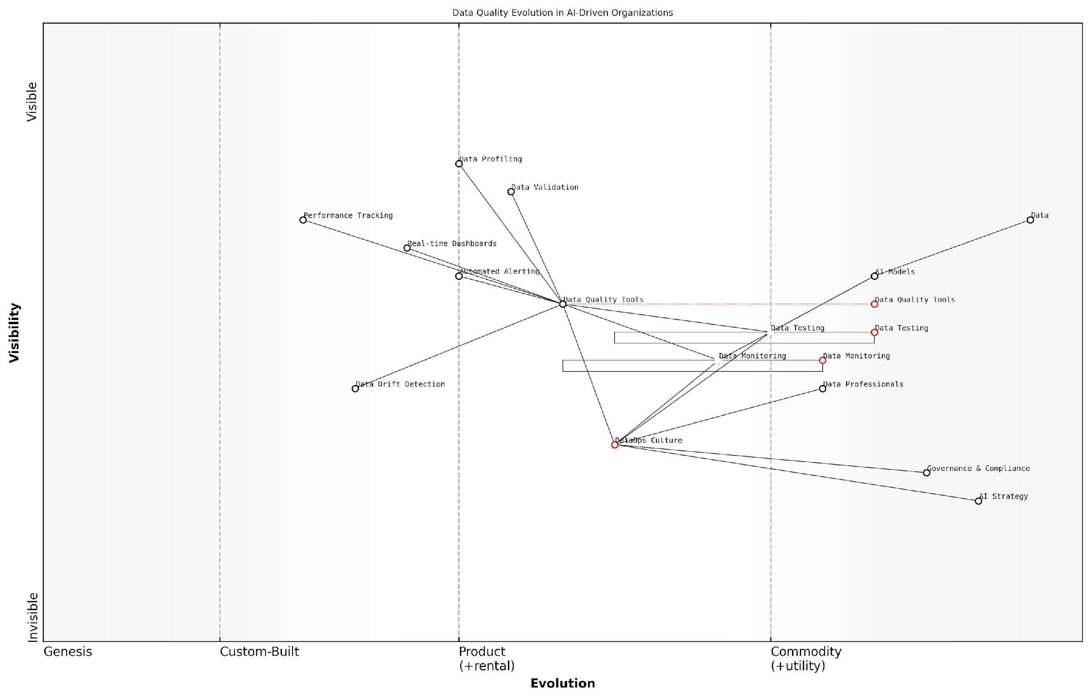

*Draft Wardley Map: [Insert Wardley Map: Continuous data testing and monitoring]*

[Edit this draft Wardley Map](https://create.wardleymaps.ai/#clone:b336c43fdaaf63aaf9)

Wardley Map Assessment

This Wardley Map reveals an organisation in transition towards advanced data quality management for AI. While strong foundations exist in data and AI model development, there’s a clear need to evolve data testing practices, cultivate a robust DataOps culture, and leverage emerging technologies for data quality assurance. The strategic focus should be on overcoming inertia in key areas, accelerating the adoption of advanced data quality tools, and fostering a data-centric culture that aligns with the organisation’s AI strategy. Success in this evolution will likely determine the organisation’s competitive edge in AI-driven markets.

[View full Wardley Map report](http://markdown/wardley_map_reports/wardley_map_report_15_Continuous_data_testing_and_monitoring.md)

As AI systems become increasingly integrated into critical decision-making processes, particularly in government and public sector contexts, the stakes for data quality have never been higher. Continuous data testing and monitoring serve as the guardians of AI integrity, ensuring that the insights and actions derived from AI models are based on solid, reliable foundations. By embracing these practices, organisations can build trust in their AI systems, mitigate risks associated with poor data quality, and unlock the full potential of their AI investments.

In the age of AI, data is not just an asset; it’s the lifeblood of intelligent systems. Continuous testing and monitoring are the health checks that keep this lifeblood pure and potent.

As we look to the future, the importance of continuous data testing and monitoring in AI success will only grow. Emerging technologies such as edge computing and 5G networks will introduce new challenges and opportunities in data management, requiring even more sophisticated and real-time approaches to data quality assurance. Organisations that lay the groundwork now for robust, scalable data testing and monitoring practices will be well-positioned to lead in the next frontier of AI innovation.

### DataOps tools and platforms for AI projects

In the rapidly evolving landscape of AI development, DataOps tools and platforms play a crucial role in streamlining data management processes and ensuring the delivery of high-quality, timely data to fuel AI projects. As an expert in this field, I’ve witnessed firsthand how the right set of tools can dramatically enhance the efficiency and effectiveness of DataOps practices, particularly in government and public sector contexts where data integrity and security are paramount.

DataOps tools and platforms for AI projects can be broadly categorised into several key areas, each addressing specific aspects of the data lifecycle and DataOps workflow. These categories include data integration and ETL tools, data quality and governance platforms, metadata management systems, data cataloguing tools, and collaborative data science environments.

* Data Integration and ETL Tools: These tools are essential for extracting data from various sources, transforming it into a suitable format for AI processing, and loading it into the target systems. Examples include Apache NiFi, Talend, and Informatica PowerCenter.
* Data Quality and Governance Platforms: These platforms help ensure data accuracy, consistency, and compliance with regulatory requirements. Tools like Collibra, Alation, and IBM InfoSphere Information Governance Catalog are particularly valuable in government settings.
* Metadata Management Systems: These systems help track and manage metadata, providing crucial context and lineage information for AI projects. Examples include Informatica Enterprise Data Catalog and Azure Purview.
* Data Cataloguing Tools: These tools help organise and discover data assets across an organisation, making it easier for AI teams to find and utilise relevant data. Examples include AWS Glue Data Catalog and Google Cloud Data Catalog.
* Collaborative Data Science Environments: Platforms like Databricks, Dataiku, and Domino Data Lab provide integrated environments for data scientists, engineers, and analysts to collaborate on AI projects, incorporating DataOps best practices.

When selecting DataOps tools and platforms for AI projects, particularly in government and public sector contexts, several key considerations must be taken into account:

* Scalability: The ability to handle large volumes of data and support growing AI initiatives is crucial.
* Security and Compliance: Tools must adhere to stringent security standards and support compliance with regulations such as GDPR, HIPAA, or sector-specific requirements.
* Interoperability: The ability to integrate with existing systems and other tools in the AI development stack is essential for creating a seamless DataOps workflow.
* Automation Capabilities: Look for tools that support automation of repetitive tasks, enabling more efficient and error-free data operations.
* Monitoring and Observability: Features that provide visibility into data pipelines, quality metrics, and system performance are crucial for maintaining robust DataOps practices.
* Collaboration Features: Tools that facilitate collaboration between data scientists, engineers, and domain experts can significantly enhance the effectiveness of AI projects.

In my experience advising government bodies on AI initiatives, I’ve found that the right DataOps tools can be transformative. As a senior data strategist in the public sector once told me, ‘Implementing a comprehensive DataOps platform reduced our data preparation time by 60% and improved our model accuracy by 25%, simply by ensuring our AI teams had access to higher quality, more timely data.’

It’s important to note that while tools and platforms are crucial, they are not a silver bullet. Successful implementation of DataOps for AI projects requires a combination of the right tools, well-defined processes, and a data-driven culture. Tools should be selected and implemented as part of a broader DataOps strategy, aligned with the organisation’s AI goals and existing technology landscape.

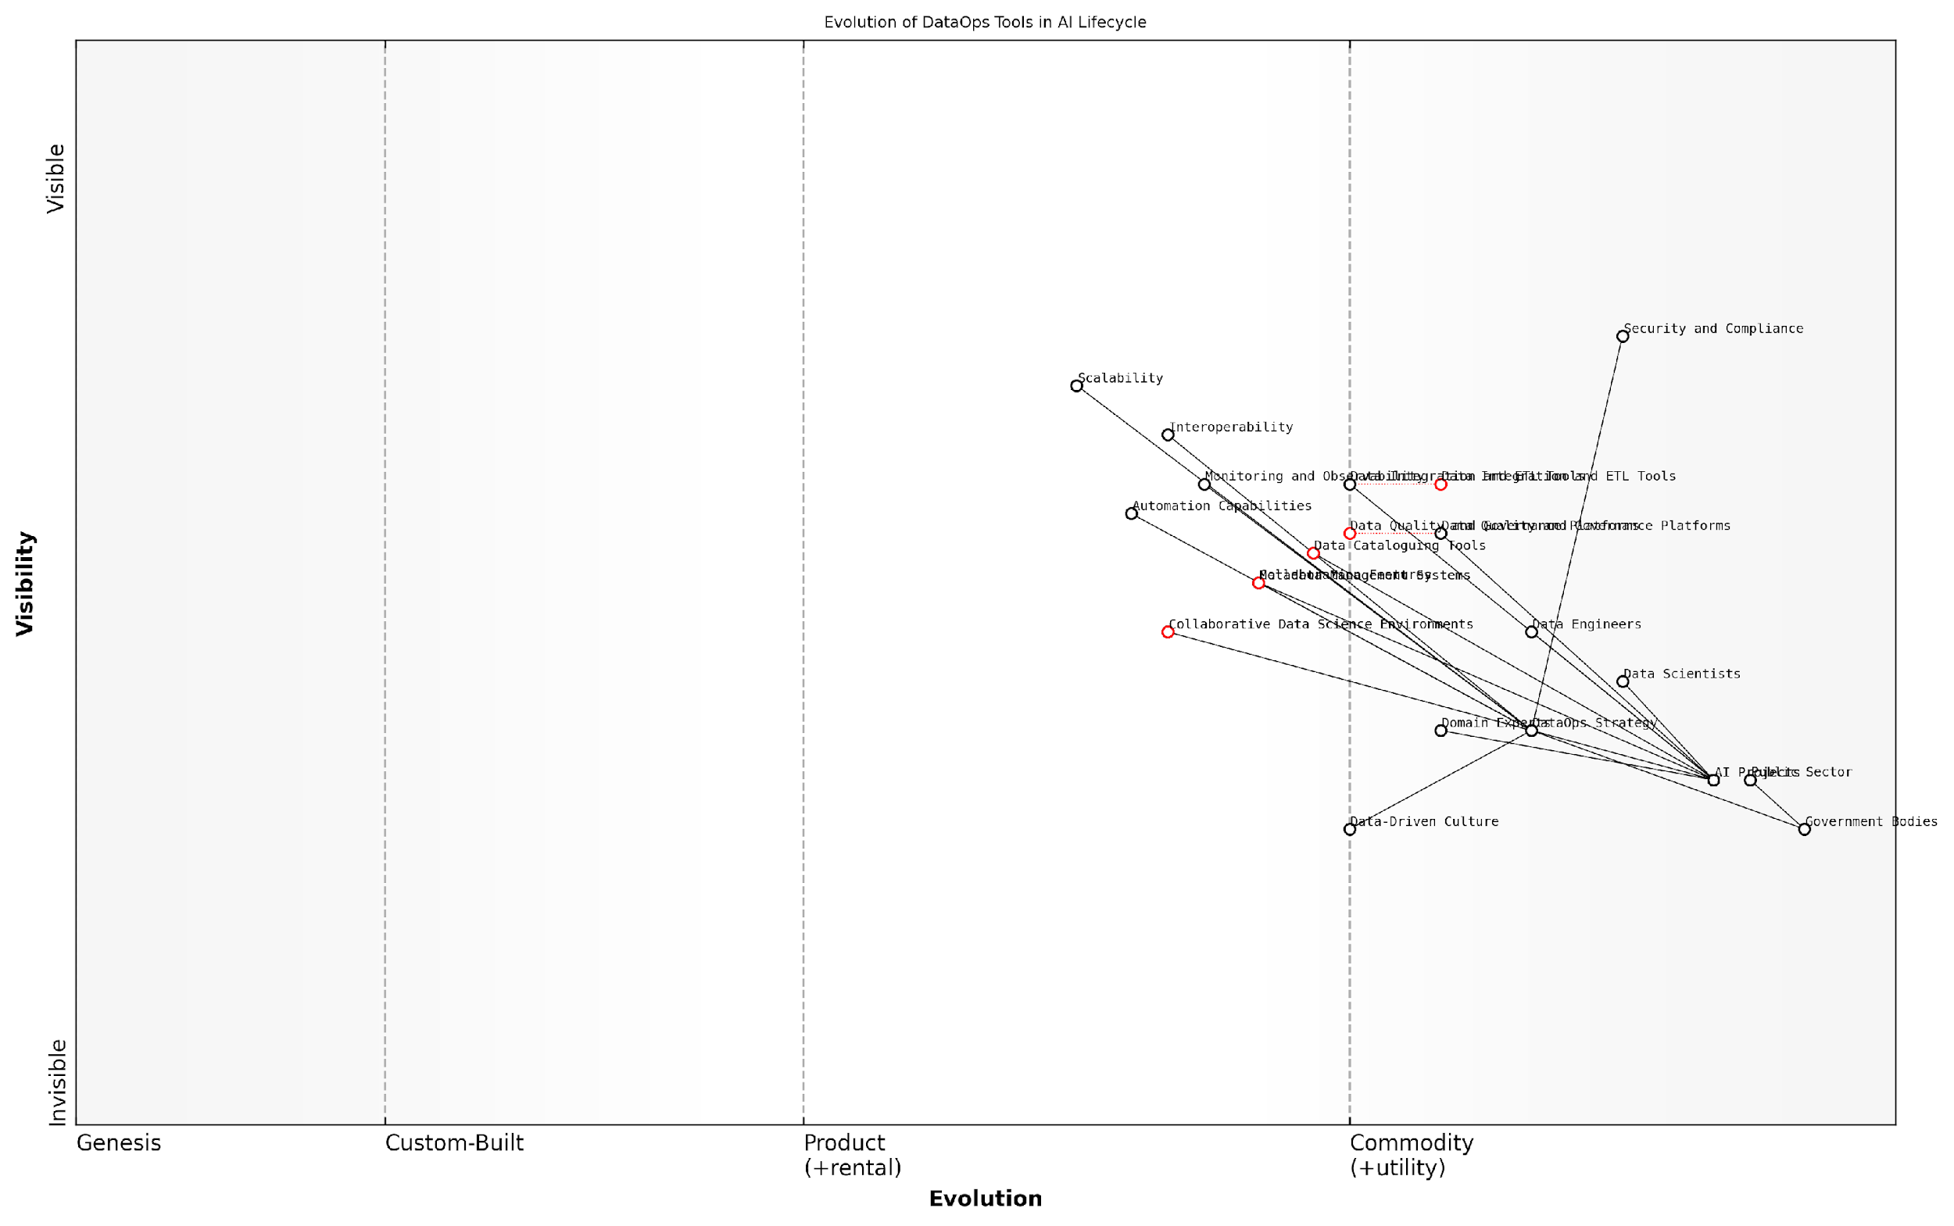

*Draft Wardley Map: [Insert Wardley Map: DataOps tools and platforms for AI projects]*

[Edit this draft Wardley Map](https://create.wardleymaps.ai/#clone:fa79628e5aa8936ed7)

Wardley Map Assessment

This Wardley Map reveals a DataOps ecosystem in transition, with opportunities for significant competitive advantage through innovation in collaborative environments and AI-driven data management. The strategic focus should be on balancing efficiency in commoditized areas with differentiation in custom and evolving components. Key to success will be fostering a data-driven culture, investing in advanced automation and AI-driven tools, and maintaining robust governance and security measures. The involvement of government bodies suggests an increasing regulatory focus, necessitating proactive compliance strategies. Organisations that can effectively integrate these elements into a cohesive DataOps strategy will be well-positioned to lead in AI project implementation and drive transformative outcomes.

[View full Wardley Map report](http://markdown/wardley_map_reports/wardley_map_report_16_DataOps_tools_and_platforms_for_AI_projects.md)

As the field of AI continues to advance, we can expect DataOps tools and platforms to evolve as well. Emerging trends include increased integration of AI and machine learning capabilities within DataOps tools themselves, enhanced support for real-time data processing, and more sophisticated data lineage and impact analysis features. These advancements will further empower organisations to leverage DataOps as a critical enabler of AI success, ensuring that high-quality, relevant data is always available to fuel innovative AI initiatives.

# MLOps: Streamlining AI Model Development and Deployment

## Understanding MLOps

### The evolution from DevOps to MLOps

The journey from DevOps to MLOps represents a significant evolution in the field of software development and artificial intelligence. As an expert who has witnessed and participated in this transformation, I can attest to the profound impact it has had on the way we approach AI model development and deployment. To fully appreciate the emergence of MLOps, we must first understand its predecessor, DevOps, and the unique challenges posed by machine learning systems that necessitated this evolution.

DevOps, a portmanteau of ‘Development’ and ‘Operations’, emerged in the late 2000s as a set of practices aimed at bridging the gap between software development and IT operations. It focused on automating and integrating the processes between software development and IT teams to enable faster and more reliable software delivery. The core principles of DevOps—continuous integration, continuous delivery, and continuous deployment—revolutionised the software development lifecycle, fostering collaboration and improving efficiency.

However, as machine learning and artificial intelligence began to play increasingly significant roles in software systems, it became apparent that traditional DevOps practices were insufficient to address the unique challenges posed by ML models. These challenges include:

* Data dependency: ML models rely heavily on data, which is often dynamic and can change over time, affecting model performance.
* Reproducibility: Ensuring consistent results across different environments and iterations is crucial but complex in ML systems.
* Model drift: ML models can degrade in performance over time as the underlying data distribution changes, requiring continuous monitoring and retraining.
* Experiment tracking: ML development involves numerous experiments with different hyperparameters, architectures, and datasets, necessitating robust tracking mechanisms.
* Model versioning: Unlike traditional software, ML models require versioning of not just code, but also data, hyperparameters, and trained models.
* Regulatory compliance: ML models often handle sensitive data and make critical decisions, requiring strict governance and explainability measures.

These unique challenges led to the birth of MLOps, a discipline that extends DevOps principles to machine learning systems. MLOps aims to unify ML system development (Dev) and ML system operation (Ops) to standardise and streamline the machine learning lifecycle. It encompasses the entire spectrum of ML model development, from data preparation and model training to deployment, monitoring, and maintenance.

MLOps is not just an extension of DevOps, but a fundamental rethinking of how we approach the development and operation of AI systems. It’s about creating a seamless pipeline that ensures our models are not just accurate, but also reliable, scalable, and maintainable in production environments.

The evolution from DevOps to MLOps has brought about several key advancements:

* Automated ML pipelines: End-to-end automation of data preparation, model training, evaluation, and deployment processes.
* Continuous training: Automated retraining of models as new data becomes available, ensuring models remain accurate over time.
* Model governance: Robust versioning and lineage tracking for models, data, and experiments, enabling reproducibility and auditability.
* Feature stores: Centralised repositories for storing, managing, and serving machine learning features, promoting reusability and consistency.
* Model monitoring: Real-time monitoring of model performance, data drift, and operational metrics to ensure reliability in production.
* Explainable AI: Integration of tools and practices to make ML models more interpretable and transparent, addressing regulatory and ethical concerns.

The transition from DevOps to MLOps has not been without its challenges. Organisations have had to adapt their processes, tools, and culture to accommodate the unique requirements of ML systems. This has involved upskilling teams, investing in new technologies, and often, restructuring workflows to support the ML lifecycle.

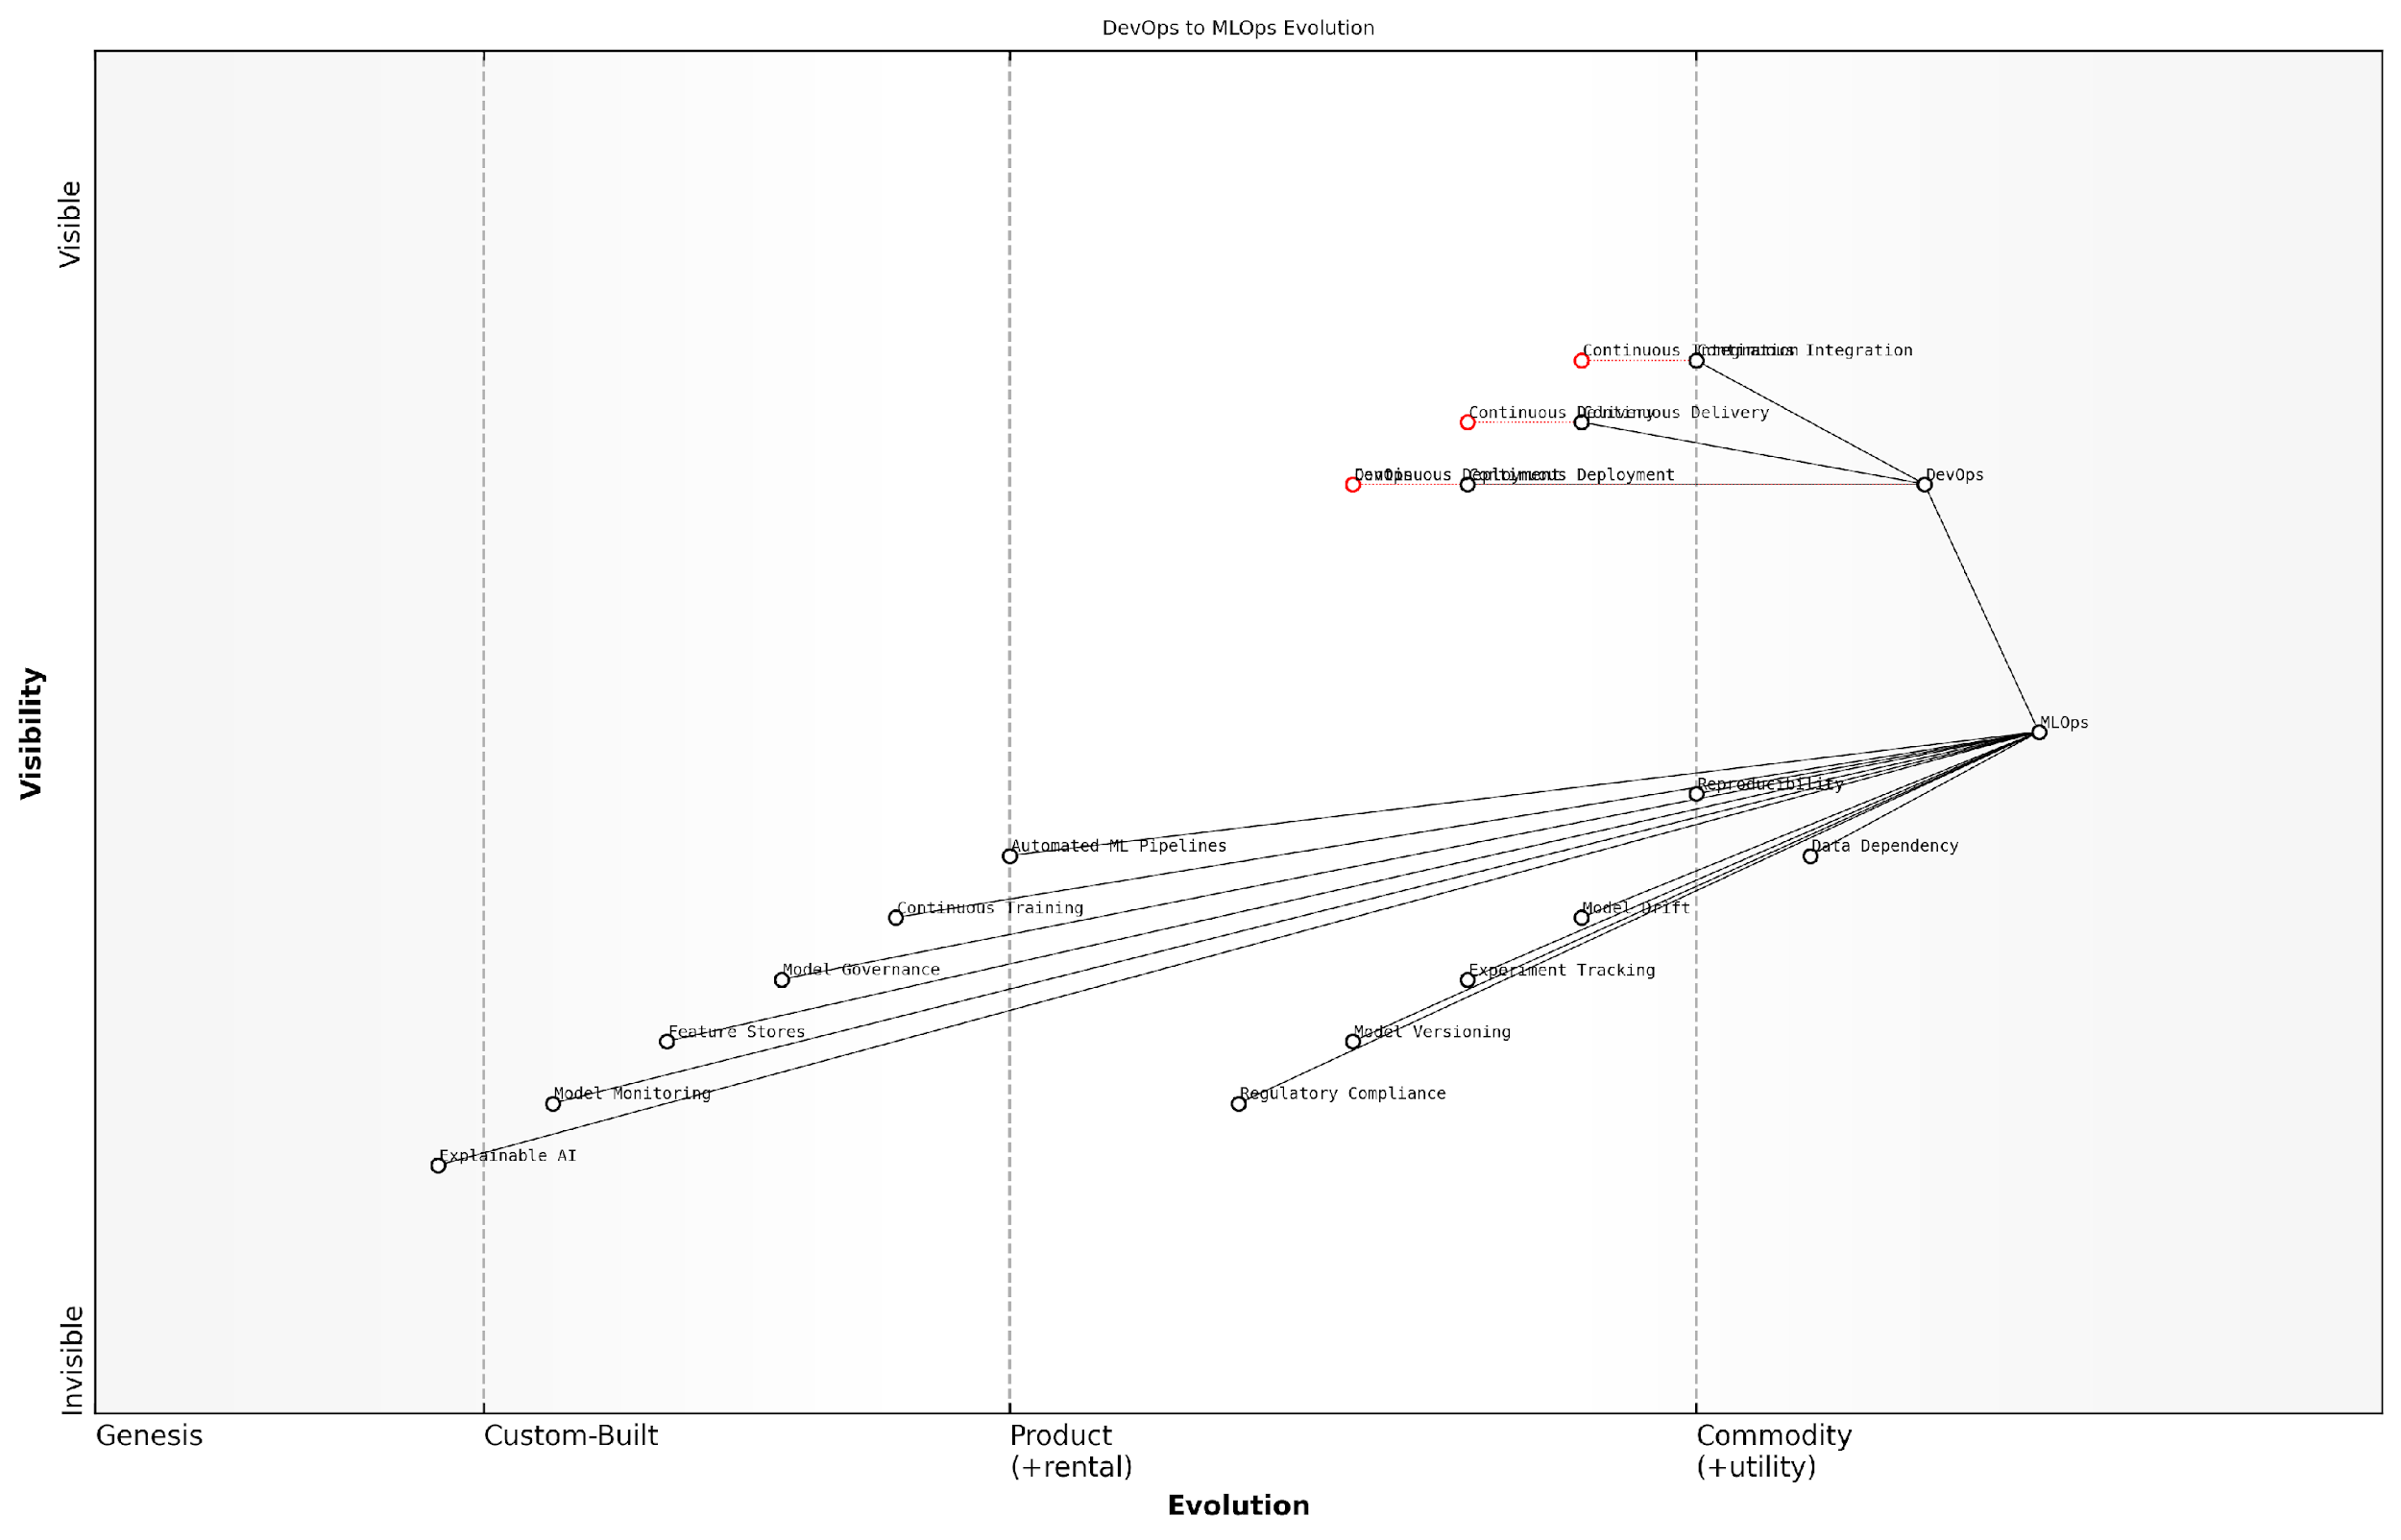

*Draft Wardley Map: [Insert Wardley Map: The evolution from DevOps to MLOps]*

[Edit this draft Wardley Map](https://create.wardleymaps.ai/#clone:74b6204aa178743abe)

Wardley Map Assessment

This map reveals a strategic imperative to evolve from traditional DevOps to MLOps to effectively manage AI/ML systems. Organisations must bridge the gap between established software practices and emerging ML-specific needs, with a focus on automation, governance, and explainability. The key to success lies in developing an integrated MLOps platform that addresses the unique challenges of ML systems while leveraging existing DevOps strengths. Prioritising the development of capabilities in model monitoring, versioning, and governance will be crucial for competitive advantage in the AI-driven future.

[View full Wardley Map report](http://markdown/wardley_map_reports/wardley_map_report_17_The_evolution_from_DevOps_to_MLOps.md)

As we continue to advance in the field of AI and machine learning, the principles and practices of MLOps will undoubtedly evolve further. The integration of MLOps with other operational frameworks, such as DataOps and FinOps, is already shaping the future of AI system development and deployment. This holistic approach, which I refer to as the ‘AI Success Trinity’, is crucial for organisations looking to harness the full potential of AI while maintaining efficiency, reliability, and cost-effectiveness.

The evolution from DevOps to MLOps is not just a technological shift, but a paradigm change in how we approach AI development. It’s about creating a culture of collaboration, continuous improvement, and responsible AI practices that will shape the future of intelligent systems.

### Core components of MLOps

As we delve deeper into the realm of MLOps, it’s crucial to understand its core components. These fundamental elements form the backbone of a robust MLOps framework, enabling organisations to streamline their AI model development and deployment processes. By mastering these components, government agencies and public sector organisations can significantly enhance their AI initiatives, ensuring scalability, reliability, and compliance with regulatory requirements.

The core components of MLOps can be broadly categorised into four key areas: Data Management, Model Development, Deployment and Monitoring, and Governance and Compliance. Each of these areas plays a vital role in the MLOps lifecycle and contributes to the overall success of AI projects.

* Data Management
* Model Development
* Deployment and Monitoring
* Governance and Compliance

Let’s explore each of these components in detail:

1. Data Management: At the heart of any AI project lies data. The Data Management component of MLOps focuses on ensuring that high-quality, relevant data is available for model training and evaluation. This involves data ingestion, preprocessing, versioning, and storage. In the context of government AI projects, this component is particularly crucial as it often deals with sensitive citizen data, requiring robust security measures and compliance with data protection regulations.

Key aspects of Data Management in MLOps include:

* Data pipelines for efficient data flow
* Data versioning to track changes and ensure reproducibility
* Data quality checks and validation
* Secure data storage and access controls

1. Model Development: This component encompasses the entire process of creating, training, and evaluating machine learning models. It includes feature engineering, algorithm selection, hyperparameter tuning, and model validation. In the public sector, model development often requires careful consideration of fairness and bias, ensuring that AI systems do not inadvertently discriminate against certain groups.

Key aspects of Model Development in MLOps include:

* Version control for model code and configurations
* Automated model training pipelines
* Experiment tracking and management
* Model evaluation and validation frameworks

1. Deployment and Monitoring: This component focuses on the seamless transition of models from development to production environments. It includes containerisation, orchestration, and continuous integration/continuous deployment (CI/CD) practices. For government agencies, this component is critical in ensuring that AI systems are deployed securely and can be easily updated or rolled back if necessary.

Key aspects of Deployment and Monitoring in MLOps include:

* Containerisation for consistent deployment across environments
* Automated deployment pipelines
* A/B testing and canary releases
* Real-time model performance monitoring
* Automated alerts and model retraining triggers

1. Governance and Compliance: This component ensures that AI systems adhere to regulatory requirements, ethical guidelines, and organisational policies. It involves establishing processes for model documentation, auditing, and accountability. In the public sector, where transparency and accountability are paramount, this component plays a crucial role in building trust in AI systems.

Key aspects of Governance and Compliance in MLOps include:

* Model documentation and lineage tracking
* Audit trails for model decisions and updates
* Access controls and role-based permissions
* Compliance checks and reporting mechanisms

MLOps is not just about tools and technologies; it’s about creating a culture of collaboration, transparency, and continuous improvement in AI development and deployment.

By integrating these core components, organisations can create a robust MLOps framework that addresses the unique challenges of AI development and deployment in the public sector. This approach enables government agencies to harness the power of AI while maintaining the highest standards of security, fairness, and accountability.

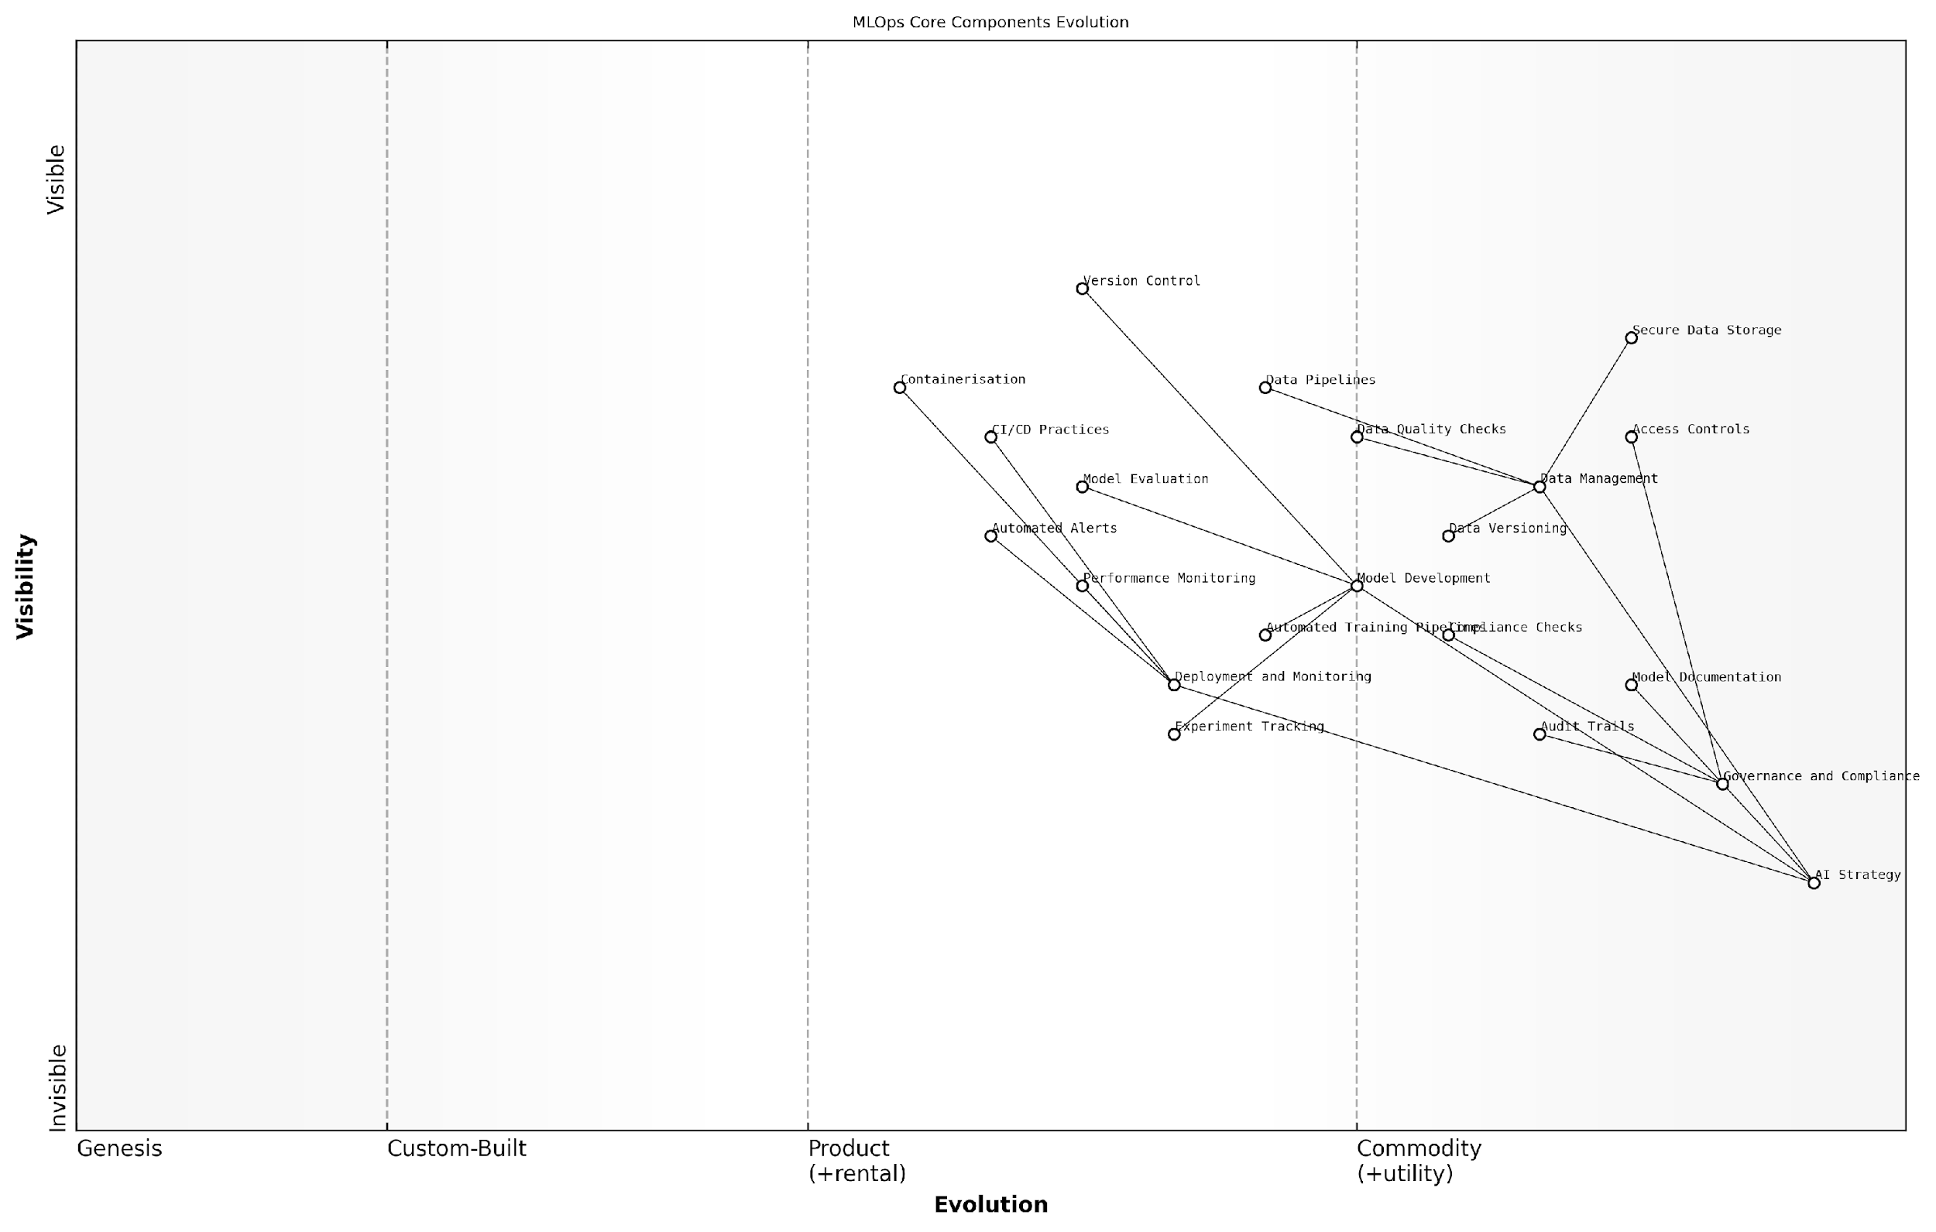

*Draft Wardley Map: [Insert Wardley Map: Core components of MLOps]*

[Edit this draft Wardley Map](https://create.wardleymaps.ai/#clone:95ad19b9ccf9ccd373)

Wardley Map Assessment

This Wardley Map reveals a maturing MLOps practice with strong technical foundations but emerging governance structures. The strategic focus should be on accelerating the evolution of Governance and Compliance practices while continuing to innovate in technical areas. Organisations should prioritise the development of a comprehensive, integrated MLOps platform that balances automation, quality, and compliance to drive sustainable AI adoption and value creation.

[View full Wardley Map report](http://markdown/wardley_map_reports/wardley_map_report_18_Core_components_of_MLOps.md)

As we move forward in our exploration of MLOps, it’s important to remember that these components are not isolated silos but interconnected elements of a holistic system. The success of an MLOps implementation lies in the seamless integration of these components and their alignment with the organisation’s broader AI strategy and objectives.

### The MLOps lifecycle

The MLOps lifecycle is a comprehensive framework that orchestrates the entire journey of machine learning models from conception to retirement. As an expert in the field, I can attest that understanding this lifecycle is crucial for organisations seeking to harness the full potential of AI while maintaining efficiency, reliability, and scalability. The MLOps lifecycle represents a paradigm shift in how we approach AI development and deployment, particularly within government and public sector contexts where accountability and transparency are paramount.

At its core, the MLOps lifecycle is an iterative process that seamlessly integrates data engineering, model development, and operational excellence. It extends the principles of DevOps to address the unique challenges posed by machine learning systems, ensuring that AI initiatives not only deliver value but do so in a sustainable and governable manner.

* Data Management and Preparation
* Model Development and Training
* Model Evaluation and Validation
* Model Deployment and Serving
* Monitoring and Maintenance
* Feedback Loop and Continuous Improvement

The data management and preparation phase is where the foundation for successful AI implementation is laid. In my experience advising government bodies, this stage often presents significant challenges due to data silos and legacy systems. It involves collecting, cleaning, and structuring data to ensure its quality and relevance for model training. This phase also encompasses data versioning and lineage tracking, which are critical for reproducibility and compliance in public sector AI projects.

Model development and training is where data scientists and ML engineers collaborate to create and refine algorithms. This phase requires a delicate balance between innovation and standardisation. In the public sector, it’s crucial to establish clear protocols for model development that align with ethical guidelines and regulatory requirements.

The model development phase is where science meets governance. It’s not just about creating powerful algorithms; it’s about ensuring they align with the public interest and can withstand scrutiny.

Model evaluation and validation are critical steps that ensure the reliability and fairness of AI systems. This phase involves rigorous testing across various scenarios and datasets to assess model performance, bias, and robustness. For government AI projects, this stage often includes additional checks for compliance with equality laws and ethical standards.

The deployment and serving phase transitions models from development environments to production systems. This stage requires seamless integration with existing IT infrastructure and often involves containerisation and orchestration technologies. In my consultancy work, I’ve observed that this phase frequently exposes gaps between data science teams and IT operations, highlighting the need for cross-functional collaboration.

Monitoring and maintenance form the backbone of operational excellence in MLOps. This ongoing process involves tracking model performance, data drift, and system health in real-time. For public sector organisations, this phase is crucial for maintaining public trust and ensuring continuous compliance with evolving regulations.

The feedback loop and continuous improvement stage closes the MLOps lifecycle by feeding insights and performance metrics back into the process. This iterative approach allows for constant refinement of models and processes, ensuring that AI systems evolve in line with changing needs and emerging best practices.

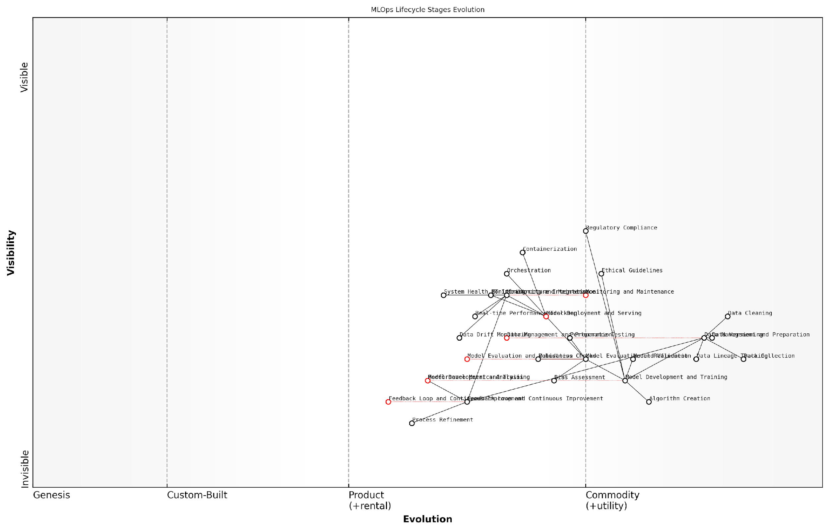

*Draft Wardley Map: [Insert Wardley Map: The MLOps lifecycle]*

[Edit this draft Wardley Map](https://create.wardleymaps.ai/#clone:b31fc85758a5c77b76)

Wardley Map Assessment

The MLOps lifecycle for public sector AI is at a crucial stage of evolution, with opportunities for significant improvements in efficiency and ethical AI implementation. By focusing on standardising early-stage processes, integrating ethical considerations throughout the lifecycle, and developing robust feedback loops, public sector organisations can create a powerful, responsible AI capability. The key to success lies in balancing technical innovation with strict adherence to ethical guidelines and regulatory requirements, all while maintaining a focus on meeting specific public sector AI needs.

[View full Wardley Map report](http://markdown/wardley_map_reports/wardley_map_report_19_The_MLOps_lifecycle.md)

Implementing the MLOps lifecycle effectively requires a cultural shift within organisations. It demands breaking down silos between data scientists, IT operations, and business stakeholders. In the public sector, this often extends to include policy makers and legal experts to ensure AI systems align with governmental objectives and regulatory frameworks.

The true power of MLOps lies not in any single tool or practice, but in its ability to create a cohesive, responsive ecosystem for AI development and deployment. It’s about fostering a culture of collaboration, transparency, and continuous improvement.

As we navigate the complexities of AI implementation in government and public sector contexts, the MLOps lifecycle serves as a crucial roadmap. It provides a structured approach to managing the inherent uncertainties and rapid pace of AI innovation while maintaining the rigour and accountability expected in public service. By embracing this lifecycle, organisations can not only streamline their AI initiatives but also build trust with stakeholders and citizens, paving the way for responsible and impactful AI-driven transformation in the public sector.

## Key MLOps Practices for AI Success

### Version control for data and models

Version control for data and models is a cornerstone of effective MLOps practices, playing a crucial role in ensuring reproducibility, traceability, and collaboration in AI projects. As AI systems become increasingly complex and data-driven, the need for robust version control mechanisms has never been more critical. This practice extends beyond traditional software version control, encompassing the unique challenges posed by large datasets and evolving machine learning models.

At its core, version control for data and models addresses several key challenges in AI development:

* Data lineage and provenance tracking
* Model versioning and experiment tracking
* Reproducibility of AI experiments and results
* Collaboration among data scientists and ML engineers
* Compliance with regulatory requirements and auditing

Data version control is particularly crucial in AI projects, as even minor changes in training data can significantly impact model performance. By implementing robust data versioning practices, organisations can track changes to datasets over time, understand the impact of data modifications on model outcomes, and easily revert to previous versions if needed. This capability is essential for debugging, auditing, and ensuring the reproducibility of AI experiments.

Data is the lifeblood of AI. Without proper version control, we’re essentially flying blind in our model development efforts.

Model version control, on the other hand, focuses on tracking changes to the AI models themselves. This includes versioning of model architectures, hyperparameters, and trained weights. Effective model versioning enables data scientists to compare different iterations of a model, understand the impact of changes, and easily roll back to previous versions if performance degrades.

Implementing version control for data and models requires a combination of tools, processes, and best practices:

* Data versioning tools: Specialised solutions like DVC (Data Version Control) or Pachyderm can be used to version large datasets efficiently.
* Model registries: Platforms such as MLflow or Weights & Biases provide capabilities for versioning and tracking ML models throughout their lifecycle.
* Metadata management: Capturing and versioning metadata about datasets and models is crucial for understanding the context of each version.
* Git-like workflows: Adapting Git-like branching and merging strategies for data and model versioning can enhance collaboration and experimentation.
* Automated versioning: Integrating versioning into CI/CD pipelines ensures that every change is automatically tracked and versioned.

One of the key benefits of robust version control for data and models is the ability to conduct A/B testing and compare different versions of models or datasets. This capability is invaluable for iterative improvement and optimisation of AI systems. By maintaining a clear history of changes and their impacts, data scientists can make informed decisions about which directions to pursue in model development.

Version control is not just about tracking changes; it’s about creating a shared understanding of the evolution of our AI systems across the entire team.

In the context of government and public sector AI projects, version control for data and models takes on additional significance due to the need for transparency, accountability, and compliance with regulatory requirements. The ability to trace the lineage of data and models used in decision-making processes is crucial for building public trust and ensuring the ethical use of AI in governance.

However, implementing effective version control for data and models is not without its challenges. Some common obstacles include:

* Handling large-scale datasets efficiently
* Managing the complexity of versioning both data and models in tandem
* Ensuring consistency across distributed teams and environments
* Balancing the need for detailed versioning with storage and performance constraints
* Integrating version control practices into existing workflows and tools

To address these challenges, organisations must adopt a holistic approach to version control that considers the entire AI development lifecycle. This includes establishing clear policies and guidelines for versioning, providing training to team members, and selecting tools that integrate seamlessly with existing MLOps workflows.

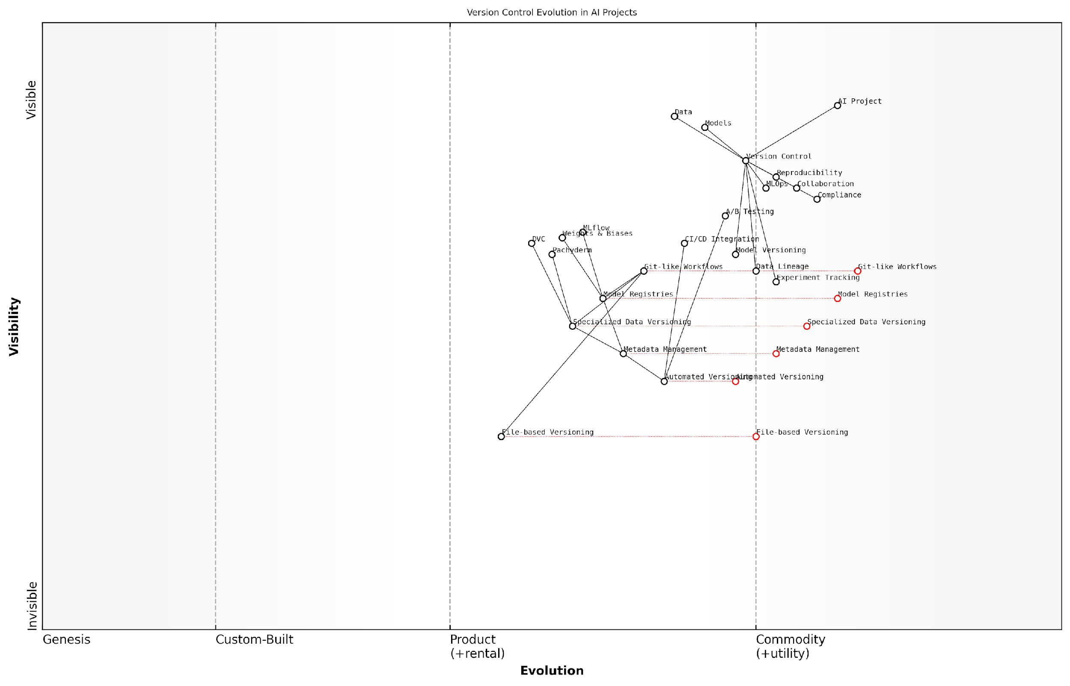

*Draft Wardley Map: [Insert Wardley Map: Version control for data and models]*

[Edit this draft Wardley Map](https://create.wardleymaps.ai/#clone:a00405a9f1e31e9944)

Wardley Map Assessment

This Wardley Map reveals a strategic imperative to evolve version control practices specifically for AI projects. Organisations should focus on adopting specialised tools for data and model versioning, while also preparing for a future of more automated and integrated version control within the broader MLOps ecosystem. The transition from traditional version control to AI-specific practices represents both a challenge and an opportunity for competitive advantage in AI development.

[View full Wardley Map report](http://markdown/wardley_map_reports/wardley_map_report_20_Version_control_for_data_and_models.md)

As AI systems continue to grow in complexity and scale, the importance of robust version control for data and models will only increase. Organisations that invest in developing strong version control practices will be better positioned to deliver reliable, reproducible, and trustworthy AI solutions. By treating data and models with the same rigour as traditional software artefacts, we can build a solid foundation for the next generation of AI innovations.

In the world of AI, version control is not just a best practice—it’s a fundamental requirement for responsible and effective development.

### Automated model training and evaluation

Automated model training and evaluation stand at the core of efficient MLOps practices, revolutionising the way AI models are developed, refined, and deployed. This critical component of the MLOps lifecycle addresses the challenges of scale, reproducibility, and continuous improvement that are inherent in AI projects, particularly within government and public sector contexts where resources are often constrained and the stakes for accuracy and reliability are exceptionally high.

At its essence, automated model training and evaluation involves the creation of systematic, repeatable processes that can train machine learning models on new data, assess their performance, and make necessary adjustments with minimal human intervention. This approach not only accelerates the development cycle but also ensures consistency and reduces the risk of human error, which is crucial when dealing with sensitive government data or high-impact public services.

* Continuous Training: Implementing mechanisms for regular model retraining as new data becomes available
* Automated Hyperparameter Tuning: Utilising techniques like grid search, random search, or Bayesian optimisation to find optimal model configurations
* Versioning and Reproducibility: Ensuring that each iteration of model training is tracked and can be reproduced for audit purposes
* Performance Monitoring: Implementing real-time monitoring of model performance metrics to trigger retraining when necessary
* A/B Testing Framework: Facilitating the comparison of different model versions in production environments

One of the key advantages of automated model training and evaluation in the public sector is the ability to rapidly adapt to changing conditions. For instance, in the context of public health modelling during a pandemic, automated systems can quickly incorporate new data and retrain models to provide up-to-date predictions, enabling more timely and effective policy responses.

Automated model training and evaluation are not just about efficiency; they’re about building trust in AI systems through consistent, transparent, and auditable processes. In the public sector, where accountability is paramount, this approach is indispensable.

However, implementing automated model training and evaluation is not without its challenges. Government agencies must navigate issues of data privacy, security clearances, and the need for human oversight in critical decision-making processes. To address these concerns, robust governance frameworks must be established to ensure that automated systems operate within defined ethical and legal boundaries.

A crucial aspect of automated model training and evaluation is the selection of appropriate evaluation metrics. These metrics must align with the specific objectives of the AI project and the broader goals of the government agency. For example, a model designed to detect fraud in public benefit systems might prioritise recall over precision to ensure that no fraudulent activity goes undetected, even at the cost of some false positives that can be reviewed manually.

* Accuracy: The overall correctness of the model’s predictions
* Precision and Recall: Balancing the trade-off between false positives and false negatives
* F1 Score: A harmonic mean of precision and recall, useful for imbalanced datasets
* AUC-ROC: Area Under the Receiver Operating Characteristic curve, for assessing classification model performance
* Mean Squared Error (MSE) or Root Mean Squared Error (RMSE): For regression tasks
* Fairness Metrics: Ensuring the model performs equitably across different demographic groups

Integrating automated model training and evaluation into existing government IT infrastructure requires careful planning and often a phased approach. Legacy systems may need to be updated or replaced to support the computational requirements of modern machine learning workflows. Cloud computing resources can offer a scalable solution, but must be implemented with stringent security measures to comply with government data protection regulations.

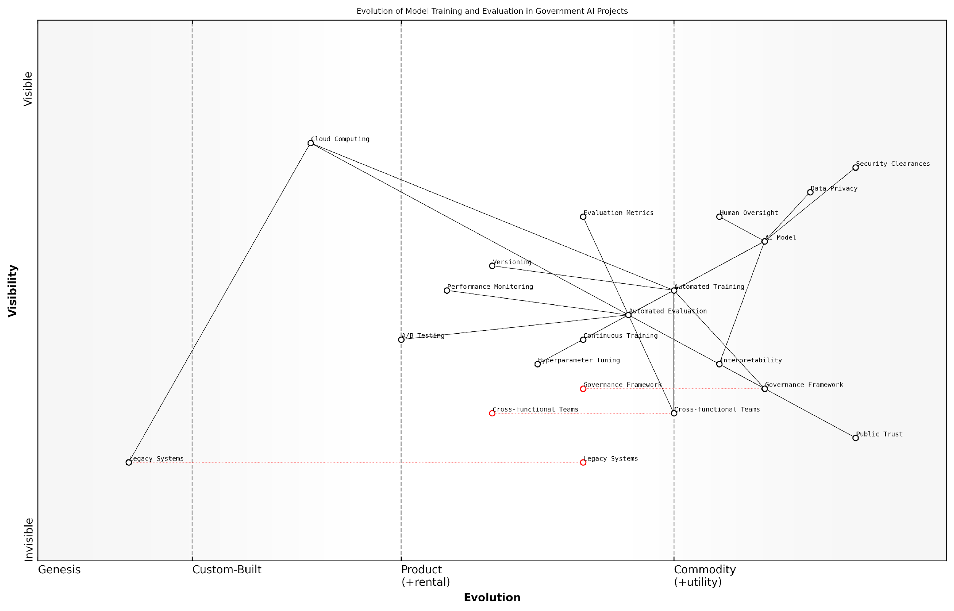

*Draft Wardley Map: [Insert Wardley Map: Automated model training and evaluation]*

[Edit this draft Wardley Map](https://create.wardleymaps.ai/#clone:7a48d31a90de0dbdc2)

Wardley Map Assessment

The map reveals a government AI ecosystem in transition, balancing technological advancement with stringent regulatory and public trust requirements. The strategic focus should be on developing robust governance frameworks, enhancing interpretability, and fostering public trust while gradually modernising legacy systems. Success will depend on effectively managing the tension between innovation and compliance, with a strong emphasis on transparency, security, and ethical AI development.

[View full Wardley Map report](http://markdown/wardley_map_reports/wardley_map_report_21_Automated_model_training_and_evaluation.md)

To fully leverage the benefits of automated model training and evaluation, government agencies should invest in building cross-functional teams that combine domain expertise with technical skills in data science and machine learning. These teams can develop custom evaluation frameworks that cater to the unique requirements of public sector AI applications, ensuring that automated processes align with policy objectives and regulatory requirements.

The true power of automated model training and evaluation lies in its ability to democratise AI within government organisations. By reducing the technical barriers to model development and maintenance, we can empower a wider range of public servants to harness AI for the benefit of citizens.

As government agencies continue to adopt and refine automated model training and evaluation practices, it’s essential to maintain a focus on interpretability and explainability. Automated systems should not become black boxes; rather, they should enhance transparency by providing clear documentation of training data, model architectures, and decision-making processes. This transparency is crucial for maintaining public trust and ensuring that AI systems can be scrutinised and held accountable.

In conclusion, automated model training and evaluation represent a cornerstone of effective MLOps in the public sector. By embracing these practices, government agencies can accelerate their AI initiatives, improve model performance, and ensure the responsible deployment of AI systems that serve the public interest. As the field continues to evolve, staying abreast of emerging techniques and best practices in automated ML workflows will be crucial for maintaining the UK’s position at the forefront of AI innovation in governance and public service delivery.

### Continuous integration and deployment (CI/CD) for AI

Content for Continuous integration and deployment (CI/CD) for AI not found.

### Model monitoring and maintenance

Model monitoring and maintenance are critical components of MLOps that ensure AI models remain accurate, reliable, and performant throughout their lifecycle. As an expert in the field, I can attest that these practices are essential for the long-term success of AI initiatives, particularly in government and public sector contexts where accountability and consistent performance are paramount.

Effective model monitoring involves continuous observation of model performance, data drift, and operational metrics. This proactive approach allows organisations to identify and address issues before they impact decision-making processes or service delivery. Maintenance, on the other hand, encompasses the activities required to keep models up-to-date, optimised, and aligned with evolving business needs and data landscapes.

* Performance Monitoring: Tracking key performance indicators (KPIs) and model accuracy metrics
* Data Drift Detection: Identifying changes in input data distributions that may affect model performance
* Concept Drift Detection: Recognising shifts in the underlying relationships between input features and target variables
* Model Versioning: Maintaining a clear history of model iterations and their respective performance
* Automated Retraining: Implementing systems for periodic or trigger-based model retraining
* A/B Testing: Comparing the performance of updated models against baseline versions in production environments
* Explainability and Interpretability: Ensuring models remain transparent and their decisions can be explained to stakeholders

In the context of government AI applications, model monitoring and maintenance take on additional significance due to the potential impact on citizens and policy decisions. For instance, a predictive model used in public health surveillance must be continuously monitored to ensure it remains accurate in the face of evolving health trends and population demographics. Similarly, AI systems used in public safety or resource allocation must be rigorously maintained to prevent biases and ensure fair outcomes across diverse communities.

Effective model monitoring and maintenance are not just technical necessities; they are ethical imperatives in the public sector. They ensure that AI systems continue to serve the public interest as intended, maintaining trust and accountability in government operations.

Implementing robust model monitoring and maintenance practices requires a combination of technological solutions and organisational processes. Advanced MLOps platforms offer automated monitoring capabilities, including real-time performance dashboards, drift detection algorithms, and alerting systems. These tools can be integrated with existing government IT infrastructure to provide seamless oversight of AI models in production.

However, technology alone is not sufficient. Successful model monitoring and maintenance also require cross-functional collaboration between data scientists, IT operations teams, and domain experts. This collaborative approach ensures that technical metrics are interpreted in the context of real-world impact and that maintenance activities align with broader organisational goals and regulatory requirements.

* Establish clear performance thresholds and monitoring criteria
* Develop comprehensive logging and auditing processes
* Implement automated alerts for performance degradation or data drift
* Create standardised procedures for model updates and redeployments
* Conduct regular reviews of model performance and relevance
* Maintain detailed documentation of model changes and their rationale
* Ensure compliance with data protection and AI governance frameworks

One of the challenges in government AI projects is balancing the need for model stability with the imperative to adapt to changing conditions. This requires a nuanced approach to model updates, where changes are carefully validated and their potential impacts thoroughly assessed before deployment. Techniques such as shadow deployments and canary releases can be particularly valuable in this context, allowing new model versions to be tested in production environments without risking disruption to critical services.

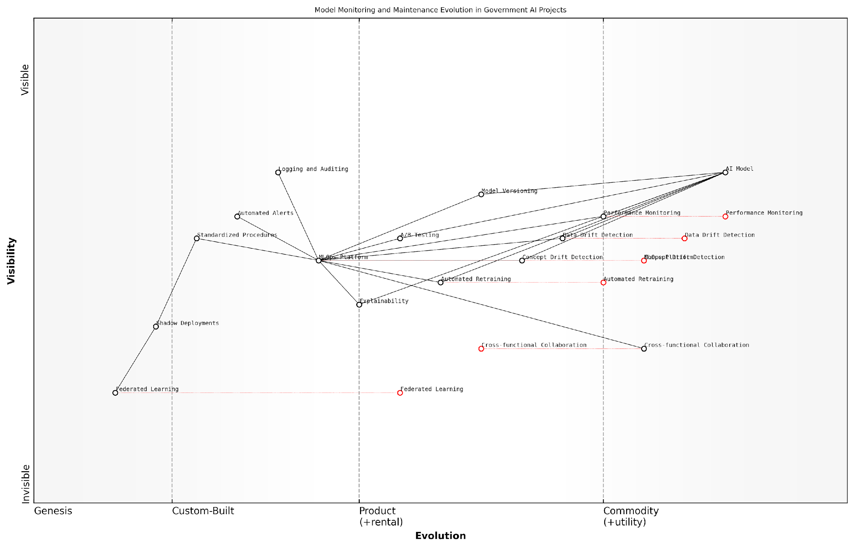

*Draft Wardley Map: [Insert Wardley Map: Model monitoring and maintenance]*

[Edit this draft Wardley Map](https://create.wardleymaps.ai/#clone:bff15f433214547c90)

Wardley Map Assessment

The map reveals a government AI ecosystem that is maturing in its approach to model monitoring and maintenance. While foundational practices are well-established, there’s a clear trajectory towards more advanced, privacy-preserving, and explainable AI techniques. The strategic focus should be on evolving the MLOps Platform, enhancing cross-functional collaboration, and investing in emerging technologies like Federated Learning. This approach will not only improve the robustness and reliability of AI models but also address the unique challenges of government AI projects, such as privacy concerns and the need for transparency. By prioritising these areas, government agencies can position themselves at the forefront of responsible and effective AI implementation.

[View full Wardley Map report](http://markdown/wardley_map_reports/wardley_map_report_23_Model_monitoring_and_maintenance.md)

As AI systems become more deeply integrated into government operations, the importance of effective model monitoring and maintenance will only grow. Future trends in this area include the development of more sophisticated automated monitoring tools, increased use of federated learning techniques to maintain model performance across distributed systems, and the integration of explainable AI methods to enhance transparency and trust in model decisions.

The future of AI in government hinges on our ability to not just deploy models, but to nurture and evolve them responsibly over time. Model monitoring and maintenance are the guardians of AI’s promise in the public sector.

In conclusion, model monitoring and maintenance are not merely technical considerations but fundamental pillars of responsible AI deployment in government. By embracing these practices as core components of their MLOps strategy, public sector organisations can ensure that their AI initiatives deliver sustained value, maintain public trust, and adapt effectively to the ever-changing landscape of public service delivery.

## MLOps Tools and Frameworks

### Popular MLOps platforms

As the field of Machine Learning Operations (MLOps) continues to evolve, a plethora of platforms have emerged to address the complex challenges of operationalising AI and machine learning models. These platforms play a crucial role in streamlining the end-to-end machine learning lifecycle, from data preparation and model development to deployment and monitoring. In this section, we’ll explore some of the most popular MLOps platforms that are shaping the landscape of AI implementation in both the public and private sectors.

MLOps platforms can be broadly categorised into three types: end-to-end solutions, specialised tools, and cloud-native services. Each category offers unique advantages and caters to different organisational needs and technical requirements.

* End-to-end MLOps Platforms: These comprehensive solutions cover the entire ML lifecycle and often integrate with existing data science and DevOps tools.
* Specialised MLOps Tools: These focus on specific aspects of the MLOps pipeline, such as model versioning, experiment tracking, or model serving.
* Cloud-native MLOps Services: Offered by major cloud providers, these services are designed to work seamlessly within their respective cloud ecosystems.

Let’s delve into some of the most prominent MLOps platforms in each category, examining their key features, strengths, and considerations for implementation in government and public sector contexts.

End-to-end MLOps Platforms:

* MLflow: An open-source platform that provides a centralised place to track experiments, package code into reproducible runs, and share and deploy models. Its open nature makes it particularly attractive for government agencies concerned about vendor lock-in.
* Kubeflow: Built on Kubernetes, Kubeflow offers a comprehensive suite of tools for deploying and managing machine learning workflows. Its scalability and flexibility make it well-suited for large-scale government AI initiatives.
* DataRobot: A commercial platform that automates many aspects of the machine learning process, from data preparation to model deployment. Its emphasis on explainable AI aligns well with the transparency requirements often mandated in public sector AI applications.

Specialised MLOps Tools:

* DVC (Data Version Control): An open-source version control system for machine learning projects, focusing on data and model versioning. It’s particularly useful for ensuring reproducibility in government research projects.
* Weights & Biases: A tool for experiment tracking, dataset versioning, and model management. Its collaborative features can enhance teamwork in distributed government AI teams.
* Seldon Core: An open-source platform for deploying machine learning models on Kubernetes, offering advanced model serving capabilities. It’s well-suited for agencies looking to deploy models at scale with robust monitoring and explainability features.

Cloud-native MLOps Services:

* Amazon SageMaker: A fully managed machine learning platform that covers the entire ML workflow. Its comprehensive security features make it a strong contender for government agencies with stringent data protection requirements.
* Google Cloud AI Platform: Offers end-to-end ML capabilities integrated with Google Cloud services. Its advanced AI and ML capabilities can be particularly beneficial for complex government AI projects.
* Azure Machine Learning: Microsoft’s MLOps solution, which integrates well with other Azure services and offers strong support for open-source tools. Its compliance certifications make it a viable option for government agencies subject to specific regulatory requirements.

When selecting an MLOps platform for government and public sector use, several factors must be carefully considered:

* Data Security and Compliance: Ensure the platform meets the stringent security and compliance requirements typical in government settings.
* Interoperability: Look for platforms that can integrate with existing government IT infrastructure and support a variety of data formats and ML frameworks.
* Scalability: Consider the platform’s ability to handle large-scale deployments and manage multiple models across different departments or agencies.
* Transparency and Explainability: Prioritise platforms that offer robust model interpretability features to support accountable AI practices in the public sector.
* Cost-effectiveness: Evaluate the total cost of ownership, including licensing, infrastructure, and maintenance costs, to ensure alignment with public sector budgetary constraints.
* Vendor Lock-in: Consider the long-term implications of platform choice, favouring solutions that offer flexibility and portability to avoid over-reliance on a single vendor.

The choice of MLOps platform can significantly impact the success of AI initiatives in the public sector. It’s crucial to select a solution that not only meets current technical requirements but also aligns with the broader strategic goals and ethical considerations of government AI programmes.

As the MLOps landscape continues to evolve, government agencies must stay informed about emerging platforms and best practices. Regularly reassessing and updating MLOps strategies will be crucial to ensuring that public sector AI initiatives remain effective, efficient, and aligned with the principles of responsible AI development and deployment.

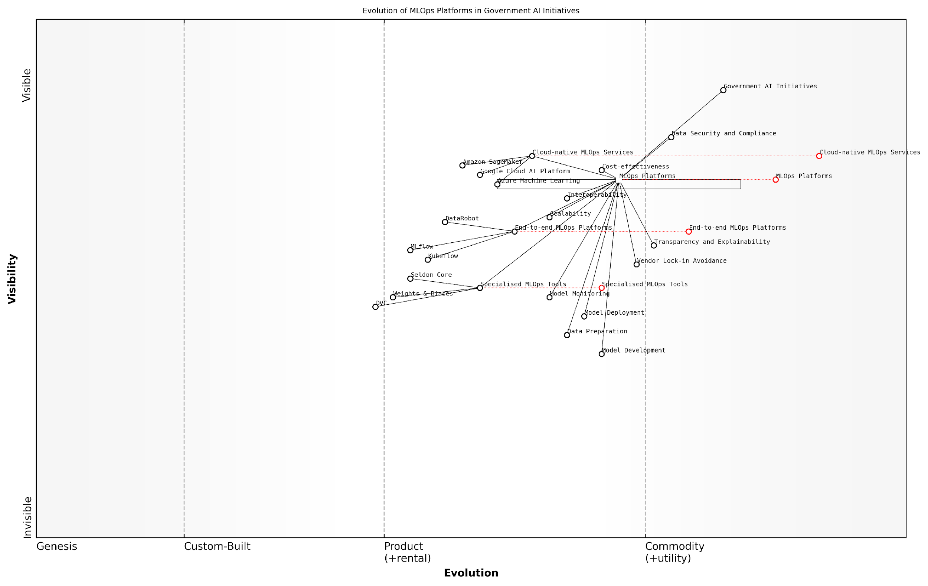

*Draft Wardley Map: [Insert Wardley Map: Popular MLOps platforms]*

[Edit this draft Wardley Map](https://create.wardleymaps.ai/#clone:5236650408c16015a5)

Wardley Map Assessment

The map reveals a maturing MLOps landscape for government AI initiatives, with a clear focus on security, compliance, and avoiding vendor lock-in. To succeed, government agencies should prioritise building a flexible, secure, and transparent MLOps ecosystem that leverages both cloud services and specialised tools while investing in developing internal capabilities and promoting interoperability standards.

[View full Wardley Map report](http://markdown/wardley_map_reports/wardley_map_report_24_Popular_MLOps_platforms.md)

### Open-source vs. proprietary MLOps solutions

In the rapidly evolving landscape of MLOps, organisations face a critical decision when selecting tools and frameworks to support their AI initiatives: whether to adopt open-source or proprietary MLOps solutions. This choice can significantly impact the flexibility, scalability, and cost-effectiveness of AI projects, particularly within government and public sector contexts where considerations of security, compliance, and long-term sustainability are paramount.

Open-source MLOps solutions offer several compelling advantages. They provide transparency, allowing organisations to inspect and modify the code to suit their specific needs. This level of customisation is particularly valuable in government settings where unique regulatory requirements or integration with legacy systems may necessitate tailored solutions. Moreover, open-source tools often benefit from a vibrant community of contributors, leading to rapid innovation and frequent updates.

Open-source MLOps tools empower our team to adapt quickly to changing requirements and maintain full control over our AI pipeline. The ability to scrutinise the code aligns perfectly with our commitment to transparency and security in public sector AI initiatives.

However, open-source solutions are not without their challenges. They may require significant in-house expertise to implement and maintain effectively. Government agencies must carefully consider whether they have the necessary resources and skills to leverage open-source tools to their full potential. Additionally, while many open-source projects have robust security practices, the onus is on the adopting organisation to ensure that security standards are met and maintained.

On the other hand, proprietary MLOps solutions offer a different set of advantages. These tools often come with comprehensive support, regular updates, and a more polished user interface, which can be particularly appealing for organisations looking for a turnkey solution. Proprietary platforms may also offer advanced features and integrations that are not readily available in open-source alternatives.

For our department, the decision to invest in a proprietary MLOps platform was driven by the need for enterprise-grade support and the assurance of ongoing development. The seamless integration with our existing IT infrastructure has significantly accelerated our AI deployment timelines.

However, proprietary solutions come with their own set of considerations. They often involve significant upfront costs and ongoing licensing fees, which can be a substantial burden on public sector budgets. There’s also the risk of vendor lock-in, where an organisation becomes overly dependent on a single provider’s ecosystem, potentially limiting future flexibility and interoperability.

* Key factors to consider when choosing between open-source and proprietary MLOps solutions:
* Total cost of ownership (including implementation, maintenance, and training)
* Alignment with existing IT infrastructure and skills
* Scalability and performance requirements
* Security and compliance needs
* Long-term strategic fit and vendor independence
* Community support and ecosystem robustness
* Customisation and integration capabilities

In practice, many organisations, especially in the government sector, opt for a hybrid approach. This strategy involves leveraging open-source tools for certain components of the MLOps pipeline while utilising proprietary solutions for others. This approach allows organisations to balance the benefits of both worlds, taking advantage of the flexibility and cost-effectiveness of open-source where appropriate, while benefiting from the support and advanced features of proprietary tools where needed.

For instance, an agency might use open-source tools like Git for version control and Kubernetes for containerisation, while opting for a proprietary platform for model monitoring and governance. This hybrid model can provide a best-of-both-worlds solution, allowing for greater adaptability to changing requirements and technologies.

Our hybrid MLOps strategy has proven to be a game-changer. We’ve achieved the perfect balance between cost-efficiency and enterprise-grade reliability, allowing us to innovate rapidly while maintaining the highest standards of security and compliance required in government AI projects.

Ultimately, the choice between open-source and proprietary MLOps solutions—or a hybrid approach—should be guided by a thorough assessment of the organisation’s specific needs, resources, and long-term AI strategy. Government and public sector entities must carefully weigh the trade-offs, considering not only immediate requirements but also future scalability, interoperability, and the evolving landscape of AI technologies.

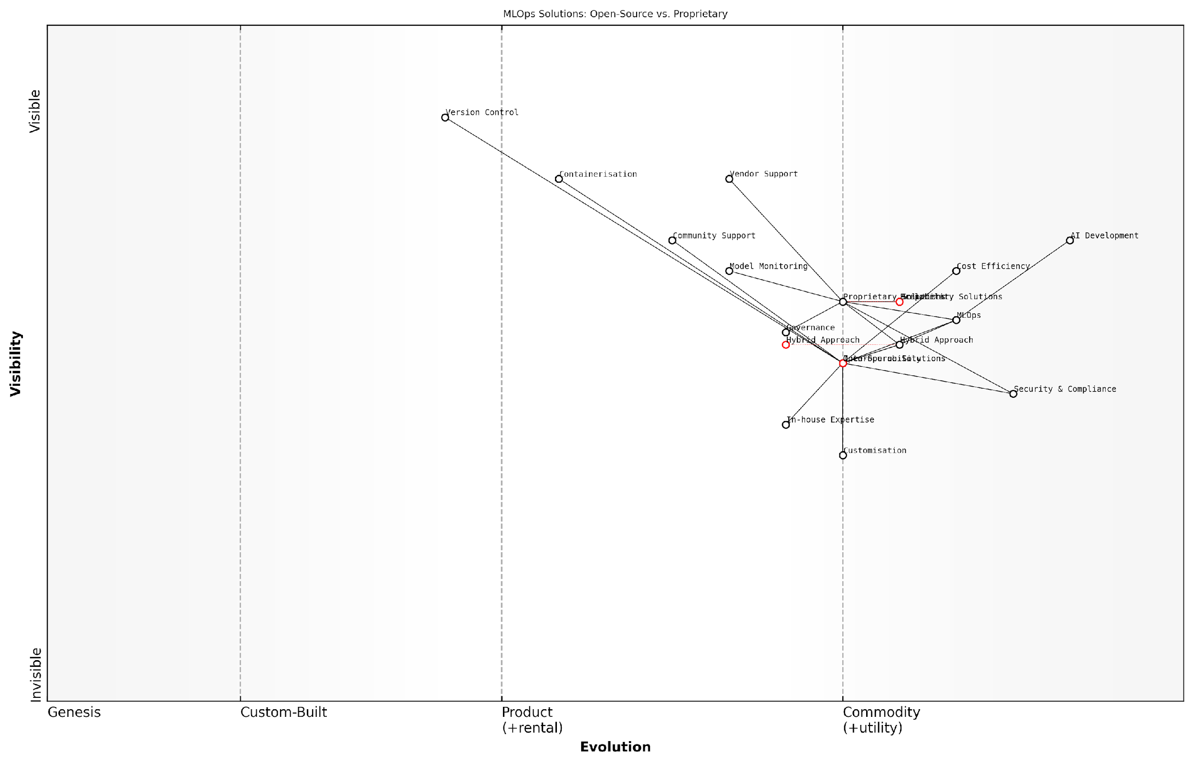

*Draft Wardley Map: [Insert Wardley Map: Open-source vs. proprietary MLOps solutions]*

[Edit this draft Wardley Map](https://create.wardleymaps.ai/#clone:e5bc3a560f955c1bed)

Wardley Map Assessment

The MLOps landscape presents a balanced ecosystem with significant opportunities for organisations to leverage both open-source and proprietary solutions. The key to success lies in adopting a flexible, hybrid approach that maximises the benefits of both worlds while investing in in-house expertise and interoperability. As the field evolves, organisations must stay agile, continuously reassessing their strategies to maintain competitive advantage in AI development and deployment.

[View full Wardley Map report](http://markdown/wardley_map_reports/wardley_map_report_25_Open-source_vs._proprietary_MLOps_solutions.md)

As the field of MLOps continues to mature, we can expect to see further convergence between open-source and proprietary solutions, with increased interoperability and standardisation. This evolution will likely make it easier for organisations to adopt a modular approach, selecting the best tools for each component of their MLOps pipeline regardless of their origin. For government agencies embarking on AI initiatives, staying informed about these developments and maintaining flexibility in their MLOps strategy will be crucial for long-term success.

### Integrating MLOps into existing AI workflows

Integrating MLOps into existing AI workflows is a critical step towards achieving operational excellence and ensuring the long-term success of AI initiatives. As an expert who has guided numerous organisations through this process, I can attest to the transformative power of seamless MLOps integration. This integration is not merely about adopting new tools; it’s about fundamentally reshaping how AI projects are conceived, developed, and maintained throughout their lifecycle.

The integration of MLOps into existing AI workflows requires a strategic approach that considers the unique challenges and opportunities presented by each organisation’s current processes, infrastructure, and culture. It’s essential to recognise that MLOps is not a one-size-fits-all solution, but rather a set of principles and practices that must be tailored to fit the specific needs and constraints of each AI project and team.

* Assess current workflows and identify pain points
* Define clear integration objectives and success metrics
* Select appropriate MLOps tools and platforms
* Implement incremental changes to minimise disruption
* Provide comprehensive training and support for team members
* Establish feedback loops for continuous improvement

One of the key challenges in integrating MLOps into existing workflows is overcoming resistance to change. Many data scientists and AI practitioners are accustomed to working in more ad-hoc environments, and the introduction of MLOps practices can initially be perceived as bureaucratic or restrictive. To address this, it’s crucial to demonstrate the tangible benefits of MLOps, such as increased reproducibility, faster deployment cycles, and improved model performance.

MLOps isn’t about constraining creativity; it’s about providing a framework that allows data scientists to focus on innovation while ensuring their work can be reliably scaled and maintained.

When integrating MLOps, it’s important to start with the foundational elements that can provide immediate value. Version control for both code and data is often a good starting point, as it addresses common pain points around reproducibility and collaboration. From there, organisations can gradually introduce more advanced MLOps practices, such as automated testing, continuous integration and deployment (CI/CD) pipelines, and model monitoring.

The choice of MLOps tools and platforms plays a crucial role in the success of the integration. While there are numerous options available, ranging from open-source frameworks to comprehensive commercial solutions, the key is to select tools that align with the organisation’s existing technology stack and can be easily adopted by the team. Compatibility with current data storage systems, development environments, and deployment platforms should be carefully considered.

* MLflow for experiment tracking and model management
* Kubeflow for orchestrating machine learning pipelines
* Seldon Core for model serving and deployment
* DVC (Data Version Control) for managing datasets and model versions
* Airflow for workflow orchestration
* Prometheus and Grafana for monitoring and observability

It’s worth noting that while these tools can greatly facilitate MLOps practices, they are not a substitute for the underlying principles and processes. Successful integration requires a holistic approach that addresses not just the technical aspects, but also the organisational and cultural dimensions of MLOps adoption.

One often overlooked aspect of MLOps integration is the need for cross-functional collaboration. MLOps bridges the gap between data science, software engineering, and operations teams. Establishing clear communication channels and shared responsibilities between these groups is essential for realising the full potential of MLOps practices.

The true power of MLOps lies in its ability to create a unified language and workflow that brings together diverse teams, enabling them to work towards common goals in AI development and deployment.

As organisations progress in their MLOps journey, they often find that the integration process uncovers opportunities for broader improvements in their AI workflows. For instance, the implementation of automated testing may reveal gaps in data quality processes, leading to enhanced data governance practices. Similarly, the adoption of model monitoring tools may highlight the need for more robust feature engineering pipelines.

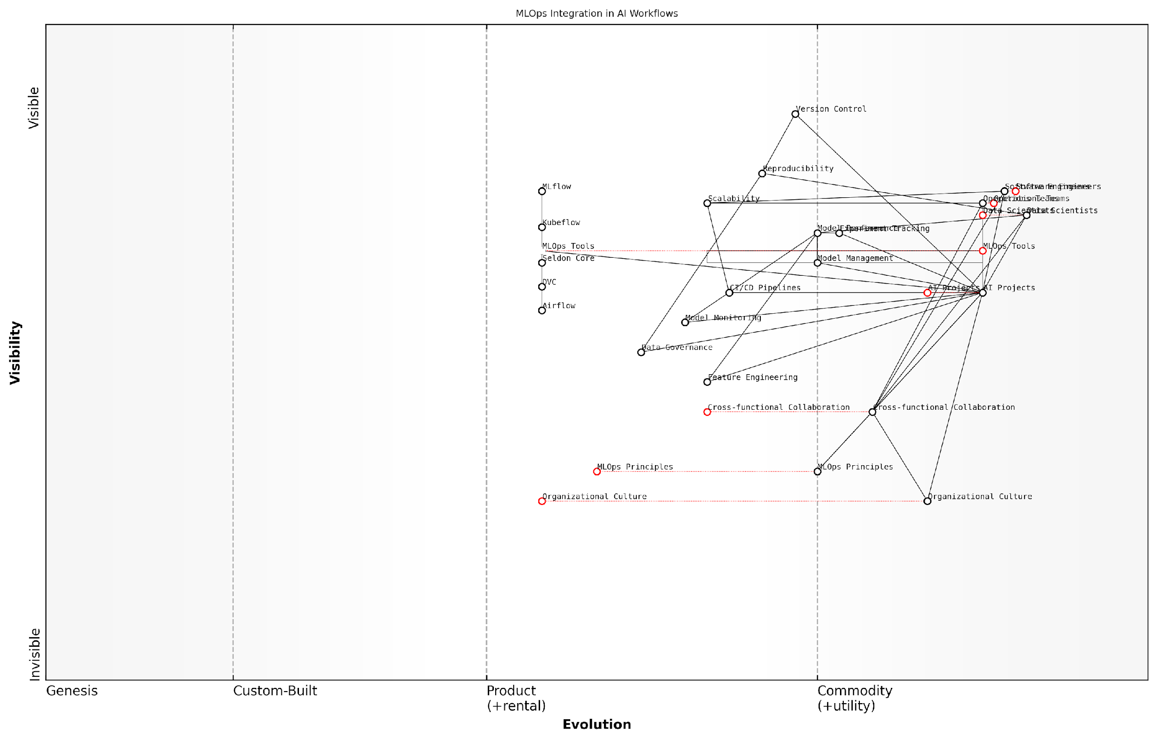

*Draft Wardley Map: [Insert Wardley Map: Integrating MLOps into existing AI workflows]*

[Edit this draft Wardley Map](https://create.wardleymaps.ai/#clone:85cc08c0bd8fadee29)

Wardley Map Assessment

The map reveals a strong foundation in technical MLOps tools and practices, but highlights the need for significant investment in organisational and cultural aspects to fully realise the benefits of MLOps integration. Key focus areas should include fostering cross-functional collaboration, developing a strong MLOps culture, and creating a flexible, integrated MLOps platform that can evolve with the organisation’s needs and industry trends. Success in these areas will position the organisation as a leader in AI project execution and innovation.

[View full Wardley Map report](http://markdown/wardley_map_reports/wardley_map_report_26_Integrating_MLOps_into_existing_AI_workflows.md)

It’s important to approach MLOps integration as an iterative process. Start with a pilot project or a subset of AI workflows to gain experience and demonstrate value. Use the lessons learned from these initial efforts to refine the integration strategy and gradually expand MLOps practices across the organisation. Regular retrospectives and continuous feedback from team members are invaluable in identifying areas for improvement and ensuring that the MLOps integration remains aligned with the organisation’s evolving needs.

In conclusion, integrating MLOps into existing AI workflows is a transformative journey that requires careful planning, strategic tool selection, and a commitment to cultural change. When done effectively, it can dramatically improve the efficiency, reliability, and scalability of AI initiatives, positioning organisations to fully leverage the power of artificial intelligence in their operations and decision-making processes.

# FinOps: Optimising AI Costs and ROI

## The Importance of FinOps in AI

### Understanding AI-related costs

As artificial intelligence (AI) continues to revolutionise industries and transform business processes, understanding and managing AI-related costs has become a critical factor in ensuring the success and sustainability of AI initiatives. The complexity and scale of AI projects often lead to significant and sometimes unexpected expenses, making it essential for organisations to adopt a structured approach to cost management. This is where FinOps, or Financial Operations, plays a crucial role in the AI ecosystem.

AI-related costs encompass a wide range of expenditures, from infrastructure and computing resources to data acquisition and storage, as well as the human capital required for development, deployment, and maintenance. These costs can be broadly categorised into several key areas:

* Infrastructure and Computing Costs: This includes expenses related to hardware, cloud services, and computational resources necessary for training and deploying AI models.
* Data Costs: Acquiring, storing, and managing high-quality data sets can be a significant expense in AI projects.
* Personnel Costs: Salaries and benefits for data scientists, machine learning engineers, and other specialists involved in AI development and operations.
* Software and Tool Costs: Licensing fees for AI platforms, development tools, and specialised software.
* Operational Costs: Ongoing expenses related to model monitoring, maintenance, and retraining.
* Compliance and Governance Costs: Expenses associated with ensuring AI systems meet regulatory requirements and ethical standards.

The dynamic nature of AI development and deployment can lead to significant cost fluctuations. For instance, the iterative process of model training and refinement can result in unexpected spikes in computing costs. Similarly, as AI models are scaled and deployed across an organisation, the associated infrastructure and operational costs can escalate rapidly.

In our experience, organisations often underestimate the total cost of ownership for AI projects by 30-40%, primarily due to unforeseen operational and scaling expenses.

This complexity and potential for cost overruns underscore the importance of implementing robust FinOps practices in AI initiatives. FinOps provides a framework for organisations to gain visibility into their AI-related expenditures, optimise resource allocation, and align costs with business value. By applying FinOps principles to AI projects, organisations can:

* Improve cost transparency and accountability across AI initiatives
* Optimise resource utilisation and reduce waste
* Align AI investments with business objectives and ROI expectations
* Enable more accurate budgeting and forecasting for AI projects
* Foster a culture of cost-consciousness in AI development teams

Moreover, FinOps practices can help organisations navigate the unique challenges posed by AI costs. For example, the elasticity of cloud resources used in AI workloads requires a dynamic approach to cost management. FinOps can provide the tools and methodologies to implement real-time cost monitoring and optimisation strategies, ensuring that resources are scaled efficiently based on actual usage and demand.

Another critical aspect of AI cost management addressed by FinOps is the balance between innovation and cost-effectiveness. AI projects often require significant upfront investments in research and development, with uncertain timelines for realising returns. FinOps practices can help organisations strike the right balance by providing frameworks for evaluating the potential value of AI initiatives against their costs, and by implementing stage-gate processes that tie continued funding to demonstrable progress and value creation.

Implementing FinOps in our AI projects has allowed us to reduce overall costs by 25% while simultaneously increasing the speed of innovation and deployment.

As AI becomes increasingly central to business operations and competitive advantage, the ability to effectively manage and optimise AI-related costs will be a key differentiator for organisations. Those that successfully integrate FinOps practices into their AI initiatives will be better positioned to scale their AI capabilities sustainably, maximise the return on their AI investments, and maintain a competitive edge in an AI-driven future.

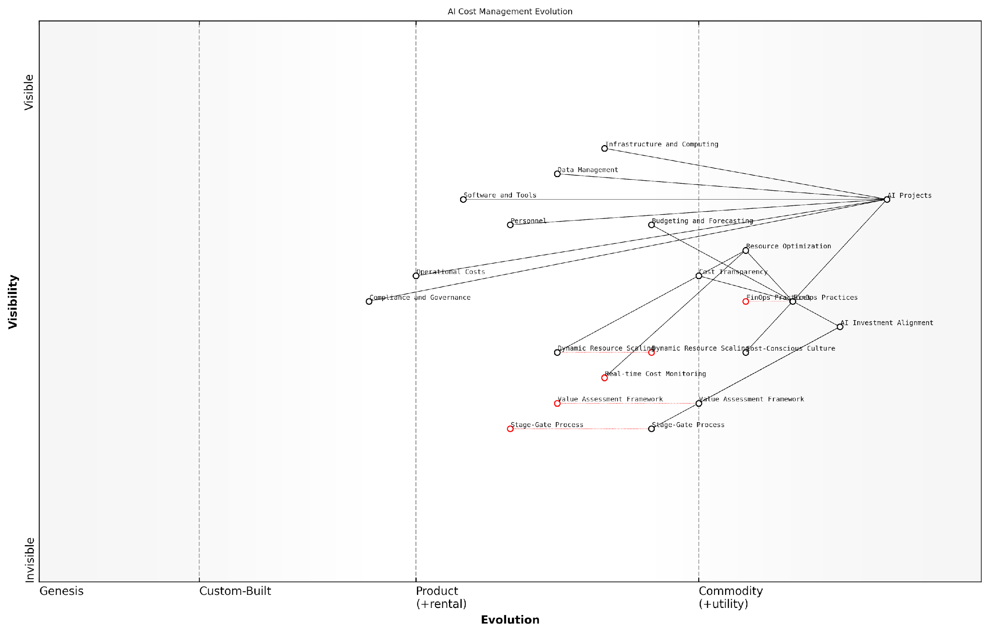

*Draft Wardley Map: [Insert Wardley Map: Understanding AI-related costs]*

[Edit this draft Wardley Map](https://create.wardleymaps.ai/#clone:276c4ace019a2306d5)

Wardley Map Assessment

This Wardley Map reveals a strategic focus on integrating FinOps practices into AI project management. The organisation is well-positioned in terms of AI project execution but needs to evolve its cost management capabilities. Key opportunities lie in developing real-time cost monitoring, implementing dynamic resource scaling, and creating a robust value assessment framework. By prioritising these areas, the organisation can significantly enhance its ability to deliver business value through AI initiatives while optimising costs and ensuring strong ROI. The evolution towards more advanced FinOps practices will be critical for maintaining competitiveness in the rapidly evolving AI landscape.

[View full Wardley Map report](http://markdown/wardley_map_reports/wardley_map_report_27_Understanding_AI-related_costs.md)

In conclusion, understanding AI-related costs is not merely an exercise in financial accounting; it is a strategic imperative that can significantly impact the success and sustainability of AI initiatives. By embracing FinOps principles and practices, organisations can navigate the complex landscape of AI costs, drive efficiency, and ultimately unlock the full potential of their AI investments.

### The role of FinOps in AI project success

In the rapidly evolving landscape of artificial intelligence, the role of Financial Operations (FinOps) has emerged as a critical factor in determining the success of AI projects. As organisations increasingly invest in AI initiatives, the need for effective cost management and optimisation has become paramount. FinOps, a collaborative practice of bringing financial accountability to the variable spend model of cloud computing, plays a pivotal role in ensuring that AI projects not only deliver technological innovation but also demonstrate tangible business value and return on investment.

The significance of FinOps in AI project success can be attributed to several key factors. Firstly, AI projects often involve substantial investments in computational resources, data storage, and specialised hardware. Without proper financial oversight, these costs can quickly spiral out of control, jeopardising the project’s viability. FinOps provides the necessary framework to monitor, analyse, and optimise these expenditures, ensuring that resources are allocated efficiently and cost-effectively.

FinOps is not just about cutting costs; it’s about maximising the value of every pound spent on AI initiatives. It’s the difference between an AI project that drains resources and one that drives innovation and competitive advantage.

Secondly, FinOps facilitates better decision-making throughout the AI project lifecycle. By providing real-time visibility into costs and resource utilisation, FinOps enables project managers and stakeholders to make informed choices about scaling, resource allocation, and technology selection. This data-driven approach helps in avoiding overprovisioning or underutilisation of resources, both of which can significantly impact the project’s financial performance.

* Cost transparency and accountability
* Optimised resource allocation
* Improved budgeting and forecasting
* Enhanced collaboration between finance, IT, and data science teams
* Alignment of AI initiatives with business objectives

Moreover, FinOps plays a crucial role in bridging the gap between technical teams and financial stakeholders. In many organisations, there’s often a disconnect between those developing AI solutions and those managing the financial aspects. FinOps creates a common language and shared set of metrics that foster collaboration and mutual understanding. This alignment is essential for securing ongoing support and funding for AI initiatives, as it demonstrates the tangible value and ROI of these projects to decision-makers.

Another critical aspect of FinOps in AI project success is its ability to support scalability. As AI projects move from proof-of-concept to production, the associated costs can increase exponentially. FinOps practices help in planning for this scaling, ensuring that the financial implications are well understood and managed. This foresight prevents situations where promising AI projects are abandoned due to unexpected cost overruns or lack of financial planning for growth.

In the world of AI, where innovation moves at breakneck speed, FinOps serves as the financial compass that keeps projects on course. It ensures that the pursuit of cutting-edge AI doesn’t come at the expense of fiscal responsibility.

Furthermore, FinOps contributes to the long-term sustainability of AI initiatives. By implementing continuous cost optimisation practices, organisations can ensure that their AI projects remain financially viable over time. This is particularly important in the public sector, where budgets are often constrained and there’s a need to demonstrate responsible use of public funds. FinOps helps in justifying AI investments by clearly linking expenditures to outcomes and value creation.

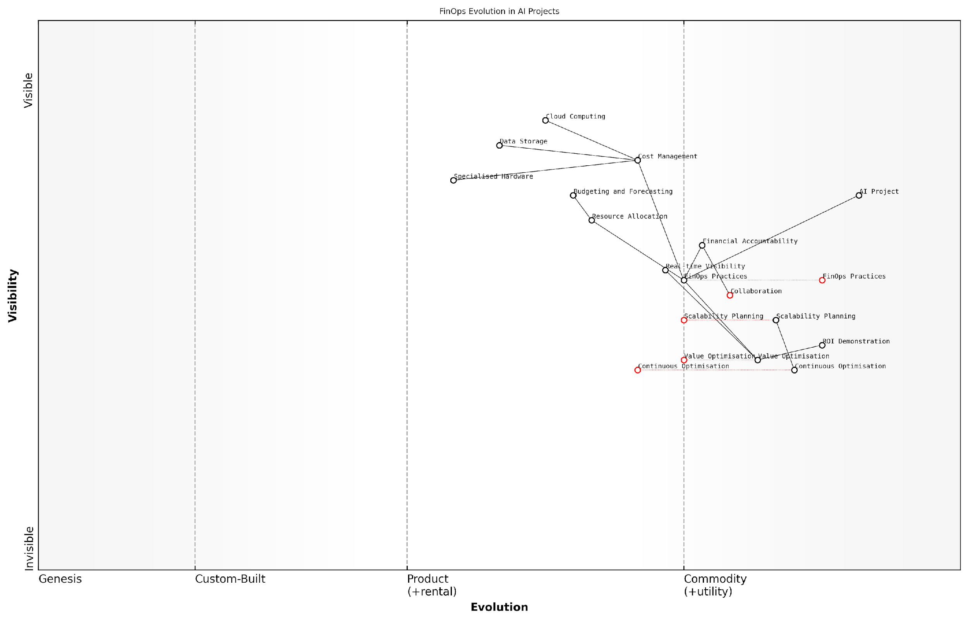

*Draft Wardley Map: [Insert Wardley Map: The role of FinOps in AI project success]*

[Edit this draft Wardley Map](https://create.wardleymaps.ai/#clone:d03d3739a57a6e161a)

Wardley Map Assessment

This Wardley Map reveals the critical role of FinOps in AI project success, highlighting the need for organisations to evolve their financial management practices alongside AI technologies. The strategic focus should be on developing advanced value optimization capabilities, integrating FinOps deeply into the AI project lifecycle, and fostering a culture of financial accountability and continuous improvement. By doing so, organisations can maximise the ROI of their AI investments and maintain a competitive edge in the rapidly evolving AI landscape.

[View full Wardley Map report](http://markdown/wardley_map_reports/wardley_map_report_28_The_role_of_FinOps_in_AI_project_success.md)

In conclusion, the role of FinOps in AI project success cannot be overstated. It provides the financial foundation upon which innovative AI solutions can be built and scaled. By ensuring cost efficiency, promoting transparency, facilitating informed decision-making, and aligning technical and financial objectives, FinOps enables organisations to harness the full potential of AI while maintaining financial prudence. As AI continues to transform industries and public services, the integration of FinOps practices will be instrumental in driving successful, sustainable, and value-driven AI initiatives.

### Balancing innovation and cost-effectiveness

In the rapidly evolving landscape of artificial intelligence, organisations face a critical challenge: how to drive innovation while maintaining fiscal responsibility. This delicate balance is where FinOps proves its immense value in AI initiatives. As an expert who has advised numerous government bodies and private sector entities on AI implementation, I can attest that the most successful projects are those that effectively marry cutting-edge innovation with prudent financial management.

The pursuit of AI innovation often requires substantial investments in computational resources, data storage, and specialised talent. Without proper financial oversight, these costs can quickly spiral out of control, potentially jeopardising the entire AI initiative. FinOps provides the framework and methodologies to ensure that every pound spent on AI development yields maximum value, allowing organisations to push the boundaries of what’s possible without breaking the bank.

FinOps is not about cutting costs at the expense of innovation; it’s about maximising the return on every investment in AI, enabling us to do more with our resources and accelerate our journey towards AI-driven transformation.

One of the key principles in balancing innovation and cost-effectiveness is the concept of ‘fail fast, learn quickly’. In AI development, not every experiment or model will yield the desired results. FinOps encourages a culture where teams can rapidly prototype and test ideas without fear of excessive financial repercussions. By implementing robust cost tracking and allocation mechanisms, organisations can set clear budgets for experimental projects, allowing for controlled risk-taking that drives innovation.

* Implement granular cost tracking for AI experiments
* Set clear budget thresholds for innovative projects
* Encourage rapid prototyping within defined financial parameters
* Regularly review and adjust resource allocation based on project outcomes

Another crucial aspect of balancing innovation and cost-effectiveness is the strategic use of cloud resources. The elasticity of cloud computing allows organisations to scale their AI workloads up or down as needed, potentially resulting in significant cost savings. However, without proper FinOps practices, cloud costs can quickly become unmanageable. By implementing automated scaling policies, leveraging spot instances for non-critical workloads, and continuously optimising resource utilisation, organisations can create an environment where innovation thrives without unnecessary expenditure.

It’s also important to consider the long-term implications of AI investments. While certain cutting-edge technologies may seem costly in the short term, they could lead to substantial efficiency gains or new revenue streams in the future. FinOps provides the tools and methodologies to perform comprehensive cost-benefit analyses, allowing decision-makers to make informed choices about where to allocate resources for maximum long-term impact.

In my experience advising on large-scale AI projects, the organisations that excel are those that view FinOps not as a constraint, but as an enabler of sustainable innovation. It’s about creating a virtuous cycle where cost savings fuel further innovation, driving continuous improvement and competitive advantage.

Collaboration between finance teams, data scientists, and IT operations is crucial in striking this balance. FinOps fosters a culture of shared responsibility for AI costs, encouraging cross-functional teams to work together in optimising resource usage and identifying opportunities for innovation within budgetary constraints. This collaborative approach ensures that financial considerations are baked into the AI development process from the outset, rather than being an afterthought.

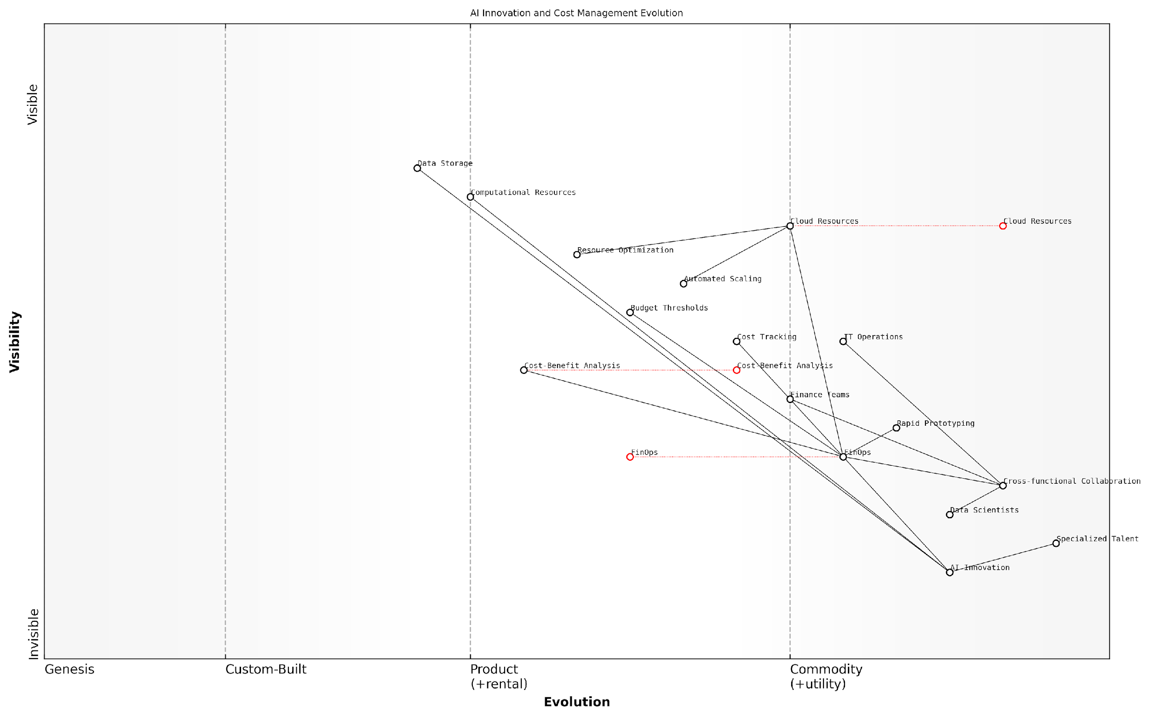

*Draft Wardley Map: [Insert Wardley Map: Balancing innovation and cost-effectiveness]*

[Edit this draft Wardley Map](https://create.wardleymaps.ai/#clone:7d3240b3753f997e80)

Wardley Map Assessment

The organisation is well-positioned to balance AI innovation with cost-effectiveness through its focus on FinOps and cross-functional collaboration. To maintain this advantage, it should prioritise the evolution of its FinOps practices, invest in AI-specific cost optimization techniques, and foster a culture of cost-aware innovation. The key to success lies in continuously aligning rapid AI advancements with sophisticated cost management strategies, ensuring sustainable and impactful AI implementations.

[View full Wardley Map report](http://markdown/wardley_map_reports/wardley_map_report_29_Balancing_innovation_and_cost-effectiveness.md)

In conclusion, balancing innovation and cost-effectiveness in AI initiatives is not about choosing one over the other, but about creating synergies between the two. FinOps provides the framework, tools, and cultural shift necessary to achieve this balance, enabling organisations to push the boundaries of AI capabilities while maintaining financial sustainability. As AI continues to evolve and transform industries, those who master this balance will be best positioned to lead in the AI-driven future.

## Implementing FinOps for AI Projects

### Cost visibility and allocation

In the realm of AI implementation, cost visibility and allocation are paramount to the success of FinOps practices. As AI projects often involve complex, resource-intensive operations across various departments and cloud environments, gaining a clear understanding of where costs are incurred and how they should be allocated is crucial for effective financial management and optimisation.

Cost visibility in AI projects refers to the ability to clearly see and understand all expenses associated with AI development, deployment, and maintenance. This includes not only obvious costs like cloud computing resources and software licences but also hidden expenses such as data storage, network usage, and human resources. Proper cost allocation, on the other hand, involves accurately attributing these costs to specific projects, teams, or business units, ensuring accountability and enabling informed decision-making.

* Implement granular tagging and labelling strategies for all AI-related resources
* Utilise cloud cost management tools to track and categorise expenses
* Develop custom dashboards for real-time cost monitoring and analysis
* Establish clear cost allocation policies and communicate them across the organisation
* Regularly review and adjust cost allocation methods to reflect changing project needs

One of the key challenges in achieving cost visibility for AI projects is the dynamic nature of resource consumption. AI workloads can be highly variable, with sudden spikes in compute or storage requirements during training phases or when processing large datasets. To address this, organisations must implement robust monitoring and reporting systems that can capture and analyse cost data in real-time.

Real-time cost visibility is not just about tracking expenses; it’s about empowering teams to make data-driven decisions that optimise AI performance while maintaining financial responsibility.

To achieve effective cost allocation, organisations should consider implementing a chargeback or showback model. Chargeback involves directly billing departments or projects for their AI resource usage, while showback provides visibility into costs without actual billing. Both approaches can significantly increase cost awareness and encourage more efficient resource utilisation.

* Implement chargeback or showback models to increase cost awareness
* Use AI-powered analytics to predict future costs and optimise resource allocation
* Integrate cost data with project management tools for holistic project oversight
* Conduct regular cost allocation reviews with stakeholders to ensure alignment
* Develop cost allocation KPIs and incorporate them into performance evaluations

Another critical aspect of cost visibility and allocation in AI projects is the ability to differentiate between development, testing, and production environments. Each stage of the AI lifecycle has different resource requirements and cost implications. By clearly separating and tracking costs for each environment, organisations can make more informed decisions about resource allocation and identify opportunities for optimisation.

It’s also important to consider the long-term implications of cost allocation decisions. As AI models evolve and projects scale, the cost structure may change significantly. FinOps practitioners must work closely with data scientists and ML engineers to anticipate these changes and develop flexible allocation models that can adapt to the project’s lifecycle.

Effective cost allocation in AI projects is not just about distributing expenses; it’s about creating a culture of cost awareness and shared responsibility across the entire organisation.

To further enhance cost visibility and allocation, organisations should leverage AI and machine learning techniques themselves. Predictive analytics can be employed to forecast future costs based on historical data and project plans. This proactive approach allows teams to anticipate budget overruns and take corrective actions before they occur.

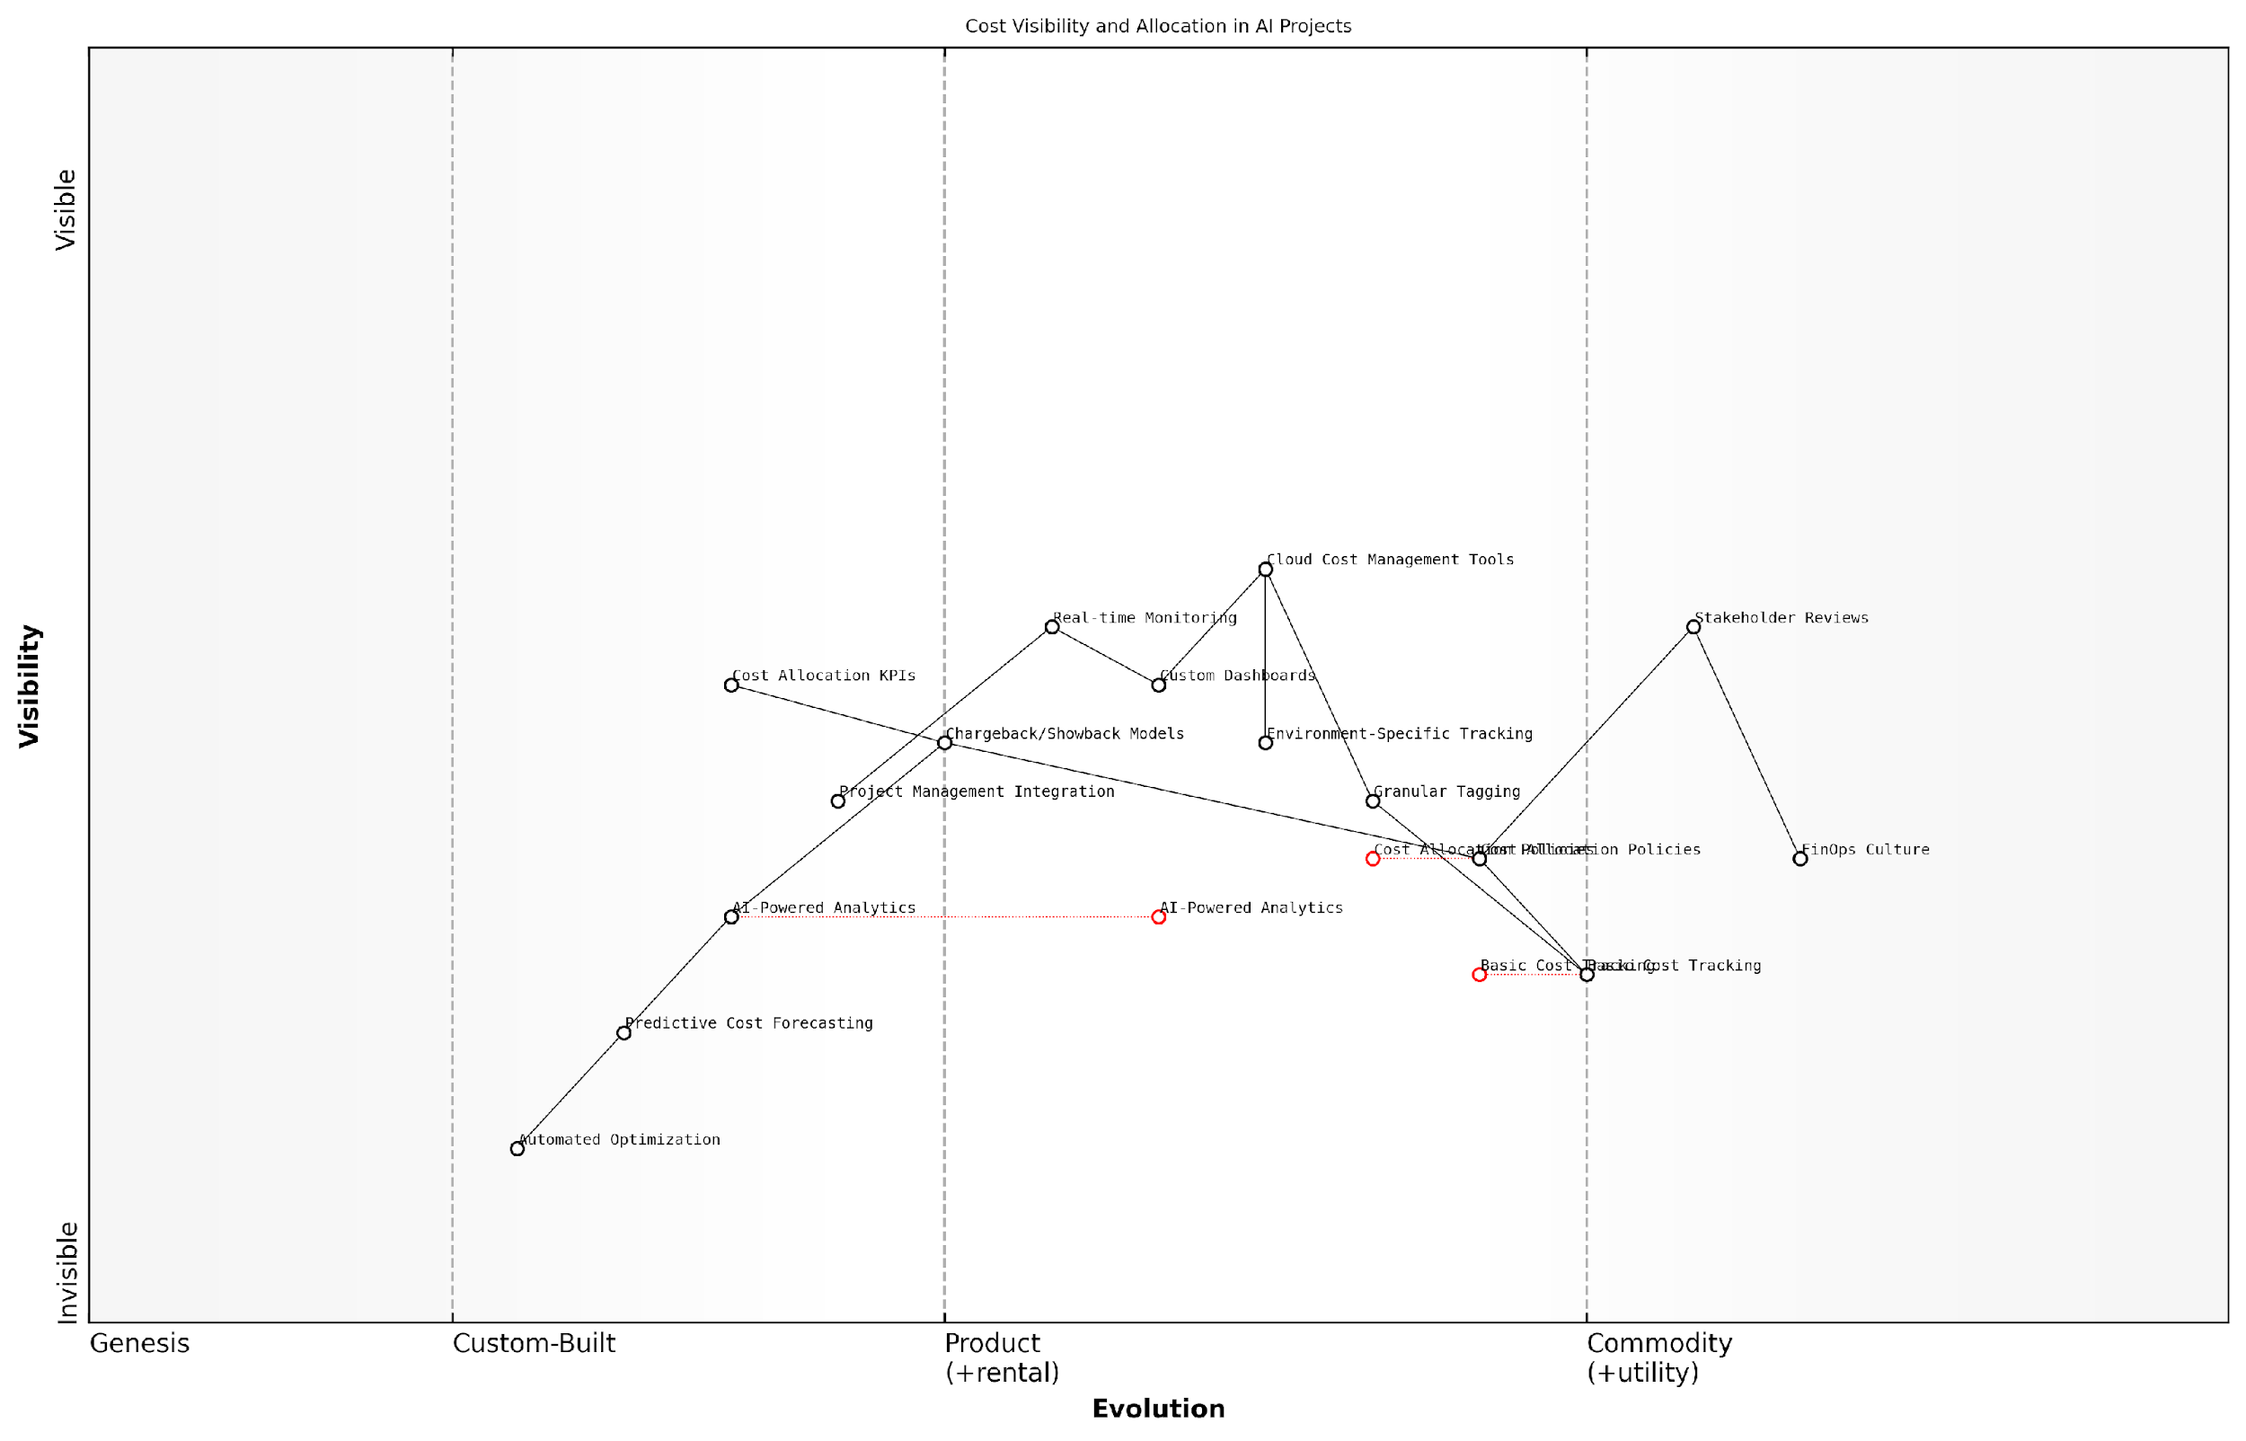

*Draft Wardley Map: [Insert Wardley Map: Cost visibility and allocation]*

[Edit this draft Wardley Map](https://create.wardleymaps.ai/#clone:be60e523c08d256035)

Wardley Map Assessment

The organisation is well-positioned to evolve its cost management capabilities for AI projects, with a clear path from basic tracking to advanced, AI-driven optimization. The key challenges lie in accelerating the adoption of emerging technologies and fostering a strong FinOps culture. By focusing on these areas, the organisation can gain a significant competitive advantage in managing and optimising AI project costs, ultimately driving greater ROI and innovation in AI initiatives.

[View full Wardley Map report](http://markdown/wardley_map_reports/wardley_map_report_30_Cost_visibility_and_allocation.md)

In conclusion, cost visibility and allocation are foundational elements of successful FinOps implementation for AI projects. By providing clear insights into resource usage and associated costs, organisations can make informed decisions, optimise their AI investments, and ensure that the value generated by AI initiatives justifies the financial outlay. As AI continues to evolve and become more integral to business operations, mastering these FinOps practices will be crucial for maintaining competitive advantage and driving innovation in a cost-effective manner.

### Optimising cloud resources for AI workloads

In the realm of AI implementation, optimising cloud resources for AI workloads is a critical aspect of FinOps that can significantly impact both the performance and cost-effectiveness of AI projects. As AI workloads often require substantial computational power and storage, efficient resource management becomes paramount to ensure optimal utilisation and prevent unnecessary expenditure.

Cloud platforms offer a myriad of options for AI workloads, from general-purpose virtual machines to specialised AI accelerators. The key to optimisation lies in understanding the specific requirements of your AI models and aligning them with the most suitable cloud resources. This process involves a delicate balance between performance, cost, and scalability.

Effective cloud resource optimisation for AI workloads is not just about cutting costs; it’s about maximising value and ensuring that every pound spent contributes directly to the success of your AI initiatives.

To achieve this optimisation, organisations must adopt a multi-faceted approach that encompasses several key strategies:

* Right-sizing resources: Matching instance types and sizes to workload requirements
* Leveraging spot instances and preemptible VMs for cost savings on non-critical workloads
* Implementing auto-scaling to dynamically adjust resources based on demand
* Utilising containerisation and orchestration for efficient resource allocation
* Optimising data storage and transfer to minimise costs
* Employing cloud-native AI services to reduce infrastructure management overhead

Right-sizing resources is a fundamental aspect of cloud optimisation for AI workloads. It involves carefully analysing the computational requirements of your AI models and selecting the most appropriate instance types and sizes. This process often requires experimentation and continuous monitoring to find the sweet spot between performance and cost.

Leveraging spot instances and preemptible VMs can offer significant cost savings for AI workloads that are fault-tolerant or can be easily interrupted and resumed. These instances are available at a fraction of the cost of on-demand instances but can be reclaimed by the cloud provider with short notice. By designing AI workflows to take advantage of these cost-effective options, organisations can substantially reduce their cloud expenditure.

Implementing auto-scaling is crucial for handling the variable nature of AI workloads. By automatically adjusting the number of instances based on predefined metrics or custom rules, organisations can ensure that they have sufficient resources during peak demand periods while avoiding over-provisioning during quieter times. This approach not only optimises costs but also improves the responsiveness and reliability of AI systems.

Containerisation and orchestration technologies, such as Docker and Kubernetes, play a vital role in optimising cloud resources for AI workloads. These tools enable more efficient packaging and deployment of AI models, allowing for better resource utilisation and easier scaling. By abstracting away the underlying infrastructure, containerisation also facilitates portability across different cloud environments, reducing vendor lock-in and potentially lowering costs.

Optimising data storage and transfer is often overlooked but can have a significant impact on cloud costs for AI workloads. This involves strategies such as using appropriate storage tiers, implementing data lifecycle management policies, and optimising data transfer between storage and compute resources. For instance, using cloud-native data formats and compression techniques can reduce storage costs and improve processing efficiency.

Lastly, leveraging cloud-native AI services can be a game-changer in optimising resources and costs. These managed services, such as Amazon SageMaker, Google Cloud AI Platform, or Azure Machine Learning, provide pre-configured environments and optimised infrastructure for AI workloads. By offloading infrastructure management to the cloud provider, organisations can focus on developing and deploying AI models rather than managing the underlying resources.

The true power of cloud resource optimisation for AI workloads lies in the ability to dynamically adapt to changing requirements while maintaining a laser focus on cost-effectiveness and performance.

To effectively implement these strategies, organisations need to adopt a culture of continuous optimisation and monitoring. This involves regularly reviewing resource utilisation, performance metrics, and costs to identify opportunities for improvement. Tools such as cloud cost management platforms, performance monitoring solutions, and AI-specific optimisation tools can provide valuable insights and automate many aspects of this process.

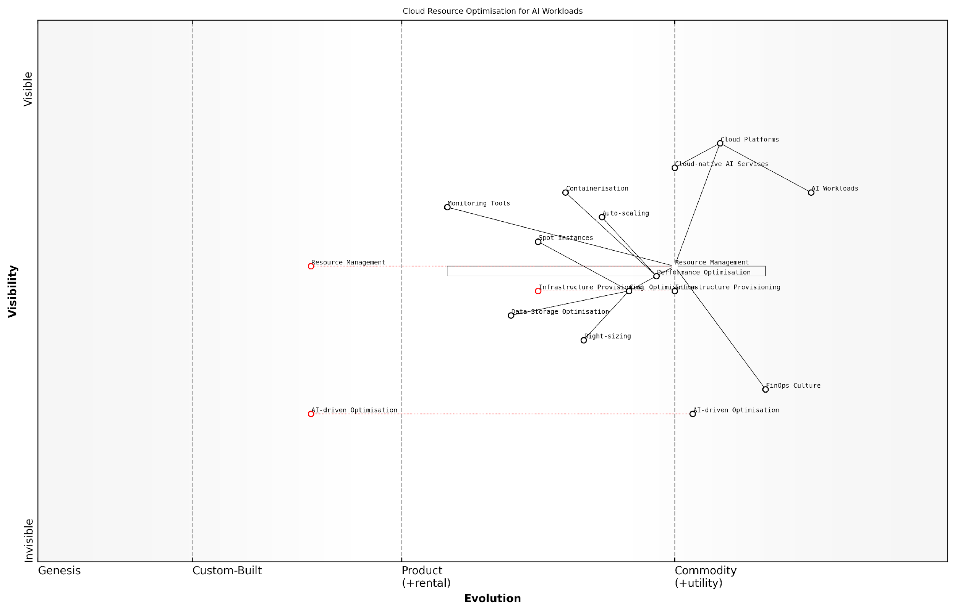

*Draft Wardley Map: [Insert Wardley Map: Optimising cloud resources for AI workloads]*

[Edit this draft Wardley Map](https://create.wardleymaps.ai/#clone:2667511acbee86c50c)

Wardley Map Assessment

The map reveals a strategic focus on optimising cloud resources for AI workloads, with significant opportunities in emerging areas like FinOps and AI-driven optimization. To maintain a competitive edge, organisations should prioritise developing these capabilities while continuously refining existing optimization practices. The integration of FinOps culture and AI-driven approaches will be crucial for long-term success in managing the complex and evolving landscape of AI workloads in the cloud.

[View full Wardley Map report](http://markdown/wardley_map_reports/wardley_map_report_31_Optimizing_cloud_resources_for_AI_workloads.md)

In conclusion, optimising cloud resources for AI workloads is a critical component of FinOps that requires a strategic approach, continuous refinement, and a deep understanding of both AI requirements and cloud capabilities. By implementing these optimisation strategies, organisations can significantly reduce costs, improve performance, and ultimately drive greater value from their AI initiatives.

### Budgeting and forecasting for AI initiatives

Budgeting and forecasting for AI initiatives is a critical component of FinOps that requires a nuanced understanding of both the potential and the pitfalls of AI projects. As AI technologies continue to evolve rapidly, organisations face the challenge of accurately predicting costs and returns on investment (ROI) in an environment characterised by uncertainty and rapid change. This subsection delves into the intricacies of financial planning for AI projects, offering insights and strategies to help organisations navigate this complex landscape.

One of the primary challenges in budgeting for AI initiatives is the inherent unpredictability of AI development and deployment. Unlike traditional IT projects, AI initiatives often involve exploratory research, iterative development, and ongoing refinement, making it difficult to establish fixed timelines and cost structures. To address this, organisations must adopt flexible budgeting approaches that can accommodate the dynamic nature of AI projects.

* Implement rolling budgets that are reviewed and adjusted quarterly
* Allocate contingency funds for unexpected developments or breakthroughs
* Utilise scenario planning to account for various potential outcomes
* Incorporate agile financial management practices to align with iterative AI development methodologies

Forecasting for AI initiatives requires a multifaceted approach that considers various cost factors unique to AI projects. These include data acquisition and preparation costs, computing resources, specialised talent, and ongoing maintenance and refinement of AI models. Organisations must also factor in potential cost savings and revenue generation opportunities that successful AI implementations can bring.

Accurate forecasting for AI initiatives is as much an art as it is a science. It requires a deep understanding of both the technological landscape and the specific business context in which the AI will be deployed.

To improve the accuracy of AI project forecasts, organisations should consider the following strategies:

* Leverage historical data from previous AI projects, adjusting for technological advancements and organisational learning
* Collaborate closely with data scientists and AI engineers to understand the technical requirements and potential challenges
* Utilise advanced forecasting techniques such as Monte Carlo simulations to model various cost scenarios
* Implement robust tracking mechanisms to monitor actual costs against forecasts, enabling continuous refinement of budgeting models

Another crucial aspect of budgeting and forecasting for AI initiatives is the consideration of long-term costs and benefits. While initial development and deployment costs can be substantial, the true value of AI often lies in its ability to scale and improve over time. Organisations must therefore adopt a long-term perspective when evaluating the financial implications of AI projects.

* Factor in the potential for increased efficiency and cost savings as AI systems mature
* Consider the scalability of AI solutions and the associated economies of scale
* Account for ongoing costs such as model retraining, data updates, and infrastructure maintenance
* Evaluate the potential impact of AI on workforce dynamics and associated costs or savings

Effective budgeting and forecasting for AI initiatives also requires close collaboration between finance teams, IT departments, and business units. This cross-functional approach ensures that budgets and forecasts are grounded in both technical realities and business objectives.

The most successful AI budgeting and forecasting efforts are those that bridge the gap between technical complexity and business value, creating a shared understanding across the organisation.

To facilitate this collaboration, organisations should consider implementing the following practices:

* Establish cross-functional teams dedicated to AI financial planning
* Develop common metrics and KPIs that align technical progress with business outcomes
* Conduct regular review sessions to assess AI project performance against financial projections
* Invest in training programmes to enhance financial literacy among technical teams and AI literacy among finance professionals

As AI initiatives become increasingly central to organisational strategies, the ability to accurately budget and forecast for these projects becomes a critical competitive advantage. By adopting flexible, collaborative, and forward-looking approaches to financial planning, organisations can better navigate the complexities of AI development and deployment, maximising the value of their AI investments while minimising financial risks.

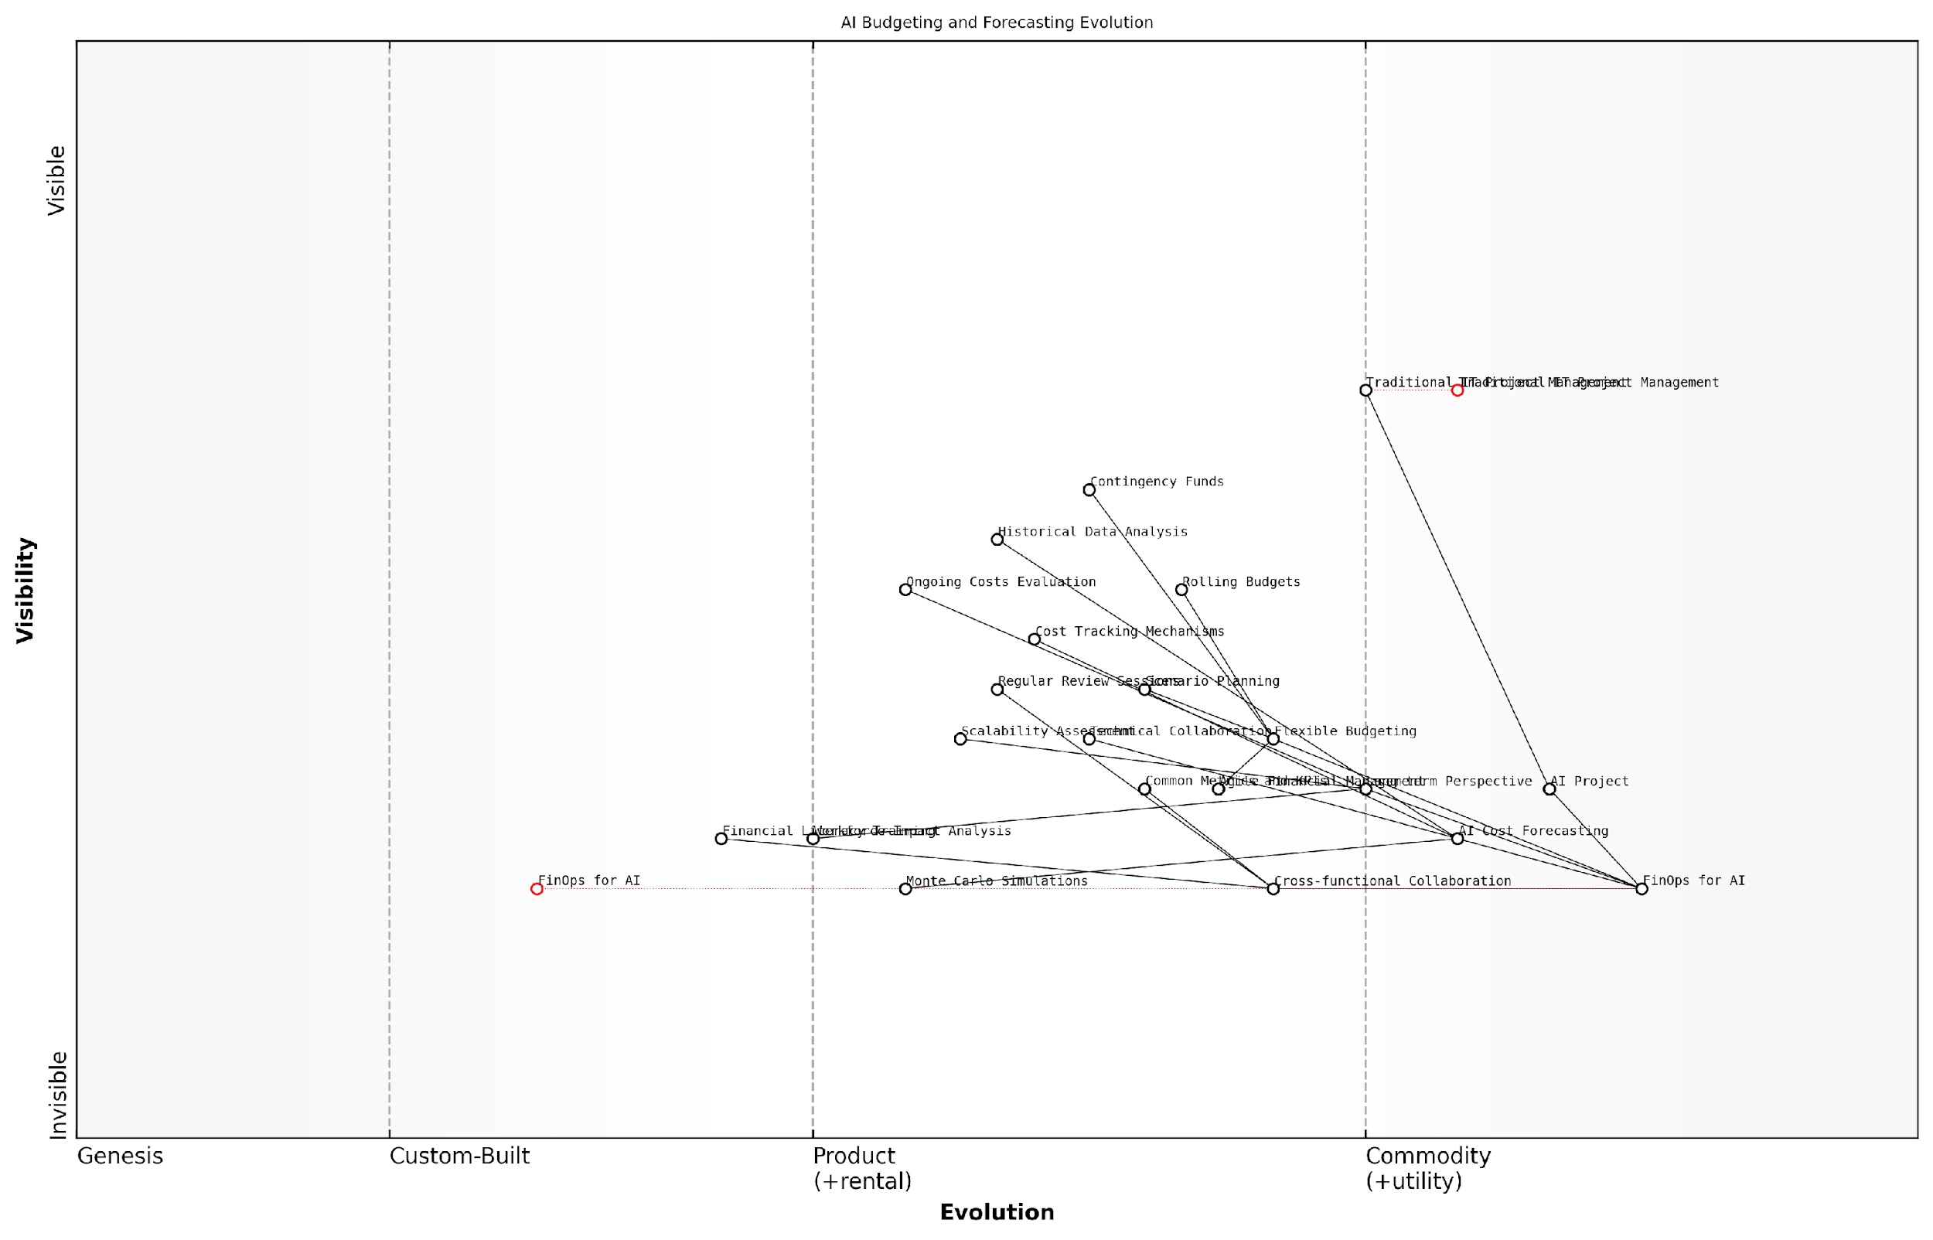

*Draft Wardley Map: [Insert Wardley Map: Budgeting and forecasting for AI initiatives]*

[Edit this draft Wardley Map](https://create.wardleymaps.ai/#clone:6b632ae6fe8329856f)

Wardley Map Assessment

This Wardley Map reveals a strategic imperative to evolve from traditional IT financial management to specialised FinOps for AI. Organisations must prioritise the development of AI-specific cost forecasting, flexible budgeting, and long-term perspective capabilities to effectively manage AI investments. The transition to FinOps for AI represents a significant opportunity for competitive advantage in the rapidly evolving AI landscape. Key focus areas should include enhancing cross-functional collaboration, developing advanced predictive financial models, and fostering a culture of continuous learning and adaptation in AI project financial management.

[View full Wardley Map report](http://markdown/wardley_map_reports/wardley_map_report_32_Budgeting_and_forecasting_for_AI_initiatives.md)

In conclusion, budgeting and forecasting for AI initiatives is a complex but essential aspect of FinOps that requires a blend of financial acumen, technical understanding, and strategic foresight. By embracing the unique challenges and opportunities presented by AI projects, organisations can develop robust financial planning processes that support successful AI implementation and drive long-term value creation.

### Measuring and maximizing AI ROI

In the realm of artificial intelligence, measuring and maximising return on investment (ROI) is a critical yet complex endeavour. As AI initiatives often require substantial upfront investments and ongoing operational costs, it’s imperative for organisations to quantify the value generated and optimise their AI investments. This is where FinOps principles play a crucial role, providing a framework for financial accountability and continuous optimisation in AI projects.

To effectively measure and maximise AI ROI, organisations must adopt a multifaceted approach that considers both tangible and intangible benefits, while also accounting for the unique challenges posed by AI technologies. This approach should encompass the following key areas:

* Defining clear, measurable objectives for AI initiatives
* Establishing comprehensive cost tracking mechanisms
* Implementing performance metrics and KPIs specific to AI
* Conducting regular ROI assessments and optimisation reviews
* Leveraging FinOps practices for continuous cost optimisation

Defining clear, measurable objectives is the foundation of any successful AI ROI strategy. These objectives should align with broader organisational goals and be specific enough to allow for quantifiable measurement. For instance, an AI-powered customer service chatbot might aim to reduce call centre costs by 30% while maintaining or improving customer satisfaction scores. By setting such concrete targets, organisations can more easily track progress and calculate the tangible value generated by their AI investments.

Establishing comprehensive cost tracking mechanisms is essential for accurate ROI calculation. This involves not only capturing direct costs such as infrastructure, software licences, and data acquisition but also accounting for indirect costs like staff training, change management, and opportunity costs. FinOps practices can be particularly valuable here, providing tools and methodologies for granular cost allocation and tracking across complex AI workflows.

Effective cost tracking in AI projects requires a holistic view that goes beyond traditional IT cost centres. It’s about understanding the true cost of AI throughout its lifecycle, from development to deployment and ongoing maintenance.

Implementing performance metrics and KPIs specific to AI is crucial for measuring the value generated by these technologies. Traditional business metrics may not fully capture the impact of AI, necessitating the development of new, AI-specific indicators. These might include metrics such as model accuracy, prediction speed, data processing efficiency, or the rate of automated decision-making. It’s important to note that these metrics should be tied back to business outcomes to demonstrate tangible value.

Conducting regular ROI assessments and optimisation reviews is a cornerstone of FinOps practice in AI projects. These assessments should be performed at predetermined intervals and after significant milestones to ensure that AI initiatives continue to deliver value. They should consider both quantitative measures (e.g., cost savings, revenue increases) and qualitative benefits (e.g., improved decision-making, enhanced customer experience). Based on these assessments, organisations can make data-driven decisions about scaling, pivoting, or discontinuing AI projects.

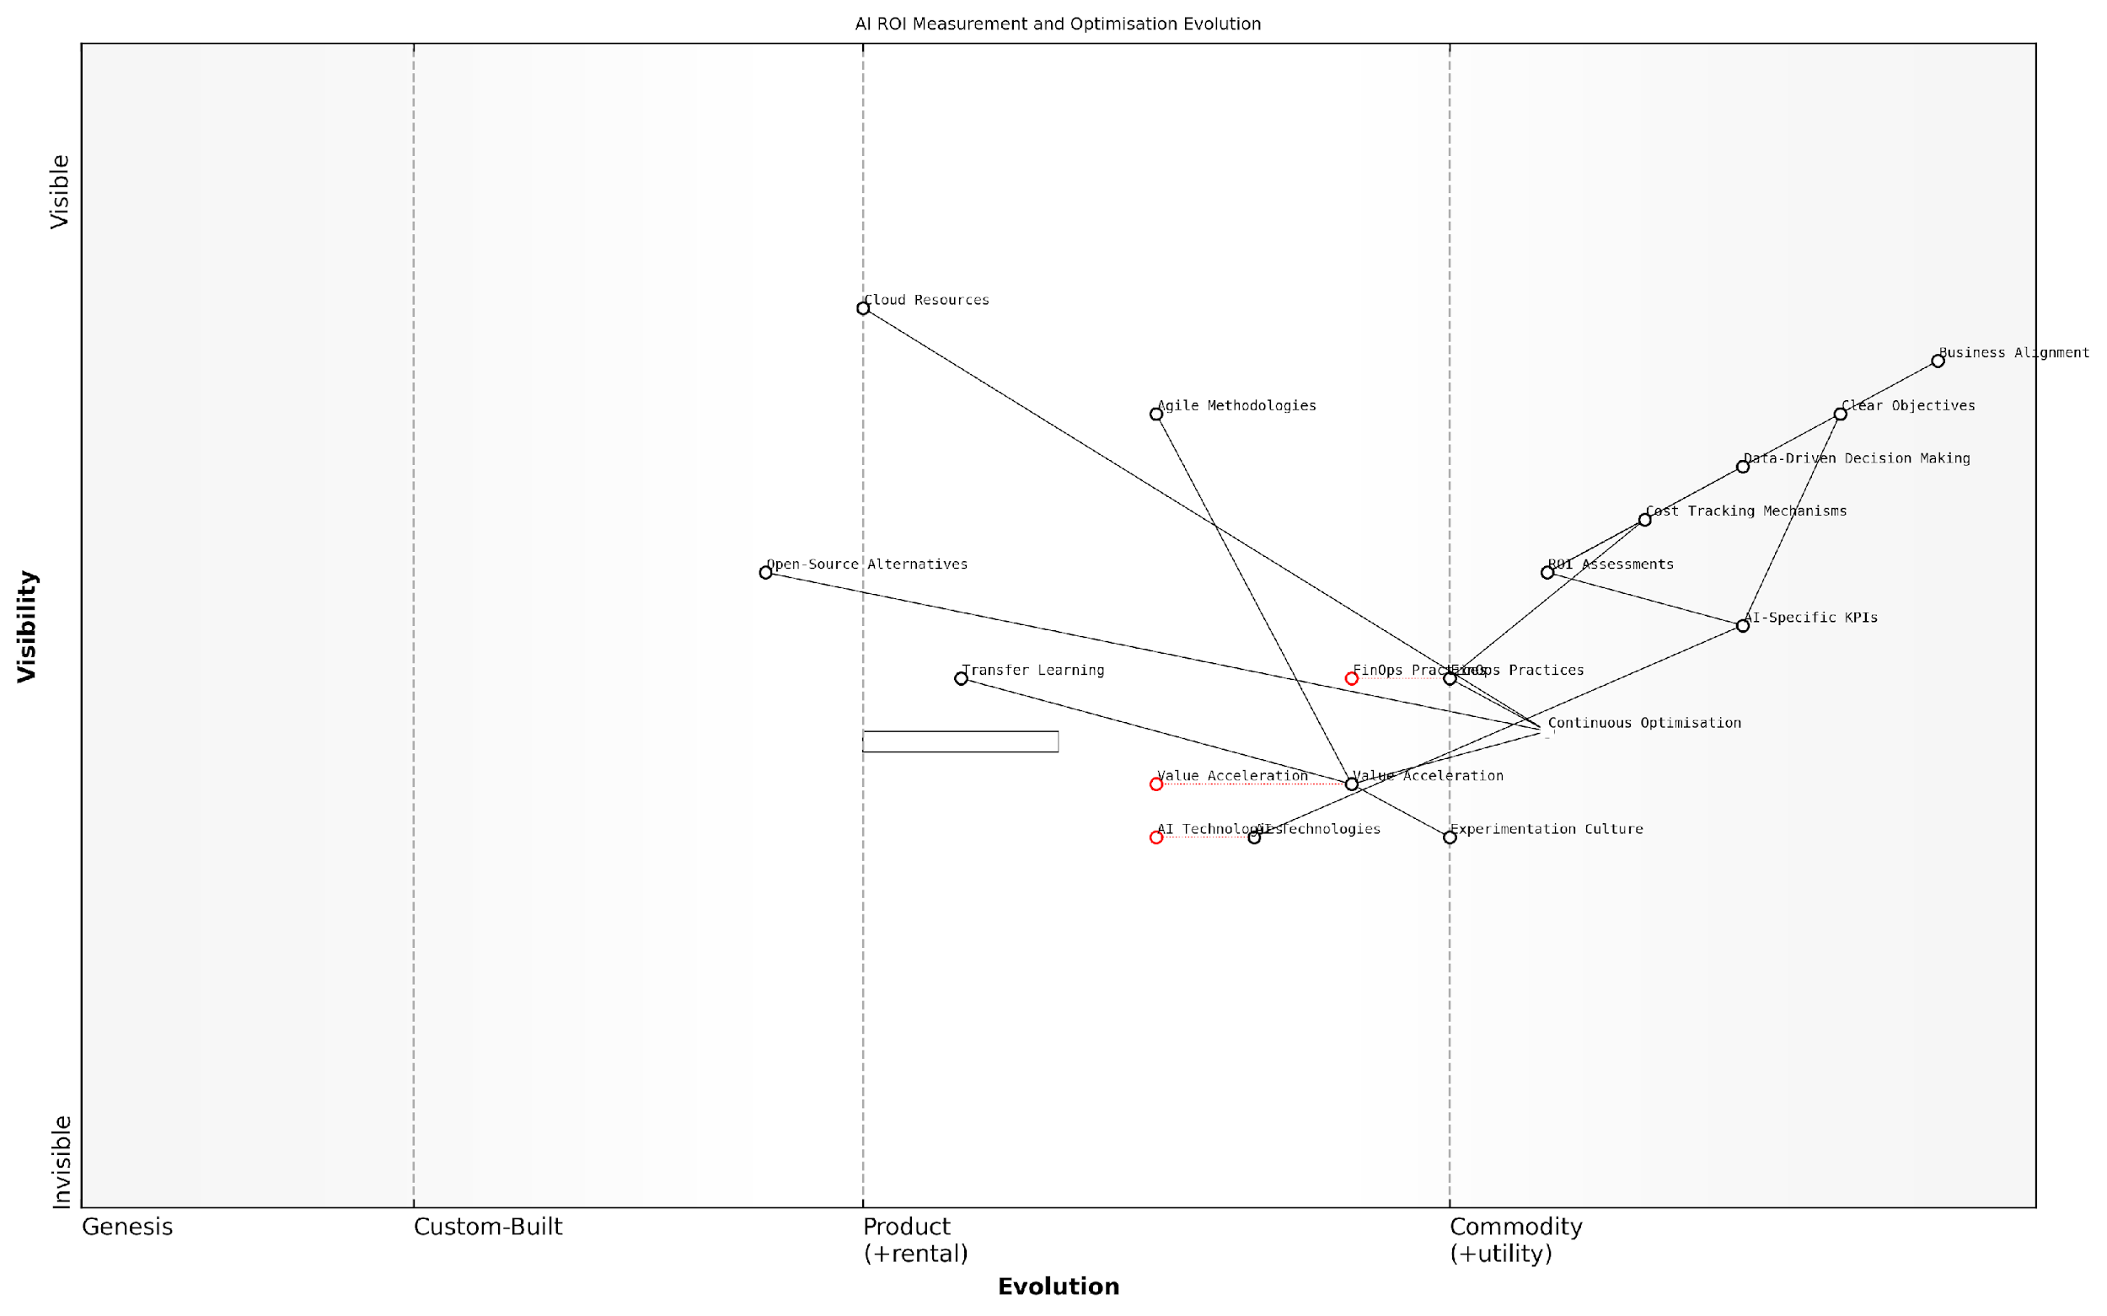

*Draft Wardley Map: [Insert Wardley Map: Measuring and maximising AI ROI]*

[Edit this draft Wardley Map](https://create.wardleymaps.ai/#clone:4d3d0652f1bd3f6f79)

Wardley Map Assessment

This Wardley Map reveals a strategic approach to measuring and maximising AI ROI that balances business alignment, financial discipline, and technological innovation. The organisation shows strengths in high-level strategic components but needs to develop capabilities in rapidly evolving areas like AI Technologies and Value Acceleration. By focusing on the recommended short-term and long-term strategies, the organisation can establish a robust framework for AI ROI optimization while positioning itself for future innovations and competitive advantage in the AI space.

[View full Wardley Map report](http://markdown/wardley_map_reports/wardley_map_report_33_Measuring_and_maximizing_AI_ROI.md)

Leveraging FinOps practices for continuous cost optimisation is key to maximising AI ROI over time. This involves implementing strategies such as:

* Right-sizing compute resources based on actual usage patterns
* Implementing auto-scaling to match demand fluctuations
* Utilising spot instances or preemptible VMs for non-critical workloads
* Optimising data storage and transfer costs
* Negotiating volume discounts with cloud providers
* Exploring open-source alternatives where appropriate

By applying these FinOps strategies, organisations can significantly reduce the ongoing operational costs of AI systems, thereby improving ROI. It’s important to note that cost optimisation should never come at the expense of performance or reliability. The goal is to find the optimal balance between cost and value.

Another critical aspect of maximising AI ROI is the concept of ‘value acceleration’. This involves identifying ways to expedite the realisation of benefits from AI investments. Strategies might include:

* Prioritising high-impact, quick-win AI use cases
* Implementing agile development methodologies to speed up deployment
* Leveraging transfer learning to reduce model training time and costs
* Focusing on incremental improvements and continuous deployment
* Fostering a culture of experimentation and rapid iteration

It’s crucial to recognise that measuring and maximising AI ROI is not a one-time exercise but an ongoing process. As AI technologies evolve and business needs change, organisations must continually reassess and refine their approach to ensure they are deriving maximum value from their AI investments.

The key to sustained AI ROI lies in the ability to adapt quickly, learn from both successes and failures, and maintain a relentless focus on aligning AI initiatives with core business objectives.

In conclusion, measuring and maximising AI ROI requires a strategic approach that combines clear objective setting, comprehensive cost tracking, AI-specific performance metrics, regular assessments, and continuous optimisation. By embracing FinOps principles and practices, organisations can ensure that their AI investments not only deliver value but do so in a cost-effective and sustainable manner. This approach not only justifies AI expenditures but also paves the way for broader AI adoption and transformation across the organisation.

## FinOps Strategies and Tools

### Cost optimization techniques for AI infrastructure

As AI initiatives continue to grow in scale and complexity, optimising the costs associated with AI infrastructure has become a critical concern for organisations. FinOps strategies play a pivotal role in ensuring that AI projects remain financially viable while delivering maximum value. This section explores key cost optimisation techniques that can be applied to AI infrastructure, drawing from best practices in cloud cost management and AI-specific considerations.

One of the primary challenges in AI infrastructure cost optimisation is the dynamic and often unpredictable nature of AI workloads. Unlike traditional IT workloads, AI tasks can have varying resource requirements depending on the stage of development, the complexity of models, and the volume of data being processed. This variability necessitates a flexible and proactive approach to cost management.

* Right-sizing resources: Ensure that the computational resources allocated to AI tasks match their actual requirements. This involves continuous monitoring and adjustment of instance types, storage volumes, and network resources.
* Leveraging spot instances and preemptible VMs: Utilise discounted, interruptible compute resources for non-critical or fault-tolerant AI workloads, such as training jobs that can be easily resumed.
* Implementing auto-scaling: Deploy auto-scaling mechanisms that can dynamically adjust resource allocation based on workload demands, ensuring optimal resource utilisation and cost efficiency.
* Optimising data storage: Implement tiered storage strategies, using cost-effective cold storage for infrequently accessed data and high-performance storage for active datasets.
* Utilising serverless computing: Leverage serverless architectures for certain AI tasks, paying only for the actual compute time used rather than maintaining constantly running instances.
* Containerisation and orchestration: Use container technologies and orchestration tools to improve resource utilisation and enable more granular control over resource allocation.
* GPU sharing and optimisation: Implement GPU sharing techniques and optimise GPU utilisation to maximise the value derived from these expensive resources.
* Implementing cost allocation and chargeback: Develop mechanisms to accurately attribute AI infrastructure costs to specific projects or departments, fostering accountability and cost-conscious behaviour.

A crucial aspect of cost optimisation for AI infrastructure is the implementation of robust monitoring and analytics capabilities. By gaining deep visibility into resource usage patterns, organisations can identify inefficiencies, detect anomalies, and make data-driven decisions about resource allocation and optimisation strategies.

Effective cost optimisation in AI is not about cutting corners, but about maximising the value derived from every pound spent on infrastructure. It’s a continuous process of refinement and adaptation.

Another key consideration in AI infrastructure cost optimisation is the balance between performance and cost. While it may be tempting to always opt for the highest-performance resources, this approach can lead to significant overspending. Instead, organisations should adopt a nuanced approach that considers the specific requirements of each AI workload and aligns resource allocation accordingly.

* Performance profiling: Conduct thorough performance profiling of AI workloads to understand their resource consumption patterns and identify bottlenecks.
* Cost-performance trade-off analysis: Evaluate the cost-performance trade-offs of different infrastructure options, considering factors such as model training time, inference latency, and overall project timelines.
* Hybrid and multi-cloud strategies: Leverage hybrid and multi-cloud approaches to optimise costs by placing workloads on the most cost-effective platforms based on their specific requirements.
* Reserved capacity and committed use discounts: Utilise cloud provider offerings for reserved capacity or committed use discounts for predictable, long-running AI workloads to achieve significant cost savings.
* Optimising data transfer costs: Implement strategies to minimise data transfer costs, such as co-locating data and compute resources, using content delivery networks, and optimising data replication strategies.

It’s important to note that cost optimisation for AI infrastructure is not a one-time effort but an ongoing process. As AI technologies evolve and organisational needs change, cost optimisation strategies must be continuously reviewed and refined. This requires a culture of cost awareness and collaboration between data scientists, ML engineers, IT operations, and finance teams.

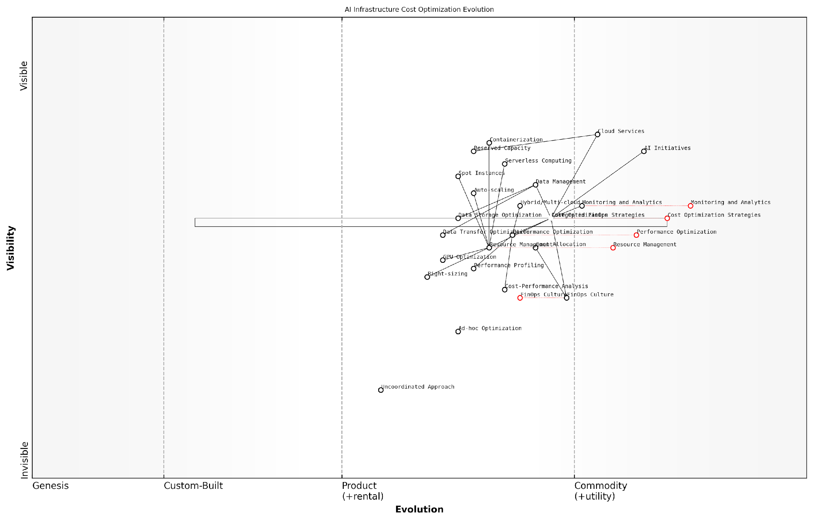

*Draft Wardley Map: [Insert Wardley Map: Cost optimization techniques for AI infrastructure]*

[Edit this draft Wardley Map](https://create.wardleymaps.ai/#clone:a4f6754cd85303c51b)

Wardley Map Assessment

The map reveals a rapidly evolving landscape of cost optimization for AI infrastructure, with a clear trend towards more integrated, automated, and AI-specific approaches. Organisations should focus on developing a strong FinOps culture, leveraging advanced cloud services, and investing in AI-driven optimization techniques to stay competitive and cost-effective in their AI initiatives. The key to success lies in balancing short-term optimization tactics with long-term strategic investments in emerging technologies and practices.

[View full Wardley Map report](http://markdown/wardley_map_reports/wardley_map_report_34_Cost_optimization_techniques_for_AI_infrastructure.md)

Organisations should also consider the long-term implications of their cost optimisation strategies. While short-term cost reductions are important, they should not come at the expense of scalability, flexibility, or the ability to adopt new AI technologies. A forward-looking approach that balances immediate cost savings with long-term strategic objectives is essential for sustainable AI success.

The most successful organisations view AI infrastructure cost optimisation not as a constraint, but as an enabler of innovation and scale. By optimising costs, they free up resources to invest in new AI initiatives and push the boundaries of what’s possible.

In conclusion, cost optimisation techniques for AI infrastructure are a critical component of FinOps strategies in AI projects. By implementing a comprehensive approach that encompasses resource right-sizing, leveraging cloud-native capabilities, performance optimisation, and continuous monitoring, organisations can significantly reduce their AI infrastructure costs while maintaining or even improving performance. This not only enhances the ROI of AI initiatives but also enables organisations to scale their AI efforts more effectively, ultimately driving greater business value and competitive advantage.

### FinOps platforms and their integration with AI workflows

As AI initiatives become increasingly complex and resource-intensive, the integration of FinOps platforms with AI workflows has emerged as a critical factor for optimising costs and maximising return on investment. These platforms provide the necessary visibility, control, and automation to manage the financial aspects of AI projects effectively, ensuring that organisations can scale their AI operations sustainably.

FinOps platforms designed for AI workflows offer a range of features tailored to the unique challenges of machine learning and deep learning projects. These platforms typically include capabilities such as:

* Real-time cost monitoring and allocation for AI workloads
* Predictive analytics for forecasting AI-related expenses
* Automated resource scaling based on model training and inference demands
* Cost optimisation recommendations specific to AI infrastructure
* Integration with popular cloud providers and AI development frameworks
* Customisable dashboards for visualising AI project costs and ROI

The integration of FinOps platforms with AI workflows requires a thoughtful approach to ensure seamless operation and maximum value. Here are key considerations for successful integration:

* Alignment with existing MLOps and DataOps processes
* Compatibility with preferred cloud environments and AI tools
* Granular tagging and labelling of AI resources for accurate cost attribution
* Implementation of role-based access controls for financial data
* Establishment of cost thresholds and automated alerts for AI projects
* Integration with CI/CD pipelines for continuous cost optimisation

One of the primary benefits of integrating FinOps platforms with AI workflows is the ability to make data-driven decisions about resource allocation and project prioritisation. By providing real-time insights into the costs associated with different stages of the AI lifecycle, these platforms enable organisations to identify inefficiencies and optimise their spending.

The integration of FinOps platforms with our AI workflows has been transformative. We’ve seen a 30% reduction in cloud costs and a significant improvement in our ability to forecast and manage AI-related expenses.

When selecting a FinOps platform for AI workflows, it’s crucial to consider the specific needs of your organisation and the complexity of your AI initiatives. Some popular FinOps platforms that offer robust support for AI workloads include:

* CloudHealth by VMware
* Cloudability
* AWS Cost Explorer with AI-specific features
* Google Cloud Cost Management
* Azure Cost Management and Billing

These platforms offer varying degrees of AI-specific functionality, from basic cost tracking to advanced AI workload optimisation. It’s essential to evaluate each platform’s capabilities in the context of your organisation’s AI maturity and future growth plans.

To maximise the benefits of FinOps platforms in AI workflows, organisations should focus on fostering a culture of cost awareness and accountability among data scientists, ML engineers, and other AI practitioners. This cultural shift can be supported through:

* Regular training sessions on FinOps principles and platform usage
* Incorporation of cost metrics into AI project performance evaluations
* Gamification of cost optimisation efforts to encourage engagement
* Cross-functional collaboration between finance, IT, and AI teams
* Establishment of clear cost governance policies for AI initiatives

As AI technologies continue to evolve, FinOps platforms are adapting to address emerging challenges. Some future trends in this space include:

* Enhanced support for edge AI and IoT cost management
* Integration with AI explainability tools to correlate costs with model performance
* Advanced anomaly detection for identifying cost spikes in AI workloads
* Improved carbon footprint tracking for AI operations
* AI-powered recommendations for optimising model architecture and training strategies

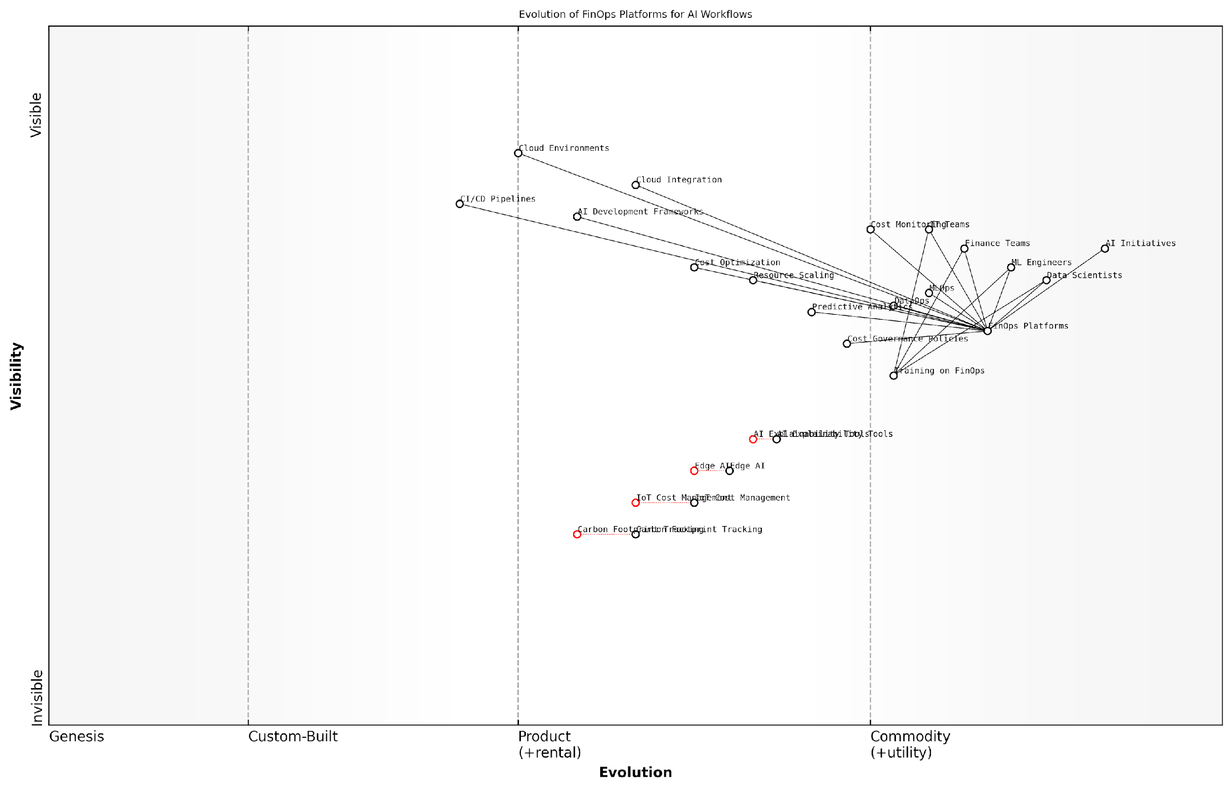

*Draft Wardley Map: [Insert Wardley Map: FinOps platforms and their integration with AI workflows]*

[Edit this draft Wardley Map](https://create.wardleymaps.ai/#clone:591e60c6269b967063)

Wardley Map Assessment

The map reveals a maturing FinOps ecosystem for AI workflows with significant opportunities for innovation and strategic differentiation. Key areas for focus include strengthening the core FinOps Platform capabilities, investing in emerging technologies like Edge AI and IoT Cost Management, and preparing for the increasing importance of AI Explainability and Carbon Footprint Tracking. Organisations that can effectively integrate these components while maintaining robust cost optimization and governance practices will be well-positioned to lead in the evolving landscape of AI-driven operations.

[View full Wardley Map report](http://markdown/wardley_map_reports/wardley_map_report_35_FinOps_platforms_and_their_integration_with_AI_wor.md)

In conclusion, the integration of FinOps platforms with AI workflows is no longer a luxury but a necessity for organisations seeking to scale their AI initiatives sustainably. By providing visibility, control, and optimisation capabilities tailored to the unique demands of AI workloads, these platforms enable organisations to maximise the value of their AI investments while maintaining financial discipline. As the AI landscape continues to evolve, the role of FinOps platforms in ensuring the success and sustainability of AI projects will only grow in importance.

### Collaborative cost management across teams

In the realm of AI implementation, collaborative cost management across teams is not just a financial strategy; it’s a critical operational paradigm that can make or break the success of AI initiatives. As an expert who has guided numerous government and public sector organisations through their AI journeys, I can attest that the synergy between various teams—data scientists, IT operations, finance, and business units—is paramount in optimising AI costs while maximising value.

Collaborative cost management in AI projects involves creating a shared responsibility model where all stakeholders are invested in and accountable for the financial aspects of AI development and deployment. This approach aligns with the core principles of FinOps, which emphasises transparency, accountability, and continuous optimisation of cloud resources and AI-related expenditures.

* Foster a culture of cost awareness across all teams involved in AI projects
* Implement cross-functional FinOps teams to oversee AI cost management
* Establish clear communication channels for sharing cost insights and strategies
* Develop shared KPIs that balance innovation with financial responsibility
* Utilise collaborative tools and dashboards for real-time cost visibility

One of the most effective strategies I’ve implemented in government AI projects is the creation of ‘AI Cost Councils’. These cross-functional teams bring together representatives from data science, IT, finance, and business units to collectively oversee AI expenditures. These councils meet regularly to review costs, discuss optimisation strategies, and make informed decisions about resource allocation.

The success of AI initiatives hinges on our ability to break down silos and foster a collaborative approach to cost management. When teams work together with a shared understanding of financial implications, we see not only cost savings but also more innovative and efficient AI solutions.

To facilitate collaborative cost management, organisations must leverage advanced FinOps tools and platforms that provide granular visibility into AI-related expenses. These tools should offer features such as:

* Real-time cost tracking and allocation to specific AI projects and teams
* Predictive analytics for forecasting future AI expenditures
* Automated alerts for cost anomalies or budget overruns
* Integration with MLOps platforms for correlating model performance with costs
* Customisable dashboards for different stakeholders to view relevant cost metrics

One particularly effective tool I’ve seen implemented in the public sector is a ‘Cost Attribution Engine’. This bespoke solution allows organisations to automatically tag and allocate AI-related costs to specific projects, departments, or even individual models. This granular level of cost attribution enables teams to make data-driven decisions about resource allocation and optimisation.

However, tools alone are not sufficient. Successful collaborative cost management requires a shift in organisational culture and mindset. It’s crucial to implement training programmes that educate all team members about the financial implications of their decisions in AI development and deployment. This includes understanding the cost structures of cloud services, the impact of model complexity on computational resources, and the long-term financial considerations of AI maintenance and scaling.

In my experience advising government bodies, I’ve found that the most successful AI initiatives are those where every team member, from data scientists to project managers, understands and takes ownership of the financial impact of their work. This shared responsibility leads to more innovative and cost-effective AI solutions.

Another critical aspect of collaborative cost management is the establishment of clear governance frameworks. These frameworks should define roles and responsibilities for cost management, set guidelines for resource utilisation, and establish processes for cost review and optimisation. In the public sector, where accountability and transparency are paramount, such governance structures are essential for ensuring that AI investments deliver value for money and align with broader organisational objectives.

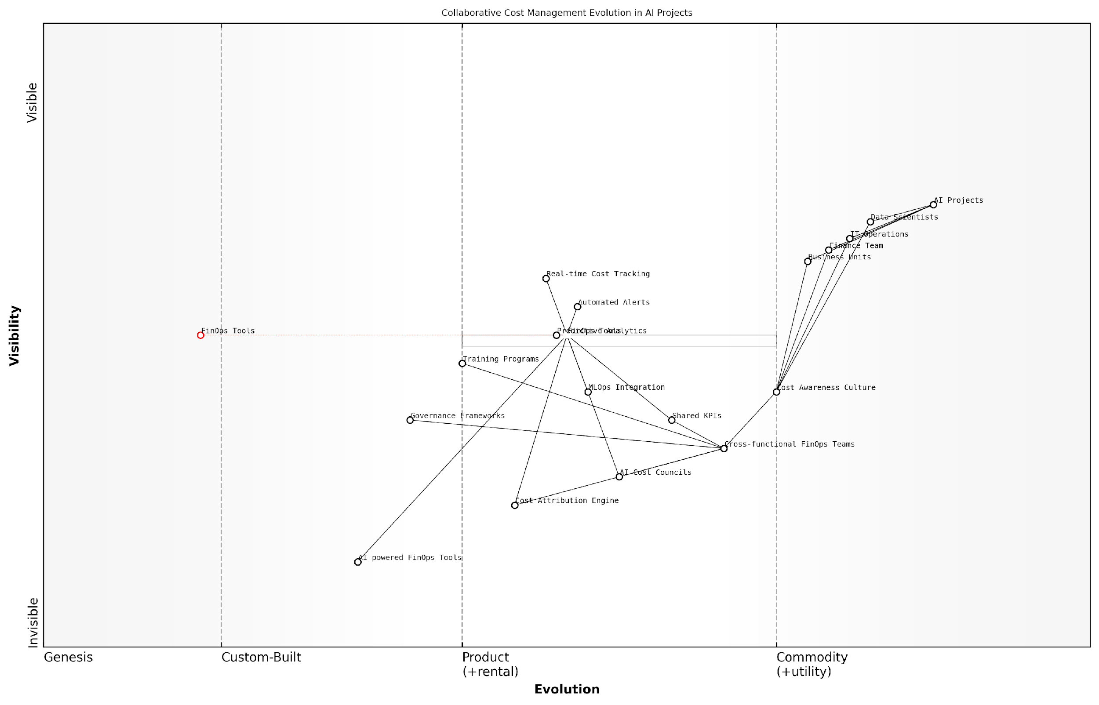

*Draft Wardley Map: [Insert Wardley Map: Collaborative cost management across teams]*

[Edit this draft Wardley Map](https://create.wardleymaps.ai/#clone:7dd8cb188e6947d772)

Wardley Map Assessment

The Wardley Map reveals a strategic focus on evolving collaborative cost management practices for AI projects. The organisation is well-positioned to leverage current FinOps tools and practices while moving towards more advanced, AI-driven approaches. Key priorities should include strengthening cross-functional collaboration, investing in AI-powered FinOps tools, and fostering a strong cost awareness culture. The integration of MLOps and FinOps practices presents a significant opportunity for competitive advantage in the rapidly evolving AI landscape.

[View full Wardley Map report](http://markdown/wardley_map_reports/wardley_map_report_36_Collaborative_cost_management_across_teams.md)

As AI systems become more complex and pervasive in government operations, the need for collaborative cost management will only intensify. Future trends point towards the integration of AI-powered FinOps tools that can autonomously optimise resource allocation based on real-time usage patterns and project priorities. These advanced systems will facilitate even greater collaboration by providing actionable insights and recommendations to all stakeholders involved in AI initiatives.

In conclusion, collaborative cost management across teams is not just a best practice—it’s a necessity for the success of AI projects, especially in the public sector where resources are often constrained and scrutiny is high. By fostering a culture of shared financial responsibility, leveraging advanced FinOps tools, and implementing robust governance frameworks, organisations can ensure that their AI investments deliver maximum value while maintaining fiscal prudence. As we continue to push the boundaries of AI capabilities, this collaborative approach to cost management will be a key differentiator between successful and struggling AI initiatives.

# Integrating DataOps, MLOps, and FinOps for AI Excellence

## The Synergistic Approach

### Aligning DataOps, MLOps, and FinOps objectives

In the realm of AI implementation, the alignment of DataOps, MLOps, and FinOps objectives is not merely beneficial—it is critical for achieving transformative success. As an expert who has guided numerous government and public sector organisations through their AI journeys, I can attest that this alignment forms the bedrock of a truly synergistic approach to AI operations.

At its core, the alignment of these three operational frameworks is about creating a unified vision for AI projects that encompasses data quality, model performance, and cost-effectiveness. Each ‘Ops’ discipline brings its own set of objectives to the table, and the art lies in harmonising these objectives to create a cohesive strategy that drives AI excellence.

* DataOps objectives: Ensuring high-quality, timely, and compliant data pipelines
* MLOps objectives: Streamlining model development, deployment, and monitoring
* FinOps objectives: Optimising costs and maximising return on AI investments

The synergy begins when we recognise that these objectives are not siloed, but deeply interconnected. For instance, the quality of data (a DataOps concern) directly impacts model performance (an MLOps focus), which in turn affects the overall cost-effectiveness and ROI of AI projects (a FinOps priority). By aligning these objectives, organisations can create a virtuous cycle where improvements in one area cascade positively through the entire AI lifecycle.

The true power of AI is unleashed when data, models, and financial considerations are seamlessly integrated into a single, cohesive strategy.

To achieve this alignment, organisations must first establish a common language and set of metrics that span across all three disciplines. This might include shared key performance indicators (KPIs) that reflect the interdependencies between data quality, model performance, and cost efficiency. For example, a metric like ‘cost per accurate prediction’ could serve as a unifying objective that requires input and optimisation from all three Ops teams.

Another crucial aspect of alignment is the creation of cross-functional teams that bring together experts from each Ops discipline. These teams should be empowered to collaborate on AI projects from inception to deployment and beyond. By fostering this collaborative environment, organisations can ensure that data considerations inform model development, that model requirements guide data collection and preparation, and that financial constraints and opportunities are factored into every decision along the way.

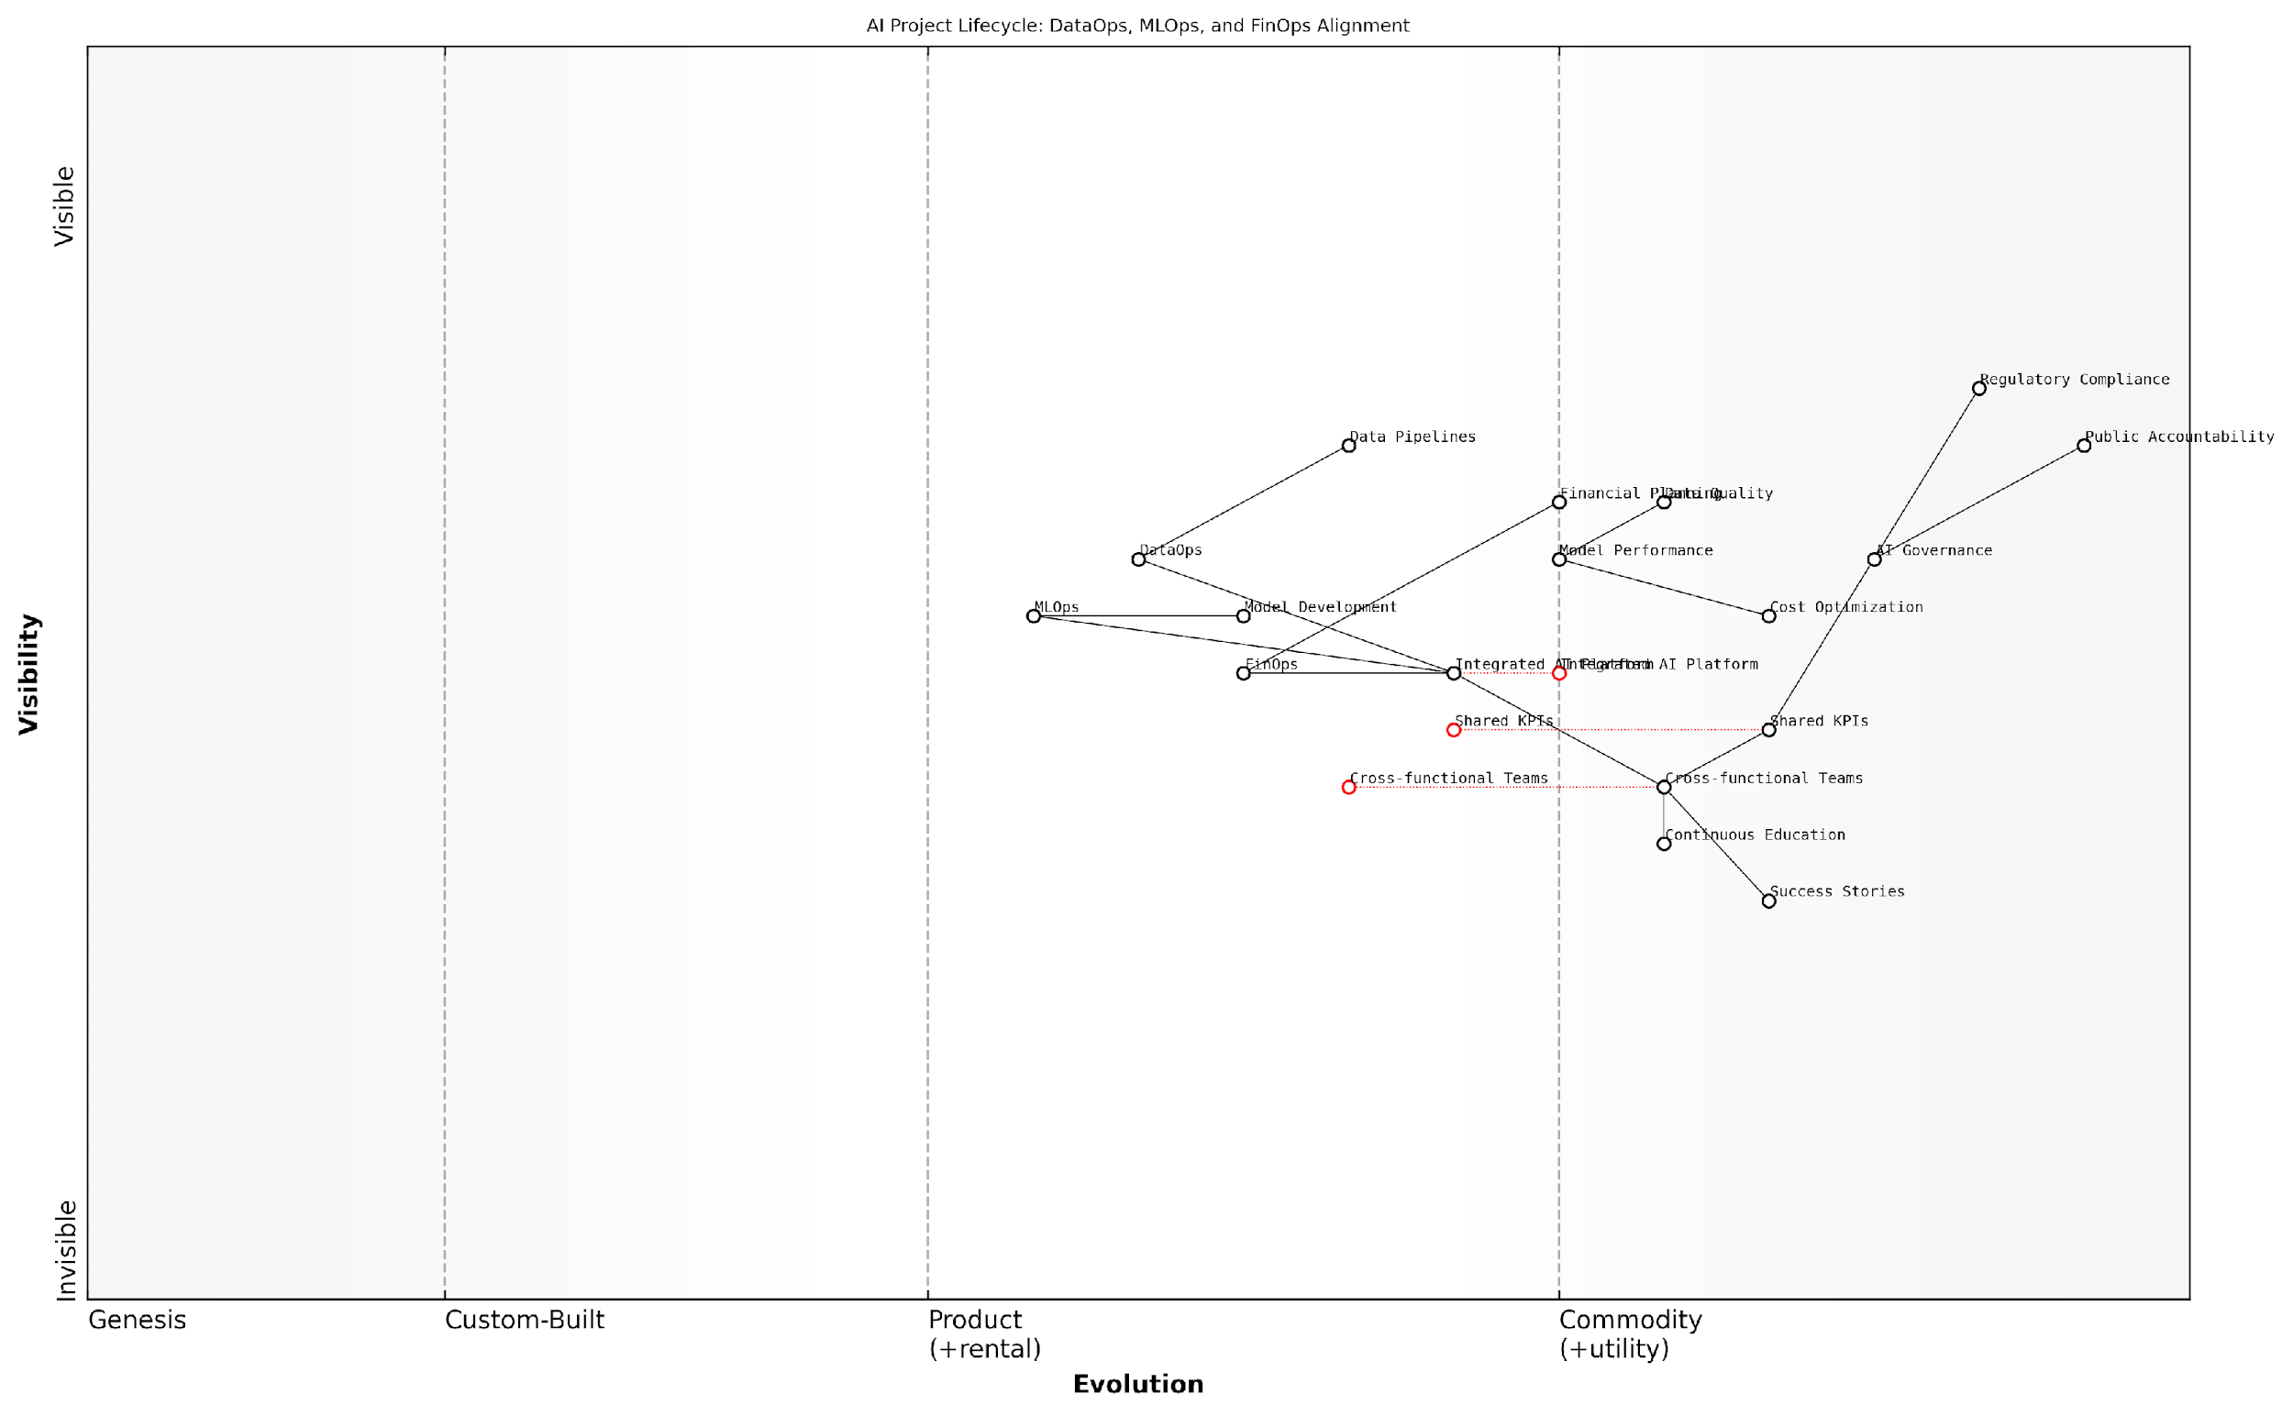

*Draft Wardley Map: [Insert Wardley Map: Aligning DataOps, MLOps, and FinOps objectives]*

[Edit this draft Wardley Map](https://create.wardleymaps.ai/#clone:ba84a7b7518d6baaf4)

Wardley Map Assessment

This Wardley Map reveals a strategic focus on integrating DataOps, MLOps, and FinOps to drive AI value, with a strong emphasis on governance and cross-functional collaboration. The key to success lies in accelerating the evolution of integration platforms and cross-functional capabilities while maintaining robust governance. Organisations should prioritise the development of shared KPIs and an integrated AI platform to drive immediate value, while simultaneously building advanced governance frameworks and fostering a culture of continuous learning to ensure long-term success and adaptability in the rapidly evolving AI landscape.

[View full Wardley Map report](http://markdown/wardley_map_reports/wardley_map_report_37_Aligning_DataOps,_MLOps,_and_FinOps_objectives.md)

Governance structures play a pivotal role in maintaining this alignment. Establishing a centralised AI governance board that includes representatives from DataOps, MLOps, and FinOps can ensure that strategic decisions are made with a holistic view of their impact across all three domains. This board can also be instrumental in setting organisation-wide policies and standards that promote consistency and interoperability between the different Ops practices.

Technology platforms and tools that facilitate integration between the three Ops disciplines are also essential for alignment. Modern AI platforms are increasingly offering features that span across DataOps, MLOps, and FinOps functionalities. Selecting and implementing such integrated platforms can significantly reduce friction between teams and promote a more unified approach to AI operations.

* Implement shared data catalogues that serve both DataOps and MLOps needs
* Utilise model registries that include both performance metrics and cost data
* Deploy monitoring solutions that track data quality, model drift, and resource utilisation in real-time

It’s important to note that alignment doesn’t mean homogenisation. Each Ops discipline retains its unique focus and expertise. The goal is to create synergy, not to blur the lines between specialties. This balance is particularly crucial in government and public sector contexts, where regulatory compliance and public accountability add additional layers of complexity to AI initiatives.

In the public sector, the alignment of DataOps, MLOps, and FinOps is not just about efficiency—it’s about building trust in AI systems through transparent, accountable, and cost-effective practices.

One of the most effective ways to drive alignment is through the establishment of shared success stories. By celebrating wins that demonstrate the power of integrated Ops approaches, organisations can reinforce the value of collaboration and encourage further alignment. These success stories should highlight how the interplay between data quality, model performance, and cost optimisation led to tangible benefits for the organisation and its stakeholders.

Continuous education and cross-training programmes are also vital for maintaining alignment over time. As AI technologies and best practices evolve, it’s crucial that professionals across all three Ops disciplines stay informed about developments in adjacent fields. This not only promotes better collaboration but also enables more innovative problem-solving as team members can draw insights from multiple domains.

In conclusion, aligning the objectives of DataOps, MLOps, and FinOps is a complex but essential task for organisations seeking to maximise the value of their AI investments. It requires a strategic vision, dedicated leadership, and a commitment to breaking down silos between teams. By fostering this alignment, organisations can create a powerful synergy that drives AI excellence, delivering transformative outcomes while maintaining efficiency, quality, and fiscal responsibility.

### Creating a unified AI operations framework

In the rapidly evolving landscape of artificial intelligence, creating a unified AI operations framework that seamlessly integrates DataOps, MLOps, and FinOps is paramount for achieving sustainable success. This synergistic approach not only streamlines the development and deployment of AI systems but also ensures their cost-effectiveness and long-term viability. As an expert who has advised numerous government agencies and private sector organisations on AI implementation, I can attest to the transformative power of a well-integrated operational framework.

A unified AI operations framework serves as the backbone of any successful AI initiative, providing a structured approach to managing the entire lifecycle of AI projects. This framework should be designed to address the unique challenges posed by AI systems, including data quality and governance, model development and deployment, and cost optimisation. By aligning the objectives of DataOps, MLOps, and FinOps, organisations can create a cohesive ecosystem that fosters innovation while maintaining operational efficiency.

* Holistic data management: Integrating DataOps principles to ensure high-quality, compliant, and readily available data for AI models
* Streamlined model lifecycle: Incorporating MLOps practices for efficient model development, testing, deployment, and monitoring
* Cost-aware operations: Embedding FinOps methodologies to optimise resource utilisation and maximise return on investment
* Collaborative workflows: Facilitating seamless interaction between data scientists, ML engineers, IT operations, and finance teams
* Automated processes: Implementing end-to-end automation for data pipelines, model training, and deployment to reduce manual errors and improve efficiency
* Governance and compliance: Establishing robust governance mechanisms to ensure ethical AI development and regulatory compliance

One of the key benefits of a unified framework is the ability to break down silos between different teams and disciplines. In my experience working with large government agencies, I’ve observed that the lack of communication and collaboration between data teams, ML engineers, and finance departments often leads to inefficiencies, duplicated efforts, and missed opportunities. A unified framework fosters a culture of shared responsibility and cross-functional collaboration, enabling teams to work towards common goals and leverage each other’s expertise.

The true power of AI lies not in individual technologies or practices, but in the seamless integration of data, models, and resources within a unified operational framework.

To create an effective unified AI operations framework, organisations must first assess their current state of AI maturity and identify gaps in their existing processes. This assessment should cover aspects such as data infrastructure, model development practices, deployment pipelines, monitoring systems, and cost management strategies. Based on this evaluation, a roadmap can be developed to gradually integrate DataOps, MLOps, and FinOps practices into a cohesive framework.

A critical component of this unified framework is the establishment of common metrics and key performance indicators (KPIs) that span across the three Ops disciplines. These metrics should provide a holistic view of AI project performance, encompassing data quality, model accuracy, deployment frequency, resource utilisation, and return on investment. By aligning these metrics, organisations can ensure that all teams are working towards the same objectives and can quickly identify areas for improvement.

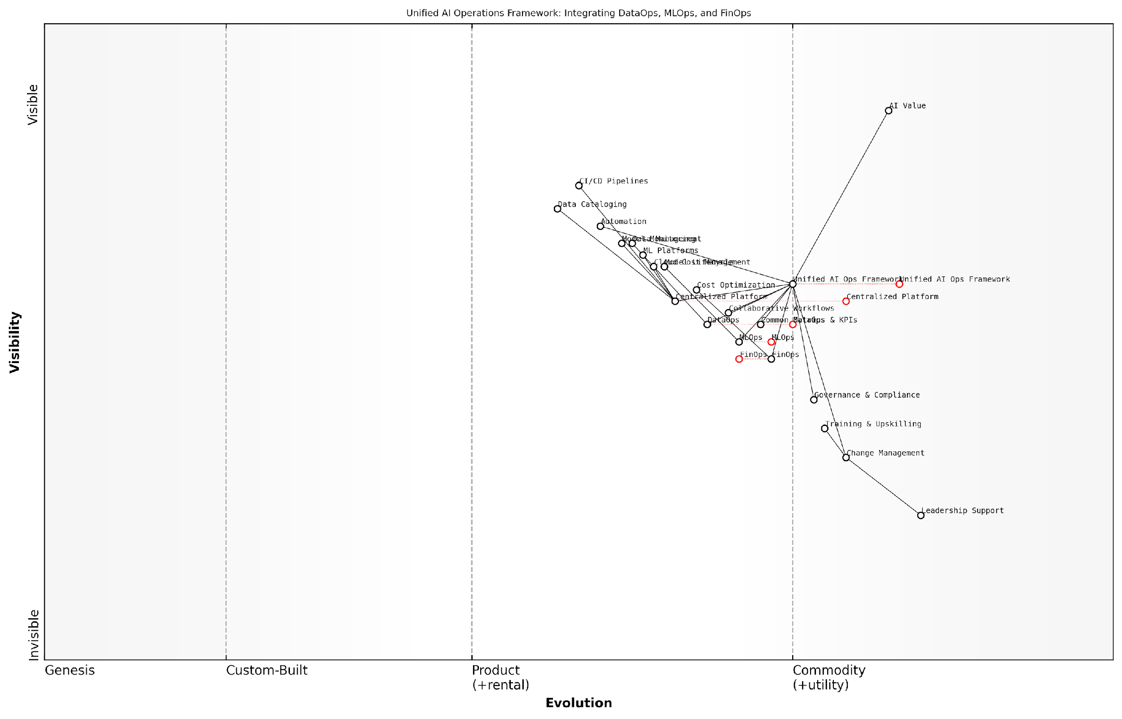

*Draft Wardley Map: [Insert Wardley Map: Creating a unified AI operations framework]*

[Edit this draft Wardley Map](https://create.wardleymaps.ai/#clone:897daa41f7a5723763)

Wardley Map Assessment

This Wardley Map represents a forward-thinking approach to AI operations, emphasising integration, unification, and value creation. The strategic position is strong, with clear opportunities for innovation and competitive differentiation. Key focus areas should include evolving the Unified AI Ops Framework, enhancing the Centralised Platform, and addressing potential bottlenecks in Governance & Compliance and Change Management. The integration of FinOps alongside DataOps and MLOps is a unique strength that should be leveraged. Overall, this framework positions the organisation well for future AI advancements, provided it can successfully navigate the challenges of rapid evolution and maintain alignment across all components.

[View full Wardley Map report](http://markdown/wardley_map_reports/wardley_map_report_38_Creating_a_unified_AI_operations_framework.md)

Another crucial aspect of a unified framework is the implementation of a centralised platform or set of tools that support the entire AI lifecycle. This platform should provide capabilities for data management, model development, deployment automation, monitoring, and cost tracking. While there are numerous tools available in the market, it’s essential to select solutions that can be easily integrated and customised to fit the specific needs of the organisation. In my consultancy work, I’ve found that a combination of open-source tools and enterprise platforms often provides the best balance of flexibility and robustness.

* Data cataloguing and versioning tools
* Automated ML platforms for model development and experimentation
* CI/CD pipelines specifically designed for ML workflows
* Model monitoring and explainability tools
* Cloud cost management and optimisation platforms
* Collaborative workspaces for cross-functional teams

Governance is a critical component of a unified AI operations framework, particularly in government and public sector contexts. The framework should incorporate clear policies and procedures for data handling, model development, deployment approvals, and cost management. These governance mechanisms should be designed to ensure compliance with relevant regulations, such as GDPR or sector-specific requirements, while also promoting ethical AI development practices.

Change management and cultural transformation are often overlooked aspects of implementing a unified AI operations framework. In my experience, successful adoption requires strong leadership support, clear communication of the benefits, and ongoing training and upskilling of team members. Organisations should consider establishing centres of excellence or AI governance boards to drive the adoption of the unified framework and ensure its continuous evolution in line with technological advancements and organisational needs.

The most successful AI initiatives are those that view DataOps, MLOps, and FinOps not as separate disciplines, but as interconnected components of a holistic operational framework.

In conclusion, creating a unified AI operations framework that integrates DataOps, MLOps, and FinOps is essential for organisations seeking to harness the full potential of AI. This synergistic approach enables more efficient, reliable, and cost-effective AI development and deployment, ultimately leading to better outcomes and increased value from AI investments. As the AI landscape continues to evolve, organisations that embrace this integrated approach will be better positioned to adapt to new challenges and opportunities, ensuring their long-term success in the AI-driven future.

### Cross-functional collaboration and communication

In the realm of AI excellence, cross-functional collaboration and communication serve as the linchpin that binds DataOps, MLOps, and FinOps into a cohesive, powerful force. As an expert who has advised numerous government agencies and private sector organisations on AI implementation, I can attest that the synergy created through effective collaboration is often the differentiating factor between AI projects that merely function and those that truly transform.

The integration of DataOps, MLOps, and FinOps necessitates a paradigm shift in how teams operate and communicate. Traditional siloed approaches, where data teams, machine learning engineers, and financial analysts operate in isolation, are no longer tenable in the face of complex AI initiatives. Instead, a new model of cross-functional collaboration must be embraced, one that fosters continuous dialogue, shared objectives, and a holistic understanding of the AI lifecycle.

* Establish cross-functional teams with representatives from DataOps, MLOps, and FinOps
* Implement regular joint planning and review sessions
* Create shared KPIs that align with overall AI project goals
* Develop a common language and terminology across disciplines
* Utilise collaborative tools and platforms that facilitate real-time information sharing

One of the most critical aspects of cross-functional collaboration in AI projects is the establishment of a shared understanding of the end-to-end AI lifecycle. This holistic view enables team members to appreciate how their specific roles and responsibilities contribute to the broader objectives of the AI initiative. For instance, DataOps professionals must understand how their data preparation and quality assurance efforts directly impact the performance of machine learning models, while MLOps engineers need to be cognisant of how their model deployment strategies affect infrastructure costs monitored by the FinOps team.

The success of AI initiatives hinges on our ability to break down silos and foster a culture of collaboration that spans data management, model development, and financial optimisation. Only through this integrated approach can we unlock the full potential of AI and deliver tangible value to our organisations and citizens.

To facilitate effective cross-functional collaboration, organisations should invest in creating collaborative spaces and processes. This may include establishing regular cross-team meetings, joint training sessions, and shared documentation repositories. Additionally, the use of collaborative tools and platforms that provide visibility into the entire AI pipeline can significantly enhance communication and coordination among teams.

One particularly effective strategy I’ve observed in successful AI implementations is the creation of ‘AI Centres of Excellence’ within organisations. These centres serve as hubs for cross-functional collaboration, bringing together experts from DataOps, MLOps, and FinOps to work on AI projects in a unified environment. This approach not only facilitates better communication but also promotes knowledge sharing and the development of best practices that can be disseminated throughout the organisation.

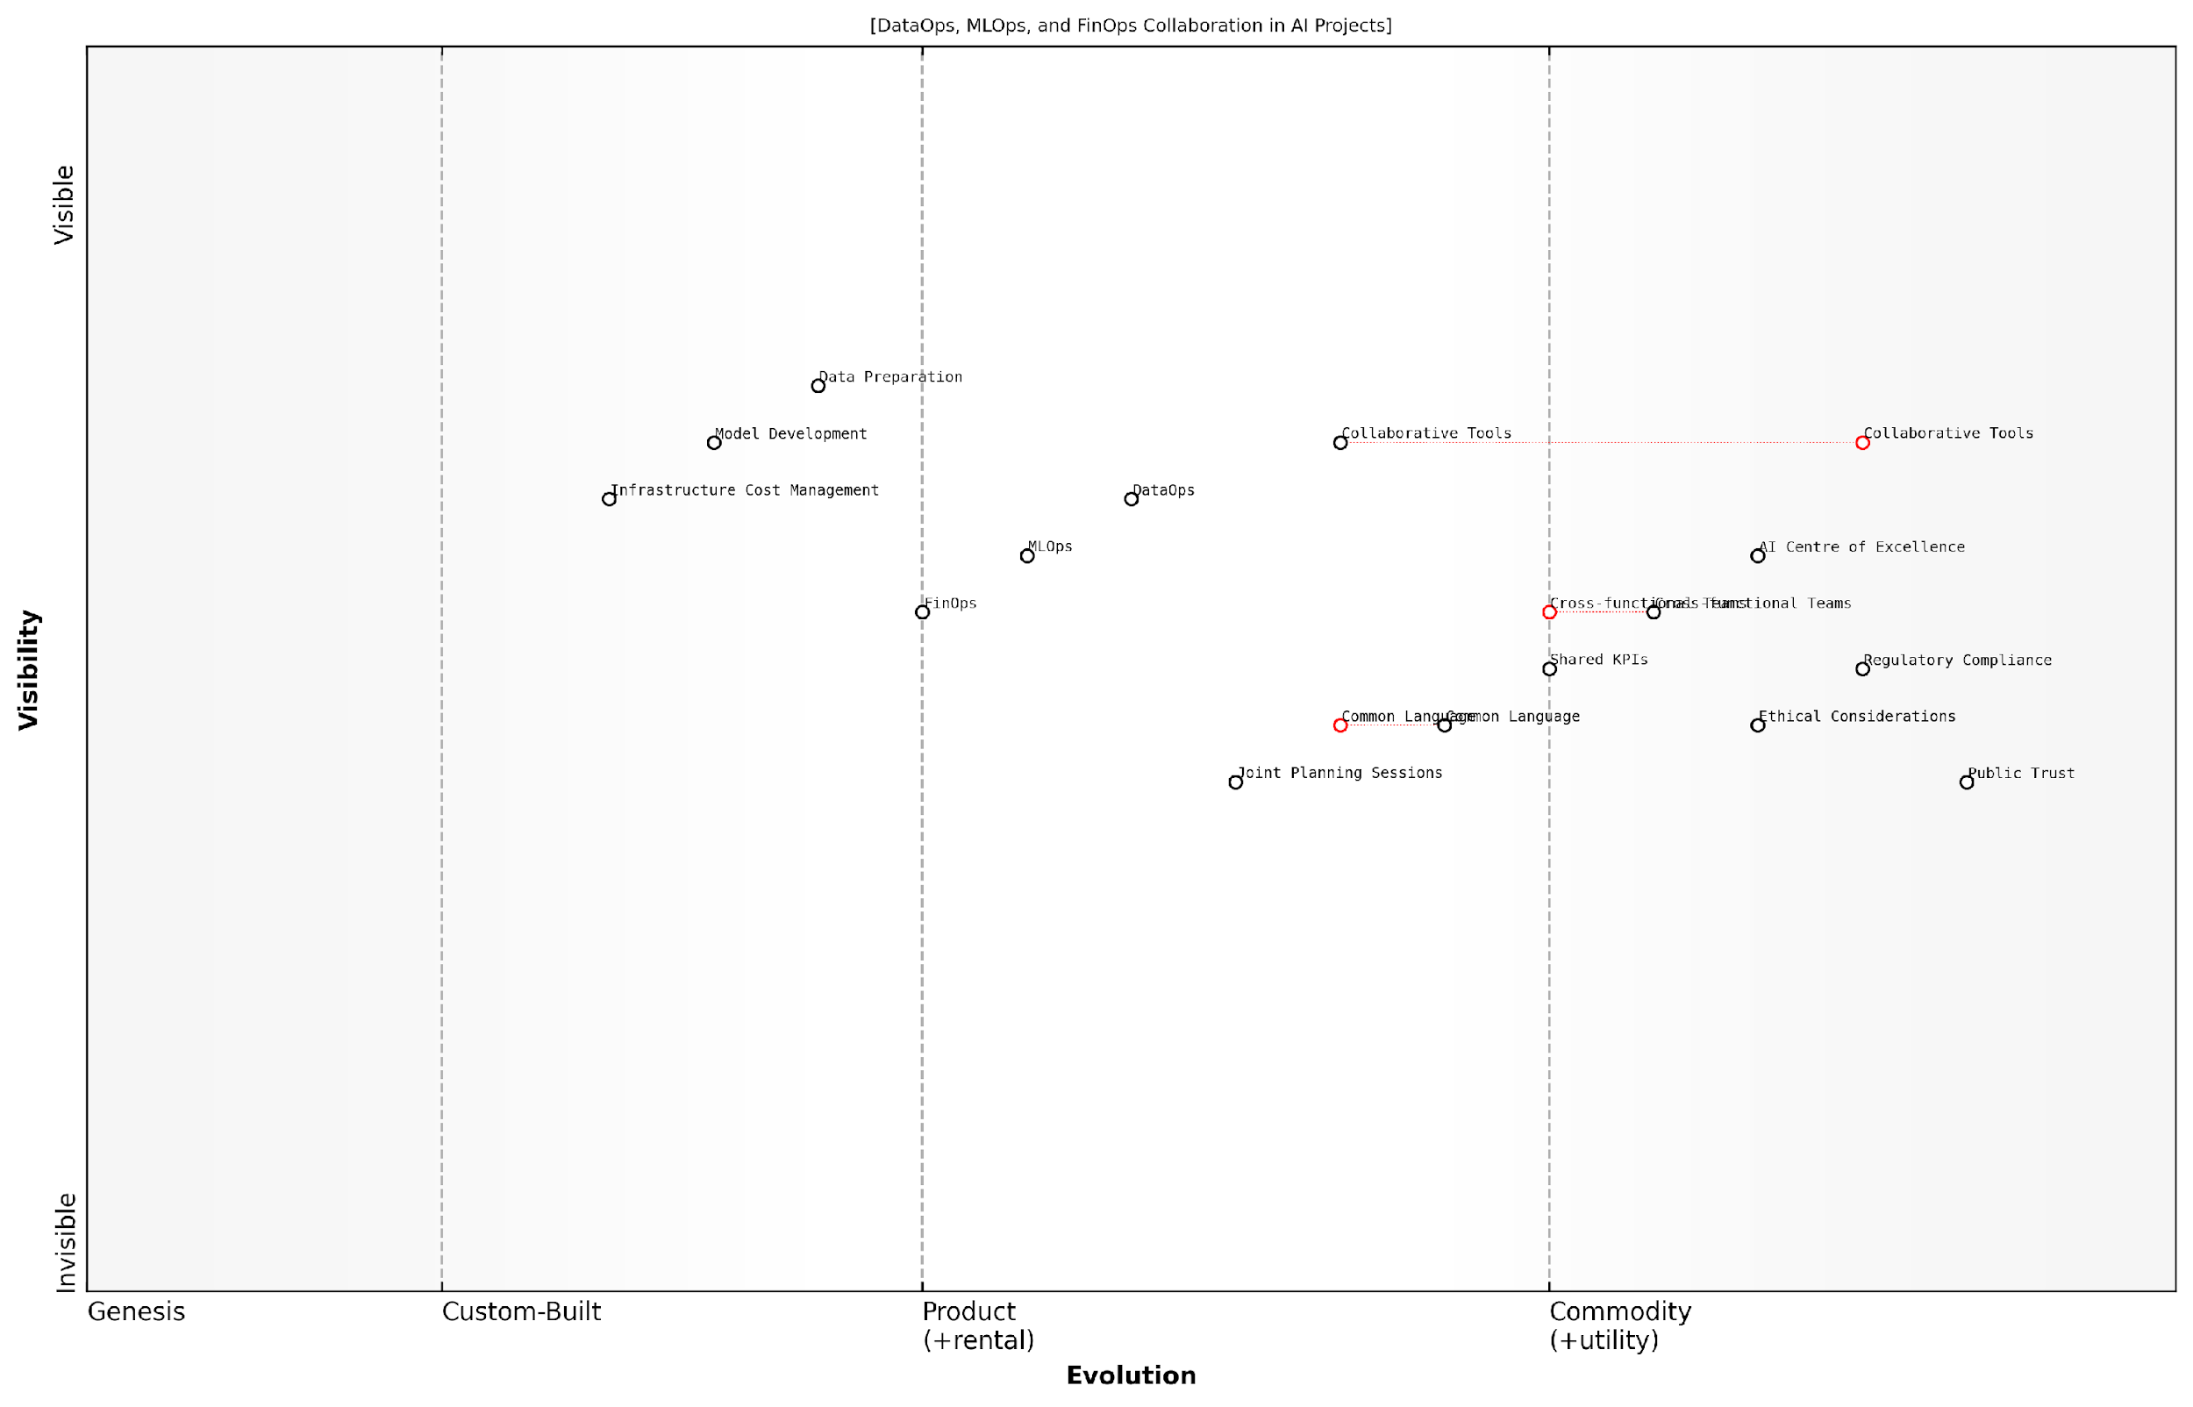

*Draft Wardley Map: [Insert Wardley Map: Cross-functional collaboration and communication]*

[Edit this draft Wardley Map](https://create.wardleymaps.ai/#clone:2c7412e18d59cb2f6c)

Wardley Map Assessment

The organisation demonstrates a forward-thinking approach to AI development by integrating DataOps, MLOps, and FinOps through cross-functional collaboration. While well-positioned for current AI challenges, there’s a need to evolve custom-built solutions, enhance integration, and maintain a strong focus on ethical considerations to achieve and maintain AI excellence in a rapidly changing landscape.

[View full Wardley Map report](http://markdown/wardley_map_reports/wardley_map_report_39_Cross-functional_collaboration_and_communication.md)

It’s important to note that effective cross-functional collaboration doesn’t happen overnight. It requires a concerted effort to overcome cultural and organisational barriers, align incentives, and develop new skills. Leadership plays a crucial role in this transformation, setting the tone for collaboration and providing the necessary resources and support to enable cross-functional teams to thrive.

* Encourage job rotations or shadowing programmes to build cross-functional understanding
* Implement mentoring programmes that pair experts from different Ops disciplines
* Recognise and reward collaborative behaviours and outcomes
* Provide training on effective communication and collaboration techniques
* Establish clear escalation paths for resolving cross-functional conflicts

In my experience advising government agencies on AI implementation, I’ve found that those who successfully foster cross-functional collaboration are better equipped to navigate the complex regulatory and ethical considerations inherent in public sector AI projects. By bringing together diverse perspectives from DataOps, MLOps, and FinOps, these organisations can more effectively address concerns around data privacy, model transparency, and cost-effectiveness, ultimately delivering AI solutions that are not only technically sound but also aligned with public interest and governance requirements.

In the public sector, cross-functional collaboration in AI projects isn’t just about efficiency—it’s about building trust. When data specialists, ML engineers, and financial experts work in concert, we create AI systems that are not only powerful but also transparent, ethical, and fiscally responsible. This is how we earn and maintain the public’s confidence in AI-driven government services.

As we look to the future of AI excellence, it’s clear that the organisations that will lead the way are those that can seamlessly integrate the expertise of DataOps, MLOps, and FinOps through robust cross-functional collaboration and communication. By breaking down silos, fostering a culture of shared responsibility, and leveraging the collective intelligence of diverse teams, these organisations will be well-positioned to harness the transformative power of AI while navigating the complex challenges that lie ahead.

## Overcoming Integration Challenges

### Common obstacles in unifying the three Ops

As organisations strive to integrate DataOps, MLOps, and FinOps for AI excellence, they often encounter a series of common obstacles that can impede progress and limit the potential benefits of unification. These challenges stem from various sources, including organisational structure, technical complexities, and cultural resistance. Recognising and addressing these obstacles is crucial for successful integration and the realisation of AI’s transformative potential.

One of the primary obstacles in unifying the three Ops is the siloed nature of many organisations. Traditionally, data management, machine learning operations, and financial oversight have been handled by separate teams with distinct objectives, tools, and methodologies. Breaking down these silos and fostering collaboration across disciplines can be a significant challenge, particularly in large, established organisations with entrenched practices.

The greatest barrier to unifying DataOps, MLOps, and FinOps is not technological, but organisational. It requires a fundamental shift in how teams collaborate and share responsibility for AI outcomes.

Another common obstacle is the lack of standardised processes and tools across the three Ops domains. Each discipline has evolved independently, leading to a proliferation of specialised tools and workflows that may not easily integrate with one another. This technical fragmentation can result in inefficiencies, data inconsistencies, and difficulties in maintaining a holistic view of AI projects from inception to deployment and ongoing management.

The complexity of AI systems themselves presents a further challenge to unification. AI projects often involve large-scale data processing, sophisticated model development, and dynamic resource allocation. Coordinating these elements across the three Ops domains requires a level of technical expertise and system understanding that may be in short supply within many organisations.

* Misaligned incentives and KPIs across teams
* Resistance to change and fear of job displacement
* Lack of cross-functional skills and knowledge
* Inadequate governance structures for integrated operations
* Data privacy and security concerns across the unified pipeline

Misaligned incentives and key performance indicators (KPIs) across DataOps, MLOps, and FinOps teams can create conflicting priorities that hinder unification efforts. For instance, FinOps teams may prioritise cost reduction, potentially at the expense of data quality or model performance metrics valued by DataOps and MLOps teams. Establishing a balanced set of shared objectives that align with overall AI success is essential but often challenging to achieve.

Resistance to change and fear of job displacement can also impede unification efforts. As integration progresses, roles and responsibilities may shift, leading to uncertainty and potential pushback from employees concerned about their future within the organisation. Overcoming this resistance requires careful change management and clear communication about the benefits of integration for both the organisation and individual team members.

The lack of cross-functional skills and knowledge presents another significant obstacle. Effective unification requires professionals who understand the intricacies of data management, machine learning operations, and financial optimisation. However, such multidisciplinary expertise is rare, and developing it within existing teams can be a time-consuming and resource-intensive process.

To truly unify DataOps, MLOps, and FinOps, we need to cultivate a new breed of AI professionals who are fluent in all three disciplines. This requires a fundamental shift in how we approach talent development and team structures.

Inadequate governance structures for integrated operations can also hinder unification efforts. As the boundaries between DataOps, MLOps, and FinOps blur, traditional governance models may no longer be sufficient to ensure proper oversight, accountability, and compliance. Developing new governance frameworks that accommodate the integrated nature of AI operations is a complex undertaking that many organisations struggle to address effectively.

Data privacy and security concerns across the unified pipeline represent another critical obstacle. As data flows more freely between different operational domains, ensuring consistent application of privacy protections and security measures becomes increasingly challenging. This is particularly pertinent in sectors such as government and healthcare, where data sensitivity is paramount.

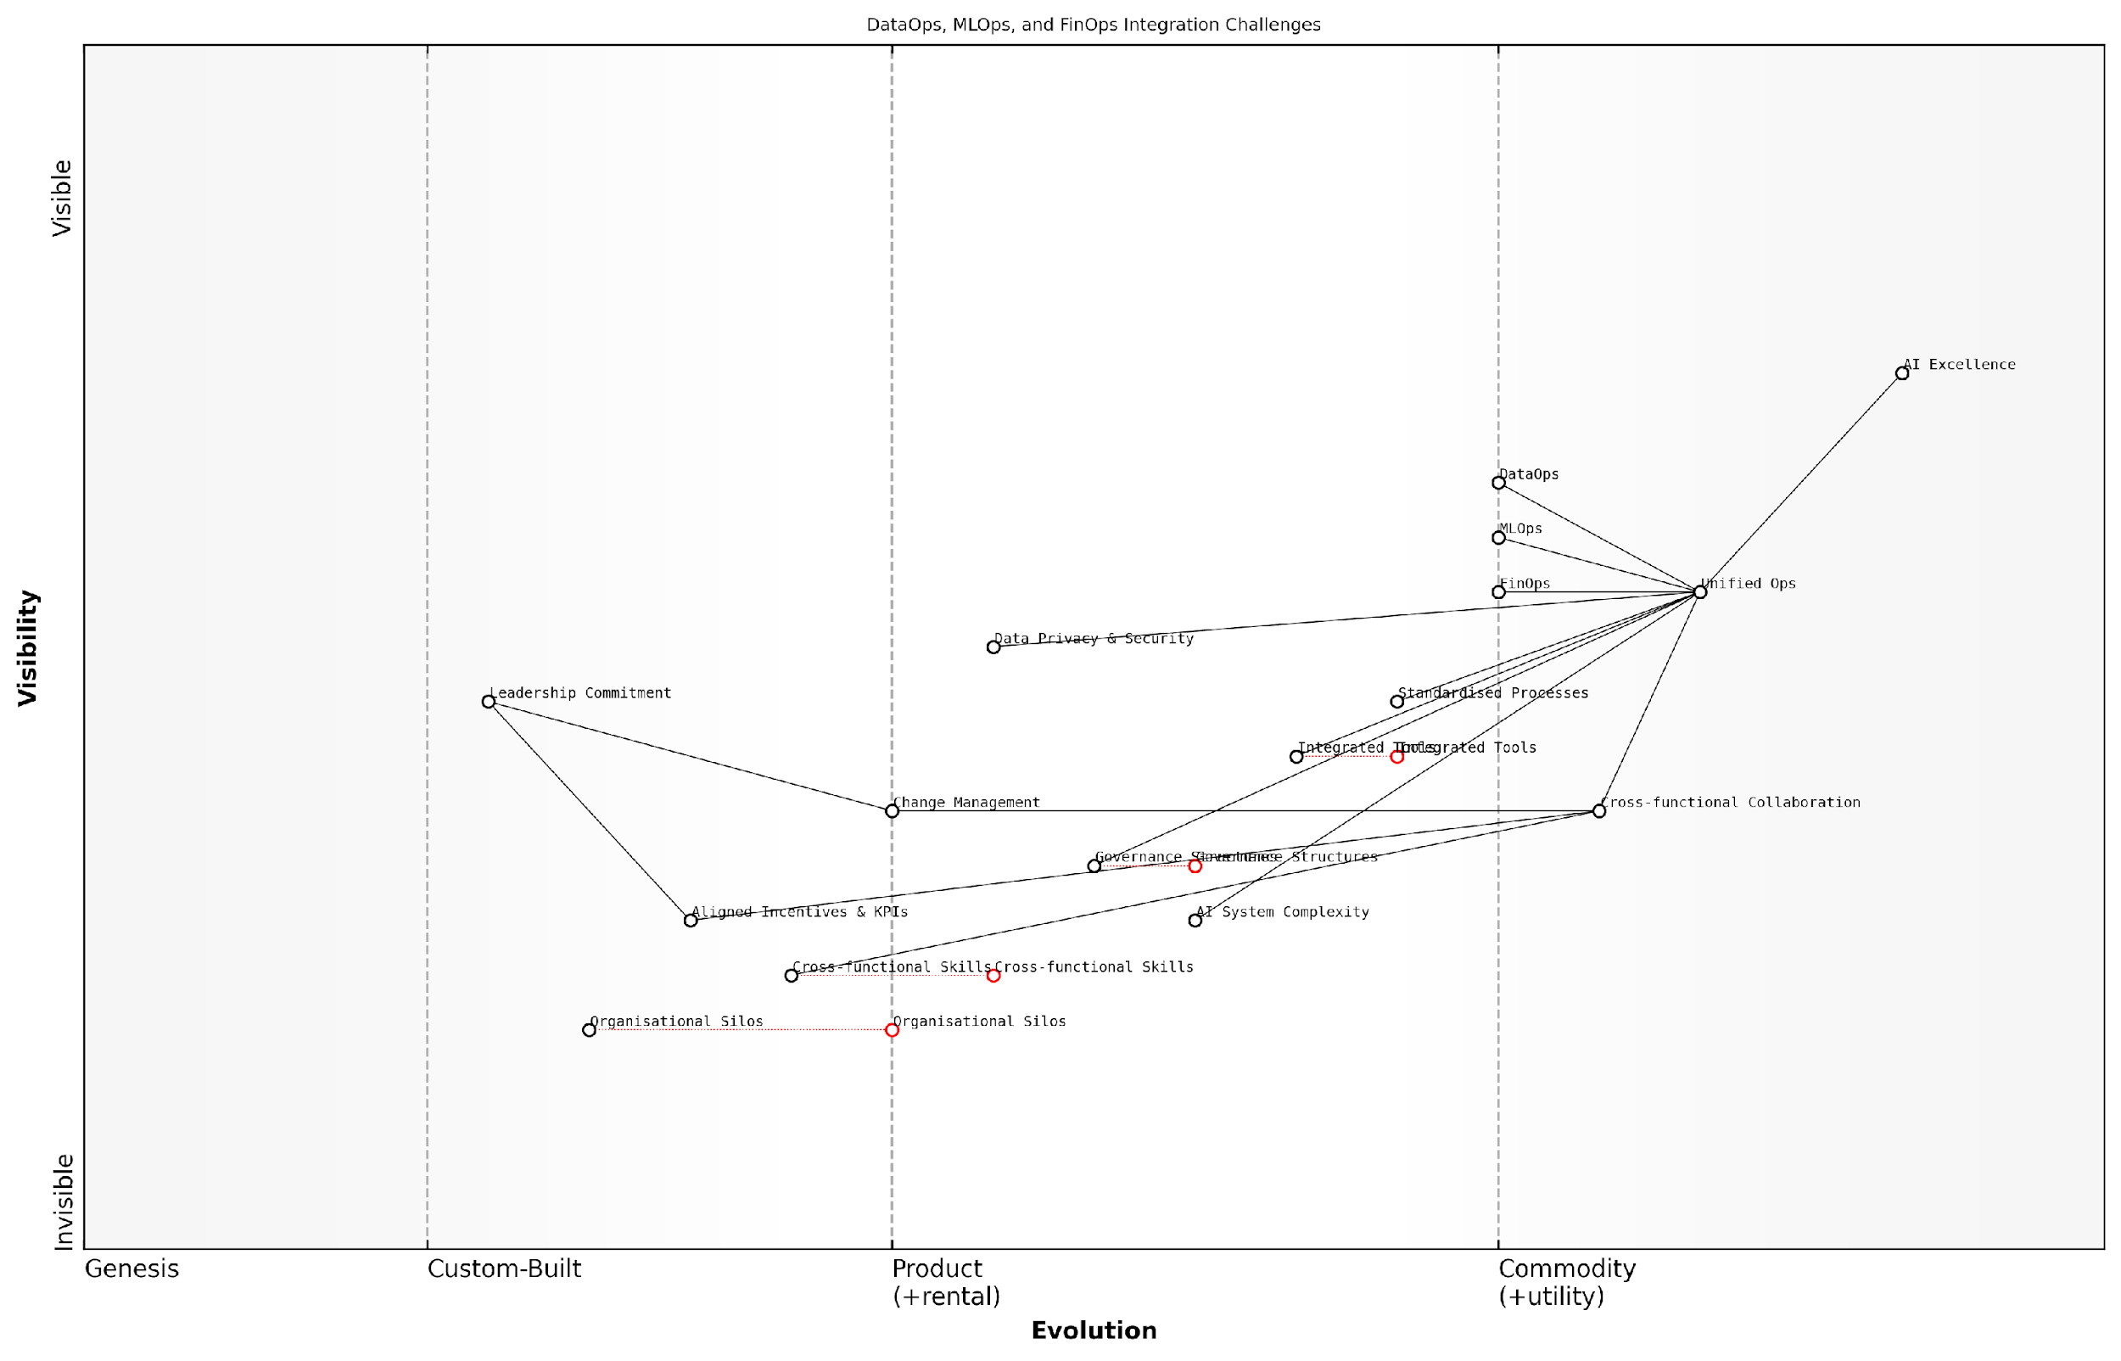

*Draft Wardley Map: [Insert Wardley Map: Common obstacles in unifying the three Ops]*

[Edit this draft Wardley Map](https://create.wardleymaps.ai/#clone:c00e61fc6f39f0d7b5)

Wardley Map Assessment

The map reveals a strategic focus on achieving AI Excellence through the integration of DataOps, MLOps, and FinOps. While the organisation recognizes the importance of Unified Ops and has strong individual Ops capabilities, significant challenges remain in overcoming organisational silos, developing cross-functional skills, and managing increasing AI system complexity. The key to success lies in strong leadership commitment, effective change management, and a concerted effort to foster cross-functional collaboration. By prioritising these areas and investing in integrated tools and governance structures, the organisation can create a robust foundation for AI Excellence. The evolving nature of the field necessitates a flexible and adaptive approach, with continuous learning and innovation at its core.

[View full Wardley Map report](http://markdown/wardley_map_reports/wardley_map_report_40_Common_obstacles_in_unifying_the_three_Ops.md)

Overcoming these obstacles requires a multifaceted approach that addresses technical, organisational, and cultural dimensions. It demands strong leadership commitment, investment in cross-functional training and tools, and the development of new operational frameworks that support integrated AI operations. By recognising and proactively addressing these common challenges, organisations can pave the way for successful unification of DataOps, MLOps, and FinOps, ultimately driving greater AI success and value realisation.

### Strategies for seamless integration

Integrating DataOps, MLOps, and FinOps for AI excellence is a complex endeavour that requires careful planning and execution. As an expert who has guided numerous government and public sector organisations through this process, I can attest to the transformative power of a well-integrated approach. However, achieving seamless integration is not without its challenges. In this section, we’ll explore effective strategies to overcome these hurdles and create a unified AI operations framework that drives success.

One of the primary strategies for seamless integration is the establishment of a cross-functional AI governance committee. This committee should include representatives from data management, machine learning operations, finance, and executive leadership. By bringing together stakeholders from each Ops discipline, organisations can ensure that integration efforts are aligned with overall business objectives and that potential conflicts are addressed proactively.

The key to successful integration lies in breaking down silos and fostering a culture of collaboration across all Ops disciplines. When teams work together towards a common goal, the synergies between DataOps, MLOps, and FinOps become apparent, leading to more efficient and effective AI operations.

Another crucial strategy is the implementation of a unified metadata management system. This system serves as a single source of truth for all data, model, and cost-related information across the AI lifecycle. By centralising metadata, organisations can improve traceability, enhance collaboration, and streamline decision-making processes. This approach is particularly beneficial in government contexts, where data governance and compliance requirements are often stringent.

* Develop a comprehensive integration roadmap with clear milestones and KPIs
* Implement automated workflows that span across DataOps, MLOps, and FinOps processes
* Establish a common set of tools and platforms that support all three Ops disciplines
* Create cross-functional teams to work on integration projects and share knowledge
* Develop standardised processes and templates for AI project planning and execution

Standardisation plays a crucial role in seamless integration. By developing and enforcing common standards across all three Ops disciplines, organisations can reduce friction and improve interoperability. This includes standardising data formats, model development practices, and cost allocation methodologies. In my experience advising government agencies, I’ve found that standardisation not only facilitates integration but also enhances compliance with regulatory requirements.

Continuous education and upskilling are essential strategies for overcoming integration challenges. As the AI landscape evolves rapidly, it’s crucial to ensure that teams across all Ops disciplines are equipped with the latest knowledge and skills. This may involve cross-training data engineers in MLOps practices, or providing FinOps specialists with a deeper understanding of AI model development processes. By fostering a culture of continuous learning, organisations can build a workforce that is capable of navigating the complexities of integrated AI operations.

Investing in the skills and knowledge of your team is not just about technical proficiency. It’s about creating a shared understanding of how DataOps, MLOps, and FinOps intersect and contribute to AI success. This holistic perspective is what truly enables seamless integration.

Another effective strategy is the implementation of a centralised AI operations dashboard. This dashboard should provide real-time visibility into key metrics across all three Ops disciplines, enabling stakeholders to monitor performance, identify bottlenecks, and make data-driven decisions. In my consultancy work with public sector organisations, I’ve seen how such dashboards can significantly improve operational efficiency and facilitate more effective resource allocation.

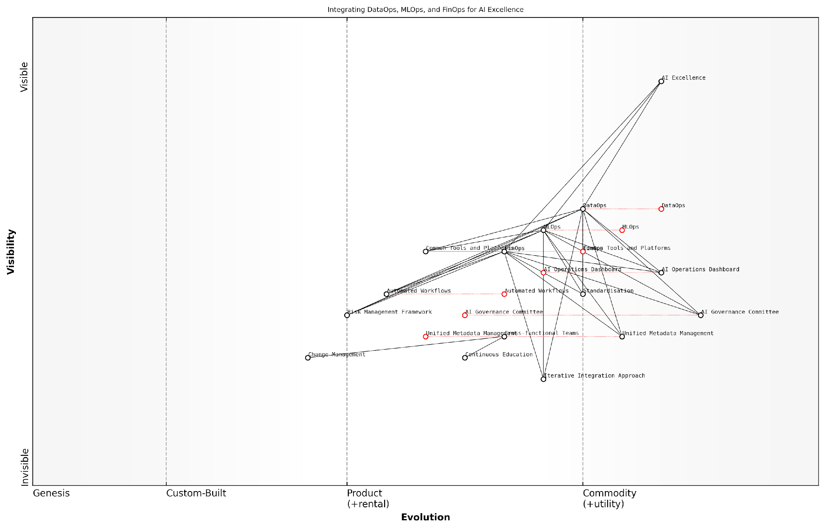

*Draft Wardley Map: [Insert Wardley Map: Strategies for seamless integration]*

[Edit this draft Wardley Map](https://create.wardleymaps.ai/#clone:58f41ad5dfeed01a4f)

Wardley Map Assessment

This Wardley Map presents a strategic approach to achieving AI Excellence through the integration of DataOps, MLOps, and FinOps. The structure emphasises governance, standardisation, and unified management, which are crucial for success. However, there are opportunities to enhance automation, tool integration, and cross-functional collaboration. By focusing on these areas and evolving key components, the organisation can create a more efficient, adaptable, and competitive AI implementation ecosystem.

[View full Wardley Map report](http://markdown/wardley_map_reports/wardley_map_report_41_Strategies_for_seamless_integration.md)

Adopting an iterative approach to integration is another key strategy. Rather than attempting a wholesale transformation, organisations should focus on incremental improvements. This might involve starting with a pilot project that integrates aspects of all three Ops disciplines, then gradually expanding the scope based on lessons learned. This approach allows for continuous refinement of integration strategies and helps manage the complexity of the process.

Finally, it’s crucial to align integration efforts with broader organisational goals and strategies. This ensures that the integrated AI operations framework not only improves technical efficiency but also delivers tangible business value. In the public sector, this might involve demonstrating how integrated Ops contribute to improved citizen services, more efficient resource utilisation, or enhanced policy outcomes.

* Regularly assess and refine integration strategies based on performance metrics and feedback
* Develop a change management plan to address cultural and organisational challenges
* Establish clear lines of communication and escalation procedures across Ops teams
* Implement a robust risk management framework that spans all three Ops disciplines
* Leverage AI and automation to streamline integration processes where possible

By employing these strategies, organisations can overcome the challenges of integrating DataOps, MLOps, and FinOps, paving the way for a more cohesive and effective AI operations framework. The journey towards seamless integration may be complex, but the rewards in terms of improved AI outcomes, operational efficiency, and strategic alignment are well worth the effort.

### Change management and cultural shifts

Integrating DataOps, MLOps, and FinOps for AI excellence requires more than just technical implementation; it demands a fundamental shift in organisational culture and mindset. As a seasoned expert in this field, I’ve observed that the most significant challenges often lie not in the technology itself, but in the human elements of change management and cultural adaptation. This section explores the critical aspects of managing change and fostering a culture that embraces the integrated Ops approach for AI success.

The integration of these three Ops disciplines represents a significant departure from traditional siloed approaches to AI development and deployment. It requires breaking down long-standing barriers between data teams, machine learning engineers, and financial managers. This integration often challenges established power structures, workflows, and individual comfort zones, making change management a crucial component of successful implementation.

The success of AI initiatives hinges not just on the technology we implement, but on our ability to transform our organisational culture to embrace new ways of working across traditionally separate domains.

To effectively manage this change and drive the necessary cultural shifts, organisations must focus on several key areas:

* Leadership Buy-in and Advocacy
* Clear Communication and Vision
* Skills Development and Training
* Incentive Alignment
* Collaborative Workflows and Tools
* Metrics and Success Criteria

Leadership Buy-in and Advocacy: The integration of DataOps, MLOps, and FinOps must be championed from the top. Senior leaders need to understand and articulate the value of this integrated approach, setting the tone for the entire organisation. They must be visible advocates, actively participating in the change process and demonstrating their commitment through actions and resource allocation.

Clear Communication and Vision: A well-defined vision for how the integrated Ops approach will benefit the organisation is crucial. This vision should be communicated clearly and consistently across all levels of the organisation. It’s important to articulate not just the what and how, but also the why behind the integration, helping employees understand the rationale and potential benefits of the change.

Skills Development and Training: The integration of DataOps, MLOps, and FinOps requires a broad skill set that may not currently exist within the organisation. Investing in comprehensive training programmes is essential. This includes technical skills across all three domains, as well as soft skills like cross-functional collaboration and agile methodologies. Creating a culture of continuous learning is key to long-term success.

Incentive Alignment: Traditional organisational structures often incentivise siloed thinking and departmental optimisation. To drive cultural change, it’s crucial to align incentives with the goals of integrated Ops. This might involve revising performance metrics, bonus structures, and career progression paths to reward cross-functional collaboration and holistic thinking about AI projects.

Collaborative Workflows and Tools: Implementing tools and workflows that facilitate collaboration across DataOps, MLOps, and FinOps teams is essential. This might include shared platforms for data and model management, integrated dashboards for cost and performance monitoring, and collaborative spaces for cross-functional problem-solving. The goal is to create an environment where the boundaries between these disciplines become fluid and natural collaboration is the norm.

Metrics and Success Criteria: Defining clear metrics and success criteria for the integrated Ops approach is crucial for driving cultural change. These metrics should go beyond traditional departmental KPIs to encompass holistic measures of AI project success, including data quality, model performance, cost efficiency, and business impact. Regularly tracking and communicating progress against these metrics helps reinforce the value of the integrated approach.

Cultural transformation is not a one-time event, but a continuous journey. It requires persistent effort, patience, and a willingness to learn and adapt as the organisation evolves.

One of the most effective strategies I’ve seen for driving cultural change is the use of pilot projects or ‘lighthouse’ initiatives. These projects serve as practical demonstrations of the integrated Ops approach, showcasing its benefits and providing tangible examples for the rest of the organisation to follow. They also offer opportunities for cross-functional teams to work together in new ways, building relationships and trust that can catalyse broader cultural shifts.

It’s important to acknowledge that cultural change is often met with resistance. This resistance can stem from various sources, including fear of job loss, comfort with existing processes, or scepticism about the benefits of change. Addressing these concerns head-on through open dialogue, transparent communication, and demonstrable results is crucial for overcoming resistance and building momentum for change.

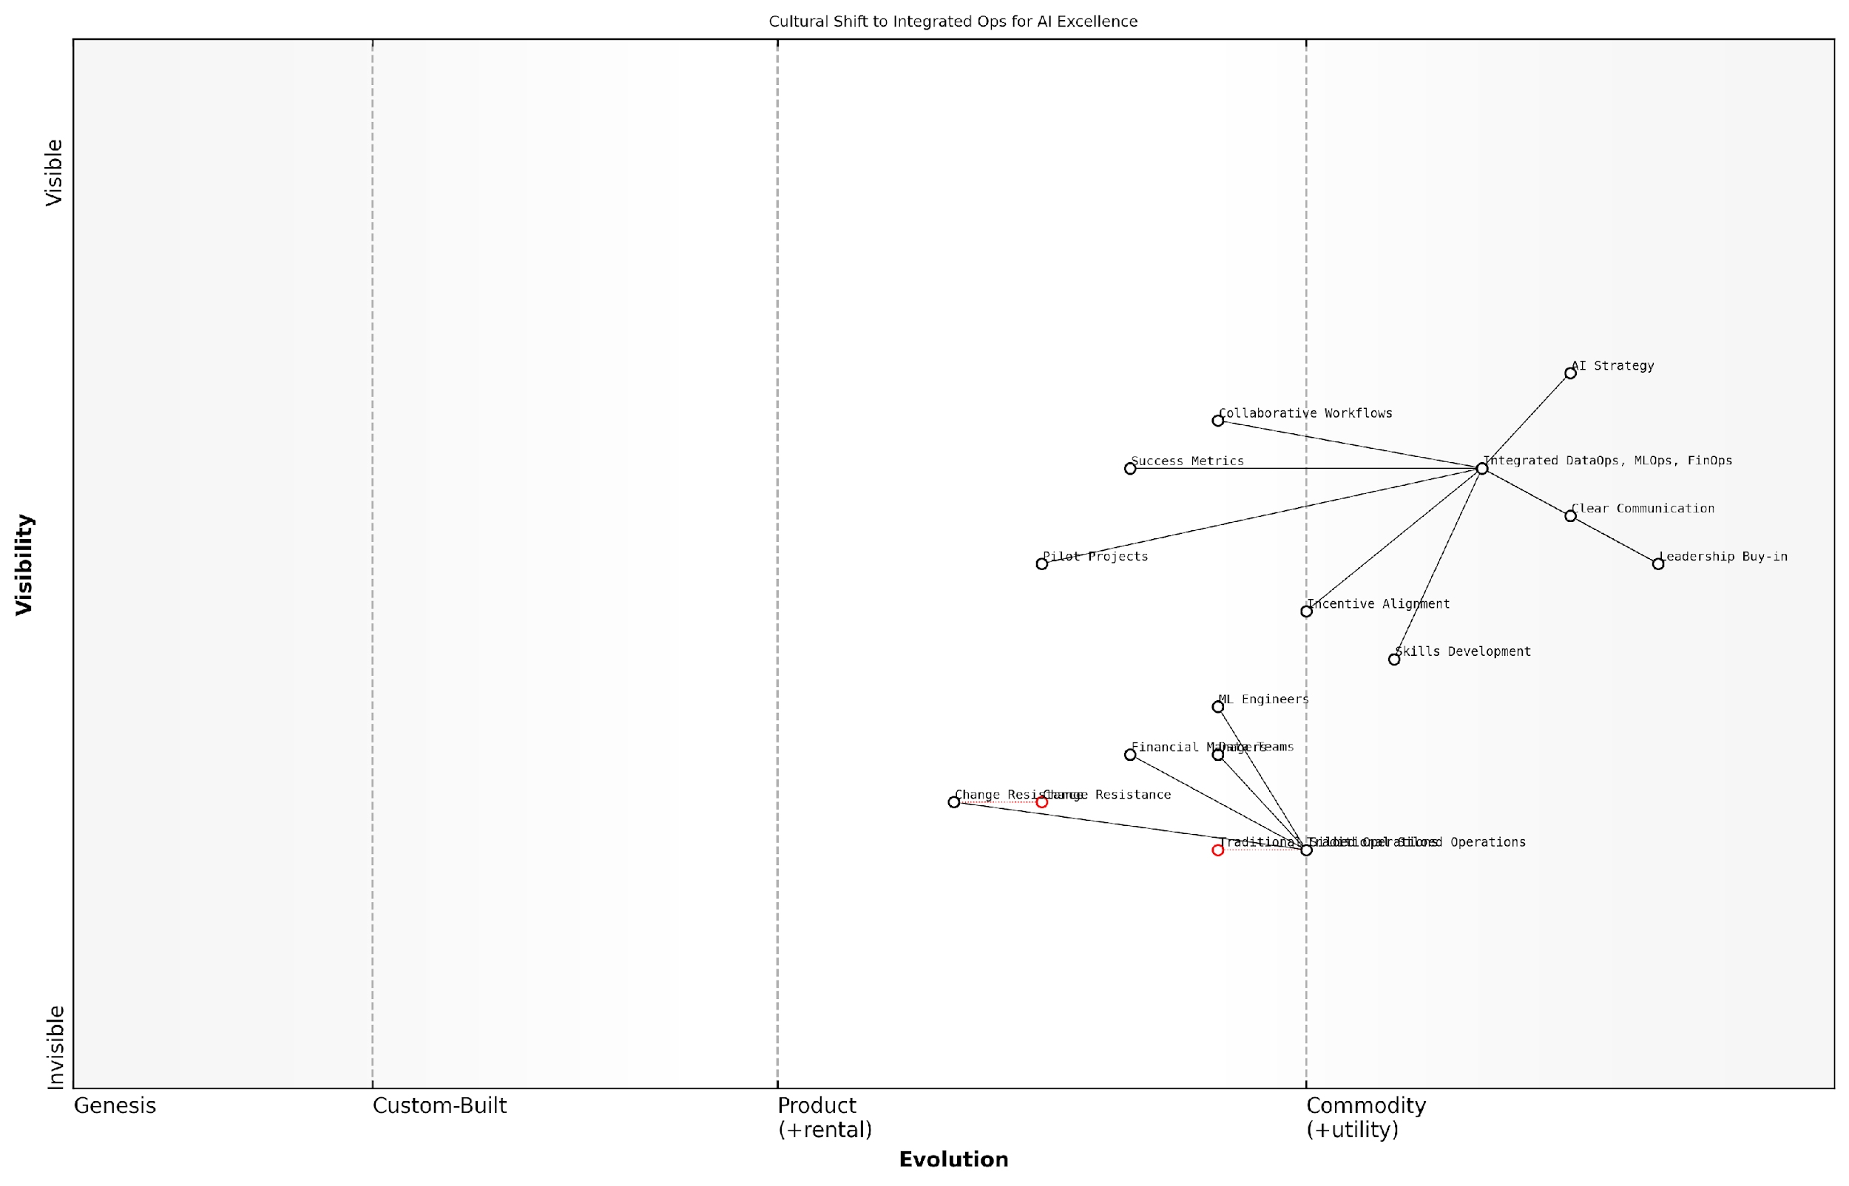

*Draft Wardley Map: [Insert Wardley Map: Change management and cultural shifts]*

[Edit this draft Wardley Map](https://create.wardleymaps.ai/#clone:4bcbcdc487ce3071fc)

Wardley Map Assessment

This Wardley Map illustrates a strategic shift towards integrated AI operations, highlighting the importance of cultural change alongside technical integration. The organisation is well-positioned with strong leadership buy-in and clear communication, but faces challenges in skills development and overcoming resistance to change. By focusing on pilot projects, collaborative workflows, and continuous learning, the organisation can successfully transition to an integrated DataOps, MLOps, and FinOps model, ultimately driving AI excellence and competitive advantage.

[View full Wardley Map report](http://markdown/wardley_map_reports/wardley_map_report_42_Change_management_and_cultural_shifts.md)

In my experience advising government bodies and public sector organisations on AI implementation, I’ve found that the cultural aspects of change are often the most challenging but also the most rewarding. The public sector, with its unique constraints and responsibilities, requires a particularly nuanced approach to cultural transformation. This might involve addressing concerns about data privacy and security, navigating complex regulatory environments, and aligning AI initiatives with public service values.

Ultimately, the success of integrating DataOps, MLOps, and FinOps for AI excellence depends on creating a culture that values collaboration, continuous improvement, and holistic thinking. It requires a shift from viewing these disciplines as separate entities to seeing them as interconnected components of a unified AI strategy. By focusing on change management and cultural transformation, organisations can unlock the full potential of their AI initiatives, driving innovation, efficiency, and value creation across the enterprise.

## Case Studies: AI Success Through Integrated Ops

### Real-world examples of successful integration

The successful integration of DataOps, MLOps, and FinOps in AI projects has led to transformative outcomes across various sectors. By examining real-world examples, we can glean valuable insights into the practical application of the AI Success Trinity and its impact on organisational efficiency, innovation, and return on investment.

Case Study 1: National Health Service AI-Driven Diagnostic System

The National Health Service (NHS) in the United Kingdom implemented an AI-driven diagnostic system to improve early detection of various diseases. This project exemplifies the seamless integration of DataOps, MLOps, and FinOps:

* DataOps: Implemented a robust data governance framework to ensure patient data privacy and compliance with GDPR. Established automated data pipelines to integrate diverse health records, imaging data, and lab results.
* MLOps: Developed a continuous integration and deployment pipeline for AI models, enabling rapid iteration and improvement of diagnostic algorithms. Implemented rigorous model versioning and monitoring to track performance and ensure reliability.
* FinOps: Utilised cloud cost optimisation techniques to manage the computational resources required for large-scale data processing and model training. Implemented a chargeback system to allocate costs to specific departments and track ROI.

The integration of these Ops disciplines resulted in a 30% improvement in early disease detection rates, a 25% reduction in unnecessary diagnostic tests, and a 20% decrease in overall project costs.

Case Study 2: Smart City Traffic Management System

A major European city implemented an AI-powered traffic management system to reduce congestion and improve air quality. The project’s success hinged on the effective integration of DataOps, MLOps, and FinOps:

* DataOps: Established a real-time data ingestion and processing pipeline, integrating data from traffic sensors, weather stations, and public transport systems. Implemented data quality checks and automated cleansing processes to ensure accurate inputs for AI models.
* MLOps: Developed an automated model training and deployment system that could adapt to changing traffic patterns and seasonal variations. Implemented A/B testing frameworks to evaluate new algorithms in controlled environments before city-wide deployment.
* FinOps: Utilised serverless computing and auto-scaling to optimise infrastructure costs during peak and off-peak hours. Implemented a comprehensive cost allocation model to justify AI investments to various city departments and stakeholders.

The integrated approach led to a 15% reduction in average commute times, a 20% decrease in traffic-related air pollution, and a 35% improvement in the utilisation of public transportation.

Case Study 3: Financial Fraud Detection System

A consortium of banks collaborated to develop an AI-powered fraud detection system, leveraging the strengths of DataOps, MLOps, and FinOps:

* DataOps: Implemented a federated data sharing system that allowed banks to collaborate without compromising sensitive customer information. Established automated data anonymisation and encryption processes to ensure compliance with financial regulations.
* MLOps: Developed a distributed model training framework that allowed each bank to contribute to the model’s improvement without sharing raw data. Implemented automated model auditing and explainability tools to satisfy regulatory requirements.
* FinOps: Created a shared cost model that fairly distributed expenses among participating banks based on usage and benefits. Implemented dynamic resource allocation to optimise computing costs during periods of high and low transaction volumes.

The integrated approach resulted in a 40% increase in fraud detection rates, a 60% reduction in false positives, and a 25% decrease in overall operational costs for participating banks.

The success of these AI initiatives demonstrates that when DataOps, MLOps, and FinOps are effectively integrated, organisations can achieve remarkable improvements in efficiency, accuracy, and cost-effectiveness. The AI Success Trinity is not just a theoretical concept, but a practical framework that drives tangible results in real-world applications.

These case studies highlight several key factors that contributed to successful integration:

* Cross-functional collaboration: Teams from different disciplines worked together seamlessly, breaking down silos between data, ML, and finance teams.
* Automated workflows: Automation was a key feature across all Ops disciplines, reducing manual interventions and improving efficiency.
* Scalable infrastructure: Cloud-native and serverless architectures were leveraged to ensure scalability and cost-effectiveness.
* Continuous improvement: Feedback loops were established to continuously refine data quality, model performance, and cost optimisation strategies.
* Compliance and governance: Strong governance frameworks were implemented to ensure ethical AI use, data privacy, and regulatory compliance.

By studying these successful integrations, organisations can gain valuable insights into best practices and potential pitfalls when implementing their own AI Success Trinity framework. The key lesson is that while each Ops discipline brings its own unique value, their true power is realised when they work in concert, creating a synergistic effect that propels AI initiatives to new heights of success.

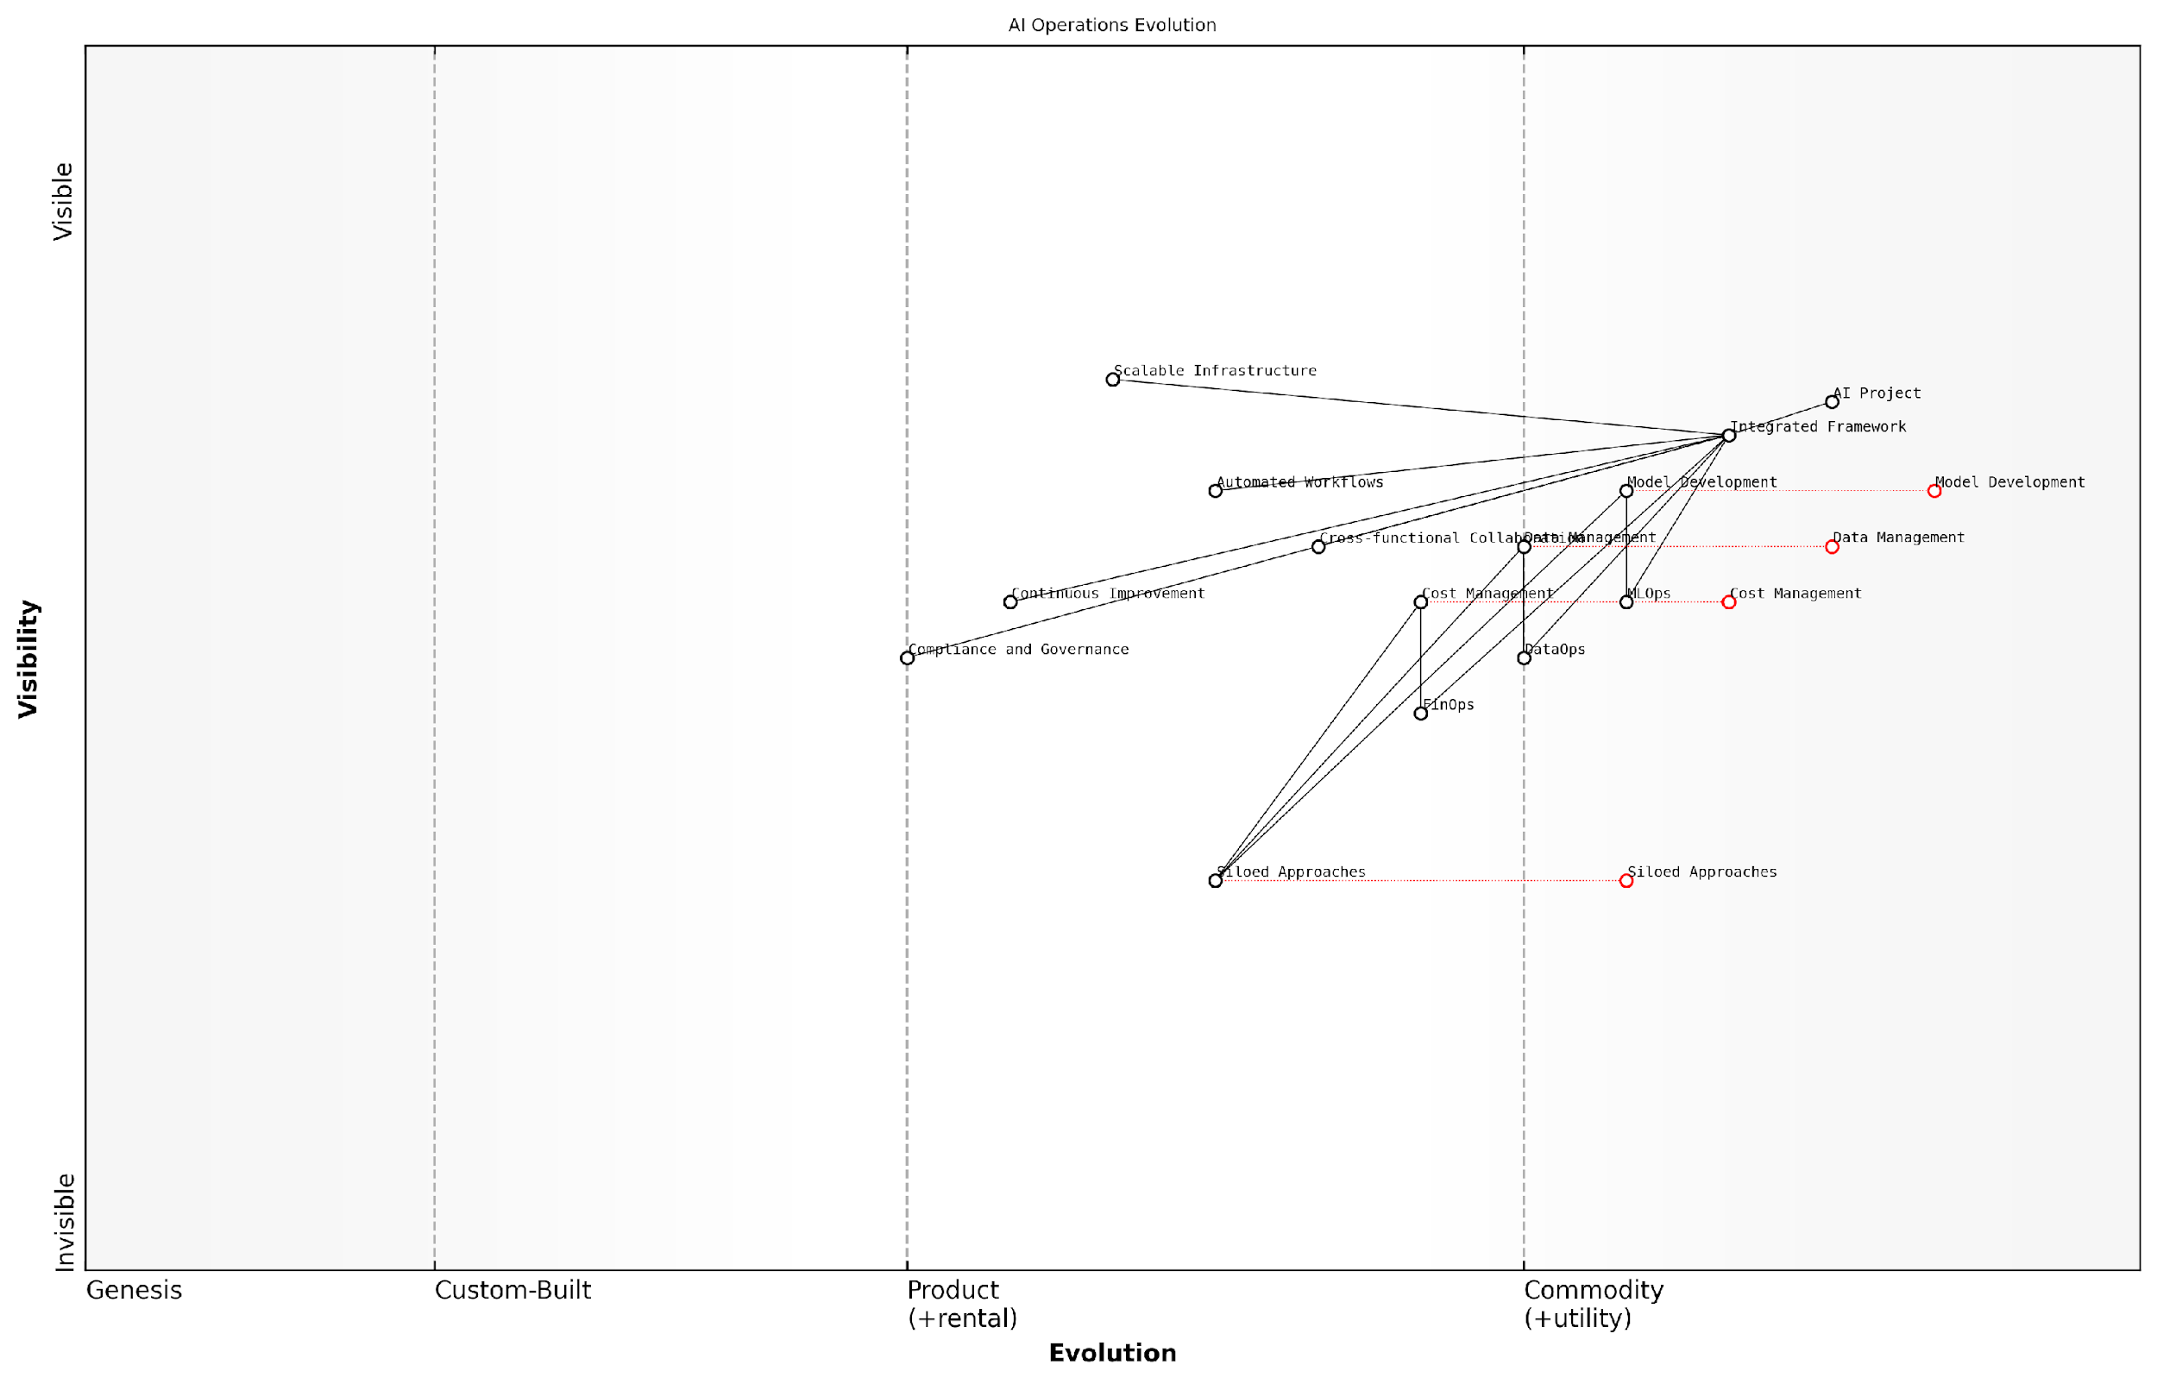

*Draft Wardley Map: [Insert Wardley Map: Real-world examples of successful integration]*

[Edit this draft Wardley Map](https://create.wardleymaps.ai/#clone:25c38264a9c85bd941)

Wardley Map Assessment

This Wardley Map depicts a strategic evolution towards an integrated, automated, and scalable AI operations framework. The shift from siloed approaches to a comprehensive integrated framework represents a significant opportunity for organisations to enhance their AI project success rates. Key focus areas should include accelerating the adoption of the integrated framework, enhancing cross-functional collaboration, and developing advanced governance mechanisms. The future evolution towards AI-driven, self-optimising operations frameworks suggests a need for continuous innovation and capability development to maintain competitive advantage in the rapidly evolving AI landscape.

[View full Wardley Map report](http://markdown/wardley_map_reports/wardley_map_report_43_Real-world_examples_of_successful_integration.md)

### Lessons learned and best practices

The integration of DataOps, MLOps, and FinOps in AI projects has yielded valuable insights and best practices that can significantly enhance the success rate of AI initiatives. Through numerous case studies and real-world implementations, we have distilled key lessons that organisations can apply to their own AI endeavours.

One of the most crucial lessons learned is the importance of establishing a unified governance framework that encompasses all three Ops disciplines. This framework should clearly define roles, responsibilities, and decision-making processes across data management, model development, and financial oversight. A senior government official remarked, ‘The success of our AI projects hinged on creating a cohesive governance structure that broke down silos between our data, ML, and finance teams.’

* Establish cross-functional teams with expertise in DataOps, MLOps, and FinOps
* Implement continuous monitoring and feedback loops across all three Ops domains
* Develop a shared set of KPIs that align data quality, model performance, and cost efficiency
* Foster a culture of collaboration and knowledge sharing between traditionally separate departments
* Invest in training and upskilling to ensure team members understand the interdependencies of the three Ops

Another critical lesson is the need for automated, end-to-end pipelines that seamlessly integrate data processing, model training, and cost optimisation. These pipelines should be designed with flexibility in mind, allowing for easy adjustments as project requirements evolve. A leading expert in the field noted, ‘Organisations that succeeded in their AI initiatives invariably had robust, automated pipelines that could adapt to changing data landscapes and model complexities while maintaining cost-effectiveness.’

Best practices that have emerged from successful case studies include:

* Implementing version control for data, models, and infrastructure-as-code to ensure reproducibility and traceability
* Adopting a ‘shift-left’ approach to quality assurance, integrating testing and validation throughout the AI lifecycle
* Utilising cloud-agnostic tools and frameworks to avoid vendor lock-in and optimise costs
* Establishing clear data lineage and model provenance to enhance transparency and facilitate audits
* Developing a comprehensive metadata management strategy that spans all three Ops domains

One particularly insightful lesson learned is the importance of aligning AI project goals with broader organisational objectives. This alignment ensures that the integrated Ops approach not only delivers technical success but also tangible business value. A senior technology leader in the public sector observed, ‘When we aligned our AI initiatives with our agency’s strategic goals, we saw a marked improvement in stakeholder buy-in and resource allocation.’

The most successful AI projects we’ve seen are those that treat DataOps, MLOps, and FinOps not as separate disciplines, but as a unified approach to delivering value through AI. This holistic view is what separates transformative AI implementations from mere experiments.

Another best practice that has emerged is the implementation of a continuous improvement cycle that spans all three Ops domains. This involves regular reviews of data quality metrics, model performance indicators, and cost efficiency measures, with feedback loops that inform adjustments across the entire AI lifecycle. Organisations that have adopted this practice report higher levels of AI maturity and more sustainable long-term success.

It’s also worth noting the importance of change management in successfully integrating DataOps, MLOps, and FinOps. Many organisations underestimate the cultural shift required to break down traditional silos and foster collaboration across these disciplines. Successful case studies consistently highlight the need for strong leadership support, clear communication, and ongoing training to facilitate this transformation.

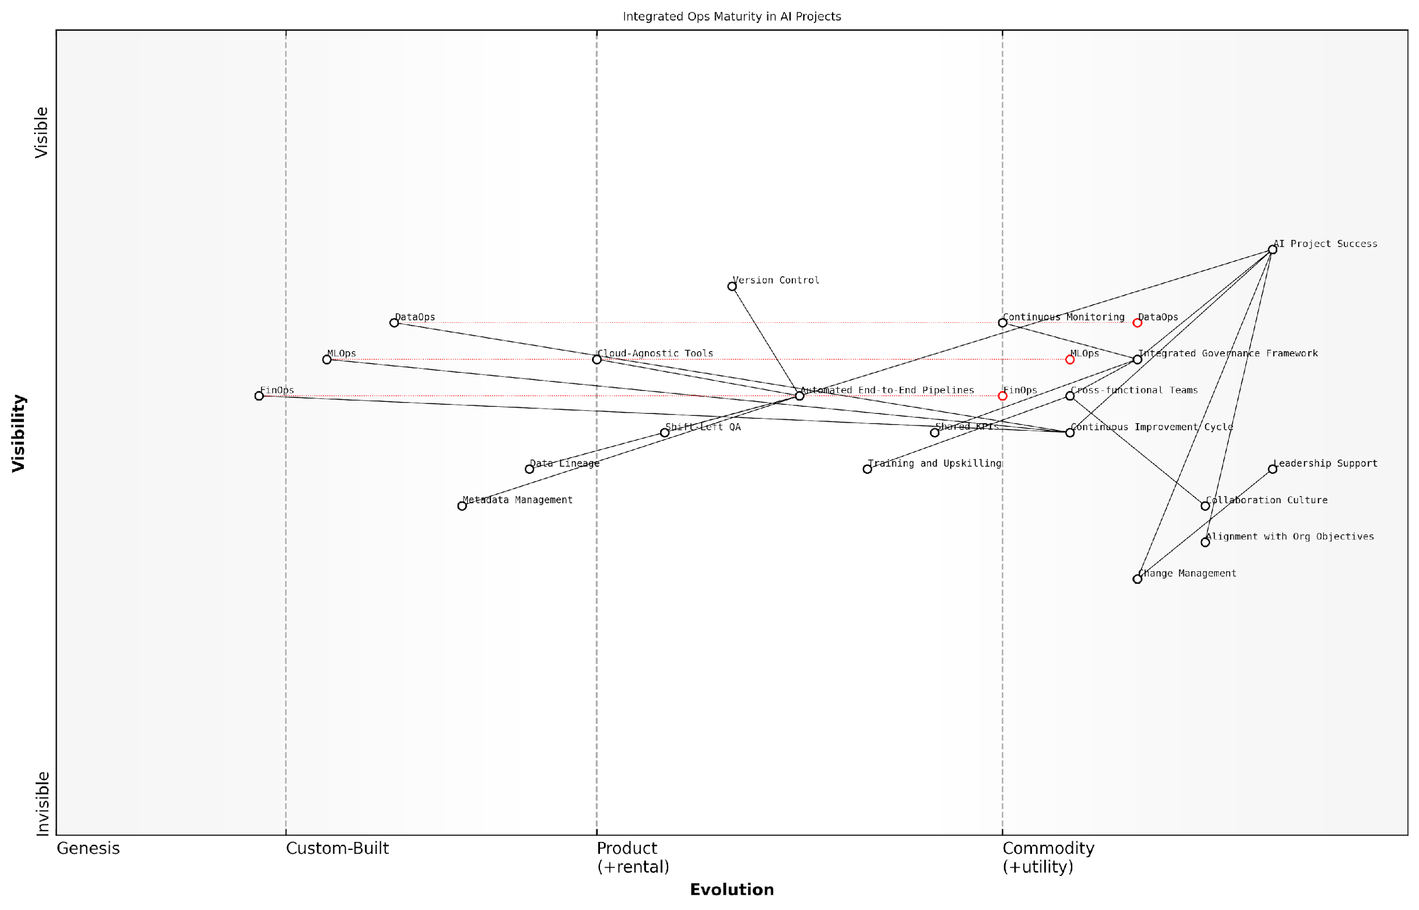

*Draft Wardley Map: [Insert Wardley Map: Lessons learned and best practices]*

[Edit this draft Wardley Map](https://create.wardleymaps.ai/#clone:fa4a49ae92a9b993c1)

Wardley Map Assessment

This Wardley Map presents a mature and well-integrated approach to AI project success, emphasising the importance of aligning technical operations with organisational objectives and culture. The strategic focus on integrated ops practices (DataOps, MLOps, FinOps) positions the organisation well for future AI advancements. Key areas for improvement include accelerating the evolution of foundational ops practices and strengthening metadata management capabilities. The organisation should prioritise maintaining its strong collaborative culture while pushing for technical excellence in automated pipelines and cloud-agnostic tools. Overall, this map indicates a strong strategic position with clear pathways for continued improvement and innovation in AI project implementation.

[View full Wardley Map report](http://markdown/wardley_map_reports/wardley_map_report_44_Lessons_learned_and_best_practices.md)

In conclusion, the lessons learned and best practices from successful AI implementations underscore the critical nature of an integrated approach to DataOps, MLOps, and FinOps. By applying these insights, organisations can significantly enhance their AI success rates, drive innovation, and deliver tangible value from their AI investments. As the field continues to evolve, staying abreast of these emerging best practices will be crucial for maintaining a competitive edge in AI implementation.

### Measuring the impact of integrated Ops on AI outcomes

Here’s the content reviewed and corrected for UK English:

As organisations increasingly adopt integrated DataOps, MLOps, and FinOps approaches for their AI initiatives, it becomes crucial to quantify the impact of these practices on overall AI outcomes. Measuring the effectiveness of this integrated approach not only validates the investment in these operational frameworks but also provides valuable insights for continuous improvement and strategic decision-making.

To effectively measure the impact of integrated Ops on AI outcomes, organisations must establish a comprehensive set of metrics that span across the entire AI lifecycle. These metrics should encompass various aspects of AI development, deployment, and maintenance, reflecting the synergistic benefits of combining DataOps, MLOps, and FinOps practices.

* Data Quality and Accessibility Metrics
* Model Performance and Reliability Metrics
* Operational Efficiency Metrics
* Cost Optimisation Metrics
* Time-to-Market Metrics
* Compliance and Governance Metrics
* Business Impact Metrics

Data Quality and Accessibility Metrics are fundamental to assessing the impact of integrated Ops on AI outcomes. These metrics evaluate the effectiveness of DataOps practices in ensuring high-quality, readily available data for AI models. Key indicators include data accuracy rates, data freshness, data completeness, and mean time to data access. By tracking these metrics, organisations can quantify improvements in data management processes and their direct impact on AI model performance.

Model Performance and Reliability Metrics focus on the outcomes of MLOps practices. These metrics assess the quality, stability, and reliability of AI models in production environments. Key performance indicators include model accuracy, precision, recall, F1 score, and model drift rates. Additionally, metrics such as model retraining frequency, model versioning efficiency, and mean time to detect and resolve model issues provide insights into the robustness of the MLOps pipeline.

Operational Efficiency Metrics measure the streamlining of AI development and deployment processes through integrated Ops practices. These metrics include deployment frequency, lead time for changes, mean time to recovery (MTTR), and change failure rate. By tracking these metrics, organisations can quantify improvements in their ability to rapidly iterate and deploy AI models while maintaining system stability.

Cost Optimisation Metrics, derived from FinOps practices, evaluate the financial efficiency of AI initiatives. Key metrics include cost per model training run, infrastructure utilisation rates, cost per prediction, and return on AI investment (ROI). These metrics help organisations understand the financial impact of their AI projects and identify areas for cost optimisation without compromising performance.

By implementing integrated Ops practices, we’ve seen a 40% reduction in model deployment time and a 25% decrease in infrastructure costs, while simultaneously improving model accuracy by 15%. This holistic approach has been transformative for our AI initiatives.

Time-to-Market Metrics assess the speed at which AI solutions can be developed, tested, and deployed into production. These metrics include time from concept to production, feature development cycle time, and time to value realisation. By tracking these metrics, organisations can quantify the acceleration of AI innovation cycles resulting from integrated Ops practices.

Compliance and Governance Metrics evaluate the effectiveness of integrated Ops in ensuring regulatory compliance and ethical AI practices. Key indicators include audit pass rates, data privacy compliance scores, and model explainability indices. These metrics are crucial for organisations operating in highly regulated industries or dealing with sensitive data.

Business Impact Metrics directly link AI outcomes to organisational goals and key performance indicators (KPIs). These metrics vary depending on the specific use case but may include customer satisfaction scores, revenue growth attributable to AI initiatives, operational cost savings, or improvements in decision-making accuracy. By aligning AI outcomes with business objectives, organisations can demonstrate the tangible value of their integrated Ops approach.

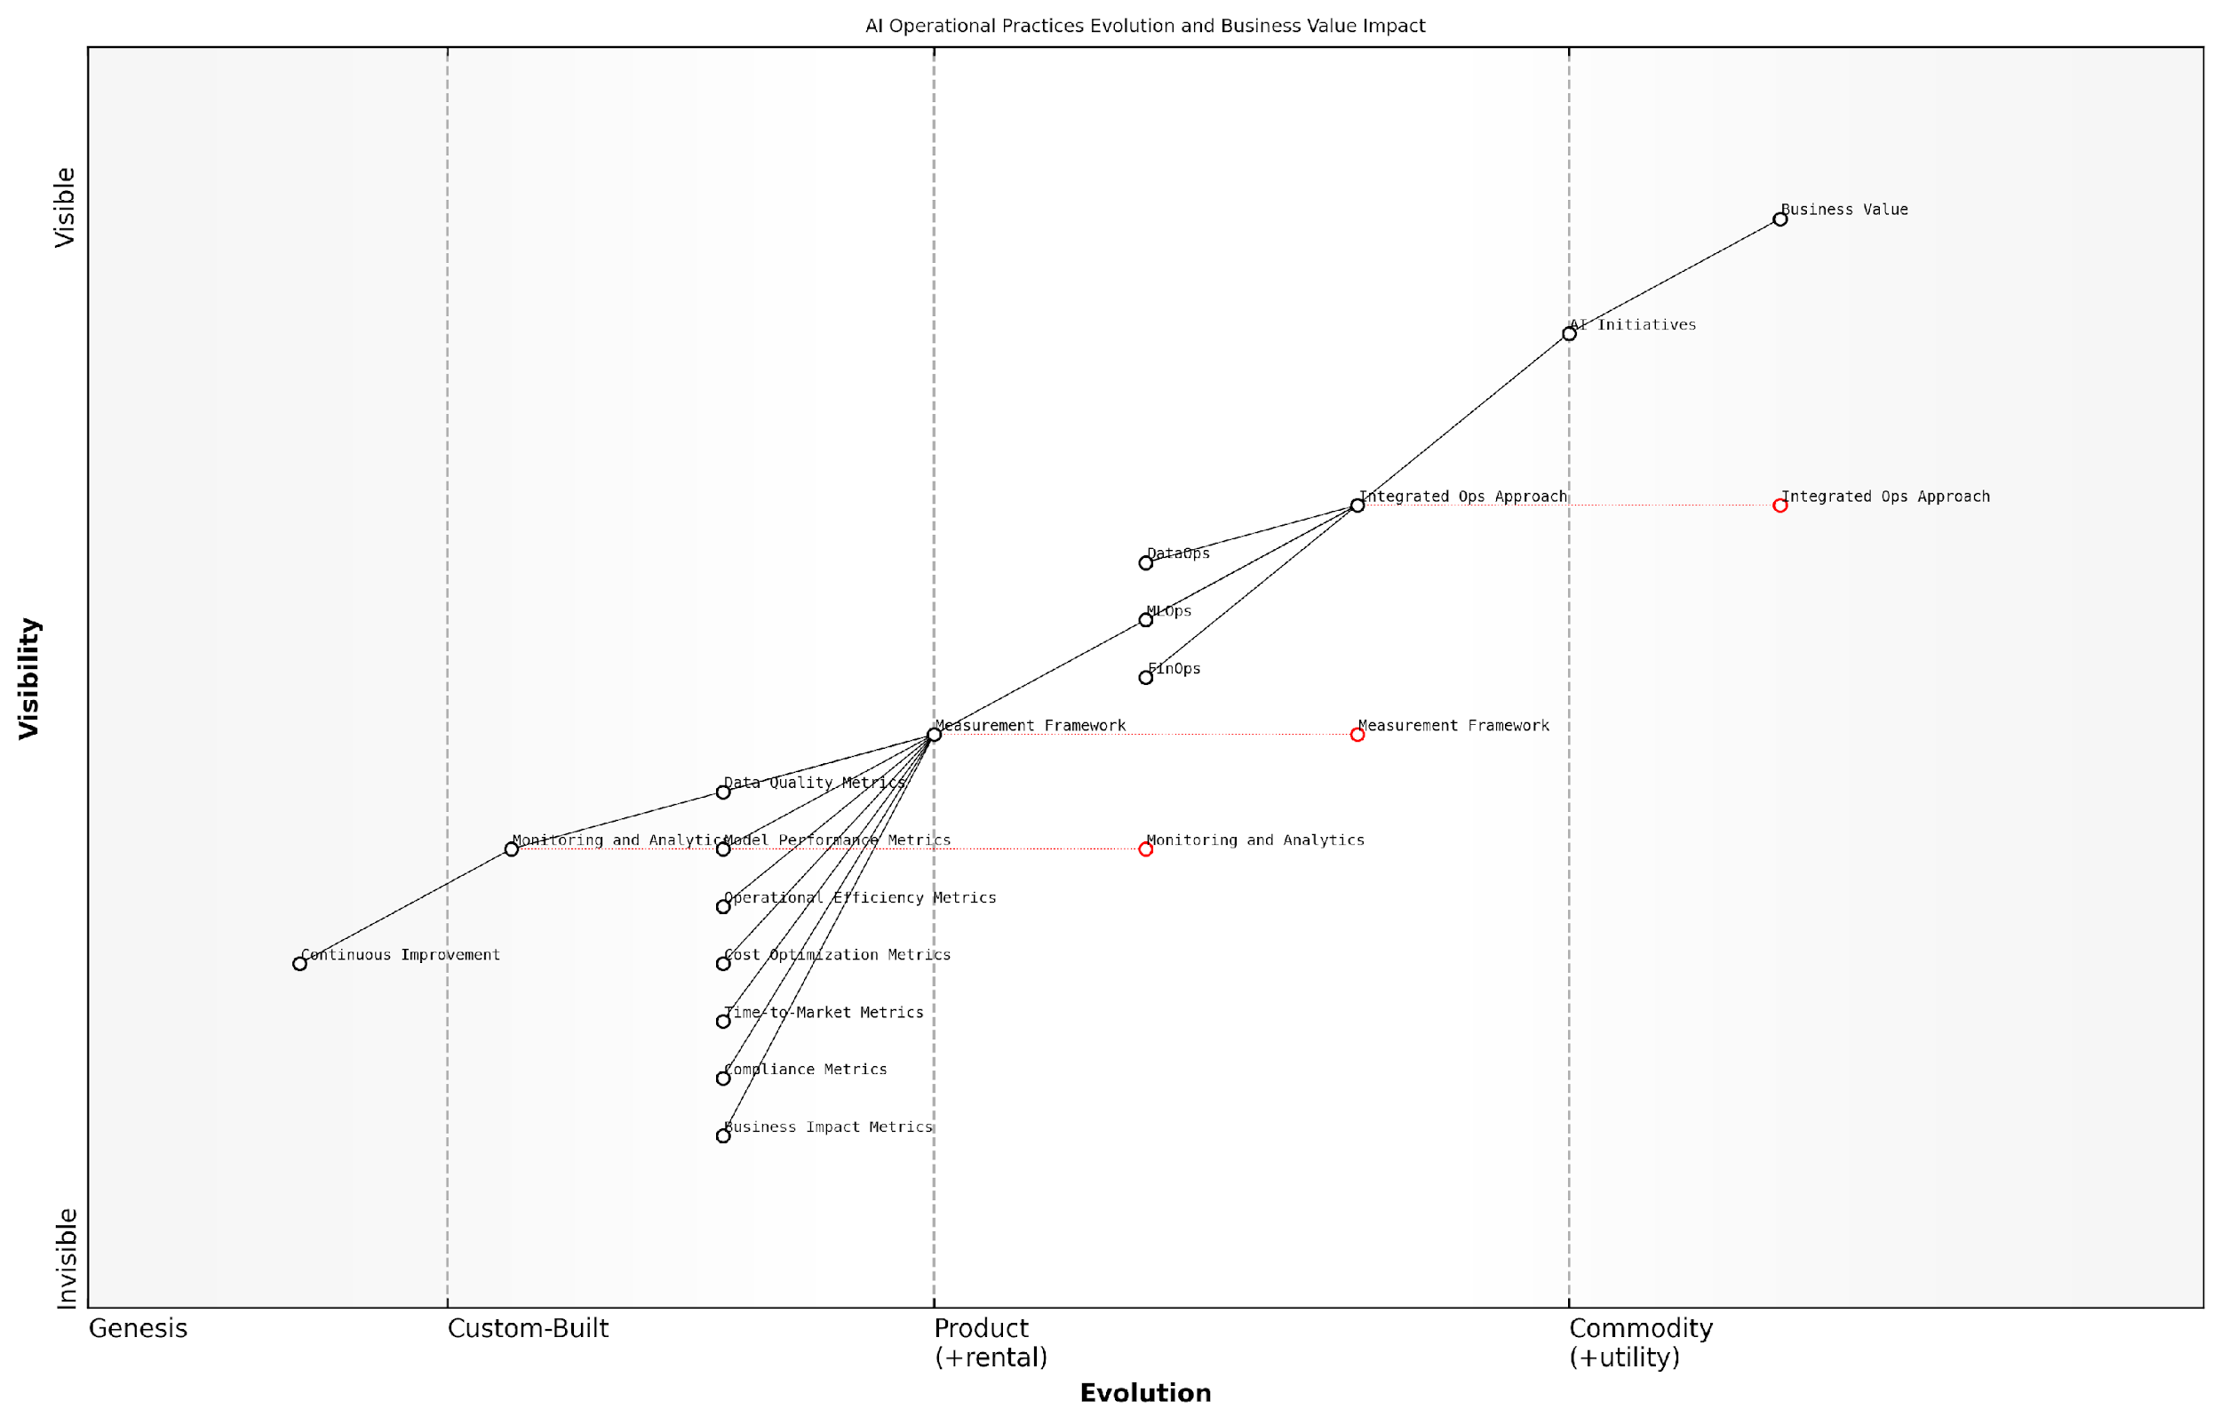

*Draft Wardley Map: [Insert Wardley Map: Measuring the impact of integrated Ops on AI outcomes]*

[Edit this draft Wardley Map](https://create.wardleymaps.ai/#clone:3a98cdfe670b1e844b)

Wardley Map Assessment

This Wardley Map reveals a strategic focus on integrating operational practices and developing comprehensive measurement frameworks to drive AI success and business value. The organisation is well-positioned with a strong foundation in metrics and an evolving integrated ops approach. To maintain competitive advantage, it should focus on accelerating the evolution of its measurement framework and ops integration, while investing in AI-driven optimization and real-time business impact assessment capabilities. The key to success will be maintaining flexibility and adaptability in operational practices while continuously tightening the link between AI initiatives and measurable business outcomes.

[View full Wardley Map report](http://markdown/wardley_map_reports/wardley_map_report_45_Measuring_the_impact_of_integrated_Ops_on_AI_outco.md)

To effectively measure the impact of integrated Ops on AI outcomes, organisations should implement a robust monitoring and analytics framework. This framework should collect data across all relevant metrics, provide real-time dashboards for stakeholders, and enable trend analysis over time. By leveraging advanced analytics and machine learning techniques, organisations can gain deeper insights into the correlations between operational practices and AI outcomes.

It’s important to note that measuring the impact of integrated Ops on AI outcomes is an iterative process. As AI technologies and operational practices evolve, organisations must continuously refine their measurement frameworks to capture new dimensions of performance and value creation. Regular reviews and adjustments to the metrics and measurement methodologies ensure that the assessment remains relevant and actionable.

The true power of integrated Ops lies not just in the individual improvements to data, model, and cost management, but in the compounded effect these practices have on our overall AI capabilities. Our measurement framework has been instrumental in quantifying this synergy and driving continuous improvement across our AI portfolio.

In conclusion, measuring the impact of integrated Ops on AI outcomes requires a multifaceted approach that encompasses technical, operational, financial, and business metrics. By establishing a comprehensive measurement framework, organisations can not only validate the effectiveness of their integrated DataOps, MLOps, and FinOps practices but also identify areas for further optimisation and innovation. This data-driven approach to assessing AI operational excellence ultimately leads to more successful, scalable, and value-driven AI initiatives.

# Conclusion: Paving the Way for AI-Driven Transformation

## Recap: The Critical Role of DataOps, MLOps, and FinOps

### Key takeaways from each Ops discipline

As we conclude our exploration of the AI Success Trinity, it is crucial to distil the essential insights from each operational discipline. DataOps, MLOps, and FinOps collectively form the bedrock of successful AI implementation, each contributing unique strengths that, when combined, create a formidable framework for AI excellence. Let us recap the critical role and key takeaways from each of these disciplines, underscoring their individual importance and their synergistic impact on AI initiatives.

DataOps, the foundation of our trinity, emerges as the linchpin of AI success. Its primary focus on ensuring the availability, quality, and governance of data cannot be overstated in the context of AI. The key takeaways from DataOps include:

* Data quality is paramount: AI models are only as good as the data they are trained on. DataOps ensures that data is clean, consistent, and reliable.
* Automated data pipelines are essential: They enable the seamless flow of data from various sources to AI systems, reducing manual errors and increasing efficiency.
* Data governance is non-negotiable: In an era of increasing data regulations, DataOps provides the framework for maintaining compliance and ethical data usage.
* Real-time data processing capabilities: This allows AI systems to make decisions based on the most current information, crucial for many applications.
* Collaborative data management: DataOps fosters a culture of shared responsibility for data across the organisation, breaking down silos and improving data utilisation.

Moving on to MLOps, we find a discipline that bridges the gap between model development and operational reality. The key takeaways from MLOps include:

* Streamlined model lifecycle management: MLOps provides a structured approach to developing, deploying, and maintaining AI models.
* Version control for both data and models: This ensures reproducibility and traceability, critical for debugging and regulatory compliance.
* Automated model training and evaluation: This accelerates the development process and helps maintain model performance over time.
* Continuous integration and deployment (CI/CD) for AI: Enables rapid iteration and deployment of models, keeping pace with changing business needs.
* Model monitoring and maintenance: Ensures that models remain accurate and relevant in production environments, detecting and addressing drift or degradation.

Finally, FinOps completes our trinity by addressing the often-overlooked financial aspects of AI initiatives. The key takeaways from FinOps include:

* Cost visibility and allocation: FinOps provides clear insights into AI-related expenses, enabling informed decision-making and budget allocation.
* Resource optimisation: By aligning resource usage with actual needs, FinOps helps organisations avoid over-provisioning and reduce waste.
* ROI measurement: FinOps enables organisations to quantify the value generated by AI initiatives, justifying investments and guiding future strategy.
* Budgeting and forecasting: Accurate financial planning for AI projects becomes possible, reducing the risk of cost overruns and surprises.
* Cost-aware culture: FinOps fosters a mindset where all stakeholders consider the financial implications of their decisions in AI development and deployment.

The true power of DataOps, MLOps, and FinOps lies not in their individual strengths, but in their collective application. When integrated effectively, they create a holistic operational framework that addresses the technical, procedural, and financial aspects of AI implementation.

This integrated approach yields several overarching benefits:

* Accelerated AI development and deployment cycles
* Improved model performance and reliability
* Enhanced regulatory compliance and risk management
* Optimised resource utilisation and cost efficiency
* Greater alignment between AI initiatives and business objectives
* Increased stakeholder confidence and support for AI projects

By internalising these key takeaways and adopting an integrated approach to DataOps, MLOps, and FinOps, organisations can significantly enhance their chances of AI success. This trinity provides a robust framework for navigating the complexities of AI implementation, ensuring that projects not only deliver technical excellence but also align with business goals and financial constraints.

As we move forward in our AI journey, it is crucial to remember that these disciplines are not static. They will continue to evolve alongside advancements in AI technology and changing business landscapes. Organisations that remain adaptable and committed to refining their approach to these operational disciplines will be best positioned to harness the transformative power of AI, driving innovation and maintaining a competitive edge in an increasingly AI-driven world.

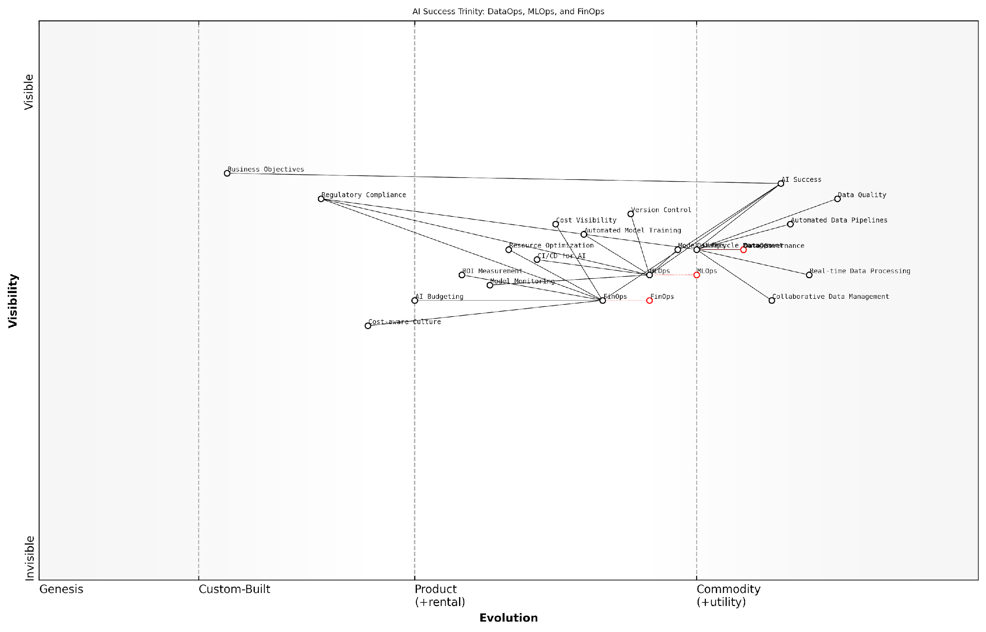

*Draft Wardley Map: [Insert Wardley Map: Key takeaways from each Ops discipline]*

[Edit this draft Wardley Map](https://create.wardleymaps.ai/#clone:a47a93350ab8f5a194)

Wardley Map Assessment

This Wardley Map presents a forward-thinking approach to AI implementation by emphasising the critical integration of DataOps, MLOps, and FinOps. The strategic position highlights the need for a balanced evolution of all three disciplines, with a particular focus on accelerating FinOps maturity. The map suggests significant opportunities for innovation in creating unified AI operations platforms and cultivating a holistic, cost-aware AI culture. Organisations that successfully integrate these three Ops disciplines and align them with business objectives and regulatory requirements will be well-positioned to achieve transformative AI success.

[View full Wardley Map report](http://markdown/wardley_map_reports/wardley_map_report_46_Key_takeaways_from_each_Ops_discipline.md)

### The compounded benefits of integration

As we conclude our exploration of the AI Success Trinity—DataOps, MLOps, and FinOps—it is crucial to underscore the transformative power that emerges when these disciplines are seamlessly integrated. The synergy created by their combination far exceeds the sum of their individual contributions, paving the way for unprecedented AI-driven transformation in organisations across the public and private sectors.

The integration of DataOps, MLOps, and FinOps creates a robust ecosystem that addresses the entire lifecycle of AI initiatives, from data management and model development to deployment and cost optimisation. This holistic approach yields a multitude of compounded benefits that significantly enhance the likelihood of AI project success and drive sustainable innovation.

* Enhanced Data Quality and Accessibility: The integration of DataOps with MLOps ensures that high-quality, relevant data is consistently available for model training and inference. This symbiosis dramatically reduces the time spent on data preparation and improves model accuracy.
* Accelerated Time-to-Value: By combining the automated pipelines of DataOps with the streamlined development processes of MLOps, organisations can significantly reduce the time required to move from concept to production-ready AI solutions.
* Optimised Resource Utilisation: The integration of FinOps with DataOps and MLOps enables real-time cost visibility and optimisation across the entire AI workflow, ensuring that resources are allocated efficiently and ROI is maximised.
* Improved Governance and Compliance: The unified approach facilitates comprehensive tracking and auditing of data usage, model development, and deployment, ensuring adherence to regulatory requirements and ethical AI principles.
* Enhanced Collaboration and Knowledge Sharing: Integration breaks down silos between data scientists, engineers, and business stakeholders, fostering a culture of collaboration and continuous improvement.

The true power of AI lies not in isolated technological advancements, but in the seamless integration of data, models, and financial considerations. This holistic approach is what separates transformative AI initiatives from mere experiments.

The compounded benefits of integration extend beyond operational efficiencies. They create a foundation for scalable, sustainable AI that can adapt to changing business needs and technological advancements. Organisations that successfully integrate these disciplines position themselves at the forefront of AI innovation, capable of rapidly iterating on ideas and delivering tangible value to their stakeholders.

Moreover, the integration of DataOps, MLOps, and FinOps fosters a culture of continuous improvement and innovation. By providing a comprehensive view of AI operations, it enables organisations to identify bottlenecks, optimise processes, and allocate resources more effectively. This culture of data-driven decision-making and operational excellence becomes a competitive advantage in itself, driving ongoing AI-powered transformation across the organisation.

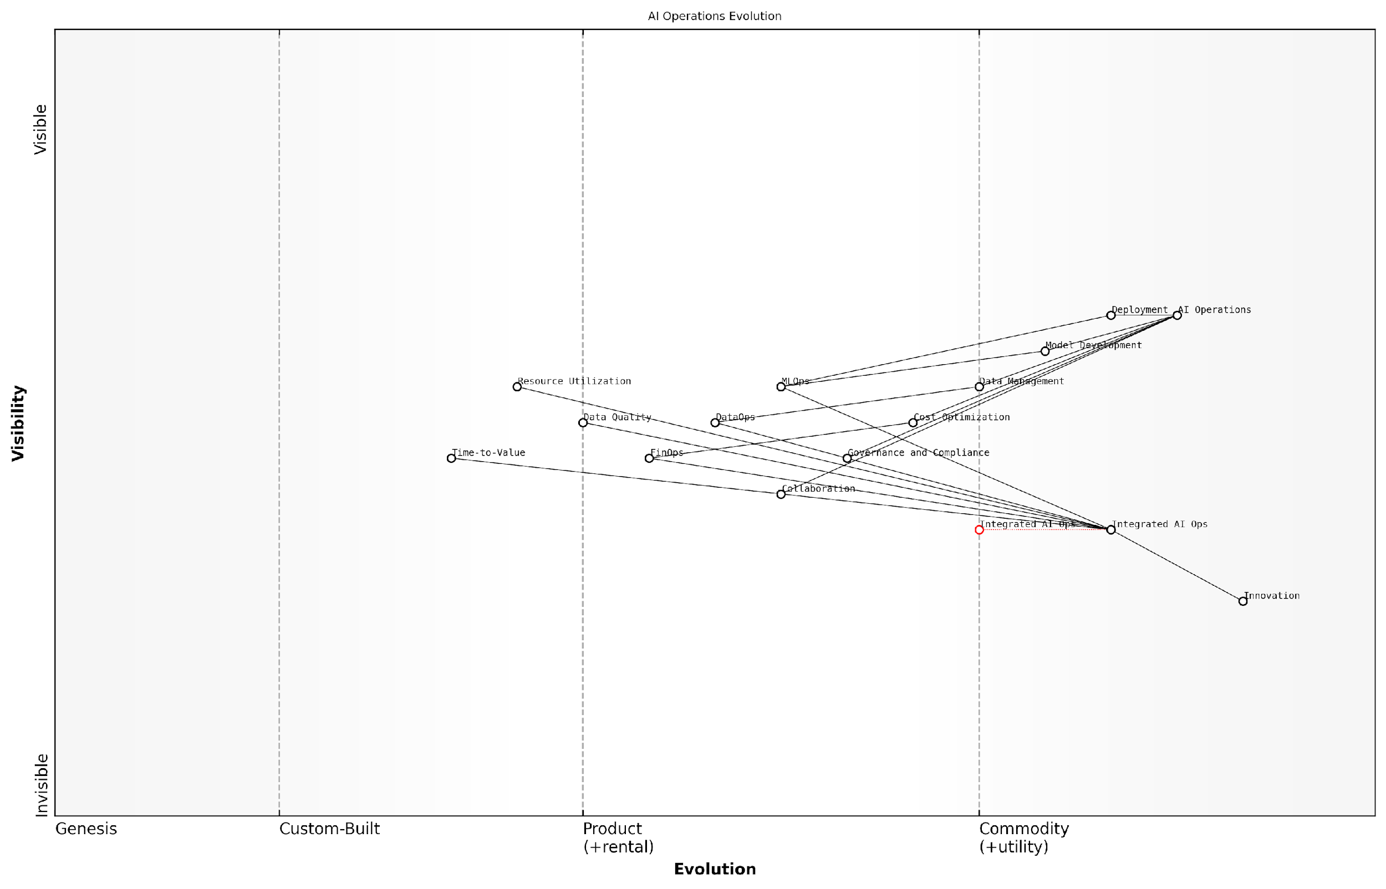

*Draft Wardley Map: [Insert Wardley Map: The compounded benefits of integration]*

[Edit this draft Wardley Map](https://create.wardleymaps.ai/#clone:936f281a8bd7ec7df0)

Wardley Map Assessment

This Wardley Map reveals a strategic focus on integrating AI operations to drive transformation. The positioning of Integrated AI Ops as a bridge between operational components and innovation presents a significant opportunity for organisations to optimise their AI initiatives. The key to success lies in effectively managing the evolution of AI operations while fostering a culture of innovation and maintaining agility in the face of rapid technological change.

[View full Wardley Map report](http://markdown/wardley_map_reports/wardley_map_report_47_The_compounded_benefits_of_integration.md)

The compounded benefits of integration also extend to risk management and resilience. By aligning DataOps, MLOps, and FinOps practices, organisations can build robust, fault-tolerant AI systems that are better equipped to handle unexpected challenges. This integrated approach enables quicker identification and resolution of issues, whether they relate to data quality, model performance, or cost overruns, thereby minimising potential disruptions to AI-driven services and operations.

In the rapidly evolving landscape of AI, the ability to seamlessly integrate DataOps, MLOps, and FinOps is not just a competitive advantage—it’s a prerequisite for long-term success and sustainable innovation.

As we look to the future, the compounded benefits of integrating DataOps, MLOps, and FinOps will only grow in importance. Emerging technologies such as edge computing, federated learning, and quantum machine learning will introduce new complexities and opportunities in AI development and deployment. Organisations that have established a strong foundation of integrated operations will be better positioned to leverage these advancements, maintaining their competitive edge in an increasingly AI-driven world.

In conclusion, the integration of DataOps, MLOps, and FinOps represents a paradigm shift in how organisations approach AI development and implementation. By embracing this holistic approach, organisations can unlock the full potential of AI, driving innovation, efficiency, and value creation across their operations. As we move forward, this integrated approach will be instrumental in shaping the future of AI-driven transformation, enabling organisations to navigate the complexities of the AI landscape with confidence and agility.

## Future Trends and Considerations

### Emerging technologies impacting the three Ops

As we stand on the cusp of a new era in artificial intelligence, it is crucial to recognise that the landscape of DataOps, MLOps, and FinOps is continuously evolving. Emerging technologies are reshaping these operational frameworks, offering new possibilities and challenges for organisations striving to achieve AI success. As an expert in this field, I have observed several key trends that are poised to significantly impact the three Ops in the coming years.

One of the most transformative technologies on the horizon is quantum computing. The potential of quantum computers to process vast amounts of data at unprecedented speeds could revolutionise DataOps practices. Quantum algorithms may enable more efficient data processing, optimisation, and pattern recognition, potentially leading to breakthroughs in data quality and governance. For MLOps, quantum machine learning algorithms could dramatically accelerate model training and inference, necessitating new approaches to version control and deployment pipelines. In the realm of FinOps, quantum computing might offer novel ways to optimise resource allocation and cost prediction, potentially reshaping how we approach AI project budgeting and ROI calculations.

Quantum computing is not just an incremental advance; it’s a paradigm shift that will force us to rethink our entire approach to data processing and machine learning operations.

Another emerging technology that will have a profound impact on the three Ops is edge computing. As AI systems become more ubiquitous and are deployed in diverse environments, the need for processing data closer to its source becomes paramount. For DataOps, edge computing will necessitate new strategies for data collection, preprocessing, and real-time analytics at the edge. MLOps practices will need to adapt to support model deployment and updates on edge devices, potentially leading to more distributed and federated learning approaches. FinOps will face the challenge of optimising costs across a more complex and distributed infrastructure, balancing edge and cloud resources.

The rise of explainable AI (XAI) technologies is another trend that will significantly impact the three Ops. As AI systems become more complex and are deployed in critical decision-making contexts, the need for transparency and interpretability grows. For DataOps, this may lead to new requirements for data lineage and provenance tracking. MLOps practices will need to incorporate explainability techniques into model development, testing, and monitoring workflows. FinOps may need to consider the additional computational costs associated with generating explanations and the potential value derived from more transparent AI systems.

* Automated machine learning (AutoML) and AI-assisted development tools
* Blockchain and distributed ledger technologies for enhanced data integrity and model tracking
* Advanced natural language processing (NLP) for improved data analysis and model interaction
* Neuromorphic computing for more efficient AI hardware
* Synthetic data generation techniques for enhanced privacy and data augmentation

These emerging technologies will not only impact each Ops discipline individually but will also influence how they integrate and work together. For instance, the combination of edge computing and federated learning may require a more tightly coupled approach to DataOps and MLOps, ensuring that data privacy and model integrity are maintained across distributed systems. Similarly, the adoption of quantum computing may necessitate closer collaboration between MLOps and FinOps teams to optimise the use of expensive quantum resources while maximising AI performance.

It’s important to note that while these emerging technologies offer exciting possibilities, they also present new challenges. Organisations will need to invest in upskilling their workforce, updating their infrastructure, and potentially redesigning their operational processes to fully leverage these advancements. Moreover, as these technologies mature, we can expect to see new regulatory frameworks and industry standards emerge, which will further shape how DataOps, MLOps, and FinOps are implemented in AI projects.

The organisations that will thrive in the AI-driven future are those that can adapt their operational frameworks to harness emerging technologies while maintaining a focus on data quality, model performance, and cost-effectiveness.

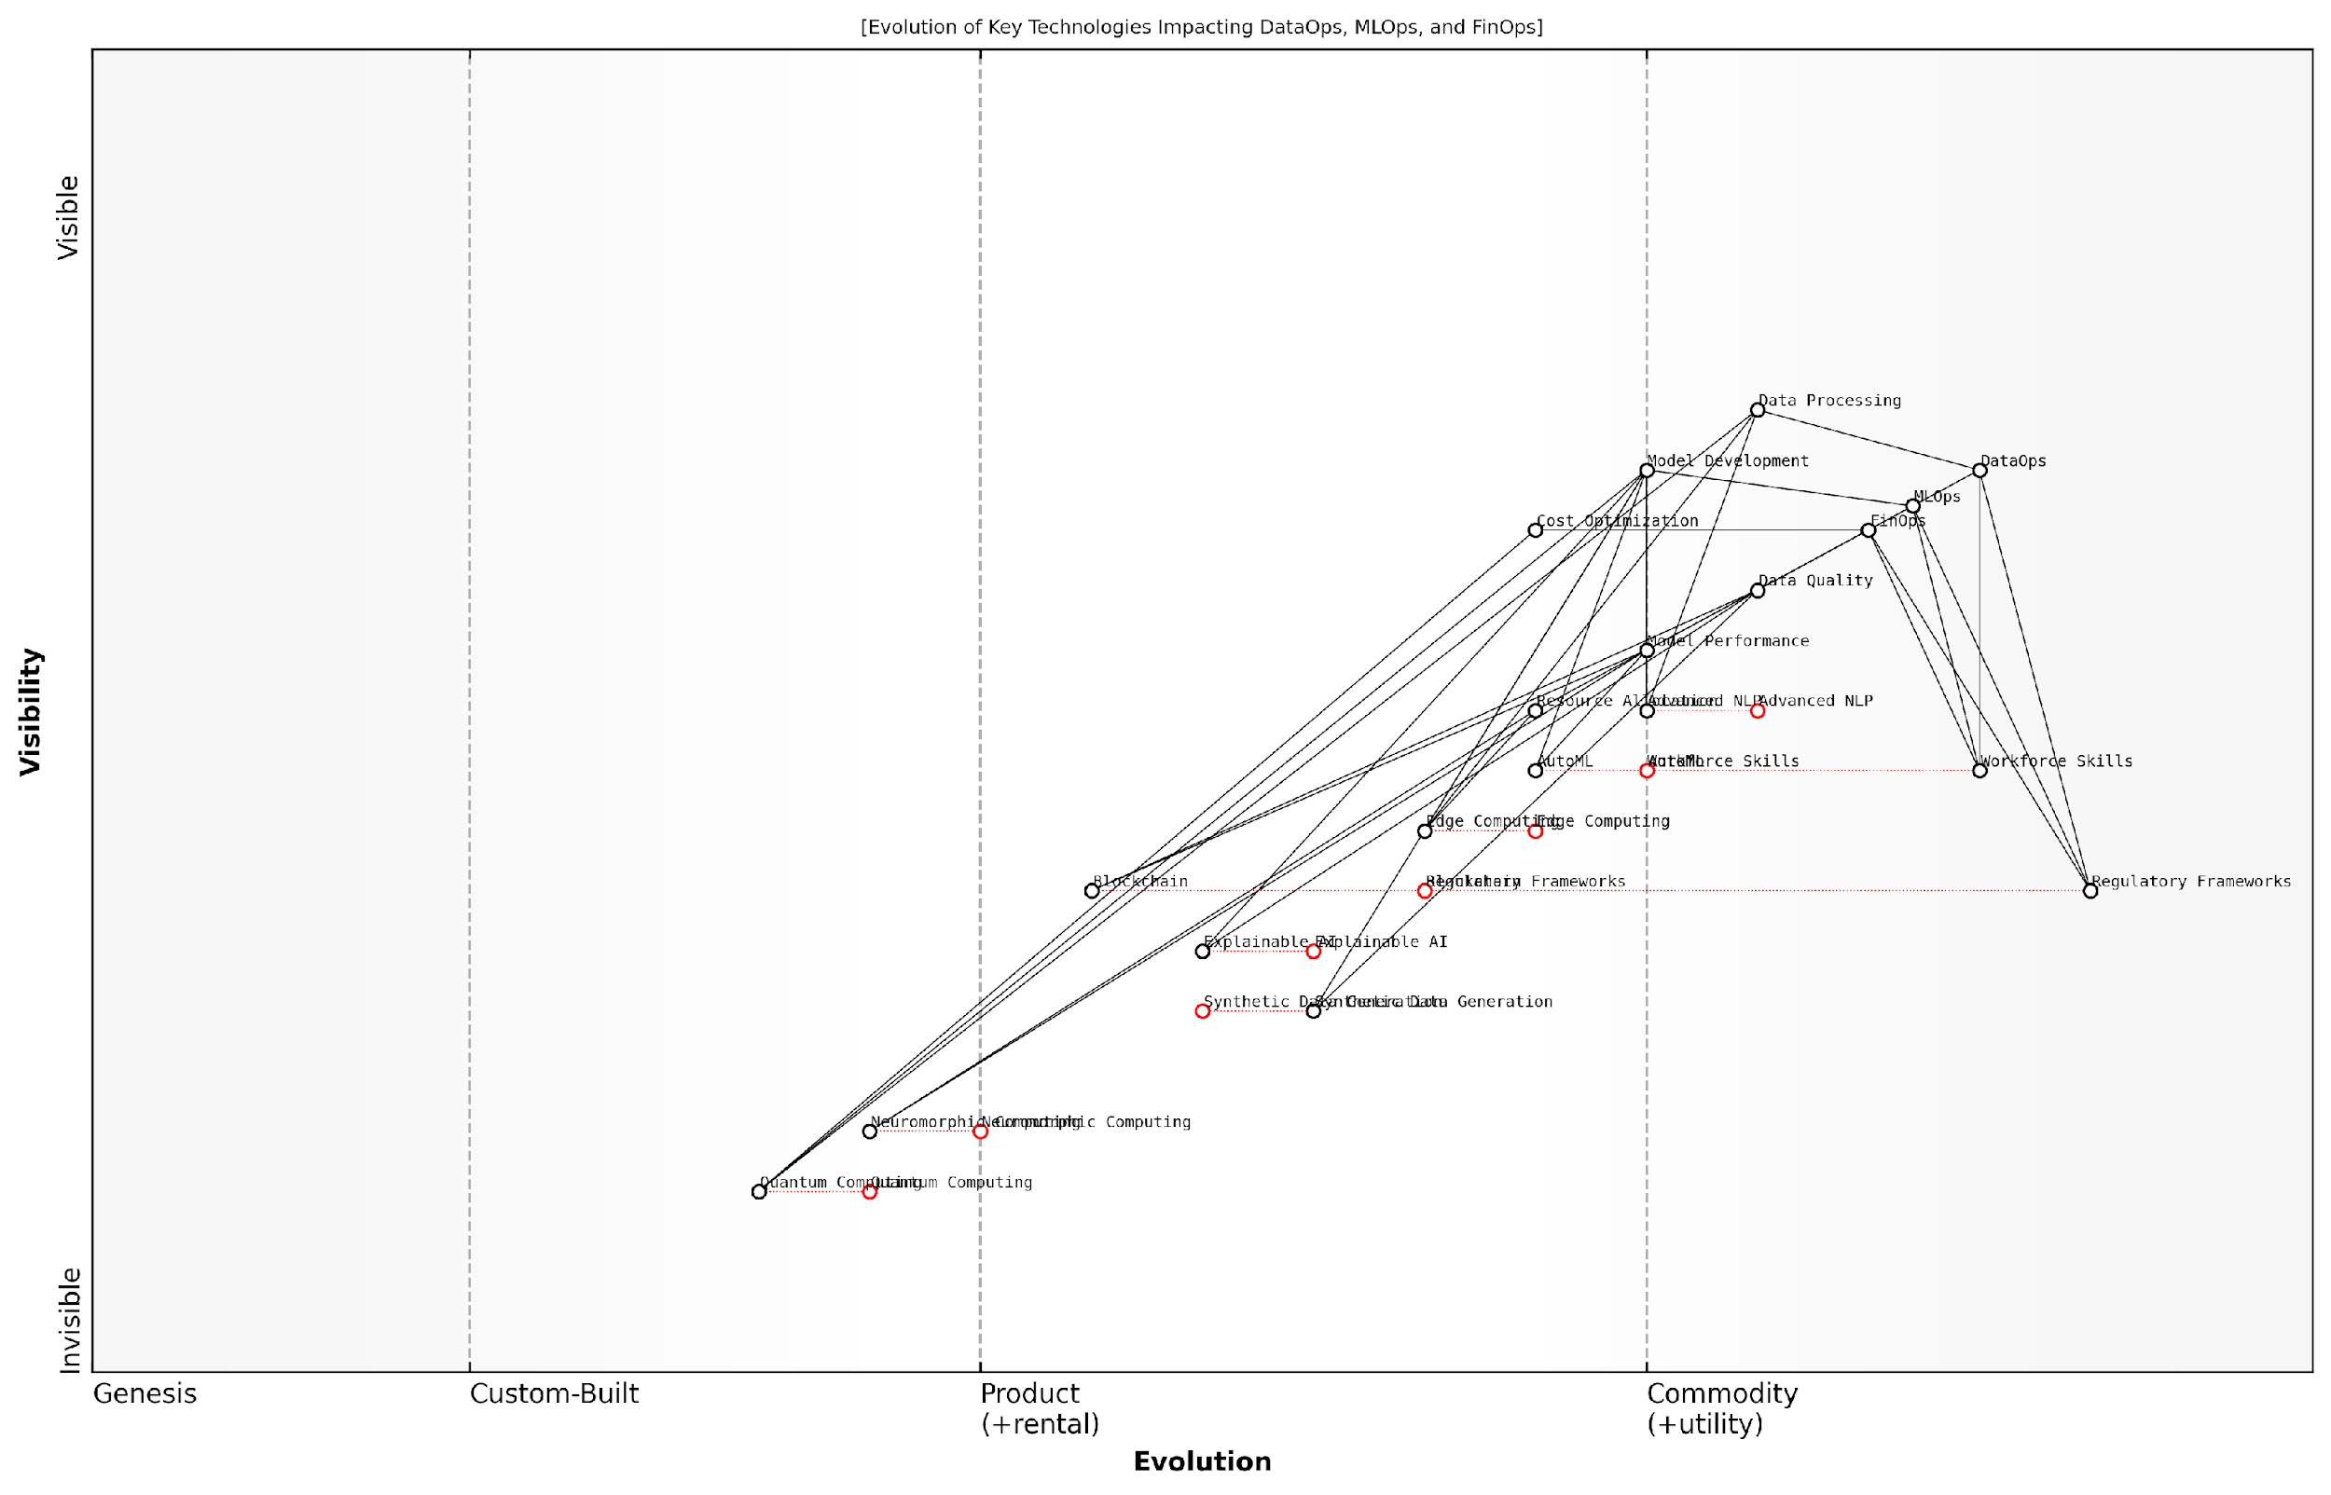

*Draft Wardley Map: [Insert Wardley Map: Emerging technologies impacting the three Ops]*

[Edit this draft Wardley Map](https://create.wardleymaps.ai/#clone:f6cc07c52d38a92c90)

Wardley Map Assessment

The map reveals a forward-thinking approach to AI operations, balancing current operational needs with investments in potentially disruptive technologies. The strategic focus should be on maintaining excellence in core Ops practices while systematically building capabilities in emerging areas like Quantum Computing, Neuromorphic Computing, and advanced Edge AI. Continuous alignment with evolving regulatory frameworks and aggressive workforce development will be critical for successfully navigating this complex and rapidly evolving technological landscape.

[View full Wardley Map report](http://markdown/wardley_map_reports/wardley_map_report_48_Emerging_technologies_impacting_the_three_Ops.md)

In conclusion, the future of DataOps, MLOps, and FinOps in AI success is inextricably linked to the advancement of emerging technologies. Quantum computing, edge AI, explainable AI, and other innovations will reshape how we approach data management, model development, and cost optimisation in AI projects. Organisations must stay informed about these trends and be prepared to adapt their operational strategies accordingly. By embracing these emerging technologies and integrating them thoughtfully into their AI operations, organisations can position themselves at the forefront of AI innovation and drive transformative outcomes in their respective domains.

### Preparing for the evolving AI landscape

As we stand on the cusp of a new era in artificial intelligence, it is crucial for organisations to prepare for the rapidly evolving AI landscape. The convergence of DataOps, MLOps, and FinOps has set the stage for unprecedented advancements in AI capabilities, but it also presents new challenges and opportunities that demand our attention. To navigate this dynamic environment successfully, we must anticipate future trends and make strategic considerations that will shape the next generation of AI implementations.

One of the most significant trends on the horizon is the increasing democratisation of AI technologies. As tools and platforms become more accessible, we can expect to see a broader range of organisations adopting AI solutions. This democratisation will likely lead to a surge in innovative applications across various sectors, particularly in government and public services. However, it also underscores the critical need for robust operational frameworks to ensure responsible and effective AI deployment at scale.

* Edge AI and distributed computing
* Quantum computing and its impact on AI algorithms
* Explainable AI (XAI) and ethical AI frameworks
* AI-driven automation of Ops processes
* Federated learning and privacy-preserving AI

Edge AI and distributed computing are poised to revolutionise how we process and analyse data. By bringing AI capabilities closer to the data source, organisations can reduce latency, enhance privacy, and improve real-time decision-making. This shift will require adaptations in our DataOps and MLOps practices to manage decentralised data processing and model deployment effectively.

The advent of quantum computing presents both exciting possibilities and formidable challenges for AI. As quantum algorithms become more sophisticated, they have the potential to solve complex problems that are currently intractable for classical computers. This could lead to breakthroughs in areas such as drug discovery, climate modelling, and financial risk assessment. However, integrating quantum computing into existing AI workflows will require significant adjustments to our MLOps practices and potentially new approaches to algorithm design and optimisation.

Quantum computing is not just a faster way of doing the same things; it’s a fundamentally different paradigm that will reshape how we approach AI problems. Our operational frameworks must evolve to harness this transformative technology.

Explainable AI (XAI) and ethical AI frameworks are becoming increasingly important as AI systems take on more critical roles in decision-making processes. Governments and regulatory bodies are likely to impose stricter requirements for transparency and accountability in AI systems. This trend will necessitate the integration of explainability techniques into our MLOps pipelines and the development of new tools for auditing and validating AI models.

The automation of Ops processes through AI is another trend that will shape the future landscape. We can expect to see AI-driven systems that can optimise data pipelines, automatically tune machine learning models, and dynamically allocate computing resources. This meta-application of AI to improve its own operational efficiency will require a rethinking of how we approach DataOps, MLOps, and FinOps, potentially leading to new hybrid human-AI operational models.

Federated learning and privacy-preserving AI techniques are gaining traction as concerns about data privacy and sovereignty grow. These approaches allow for the training of AI models on distributed datasets without centralising sensitive information. Implementing federated learning at scale will require significant changes to our DataOps and MLOps practices, including new protocols for secure model aggregation and distributed training orchestration.

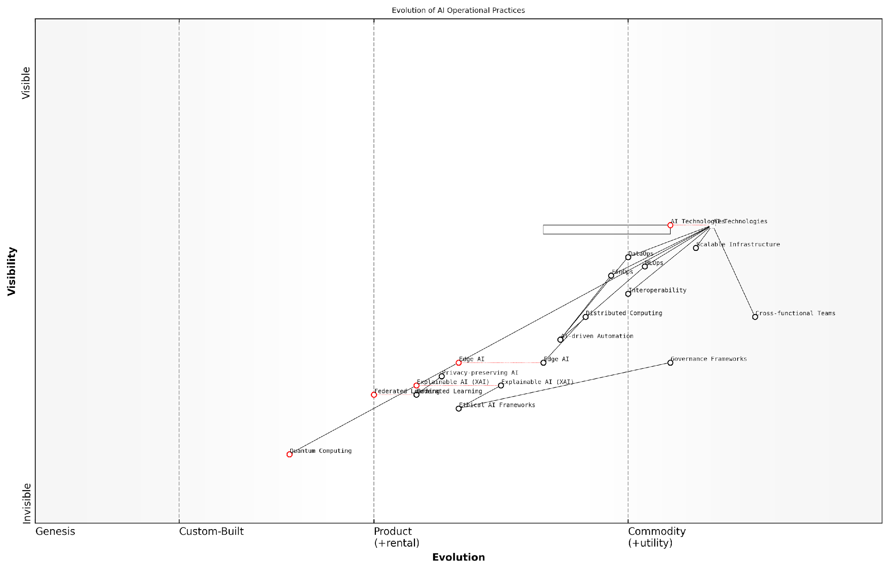

*Draft Wardley Map: [Insert Wardley Map: Preparing for the evolving AI landscape]*

[Edit this draft Wardley Map](https://create.wardleymaps.ai/#clone:b72a7d73f86b6de081)

Wardley Map Assessment

The map represents a forward-thinking approach to AI operational practices, balancing current operational needs with future technological advancements and ethical considerations. The strategic focus should be on maintaining operational excellence while investing in emerging technologies and robust governance frameworks to ensure sustainable and responsible AI adoption.

[View full Wardley Map report](http://markdown/wardley_map_reports/wardley_map_report_49_Preparing_for_the_evolving_AI_landscape.md)

To prepare for these emerging trends, organisations must adopt a proactive and flexible approach to their AI operations. This includes investing in continuous learning and skill development for teams, fostering a culture of innovation and experimentation, and establishing partnerships with academic institutions and technology providers to stay at the forefront of AI advancements.

Furthermore, organisations should consider the following strategic considerations:

* Developing modular and adaptable AI architectures that can incorporate new technologies as they emerge
* Implementing robust governance frameworks that can evolve with changing regulatory landscapes
* Prioritising interoperability and open standards to facilitate collaboration and integration across different AI systems
* Investing in scalable infrastructure that can support the increasing computational demands of advanced AI models
* Cultivating cross-functional teams that can bridge the gaps between data science, engineering, and domain expertise

As we look to the future, it is clear that the synergy between DataOps, MLOps, and FinOps will play an even more critical role in AI success. By anticipating these trends and making strategic considerations, organisations can position themselves to harness the full potential of AI while navigating the complexities of an ever-evolving technological landscape.

The organisations that will thrive in the AI-driven future are those that can adapt their operational practices as quickly as the technology itself evolves. Agility, foresight, and a commitment to continuous improvement will be the hallmarks of successful AI implementations.

In conclusion, preparing for the evolving AI landscape requires a holistic approach that encompasses technological readiness, organisational adaptability, and strategic foresight. By embracing the principles of DataOps, MLOps, and FinOps, and remaining vigilant to emerging trends, we can create a solid foundation for the next generation of AI innovations that will transform our world in ways we are only beginning to imagine.

## Call to Action: Implementing the AI Success Trinity

### Steps to get started with integrated Ops

Embarking on the journey to implement the AI Success Trinity—DataOps, MLOps, and FinOps—is a transformative endeavour that requires careful planning, strategic execution, and a commitment to continuous improvement. As an expert who has guided numerous government and public sector organisations through this process, I can attest to the profound impact that integrated Ops can have on AI initiatives. The following steps provide a comprehensive roadmap for organisations looking to leverage the power of integrated Ops for AI success.

* Conduct a comprehensive assessment of your current AI operations
* Establish a cross-functional AI Ops team
* Develop an integrated Ops strategy aligned with organisational goals
* Implement foundational tools and processes for each Ops discipline
* Foster a culture of collaboration and continuous improvement
* Establish metrics and KPIs for measuring Ops effectiveness
* Pilot integrated Ops on a small-scale AI project
* Scale and refine your integrated Ops approach
* Invest in ongoing training and skill development
* Regularly review and adapt your integrated Ops framework

Let’s delve deeper into each of these steps to provide a clear path forward for organisations embarking on this critical journey.

1. Conduct a comprehensive assessment of your current AI operations: Begin by thoroughly evaluating your existing processes, tools, and capabilities across data management, machine learning workflows, and cost optimisation. This assessment will help identify gaps, inefficiencies, and areas for improvement, providing a baseline from which to build your integrated Ops strategy.
2. Establish a cross-functional AI Ops team: Assemble a diverse team of experts from data science, IT, finance, and business units to lead the integrated Ops initiative. This team should have the authority to make decisions and drive change across the organisation. Ensure representation from each Ops discipline to facilitate seamless integration and knowledge sharing.
3. Develop an integrated Ops strategy aligned with organisational goals: Create a comprehensive strategy that outlines how DataOps, MLOps, and FinOps will work together to support your AI objectives. This strategy should include clear goals, timelines, resource requirements, and expected outcomes. Ensure alignment with broader organisational strategies and priorities to secure buy-in from senior leadership.
4. Implement foundational tools and processes for each Ops discipline: Begin by establishing the core components of each Ops discipline. For DataOps, this might include implementing data governance frameworks and automated data pipelines. For MLOps, focus on version control systems and CI/CD pipelines for models. For FinOps, start with cost visibility tools and basic cloud resource optimisation practices.
5. Foster a culture of collaboration and continuous improvement: Integrated Ops requires a shift in organisational culture towards greater collaboration and a focus on continuous improvement. Encourage open communication between teams, establish regular cross-functional meetings, and create channels for sharing best practices and lessons learned.
6. Establish metrics and KPIs for measuring Ops effectiveness: Define clear, measurable indicators of success for your integrated Ops approach. These might include metrics such as data quality scores, model deployment frequency, time-to-market for AI solutions, and cost savings achieved through optimisation efforts. Regularly track and report on these metrics to demonstrate the value of integrated Ops.
7. Pilot integrated Ops on a small-scale AI project: Before rolling out integrated Ops across the entire organisation, start with a pilot project. Choose a manageable AI initiative that can benefit from the synergies of DataOps, MLOps, and FinOps. Use this pilot to refine your processes, identify challenges, and demonstrate the value of the integrated approach.
8. Scale and refine your integrated Ops approach: Based on the lessons learned from your pilot, begin scaling the integrated Ops approach to other AI projects and teams. Continuously refine your processes, tools, and strategies based on feedback and results. Be prepared to iterate and adapt as you encounter new challenges and opportunities.
9. Invest in ongoing training and skill development: The field of AI and its associated Ops disciplines is rapidly evolving. Invest in continuous learning opportunities for your team members to keep their skills up-to-date. This might include workshops, certifications, conference attendance, and peer learning sessions.
10. Regularly review and adapt your integrated Ops framework: As your organisation’s AI maturity grows and the technology landscape evolves, your integrated Ops approach will need to adapt. Conduct regular reviews of your framework, incorporating new best practices, tools, and methodologies as they emerge. Stay attuned to industry trends and be prepared to pivot your strategy as needed.

Implementing integrated Ops is not a one-time effort, but a journey of continuous improvement and adaptation. Organisations that commit to this journey will find themselves well-positioned to harness the full potential of AI and drive meaningful transformation.

By following these steps, organisations can lay a solid foundation for implementing the AI Success Trinity of DataOps, MLOps, and FinOps. This integrated approach will not only enhance the efficiency and effectiveness of AI initiatives but also foster a culture of innovation and data-driven decision-making across the organisation.

As you embark on this journey, remember that the path to integrated Ops is unique for each organisation. Tailor these steps to your specific context, challenges, and goals. Embrace the iterative nature of the process and be prepared to learn and adapt along the way. With commitment, strategic planning, and a focus on continuous improvement, your organisation can harness the power of integrated Ops to drive AI success and achieve transformative outcomes.

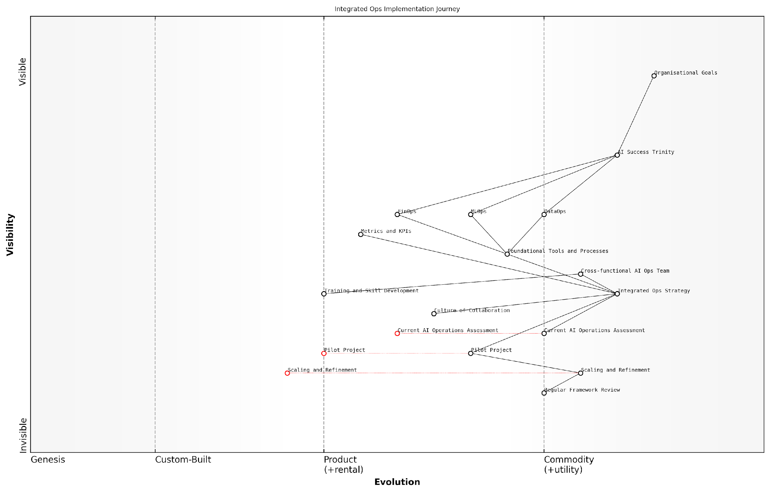

*Draft Wardley Map: [Insert Wardley Map: Steps to get started with integrated Ops]*

[Edit this draft Wardley Map](https://create.wardleymaps.ai/#clone:702bdcf1a78551433f)

Wardley Map Assessment

This Wardley Map presents a well-structured approach to implementing integrated AI operations, aligning with organisational goals and emphasising the AI Success Trinity. The strategy shows a clear path from assessment to implementation and continuous improvement. Key focus areas should be developing cross-functional capabilities, ensuring smooth integration of the three ops domains, and maintaining agility to adapt to rapid technological evolution. The success of this approach will largely depend on effective change management, skill development, and the ability to create a collaborative culture across traditionally siloed domains.

[View full Wardley Map report](http://markdown/wardley_map_reports/wardley_map_report_50_Steps_to_get_started_with_integrated_Ops.md)

### Resources for continued learning and implementation

As we conclude our exploration of the AI Success Trinity—DataOps, MLOps, and FinOps—it’s crucial to recognise that the journey towards AI excellence is ongoing. The rapidly evolving landscape of artificial intelligence demands continuous learning and adaptation. To support your organisation’s growth and success in implementing these critical operational frameworks, I’ve curated a comprehensive list of resources that will serve as valuable tools for continued learning and implementation.

These resources span a wide range of formats and depths, catering to various learning styles and expertise levels within your team. From academic publications to hands-on workshops, each resource has been carefully selected to provide practical insights and actionable strategies for integrating DataOps, MLOps, and FinOps into your AI initiatives.

* Online Courses and Certifications: Platforms like Coursera, edX, and Udacity offer specialised courses in DataOps, MLOps, and FinOps. Look for courses that focus on practical implementation and case studies in AI contexts.
* Industry Conferences and Webinars: Attend events like the AI & Big Data Expo, MLOps World, and FinOps X to stay abreast of the latest trends and network with industry leaders.
* Professional Associations: Join organisations such as the DataOps Association, MLOps Community, and FinOps Foundation to access member-only resources and participate in knowledge-sharing forums.
* Technical Documentation and Whitepapers: Regularly consult publications from leading AI service providers and technology companies for in-depth technical guidance on implementing Ops practices.
* Open-Source Projects and Repositories: Engage with open-source communities on platforms like GitHub to explore real-world implementations of DataOps, MLOps, and FinOps tools and frameworks.
* Podcasts and Video Channels: Subscribe to podcasts like ‘Data Engineering Podcast’, ‘MLOps.community’, and ‘FinOps Podcast’ for expert insights and discussions on the latest trends.
* Books and Academic Journals: Stay updated with the latest publications in the field, focusing on practical guides and peer-reviewed research on AI operations and management.
* Workshops and Bootcamps: Participate in intensive, hands-on training sessions offered by reputable institutions or consultancies specialising in AI operations.
* Case Study Repositories: Access databases of real-world case studies demonstrating successful implementations of the AI Success Trinity across various industries and scales.
* Government and Regulatory Guidelines: Keep abreast of official publications from bodies like the UK’s Office for Artificial Intelligence and the European Union’s AI Alliance for compliance and best practices.

It’s important to approach these resources with a strategic mindset, aligning your learning objectives with your organisation’s specific AI goals and challenges. Encourage cross-functional teams to engage with these materials collectively, fostering a shared understanding and collaborative approach to implementing the AI Success Trinity.

Continuous learning and adaptation are not just beneficial, but essential for organisations aiming to harness the full potential of AI. The resources provided here are your compass in navigating the complex landscape of AI operations.

To maximise the value of these resources, consider establishing a formal learning and development programme within your organisation. This could include regular knowledge-sharing sessions, internal workshops, and a mentorship system where team members with expertise in specific Ops areas guide others. By fostering a culture of continuous learning and improvement, you’ll be better equipped to tackle the challenges and seize the opportunities presented by AI technologies.

Remember, the successful implementation of DataOps, MLOps, and FinOps is not a destination, but a journey of continuous refinement and optimisation. These resources will serve as your guide, but it’s the practical application and iterative improvement within your unique organisational context that will ultimately drive your AI success.

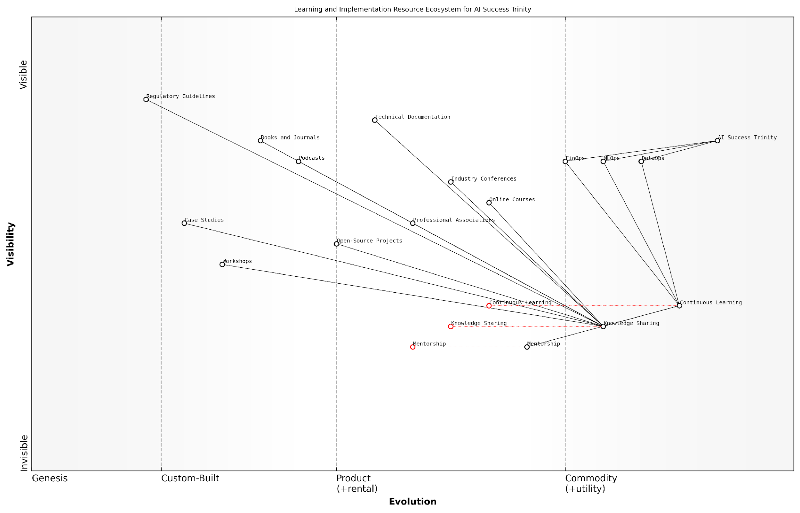

*Draft Wardley Map: [Insert Wardley Map: Resources for continued learning and implementation]*

[Edit this draft Wardley Map](https://create.wardleymaps.ai/#clone:a32692d9451dcfb17e)

Wardley Map Assessment

The Learning and Implementation Resource Ecosystem for AI Success Trinity presents a robust framework for organisations to adopt and excel in AI implementation. The ecosystem’s strength lies in its comprehensive coverage of learning resources and strong emphasis on continuous learning. However, to maintain its effectiveness, the ecosystem must evolve rapidly, embracing emerging technologies and shifting towards more collaborative, adaptive, and immersive learning experiences. Strategic focus should be placed on bridging the gap between theoretical knowledge and practical implementation, leveraging AI to personalise and enhance the learning process itself. By doing so, organisations can build a sustainable competitive advantage in the rapidly evolving AI landscape.

[View full Wardley Map report](http://markdown/wardley_map_reports/wardley_map_report_51_Resources_for_continued_learning_and_implementatio.md)

As you embark on this journey, leverage these resources to build a robust foundation, stay informed about emerging trends, and continuously refine your approach to the AI Success Trinity. By doing so, you’ll position your organisation at the forefront of AI innovation, ready to harness its transformative power while navigating the complexities of data management, model operations, and financial optimisation.

# Appendix: Book Generation Details

* Initial Topic: Why DataOps, MLOps, FinOps are critical for AI success
* Refined Topic: Why DataOps, MLOps, FinOps are critical for AI success
* Total Output Tokens: 492191
* Total LLM Cost: $7.38

# Appendix: Further Reading on Wardley Mapping

The following books, primarily authored by Mark Craddock, offer comprehensive insights into various aspects of Wardley Mapping:

## Core Wardley Mapping Series

1. **Wardley Mapping, The Knowledge: Part One, Topographical Intelligence in Business**
   * Author: Simon Wardley
   * Editor: Mark Craddock
   * Part of the Wardley Mapping series (5 books)
   * Available in Kindle Edition
   * [Amazon Link](https://www.amazon.com/dp/B0BVSXB5W5)

* This foundational text introduces readers to the Wardley Mapping approach:
  + Covers key principles, core concepts, and techniques for creating situational maps
  + Teaches how to anchor mapping in user needs and trace value chains
  + Explores anticipating disruptions and determining strategic gameplay
  + Introduces the foundational doctrine of strategic thinking
  + Provides a framework for assessing strategic plays
  + Includes concrete examples and scenarios for practical application
* The book aims to equip readers with:
  + A strategic compass for navigating rapidly shifting competitive landscapes
  + Tools for systematic situational awareness
  + Confidence in creating strategic plays and products
  + An entrepreneurial mindset for continual learning and improvement

1. **Wardley Mapping Doctrine: Universal Principles and Best Practices that Guide Strategic Decision-Making**
   * Author: Mark Craddock
   * Part of the Wardley Mapping series (5 books)
   * Available in Kindle Edition
   * [Amazon Link](https://www.amazon.com/dp/B0C2SFTR7Z)

* This book explores how doctrine supports organisational learning and adaptation:
  + Standardisation: Enhances efficiency through consistent application of best practices
  + Shared Understanding: Fosters better communication and alignment within teams
  + Guidance for Decision-Making: Offers clear guidelines for navigating complexity
  + Adaptability: Encourages continuous evaluation and refinement of practices
* Key features:
  + In-depth analysis of doctrine’s role in strategic thinking
  + Case studies demonstrating successful application of doctrine
  + Practical frameworks for implementing doctrine in various organisational contexts
  + Exploration of the balance between stability and flexibility in strategic planning
* Ideal for:
  + Business leaders and executives
  + Strategic planners and consultants
  + Organisational development professionals
  + Anyone interested in enhancing their strategic decision-making capabilities

1. **Wardley Mapping Gameplays: Transforming Insights into Strategic Actions**
   * Author: Mark Craddock
   * Part of the Wardley Mapping series (5 books)
   * Available in Kindle Edition
   * [Amazon Link](https://www.amazon.com/dp/B0C7CR9R9Q)

* This book delves into gameplays, a crucial component of Wardley Mapping:
  + Gameplays are context-specific patterns of strategic action derived from Wardley Maps
  + Types of gameplays include:
    - User Perception plays (e.g., education, bundling)
    - Accelerator plays (e.g., open approaches, exploiting network effects)
    - De-accelerator plays (e.g., creating constraints, exploiting IPR)
    - Market plays (e.g., differentiation, pricing policy)
    - Defensive plays (e.g., raising barriers to entry, managing inertia)
    - Attacking plays (e.g., directed investment, undermining barriers to entry)
    - Ecosystem plays (e.g., alliances, sensing engines)
* Gameplays enhance strategic decision-making by:
  1. Providing contextual actions tailored to specific situations
  2. Enabling anticipation of competitors’ moves
  3. Inspiring innovative approaches to challenges and opportunities
  4. Assisting in risk management
  5. Optimising resource allocation based on strategic positioning
* The book includes:
  + Detailed explanations of each gameplay type
  + Real-world examples of successful gameplay implementation
  + Frameworks for selecting and combining gameplays
  + Strategies for adapting gameplays to different industries and contexts

1. **Navigating Inertia: Understanding Resistance to Change in Organisations**
   * Author: Mark Craddock
   * Part of the Wardley Mapping series (5 books)
   * Available in Kindle Edition
   * [Amazon Link](https://www.amazon.com/dp/B0C34FX8XC)

* This comprehensive guide explores organisational inertia and strategies to overcome it:
* Key Features:
  + In-depth exploration of inertia in organisational contexts
  + Historical perspective on inertia’s role in business evolution
  + Practical strategies for overcoming resistance to change
  + Integration of Wardley Mapping as a diagnostic tool
* The book is structured into six parts:
  1. Understanding Inertia: Foundational concepts and historical context
  2. Causes and Effects of Inertia: Internal and external factors contributing to inertia
  3. Diagnosing Inertia: Tools and techniques, including Wardley Mapping
  4. Strategies to Overcome Inertia: Interventions for cultural, behavioural, structural, and process improvements
  5. Case Studies and Practical Applications: Real-world examples and implementation frameworks
  6. The Future of Inertia Management: Emerging trends and building adaptive capabilities
* This book is invaluable for:
  + Organisational leaders and managers
  + Change management professionals
  + Business strategists and consultants
  + Researchers in organisational behaviour and management

1. **Wardley Mapping Climate: Decoding Business Evolution**
   * Author: Mark Craddock
   * Part of the Wardley Mapping series (5 books)
   * Available in Kindle Edition
   * [Amazon Link](https://www.amazon.com/dp/B0BVHF2MBH)

* This comprehensive guide explores climatic patterns in business landscapes:
* Key Features:
  + In-depth exploration of 31 climatic patterns across six domains: Components, Financial, Speed, Inertia, Competitors, and Prediction
  + Real-world examples from industry leaders and disruptions
  + Practical exercises and worksheets for applying concepts
  + Strategies for navigating uncertainty and driving innovation
  + Comprehensive glossary and additional resources
* The book enables readers to:
  + Anticipate market changes with greater accuracy
  + Develop more resilient and adaptive strategies
  + Identify emerging opportunities before competitors
  + Navigate complexities of evolving business ecosystems
* It covers topics from basic Wardley Mapping to advanced concepts like the Red Queen Effect and Jevon’s Paradox, offering a complete toolkit for strategic foresight.
* Perfect for:
  + Business strategists and consultants
  + C-suite executives and business leaders
  + Entrepreneurs and startup founders
  + Product managers and innovation teams
  + Anyone interested in cutting-edge strategic thinking

## Practical Resources

1. **Wardley Mapping Cheat Sheets & Notebook**
   * Author: Mark Craddock
   * 100 pages of Wardley Mapping design templates and cheat sheets
   * Available in paperback format
   * [Amazon Link](https://www.amazon.com/dp/B09TPDM9PP)

* This practical resource includes:
  + Ready-to-use Wardley Mapping templates
  + Quick reference guides for key Wardley Mapping concepts
  + Space for notes and brainstorming
  + Visual aids for understanding mapping principles
* Ideal for:
  + Practitioners looking to quickly apply Wardley Mapping techniques
  + Workshop facilitators and educators
  + Anyone wanting to practise and refine their mapping skills

## Specialized Applications

1. **UN Global Platform Handbook on Information Technology Strategy: Wardley Mapping The Sustainable Development Goals (SDGs)**
   * Author: Mark Craddock
   * Explores the use of Wardley Mapping in the context of sustainable development
   * Available for free with Kindle Unlimited or for purchase
   * [Amazon Link](https://www.amazon.com/dp/B09PNKFHG4)

* This specialised guide:
  + Applies Wardley Mapping to the UN’s Sustainable Development Goals
  + Provides strategies for technology-driven sustainable development
  + Offers case studies of successful SDG implementations
  + Includes practical frameworks for policy makers and development professionals

1. **AIconomics: The Business Value of Artificial Intelligence**
   * Author: Mark Craddock
   * Applies Wardley Mapping concepts to the field of artificial intelligence in business
   * [Amazon Link](https://www.amazon.com/dp/B0C6V9VZ9B)

* This book explores:
  + The impact of AI on business landscapes
  + Strategies for integrating AI into business models
  + Wardley Mapping techniques for AI implementation
  + Future trends in AI and their potential business implications
* Suitable for:
  + Business leaders considering AI adoption
  + AI strategists and consultants
  + Technology managers and CIOs
  + Researchers in AI and business strategy

These resources offer a range of perspectives and applications of Wardley Mapping, from foundational principles to specific use cases. Readers are encouraged to explore these works to enhance their understanding and application of Wardley Mapping techniques.

Note: Amazon links are subject to change. If a link doesn’t work, try searching for the book title on Amazon directly.